Rhode Island Unified Health Infrastructure Project (UHIP)

Phase 2- Process Doc-Eligibility-Medicaid Hierarchy Updates

Document Control Information

Document Information

|  |  |
| --- | --- |
| Document Identification | P2-Process Doc |
| Document Name | Phase 2- Process Doc –Eligibility-Medicaid Hierarchy Updates |
| Project Name | Rhode Island Unified Health Infrastructure Project |
| Client | State of Rhode Island |
| Document Author | Raveenkumar Govindasamy |
| Document Version | 5.2 |
| Document Status | Updated Submission (Post Approval) |
| Date Released | 04/028/2016 |
| File Name | 03.17-P2-Process Doc-Eligibility-Medicaid Hierarchy Updates_v5.2.docx |

Document Edit History

| Version | Date | Additions/Modifications | Prepared/Revised by |
| --- | --- | --- | --- |
| 3.0 | 08/27/2015 | Initial Submission | Anjali Sridhar  Anish Ashturkar |
| 3.1 | 10/1/2015 | Updated based on comments received from State | Anjali Sridhar |
| 3.2 | 11/13/2015 | Updated based on comments received from State on 10/20/2015 | Anjali Sridhar |
| 5.0 | 01/19/2016 | Updated with requirements from Phase 1 R6.6 and technical updates. | Anjali Sridhar |
| 5.1 | 04/05/2016 | Updated Change Reporting Mode section as per CM-103944, CM-105883, CM-102713, CM-100026.  Updated for technical clarifications and implementation. | Matt McAlpine |
| 5.2 | 07/28/2016 | * Cancer and Pre-Cancer section updated with other health insurance types. * Sherlock hierarchy is updated | Anish Ashturkar/ Raveen Govindasamy |

Document Review/Approval History

| Date | Name | Organization/Title | Comments |
| --- | --- | --- | --- |
|  |  |  |  |
|  |  |  |  |

Distribution of Final Document

The following people are designated recipients of the final version of this document:

| State of Rhode Island | | Deloitte | |
| --- | --- | --- | --- |
| Art Schnure | Sally McGrath | Jessica Baka | Venkatesh Gurumurthy |
| Matt Stark | George Bowen | Jim Ritter | Sara Tahir Butt |
| Carson Colmore | Phil Silva | Tamil Balakrishnan | Mary Ellen Schaefer |
| Sumit Ohri | Vanessa Doorley | Michael McDonough | Kailash Bolar |
|  | Thomas DeQuattro |  |  |

Table of Contents

1 Introduction 8

1.1 Document Purpose 8

1.2 Scope 8

1.3 References 8

1.4 Assumptions 8

1.5 Maintenance 9

2 Change Request Overview 10

2.1 Business Need/Value 10

2.2 Current State/Existing Functionality 10

2.3 Business Process Impacts 10

3 Design 11

3.1 Process Flow 11

3.2 Type of Assistance 13

Narrative 13

Types of Assistance for MAGI Eligibility 13

Types of Assistance for Comprehensive Eligibility 14

3.3 Hierarchy Flow 16

Medicaid Type 16

Health Insurance Application 17

DHS-2 Application with SSI Medicaid 17

DHS-2 Application with DCYF Medicaid 18

DHS-2 Application Regular 18

DHS-2 Application with Women’s Cancer Screening Program 20

DHS-2 Application with DEA Copay program (D1 & D2) 20

DHS-2 Application with Intellectually Delayed (ID) 21

DHS-2 Application with Drug Court( DG) 21

Eligibility Determination Group (EDG)/ Filing Unit 21

Use Cases 23

Medicaid Eligibility Start and End Date 28

Adverse Action 31

3.4 Chafee Kids Medicaid 31

Chafee Kids Group Composition 32

Chafee Kids Non-Financial 32

Chafee Kids Financial 33

Chafee Kids Verification 33

Chafee Medicaid – Renewals 33

Chafee Medicaid – Screens and Tables 33

Chafee Kids – Tasks & Mass update 36

Chafee Kids – Security 36

3.5 Katie Beckett Medicaid 36

Katie Beckett Medicaid – Group Composition 37

Katie Beckett Medicaid – Non-Financial 38

Level of Care Overall Process 38

Katie Beckett Medicaid –Financial 40

Katie Beckett Medicaid – Verifications 40

Katie Beckett Medicaid – Renewals 41

Katie Beckett Medicaid – Screens and Tables 41

Katie Beckett – Tasks/Alerts/Mass Updates 43

Katie Beckett – Security 44

Level of Care Screens – Security 44

Age-Out Batch 44

MMIS Interface 44

Katie Beckett – Notices 44

3.6 SSI Medicaid 44

SSI Medicaid – Group Composition 45

SSI Ex-Parte/Termination Process 45

SSI Medicaid – Non-Financial 46

SSI Medicaid – Financial 47

SSI Medicaid – Verifications 47

SSI Medicaid – Renewals 47

SSI Medicaid – Screens and Tables 48

SSI Medicaid – Tasks/Alerts/Mass Updates 48

SSI Medicaid – Security 48

SSI Medicaid – Batches/Interfaces 48

SSI Medicaid – Notices 52

3.7 SSI Lookalikes 52

Pickle Amendment 53

Disabled Adult Child 53

SSI Inelig Actuar Changes 54

Protected Widow(ers) Age 60 – 65 54

Disabled Widow(ers), Divorced Spouse 55

3.8 Emergency Medicaid (MAGI and ABD) 55

Emergency Medicaid – Group Composition 56

Emergency Medicaid – Non-Financial 57

Emergency Medicaid – Financial 57

Emergency Medicaid – Verifications 57

Emergency Medicaid – Renewals 58

Emergency Medicaid – Screens and Tables 58

Emergency Medicaid – Security 59

Emergency Medicaid – Batches/Interfaces 59

Emergency Medicaid – Notices 60

3.9 MA – Transitional Medicaid (MA-XMA) 60

Extended/Transitional Medicaid – Group Composition 60

Initial Criteria for Extending Medicaid 61

Loss of Benefits Due to Employment 61

Individuals Eligible to be Included 61

Initial Receipt of Extended Medicaid 61

Continuing Receipt of Extended Medicaid 61

Submitting the Earned Income Report 61

Extended/Transitional Medicaid – Non-Financial 62

Extended/Transitional Medicaid – Financial 62

Extended/Transitional Medicaid – Verifications 62

Extended/Transitional Medicaid – Renewals 63

Extended/Transitional Medicaid – Screens and Tables 63

Extended/Transitional Medicaid – Tasks/Alerts/Mass Updates 63

Extended/Transitional Medicaid – Security 63

Extended/Transitional Medicaid – Batches/Interfaces 63

Extended/Transitional Medicaid – Notices 63

3.10 Long Term Services and Supports (LTSS) Medicaid 63

LTSS Medicaid – Group Composition 66

LTSS Medicaid – Non-Financial 67

LTSS Medicaid – Financial 68

LTSS Medicaid – Verifications 69

LTSS Medicaid – Renewals 70

LTSS Medicaid – Screens and Tables 70

LTSS Medicaid – Tasks/Alerts/Mass Updates 70

LTSS Medicaid – Security 70

LTSS Medicaid – Batches/Interfaces 71

MMIS Interface 71

Batch – LOC Renewal 74

LTSS Medicaid – Notices 74

3.11 Community Medicaid (ABD) 74

Community Medicaid – Group Composition 74

Community Medicaid – Non-Financial 76

Community Medicaid – Financial 76

Community Medicaid – Verifications 76

Community Medicaid – Renewals 77

Community Medicaid – Screens and Tables 77

Community Medicaid – Tasks/Alerts/Mass Updates 77

3.12 Sherlock Plan 77

3.13 Medicare Premium Payment 77

3.14 DCYF Medicaid 78

Adoption Subsidy with Title IV-E 79

Foster Care with Title IV-E 79

Adoption Subsidy without Title IV-E 79

Foster Care without Title IV-E 79

State Adoption Subsidy 79

Other Rules 79

3.15 Creation of Duplicate Accounts 79

Screen Edits across Customer and Worker Portal 80

Modification in Eligibility Determination: 81

3.16 Other Miscellaneous Changes 82

Task Generation Functionality 82

Partial Authorization/Disposition 82

Excluding Specified Individuals from Medicaid 83

3.17 Design Artifacts Inserted (otherwise refer to attachment) 84

02.03.10: Level of Care Summary 84

02.03.10: Wireframe 85

Level of Care Details 85

02.03.09: Wireframe 86

Plan of Care Summary 86

02.03.12: Wireframe 87

Plan of Care Details 87

02.03.11: Wireframe 88

Missing Verification Checklist: 91

Filing Unit Summary 97

Notice Reasons 102

03.12.06: Resources 105

Resources Deeming 125

Income 142

Deemed Income 160

Cost of Care 161

Community Spouse Allowance 168

Dependent Allowance 171

Dependent Allowance 173

Level of Care Authorization 175

3.18 Interfaces – MMIS 180

3.19 Business Rules Listings 182

Group Composition 182

The person is in institution 232

The person is in community 232

Non-Financial 248

Financial 276

4 Technical Design 308

4.1 Introduction 308

4.2 Design 308

User Interface Design 308

Business Layer Design 310

Persistent Layer Design 313

Security Design 313

Reports 314

Notices 315

Master Client Index 315

Rules Engine Integration 315

5 Glossary 321

6 Appendix 323

Aid Category Codes 323

# **Introduction**

## Document Purpose

The objective of this document is to describe components of the Medicaid Hierarchy functional and technical design of the UHIP system. This document uses narratives, process flows and business rules to narrate the functionality design. The document only addresses changes to the Medicaid Hierarchy functionality. It addresses the hierarchy that will be followed if a person were to apply for health coverage online or through paper applications. It does not address the existing design for other DHS programs like SNAP, Rhode Island Works and CCAP.

## Scope

The scope of this document is defining the functionality and business rules to meet the Medicaid Hierarchy functional requirements for RI UHIP system.

## References

Following are the Reference documents used in this functional component.

* All the Financial eligibility rules related to use of income specific to each program is discussed in detail in the latest version of the following document: **03.06-P2-ProcessDoc-Eligibility-Financial.docx.**
* Details of all changes associated with Private Insurance is discussed in the latest version of the following document: **03.13-P2-Process Doc-Eligibility-Contact Center Integration.docx.**
* All automation of verification rules are discussed in the latest version of the following document: **03.18-P2-ProcessDoc-Eligibility-Automation of Verification for Complex Medicaid.docx.**
* All renewal and redetermination rules are discussed in the latest version of the following document: **03.19-P2-ProcessDoc-Eligibility-Passive Renewal.docx.**
* All details regarding rules for the Sherlock Plan are discussed in the latest version of the following document: **03.20-P2-ProcessDoc-Eligibility-Sherlock Change.docx.**
* All details regarding the Age Out Batch are discussed in the latest version of the following document: **03.21-P2-ProcessDoc-Eligibility-Age Out Batch.docx.**
* All details regarding the overall architecture and a detailed description of all the frameworks are described in the **Architecture Technical Bulletin** - RI Technical Design Document and can be found in the following location:

## Assumptions

The following is a list of assumptions applicable to the Medicaid Hierarchy Updates process design document:

* BHDDH – DD Client Level of Care Process will be reported by BHDDH Agency in Level of Care Determination screen.
* All the policy updates required for this design will be incorporated in policy before July 2016 implementation.
* State will provide Conversion rules to convert existing waiver/HCBS code to Care planning services.
* MMIS File Layout changes are discussed in MMIS Functional Design Document.
* Medicaid Enrollment and QHP Enrollment functionality is discussed in Enrollment functionality.
* Rite Share is a separate process and documented independently in the Rite Share Functional Design Document.

## Maintenance

This document contains a revision history log. When changes occur, the version number will be updated to the next increment. In addition, the date, the owner making the change, and a change description will be added to the revision history log.

The final (approved) versions of these documents will be stored in the RI SharePoint site.

# Change Request Overview

## Business Need/Value

The system shall evaluate the MAGI clients for LTSS services so that the State can claim 100% FMAP match for Expansion populations. Additionally, LTSS Workflow is modified which yield following benefits:

1. Authorization of services are setup at acuity level for each services, which provides flexibility in future to setup payment at acuity level.
2. Existing LTSS programs are modified to align with 1115 Waiver.

Community Medicaid clients can be evaluated for MAGI Medicaid if they lose their disability characteristics. This streamlines the ex-parte process for Community Medicaid clients. SSI clients Exparte review process is automated, so that SSI unit has minimal intervention as opposed to current laborious business task.

Katie Beckett Eligibility criteria is modified so that applicants are evaluated for MAGI before being determined eligible for Katie Beckett. Additionally, Katie Beckett will no longer be a separate case which provides an option to the Katie Beckett Unit to process required updates on an existing account/case instead of creating a new case.

MART review is no longer required for LTSS Programs. Clinical/functional disability review by the Office of Medical Review is required. MART review is required for anyone under the age of 65 seeking community Medicaid based on disability, requesting retro coverage or eligible for or enrolled in Medicare.

## Current State/Existing Functionality

Currently system evaluates a client for MAGI Medicaid, if the same client is applying for LTSS services, they are not evaluated for LTSS Medicaid and they remain in MAGI. Existing LTSS Workflow follows InRhodes Care/Waiver Codes. Katie Beckett Unit normally worked on a separate case. MART Review is required for LTSS Programs. A Level of Care Assessment is done by the Office of Medical Review.

## Business Process Impacts

Admin Worker, EOHHS Workers, Katie Beckett Unit, LTSS Workers, BHDDH Workers Medicaid Workers, HSRI administrators and HSRI workers need to understand the Medicaid hierarchy and process flow described in this document in order to understand the system determination results.

# Design

## Process Flow

Clients can apply for health insurance through the citizen portal exchange or a worker can register and process the application on behalf of the client through the worker portal. Once submitted, the application is evaluated to identify the appropriate coverage based on the client’s characteristics and needs.

Below is a high-level process flow for a health insurance application in RIBridges.



*\*Please note that OPA rules illustrated in Section 3.17 are used to determine the eligibility based on the cascade of the hierarchy.*

| Step | Title | Business Rule |
| --- | --- | --- |
| 1. | Health insurance application submitted. | User can submit health insurance application through multiple ways –   1. Client portal (HIX-only) for Health Insurance Application. 2. Self-service portal (DHS-2 application) for Complex Medicaid programs |
| 2. | Application received in RIBridges. | RIBridges can receive the application through multiple ways –   1. Submission through client portal. 2. Submission through self-service portal. 3. Submission through worker portal. 4. Received through conversion. |
| 3. | Application Date prior to Conversion Date. | System evaluates if the application date is prior to the date of conversion.  If Yes -Go to Step 4.  If No – Go to Step 5. |
| 4. | Run rules per DHS-2 hierarchy. | If the application is received prior to the date of conversion, the system will only evaluate the application per the DHS-2 hierarchy of types of assistance. |
| 5. | Create group composition for MAGI evaluation. | For applications received after the conversion date, the system runs the group composition rules to evaluate the application for MAGI-eligibility. |
| 6. | Run rules based on MAGI hierarchy. | The system runs the non-financial and financial rules and then runs the verifications for MAGI and Private Insurance eligibility. |
| 7. | MAGI-eligible? | System identifies if the application is MAGI-eligible.  If No – go to Step 8.  If Yes – go to Step 11. |
| 8. | EFP or TMA Eligible? | The system runs the rules to identify if the applicant is Extended Family Planning (EFP) or Transitional Medical Assistance (TMA) eligible based on current eligibility status.  If Yes – go to Step 11.  If No – go to Step 9. |
| 9. | QHP-eligible? | The system runs the rules for QHP/APTC/CSR eligibility to identify if the applicant is eligible for QHP/APTC/CSR.  If Yes – go to Step 11.  If No – go to Step 10. |
| 10. | Client identified as Exchange Ineligible. | If the client fails meeting QHP eligibility requirements, they are identified as Exchange Ineligible. |
| 11. | Auto-authorize eligibility. | If the applicant is MAGI-eligible, the system will auto-authorize the MAGI eligibility (This includes MAGI Medicaid and QHP).  Go to Step 12. |
| 12. | Continue with Enrollment process. | If client is MAGI-eligible or QHP-eligible, they will continue with the enrollment process. |
| 13. | Applicant continues with DHS-2. | Applicant chooses to continue with the DHS-2 application.  If Yes – go to Step 14.  If No – go to Step 15. |
| 14. | Continue with DHS-2 application rules. | The system will continue to process the DHS-2 application based on DHS-2 hierarchy |
| 15. | Complete application process. | The system completes the eligibility determination for the particular application and completes the application process. |

Clients who are first-time applicants are evaluated first within the MAGI hierarchy of assistance. These forms of assistance provide coverage while evaluating only the income eligibility of the applicant group. It does not take into account resources and other assets. If a client requires additional coverage, they are then evaluated for complex Medicaid.

Existing clients, on the other hand, are evaluated within the complex Medicaid hierarchy of types of assistance right from the onset. In order to ensure their continued coverage, they do not go through the MAGI hierarchy initially. In the process of evaluating them through the complex Medicaid hierarchy, if MAGI eligibility is found to be the best fit for their needs and their income/resources, they will have access to MAGI Medicaid.

When clients are eligible for MAGI Medicaid, they will be auto-authorized for MAGI Medicaid. Workers will not need to further authorize MAGI Medicaid. Users who have MAGI Medicaid or Private Insurance can further apply for complex Medicaid, where applicable. The system will allow users to have multiple overlapping types of assistance with one of them authorized at any point in time. Exceptions to this are further described in the particular sections within this document.

## Type of Assistance

### Narrative

A type of assistance code is assigned to each category of the programs evaluated for Health Insurance. Whenever a specific Medicaid Type is selected in “Program Request” screen, the system shall evaluate the clients only specific to these programs. Whenever Medicaid Type is “Blank” i.e., regular Medicaid application then they are evaluated for all programs except special categories.

1. If an applicant is received through the SDX interface, the system will create an SSI Medicaid case only (Medicaid Type – SSI). It will not evaluate the case for other types of assistance.

2. If an applicant is created by the DCYF Unit for ‘DCYF Medicaid’, the system will create an independent DCYF Medicaid case (Program Group – DCYF). It will not evaluate the case for other types of assistance.

3. If an applicant is received through the Health Insurance application (HIX application through client portal), they will be evaluated through the MAGI flow only. They will be evaluated for MA- Chafee, MAGI Medicaid, Extended Family Planning (EFP) and Extended Medicaid (TMA). If they do not meet the eligibility requirements for these types of assistance, they will be evaluated for QHP.

4. If an applicant is received through the DHS-2 application, they will be evaluated for MAGI Medicaid, Private Insurance programs and Complex Medicaid. They will be first evaluated through the MAGI eligibility determination point and then through Complex Medicaid (Comprehensive) eligibility determination point, based on their characteristics and application information.

5. If an applicant is on complex Medicaid in InRhodes and has been created in RIBridges through conversion, they will be evaluated through the Complex Medicaid hierarchy only. They will be evaluated for MAGI categories only at the end. This is to ensure the MAGI eligibility is determined using Tax household information and Tax information is not available in InRhodes.

Below describes the hierarchy of Types of Assistance both within the MAGI and Complex Medicaid hierarchies.

### Types of Assistance for MAGI Eligibility

| **TOA Code** | | **Short Formal Description**  **(8 characters)** | **Long Formal Description** | **Associated Program Group** |
| --- | --- | --- | --- | --- |
| FCTM | | MA – Chafee | Chafee Kids Medicaid | MAGI |
| TP40 | | MA – MAGI | MAGI Medicaid | MAGI |
| TP07 | | MA – XMA | Extended Medical Assistance | TMA |
| PFFP | | MA – EFP | Extended Family Planning | EFP |
| APTC | | APTC | Advanced Premium Tax Credit | Private Insurance |
| CSR | | CSR | Cost Sharing Reduction | Private Insurance |
| PCPA | PCPA | | Parent/Caretaker Premium Amount | Private Insurance |
| QHP | | QHP | Qualified Health Plan | Private Insurance |

Note 1: Whenever client is determined eligible for EFP, they are still determined eligible for APTC/CSR/QHP. This is to ensure they have option to retain only EFP or EFP with QHP.

Note 2: A client who is eligible for APTC, CSR or PCPA will also be eligible for QHP. They will receive APTC, CSR or PCPA along with QHP.

Note 3: When a client changes from Medicaid to a EFP QHP determination the system should not create a Medicaid Termination Notice trigger as we will not send this notice in this situation.

### Types of Assistance for Comprehensive Eligibility

| **TOA Code** | **Short Formal Description**  **(8 characters)** | **Long Formal Description** | **Associated Program Group** | **Retro Medicaid Applicable** | |
| --- | --- | --- | --- | --- | --- |
| TP17 | LTSS – SSI | SSI with LTSS | LTSS | Yes | |
| TP13 | MA – SSI | SSI Medicaid | SSI | Yes | |
| FC4E | MA – FC4E | Foster Care Title IV-E Medicaid | DCYF | Yes | |
| FCDW | MA – FCN4E | Foster Care Medicaid non Title IV-E | DCYF | Yes | |
| AS4E | MA – AS4E | Adoption Subsidy with Title IV-E | DCYF | Yes | |
| ASDW | MA – ASN4E | Adoption Subsidy not Title IV-E | DCYF | Yes | |
| ASSO | MA - ASSO | State Adoption Subsidy | DCYF | | Yes |
| TA20 | MAGI - LTSS | MAGI with LTSS | LTSS | Yes | |
| TA25 | LTSS – Special Income | LTSS - Special Income | LTSS | Yes | |
| TA26 | LTSS - HCBS Waiver | HCBS Waiver (217 like) | LTSS | Yes | |
| TA23 | LTSS – Med | LTSS – Medically Needy | LTSS | Yes | |
| TP03 | MA – Pickle | Pickle Amendment | SSI Lookalikes | Yes | |
| TP22 | MA – PW | Protected Widow(ers) Aged 60-65 | SSI Lookalikes | Yes | |
| TP21 | MA – AC | SSI Disabled Widow(er) – Actuarial Change | SSI Lookalikes | Yes | |
| TP18 | MA – DAC | Disabled Adult Children (DAC) Medicaid | SSI Lookalikes | Yes | |
| TP19 | MA - DW | Disabled Widower(ers)/Divorced Spouse | SSI Lookalikes | Yes | |
| FCTM | MA – Chafee | Chafee Kids Medicaid | MAGI | No | |
| TP40 | MA – MAGI | MAGI Medicaid | MAGI | No | |
| TP07 | MA – XMA | Extended Medical Assistance | TMA | No | |
| ADMA | AB – Blind | Aged Blind Medicaid | Community | Yes | |
| SSMA | ABD - OSS | Optional State Supplement Medicaid | Community | Yes | |
| ECMA | AD – Low | Low income for aged and disabled | Community | Yes | |
| CMMN | ABD – Med | Community Medicaid – Medically Needy | Community | Yes | |
| HCCM | MA – KB | Katie Beckett Medicaid | LTSS | Yes | |
| MAEM | MAGI – EMER | Emergency Medical Services through MAGI methodology | Emergency | Yes | |
| ADEM | ABD – EMER | Emergency Medical Services through Community Medicaid | Emergency | Yes | |
| TP24 | MC – QMB | Qualified Medicare Beneficiaries | MPP | No | |
| TP23 | MC – SLMB | Special Low-Income Medicare Beneficiaries (SLMB) | MPP | Yes | |
| TP26 | MC - QI1 | Qualified Individual QI-1 | MPP | Yes (within policy year) | |
| BCCD | Pre Cancer | Women’s Pre-Cancer Screening Program | Cancer Treatment | No | |
| BCCP | Cancer | Women’s Cancer Screening Program | Cancer Treatment | No | |
| G2SM | ABD – Flex | Flexible Test of Income | Community | Yes | |
| FTLM | LTSS - Sherlock | Sherlock Plan with LTSS | Sherlock | Yes | |
| FTWM | MA-Sherlock | Sherlock Community Plan | Sherlock | Yes | |
| PFFP | MA – EFP | Extended Family Planning | EFP | No | |
| CN02 | CNOM – D1 | DEA1Copay Program | DEA | No | |
| CN03 | CNOM – D2 | DEA2Copay Program | DEA | No | |
| CN04 | CNOM - Drug Court | Drug Court for Children under 18 | Drug Court | No | |
| DD01 | CNOM - ID | Intellectually Delayed CNOM | BHDDHD | No | |
| APTC | APTC | Advanced Premium Tax Credit | Private Insurance | No | |
| CSR | CSR | Cost Sharing Reduction | Private Insurance | No | |
| PCPA | PCPA | Parent/Caretaker Premium Assistance | Private Insurance | No | |
| QHP | QHP | Qualified Health Plan | Private Insurance | No | |

## Hierarchy Flow

### Medicaid Type

“Medicaid Type” is a drop down option provided in program request screen to enable system to determine eligibility for special programs and/or for cut through process. Whenever user doesn’t select any Medicaid Types, the system evaluates them for following program groups:

1. Chafee Kids Medicaid
2. MAGI Medicaid
3. Extended Medicaid (TMA)
4. LTSS Medicaid
5. Katie Beckett Medicaid(LTSS)
6. SSI Protected Population (SSI lookalike)
7. Community Medicaid
8. Sherlock Medicaid
9. Extended Family Planning
10. Private Insurance Programs (QHP, APTC,CSR and PCPA)

*Note: SSI is a cut through process from SSA*

Following is the list of Special Medicaid Types that can be selected by a worker to streamline eligibility for specific programs. All of these programs are either a cut-through process or CNOM/special programs handled by specific Units or agencies.

* SSI Medicaid (Cut through Process from SDX)
* DCYF Medicaid (Cut through Process for DCYF Agency)
* Women’s Cancer Screening Program (DOH Program)
* D1& D2 Copay (DEA Copay Program)
* Drug Court (CNOM)
* Intellectually Delayed Program (CNOM)

### Health Insurance Application

Whenever Health Insurance application is submitted through Citizen Portal, following is the hierarchy of programs evaluated. If the client meets the program requirements, then the approved program is displayed online. Additionally, these programs are auto approved. If he/she fails the program requirements then system evaluates the client for the next program in the hierarchy.

| **TOA Code** | | **Short Formal Description**  **(8 characters)** | **Long Formal Description** | **Associated Program Group** |
| --- | --- | --- | --- | --- |
| FCTM | | MA – Chafee | Chafee Kids Medicaid | MAGI |
| TP40 | | MA – MAGI | MAGI Medicaid | MAGI |
| TP07 | | MA – XMA | Extended Medical Assistance | TMA |
| PFFP | | MA – EFP | Extended Family Planning | EFP |
| APTC | | APTC | Advanced Premium Tax Credit | Private Insurance |
| CSR | | CSR | Cost Sharing Reduction | Private Insurance |
| PCPA | PCPA | | Parent/Caretaker Premium Assistance | Private Insurance |
| QHP | | QHP | Qualified Health Plan | Private Insurance |

### DHS-2 Application with SSI Medicaid

Whenever SDX process creates/updates a SSI case, system evaluates the client for following programs. If the client meets the SSI program requirements, then that SSI program is auto approved. Additionally, SSI client can apply for LTSS benefits, under this scenario, eligibility evaluates for LTSS-SSI.

| **TOA Code** | **Short Formal Description**  **(8 characters)** | **Long Formal Description** | **Associated Program Group** | **Retro Medicaid Applicable** |
| --- | --- | --- | --- | --- |
| TP17 | LTSS – SSI | SSI with LTSS | LTSS | Yes |
| TP13 | MA – SSI | SSI Medicaid | SSI | Yes |

### DHS-2 Application with DCYF Medicaid

Whenever DCYF unit submits/processes a DCYF Medicaid application then system evaluates the client for following programs in hierarchy. If he/she fails the program requirements then system evaluates the client for the next program in the hierarchy. DCYF program eligibility is based on information reported in special medicaid approval screens.

| **TOA Code** | **Short Formal Description**  **(8 characters)** | **Long Formal Description** | **Associated Program Group** | **Retro Medicaid Applicable** |
| --- | --- | --- | --- | --- |
| FC4E | MA – FC4E | Foster Care Title IV-E Medicaid | DCYF | Yes |
| FCDW | MA – FCN4E | Foster Care Non Title IV-E Medicaid | DCYF | Yes |
| AS4E | MA – AS4E | Adoption Subsidy with Title IV-E | DCYF | Yes |
| ASDW | MA – ASN4E | Adoption Subsidy not Title IV-E | DCYF | Yes |
| ASST | MA - SAS | State Adoption Subsidy, Age18 to 21 | DCYF | Yes |
| FCTM | MA – Chafee | Chafee Kids Medicaid | MAGI | No |

### DHS-2 Application Regular

Whenever worker starts processing a DHS-2 application, they are initially navigated through MAGI program specific questions and screens. Once the MAGI specific application portion is submitted they are evaluated for the programs specified in section 3.3.2(MAGI Programs).

Whenever worker completes the questions related to DHS-2 application (Non-MAGI specific questions), then are evaluated for the programs in the below mentioned order. If he/she fails the program requirements then system evaluates the client for the next program in the hierarchy. Additionally, if the client is pending eligibility due to following reasons, system will continue to evaluate the client for next program in the hierarchy.

* Clinical Determination is pending
* Disability determination is pending due to MART review.

***Under following scenarios client should NOT be evaluated for MAGI. (Policy Ref: 42 CFR 435.603 (j))***

* Client who is determined disabled by MART
* SSI client
* SSI Protected population/SSI lookalike

**Note:**

* Converted Community Medicaid clients from InRhodes, who do not have Tax household relationship information in RIBridges, should continue to be eligible under Community Medicaid even though they meet MAGI Criteria. However, if their Community Medicaid is getting closed due to losing disability characteristics then they can be evaluated for MAGI Medicaid.
* A parent/caretaker receiving RSDI, enrolled in Part A and/or eligible for Part B can be eligible for MAGI and should be evaluated for this program.

| **TOA Code** | **Short Formal Description**  **(8 characters)** | **Long Formal Description** | **Associated Program Group** | **Retro Medicaid Applicable** |
| --- | --- | --- | --- | --- |
| TA20 | MAGI - LTSS | MAGI with LTSS | LTSS | Yes |
| FTLM | LTSS - Sherlock | Sherlock Plan with LTSS | Sherlock | Yes |
| TA25 | LTSS–Special Income | LTSS - Special Income | LTSS | Yes |
| TA26 | LTSS - HCBS Waiver | HCBS Waiver (217 like) | LTSS | Yes |
| TA23 | LTSS – Med | LTSS – Medically Needy | LTSS | Yes |
| TP03 | MA – Pickle | Pickle Amendment | SSI Lookalikes | Yes |
| TP22 | MA – PW | Protected Widow(ers) Aged 60-65 | SSI Lookalikes | Yes |
| TP21 | MA – AC | SSI Disabled Widow(er) – Actuarial Change | SSI Lookalikes | Yes |
| TP18 | MA – DAC | Disabled Adult Children (DAC) Medicaid | SSI Lookalikes | Yes |
| TP19 | MA - DW | Disabled Widower(ers)/Divorced Spouse | SSI Lookalikes | Yes |
| FCTM | MA – Chafee | Chafee Kids Medicaid | MAGI | No |
| TP40 | MA – MAGI | MAGI Medicaid | MAGI | No |
| TP07 | MA – XMA | Extended Medical Assistance | TMA | No |
| ADMA | AB – Blind | Aged Blind Medicaid | Community | Yes |
| SSMA | ABD - OSS | Optional State Supplemental Medicaid | Community | Yes |
| ECMA | AD – Low | Low income for aged and disabled | Community | Yes |
| CMMN | ABD – Med | Community Medicaid – Medically Needy | Community | Yes |
| HCCM | MA – KB | Katie Beckett Medicaid | LTSS | Yes |
| MAEM | MAGI – EMER | Emergency Medical Services through MAGI methodology | Emergency | No |
| ADEM | ABD – EMER | Emergency Medical Services through Community Medicaid | Emergency | No |
| FTWM | MA-Sherlock | Sherlock Community Plan | Sherlock | Yes |
| G2SM | ABD – Flex | Flexible Test of Income | Community | Yes |
| PFFP | MA – EFP | Extended Family Planning | EFP | No |
| APTC | APTC | Advanced Premium Tax Credit | Private Insurance | No |
| CSR | CSR | Cost Sharing Reduction | Private Insurance | No |
| PCPA | PCPA | Parent/Caretaker Premium Assistance | Private Insurance | No |
| QHP | QHP | Qualified Health Plan | Private Insurance | No |

### DHS-2 Application with Women’s Cancer Screening Program

Whenever Medicaid Type is selected as “Women’s Cancer Screening Program” then system shall evaluate only two categories of type of assistance:

* + Pre-Cancerous
  + Cancer

This type of evaluation is based on User selected value in “Special Medicaid Approval” screen. This program is not provided if a person receives any other form of health insurance (Medicare or any Private/Public MEC insurance). Pre-Cancerous has four (4) months renewal date and Cancer Treatment has twelve (12) months renewal date. The renewal and closure of these programs go through the standard renewal flow where the client receives a renewal notice prior to the renewal date. If they fail to return their renewal request information, the case is closed based on their renewal due date.

| **TOA Code** | **Short Formal Description**  **(8 characters)** | **Long Formal Description** | **Associated Program Group** | **Retro Medicaid Applicable** |
| --- | --- | --- | --- | --- |
| BCCD | Pre Cancer | Women’s Pre-Cancer Screening Program | Cancer Treatment | No |
| BCCP | Cancer | Women’s Cancer Screening Program | Cancer Treatment | No |

### DHS-2 Application with DEA Copay program (D1 & D2)

Whenever Medicaid Type is selected as “D1 Copay’ or ‘D2 Copay” then the system shall evaluate only two categories of type of assistance:

* + D1 Copay
  + D2 Copay

This type of evaluation is based on User selected value in “Special Medicaid Approval” screen. There is a renewal date for this CNOM. As part of the renewal process, a new application is submitted. Renewal period is twelve (12) months for DEA copay programs. If the case is not renewed manually, the system will close the eligibility as of the renewal date. This program goes through only Group Composition and Non-Financial rules. It does not go through Financial, Resources or Verification rules as this is a cut through process.

| **TOA Code** | **Short Formal Description**  **(8 characters)** | **Long Formal Description** | **Associated Program Group** | **Retro Medicaid Applicable** |
| --- | --- | --- | --- | --- |
| CN02 | CNOM – D1 | DEA1Copay Program | DEA | No |
| CN03 | CNOM – D2 | DEA2Copay Program | DEA | No |

### DHS-2 Application with Intellectually Delayed (ID)

This a BHDDH CNOM Program. Whenever Medicaid Type is selected as “CNOM ID” then system shall evaluate for ID CNOM Program. This program goes through only Group Composition and Non-Financial rules. It does not go through Financial, Resources or Verification rules as this is a cut through process.

| **TOA Code** | **Short Formal Description**  **(8 characters)** | **Long Formal Description** | **Associated Program Group** | **Retro Medicaid Applicable** |
| --- | --- | --- | --- | --- |
| DD01 | CNOM - ID | Intellectually Delayed CNOM | BHDDHD | No |

### DHS-2 Application with Drug Court( DG)

Whenever Medicaid Type is selected as “Drug Court”, system evaluates the client for following program. This program goes through only Group Composition and Non-Financial rules. It does not go through Financial, Resources or Verification rules.

Please note – Notices should be **NOT** generated for clients in the Drug Court program. They should not receive a Benefits Determination Notice (DHS-1605) when they are approved or closed from the Drug Court program.

| **TOA Code** | **Short Formal Description**  **(8 characters)** | **Long Formal Description** | **Associated Program Group** | **Retro Medicaid Applicable** |
| --- | --- | --- | --- | --- |
| CN04 | CNOM - Drug Court | Drug Court for Children under 18 | Drug Court | No |

### Eligibility Determination Group (EDG)/ Filing Unit

An EDG is defined as members of a household whose needs, resources, incomes and deductions are considered in determining eligibility for benefits. The EDG includes members who are eligible, and may include members who are not eligible for or requesting benefits. As part of the Phase 2 design, EDGs will be created at the individual level and type of assistance level for each individual requesting coverage. Each EDG will have only one requesting member as the target and all the other members will be included or excluded from the EDG group as per existing functionality. For each individual requesting services, an independent EDG is created for the person per type of assistance. One person can potentially have multiple overlapping EDGs created, but only one authorized program. However, when a person’s coverage within a particular type of assistance is discontinued or reinstated, the EDG group for the person does not change. When a person moves from one type of assistance to another, a new EDG group is created for the person. If a person were to close with one type of assistance at one point in time and then be eligible for the same type of assistance at a later point, the EDG number for the particular person and type of assistance will be the same for the two time periods.

Similarly, if a case has multiple requesting members, the each EDG will have only one requesting member identified as the target while the other members will be identified as non-targets but part of the EDG group. There will be a unique EDG built for each member in the case. The other members will exist in each of the EDGs as non-target members.

The Filing Unit consists of all members in the household identified by the following parameters –

* Members who are considered part of the **Assistance Unit** – members requesting assistance and meets program eligibility criteria for the particular type of assistance. The Assistance Unit in each EDG will always be one (1) as the particular person will be considered as asking for assistance within that particular EDG.
* Members who are considered part of the **Certified Group** – members included in the household composition where they are a potential recipient of benefits. Each member of the Certified Group is further identified as –
  + **Eligible Adult:** Adult whose income/resources and needs are considered.
  + **Eligible Child:** Child whose income/resources and needs are considered.
* Members who are considered part of the Financial Unit – members whose income and resources are considered for the particular type of assistance. This includes Eligible, Other and Disqualified participants.
  + **Other Adult:** Adult’s income/resources are considered but need is not considered. The person may not be considered because of program policy or because they are not seeking assistance.
  + **Other Child:** Child’s income/resources are considered but need is not considered.
  + **Disqualified Adult:** Adult’s income/resources are considered but adult is disqualified from participating in the program.
  + **Disqualified Child:** Child’s income/resources are considered but child is disqualified from participating in the program.
* Members who are excluded from Financial Unit. The member is excluded from the household composition because they do not meet the requirements of the program.
  + **Excluded Adult:** An adult excluded from the household composition as they do not meet program requirements.
  + **Excluded Child:** Child excluded from household composition as they do not meet program requirements.

For new clients and cases created in RIBridges, the system will first evaluate the requesting individual for eligibility through the entire MAGI hierarchy. If the applicant has applied for Complex Medicaid, they are then taken through the cascading hierarchy of the Complex Medicaid hierarchy after being evaluated through the MAGI hierarchy first.

Please note – prior to creating the EDG group and running eligibility, the eligibility process identifies is there is any critical piece of information missing. If any information is missing, eligibility will not run and a Missing Information screen is displayed. The user will not be able to proceed with running eligibility for the case until this information is present.

If a client requesting assistance through a DHS-2 application has only an Estimated Date of Birth rather than an actual Date of Birth, an EDG will not be created and eligibility will not run. In the HIX flow, the eligibility process will display a message on the screen informing the user that the real date of birth is required. The eligibility process will also generate a Correspondence Trigger for the Estimated DOB notice to be generated.

If the estimated DOB is in the DHS-2 flow, this will be included in the Missing Information screen prior to the eligibility run. Again, the eligibility process will generate a correspondence trigger for the Estimated DOB notice to be generated.

Clients who are already enrolled in complex Medicaid or have been brought into RIBridges through conversion will be evaluated only in the Complex Medicaid hierarchy. They will not be evaluated through the MAGI hierarchy first. This ensures that their existing coverage continues. If they were to be evaluated through the MAGI flow first, they would potentially lose complex Medicaid coverage because they would be created as MAGI – Pending because of lack of tax information needed to complete their MAGI Medicaid evaluation.

### Use Cases

***Scenario 1: MAGI – Approved and LTSS-Pending – New Client***

A childless adult (age 37) applies for health insurance coverage requests long term support services with an application date of 07/16/2015. The applicant is new to RIBridges. They do not have a significant income. The client completes application registration for complex Medicaid.

Upon submission of the application, the system runs eligibility determination and determines eligibility in the following manner:

|  |  |  |  |  |  |  |
| --- | --- | --- | --- | --- | --- | --- |
| Filing Unit # | Participant | TOA | Benefit Status | Benefit Start | Benefit End | Financial Unit |
| 121001 | Albert Ford 37M | MAGI | Approved | 07/01/2015 | 07/31/2015 | 1 |
| 121001 | Albert Ford 37M | MAGI | Approved | 08/01/2015 | Ongoing | 1 |

Upon application registration, a task is generated for the LTSS worker regarding the potential LTSS-eligible case. When the worker initiates the Level of Care Assessment and runs the eligibility determination again, the following eligibility results will be created:

|  |  |  |  |  |  |  |
| --- | --- | --- | --- | --- | --- | --- |
| Filing Unit # | Participant | TOA | Benefit Status | Benefit Start | Benefit End | Financial Unit |
| 121001 | Albert Ford 37M | MAGI | Approved | 07/01/2015 | 07/31/2015 | 1 |
| 121001 | Albert Ford 37M | MAGI | Approved | 08/01/2015 | Ongoing | 1 |
| 121002 | Albert Ford 37M | MAGI – LTSS | Pending | 07/01/2015 | 07/31/2015 | 1 |
| 121002 | Albert Ford 37M | MAGI – LTSS | Pending | 08/01/2015 | Ongoing | 1 |

If the Level of Care Assessment is authorized on 09/10/2015, the eligibility is retroactively set as authorized and the MAGI eligibility will be closed. The eligibility determination will be displayed in the following manner:

|  |  |  |  |  |  |  |
| --- | --- | --- | --- | --- | --- | --- |
| Filing Unit # | Participant | TOA | Benefit Status | Benefit Start | Benefit End | Financial Unit |
| 121001 | Albert Ford 37M | MAGI | Closed | 07/01/2015 | 07/31/2015 | 1 |
| 121001 | Albert Ford 37M | MAGI | Closed | 08/01/2015 | 08/31/2015 | 1 |
| 121001 | Albert Ford 37M | MAGI | Closed | 09/01/2015 | 09/30/2015 | 1 |
| 121002 | Albert Ford 37M | MAGI – LTSS | Approved | 07/01/2015 | 07/31/2015 | 1 |
| 121002 | Albert Ford 37M | MAGI - LTSS | Approved | 08/01/2015 | 08/31/2015 | 1 |
| 121002 | Albert Ford 37M | MAGI - LTSS | Approved | 09/01/2015 | Ongoing | 1 |

For clients in converted cases, an EDG is built for each individual with the client requesting for services identified as the ‘target’ individual in the EDG. When eligibility is re-run for the case in RIBridges, the eligibility determination is identified at the EDG level for each program. The converted individuals will first be evaluated for health insurance based on DHS-2 flow. They will not be evaluated in the MAGI flow if they do not have tax information submitted. If they are determined to be potentially MAGI-eligible, they will be sent an R-DOC requesting this information.

***Scenario #2: Converted clients with disability determined in InRhodes prior to conversion***

A family of two (2) in InRhodes with coverage for Medicaid established in InRhodes prior to conversion. The client applies through the DHS-2 application and meets the disability requirements. The eligibility in InRhodes had been established on 03/01/2015. The conversion date is 07/01/2015.

When the eligibility is run in RIBridges, the eligibility determination is determined in the following hierarchy for both the family members –

1. LTSS - MAGI
2. LTSS – Low Income for Aged+Disabled
3. LTSS – Special Income
4. LTSS – HCBS Waiver
5. LTSS - Medically Needy
6. AB – Blind
7. AD – Low
8. ABD – Med
9. MA – MAGI

Based on the information for the two participants, the eligibility for the clients are built in the following manner:

|  |  |  |  |  |  |  |
| --- | --- | --- | --- | --- | --- | --- |
| Filing Unit # | Participant | TOA | Benefit Status | Benefit Start | Benefit End | Financial Unit |
| 121001 | Thomas Ford 45M | AD – Low | Approved | 07/01/2015 | 07/31/2015 | 2 |
| 121001 | Thomas Ford 45M | AD – Low | Approved | 08/01/2015 | Ongoing | 2 |
| 121002 | Maggie Ford 42F | MAGI | Pending* | 07/01/2015 | 07/31/2015 | 2 |
| 121002 | Maggie Ford 42F | MAGI | Pending | 08/01/2015 | Ongoing | 2 |

*\* The spouse is identified as MAGI-eligible. However, because InRhodes does not have tax information for the client, they are determined as MAGI – Pending. An R-DOC will be sent to the client asking them for tax information.*

***Scenario #3: Existing InRhodes clients receiving LTSS with new person added in RIBridges***

A family of two (2) in InRhodes with coverage for Medicaid established in InRhodes prior to conversion. The client applies through the DHS-2 application and meets the disability requirements. The eligibility in InRhodes had been established on 03/01/2015. The conversion date is 07/01/2015. A new person is added to the family on 07/10/2015.

When the eligibility is run in RIBridges, the eligibility determination is determined in the following hierarchy for the two existing family members in the following order –

* LTSS – SSI
* LTSS – Low Income for Aged+Disabled
* LTSS – Special Income
* LTSS – HCBS Waiver
* LTSS-Medically Needy
* ABD – Blind
* AD – Low
* ABD – Med
* MA – MAGI

For the new person added directly in RIBridges, the following hierarchy will be used to determine their eligibility –

1. MA – Chafee
2. MA – MAGI
3. MA – EFP
4. QHP
5. APTC
6. CSR
7. LTSS – Cat (MAGI)
8. LTSS – Med (MAGI)

Based on the information for the participants, the eligibility for the clients are built in the following manner:

|  |  |  |  |  |  |  |
| --- | --- | --- | --- | --- | --- | --- |
| Filing Unit # | Participant | TOA | Benefit Status | Benefit Start | Benefit End | Financial Unit |
| 121001 | Thomas Ford | AD – Low | Approved | 07/01/2015 | 07/31/2015 | 2 |
| 121001 | Thomas Ford | AD – Low | Approved | 08/01/2015 | Ongoing | 2 |
| 121002 | Maggie Ford | MAGI | Pending* | 07/01/2015 | 07/31/2015 | 2 |
| 121002 | Maggie Ford | MAGI | Pending | 08/01/2015 | Ongoing | 2 |
| 121003 | Thomas Ford Jr. | MAGI | Approved | 07/01/2015 | 07/31/2015 | 2 |
| 121003 | Thomas Ford Jr. | MAGI | Approved | 08/01/2015 | Ongoing | 2 |

*\* The spouse is identified as MAGI-eligible. However, because InRhodes does not have tax information for the client, they are determined as MAGI – Pending. An R-DOC will be sent to the client asking them for tax information.*

***Scenario #4: Converted clients who apply for benefits only in RIBridges***

A family of two (2) existed in InRhodes with a SNAP eligibility. They are converted into RiBridges as an existing InRhodes client. They apply for health coverage (DHS-2) after the conversion date. One person has applied for LTSS.

As the person did not have coverage prior to conversion, they will be considered as new clients in RIBridges. They will first be evaluated in the MAGI flow and then in the DHS-2 flow, like all new clients are evaluated. The family will be evaluated for health coverage based on the following hierarchy:

* MAGI
* SSI and SSI lookalike
* LTSS - MAGI
* LTSS – Low Income for Aged+Disabled
* LTSS – Special Income
* LTSS – HCBS Waiver
* LTSS-Medically Needy
* Community Medicaid
* MA – Sherlock
* APTC
* PTC
* CSR

If the client is determined to be MAGI-eligible, they will have both a MAGI determination and a LTSS – MAGI determination. The LTSS-MAGI determination will be pending the Level of Care assessment. The eligibility determination for the family will look like the following:

|  |  |  |  |  |  |  |
| --- | --- | --- | --- | --- | --- | --- |
| Filing Unit # | Participant | TOA | Benefit Status | Benefit Start | Benefit End | Financial Unit |
| 121101 | Peter Ford 45M | MAGI | Approved | 07/01/2015 | 07/31/2015 | 2 |
| 121101 | Peter Ford 45M | MAGI | Approved | 08/01/2015 | Ongoing | 2 |
| 121103 | Peter Ford 45M | LTSS - MAGI | Pending* | 07/01/2015 | 07/31/2015 | 2 |
| 121103 | Peter Ford 45M | LTSS - MAGI | Pending* | 08/01/2015 | Ongoing | 2 |
| 121102 | Irene Ford 42F | MAGI | Approved | 07/01/2015 | 07/31/2015 | 2 |
| 121102 | Irene Ford 42F | MAGI | Approved | 08/01/2015 | Ongoing | 2 |

*\* The LTSS is Pending Level of Care Assessment for the client. The Level of Care Assessment may have been initiated by the worker and with a Pending status. Even if it had not been initiated by the worker, the LTSS eligibility would be created in a Pending status because the user completes a DHS-2 application requesting for LTSS.*

The DHS worker has 90 days to complete the Level of Care Assessment. In this scenario, they complete the assessment within the timeframe and approve the level of care assessment. This is recorded on 09/02/2015. The worker then reruns the eligibility.

|  |  |  |  |  |  |  |
| --- | --- | --- | --- | --- | --- | --- |
| Filing Unit # | Participant | TOA | Benefit Status | Benefit Start | Benefit End | Financial Unit |
| 121101 | Peter Ford 45M | MAGI | Closed | 07/01/2015 | 07/31/2015 | 2 |
| 121101 | Peter Ford 45M | MAGI | Closed | 08/01/2015 | 08/31/2015 | 2 |
| 121101 | Peter Ford 45M | MAGI | Closed | 09/01/2015 |  | 2 |
| 121103 | Peter Ford 45M | LTSS - MAGI | Approved | 07/01/2015 | 07/31/2015 | 2 |
| 121103 | Peter Ford 45M | LTSS - MAGI | Approved | 08/01/2015 | 08/31/2015 | 2 |
| 121103 | Peter Ford 45M | LTSS - MAGI | Approved | 09/01/2015 | Ongoing | 2 |
| 121102 | Irene Ford 42F | MAGI | Approved | 07/01/2015 | 07/31/2015 | 2 |
| 121102 | Irene Ford 42F | MAGI | Approved | 08/01/2015 | 08/31/2015 | 2 |
| 121102 | Irene Ford 42F | MAGI | Approved | 09/01/2015 | Ongoing | 2 |

***Scenario #5: Client on QHP and MART review confirmed.***

A childless adult, Jonas Ford 34M, applies for health insurance with financial assistance on 07/02/2015. They indicate that they have a disability. They have self-employment income. They do not request long-term support services. The client is denied MAGI but approved for QHP. They choose to enroll into a plan and pays the premium for it as well.

On submitting their DHS-2 application, the system will evaluate them, first in the MAGI flow and then in the DHS-2 flow. They will be evaluated in the following manner –

1. MA – MAGI
2. APTC/CSR/QHP
3. ABD (all types)
4. MA - Sherlock

Upon running eligibility, the eligibility determination results look as follows:

|  |  |  |  |  |  |  |
| --- | --- | --- | --- | --- | --- | --- |
| Filing Unit # | Participant | TOA | Benefit Status | Benefit Start | Benefit End | Financial Unit |
| 121101 | Jonas Ford 34M | MAGI | Denied | 07/01/2015 | 07/31/2015 | 1 |
| 121106 | Jonas Ford 34M | QHP | Confirmed | 08/01/2015 | 08/31/2015 | 1 |
| 121106 | Jonas Ford 34M | QHP | Confirmed | 09/01/2015 | Ongoing | 1 |
| 121107 | Jonas Ford 34M | ABD – Med | Pending* | 07/01/2015 | 07/31/2015 | 1 |
| 121107 | Jonas Ford 34M | ABD - Med | Pending* | 08/01/2015 | Ongoing | 1 |

*\* ABD – Med is Pending due to a pending MART review.*

The worker completes the MART review on 07/25/2015 and records the information in the system. They run the eligibility again. The eligibility determination looks as follows:

|  |  |  |  |  |  |  |
| --- | --- | --- | --- | --- | --- | --- |
| Filing Unit # | Participant | TOA | Benefit Status | Benefit Start | Benefit End | Financial Unit |
| 121101 | Jonas Ford 34M | MAGI | Denied | 07/01/2015 | 07/31/2015 | 1 |
| 121106 | Jonas Ford 34M | QHP | Closed | 08/01/2015 | 08/31/2015 | 1 |
| 121106 | Jonas Ford 34M | QHP | Closed | 09/01/2015 |  | 1 |
| 121107 | Jonas Ford 34M | ABD – Med | Approved | 07/01/2015 | 07/31/2015 | 1 |
| 121107 | Jonas Ford 34M | ABD - Med | Approved | 08/01/2015 | Ongoing | 1 |

*\* The person will be disenrolled from QHP when they are approved for ABD – Med Needy.*

In addition to this, a task is created to the Contact Center to refund the QHP premium amount as the approval was after the 23rd of the month but before the 1st of the following month. Further, an 834 transaction is triggered to cancel their enrollment from the QHP provider. A transaction is sent to NFP to cancel their enrolment.

### Medicaid Eligibility Start and End Date

Medicaid Eligibility Start Date is based on the Application Date or the Change Reporting Date. If the client asks for retro-active coverage prior to the Application Date, eligibility benefit periods will be computed for the retro-period for traditional Medicaid. The few exceptions for when an eligibility start date is established as not the 1st of the month are as following:

* When there is timely reporting of a newborn.
* Emergency Medicaid coverage start date can be any day of the month.
* Spend down met date can be any day of the month.

The Eligibility End Date is based on the last date of the month on which the eligibility ends, unless the person is reported as deceased.

***Intake Mode:*** In the Intake mode, the Medicaid Eligibility Start Date for a new application is identified as the 1st of the month associated with the Application Date. When eligibility determination is run, the benefit periods identified are for the current month and the following month. The eligibility determination for the following month is identified as an ongoing eligibility benefit period.

The Eligibility Determination Summary will look as the following:

|  |  |  |  |  |  |  |
| --- | --- | --- | --- | --- | --- | --- |
| Filing Unit # | Participant | TOA | Benefit Status | Benefit Start | Benefit End | Financial Unit |
| 121002 | Maggie Ford | MAGI | Approved | 07/01/2015 | 07/31/2015 | 3 |
| 121002 | Maggie Ford | MAGI | Approved | 08/01/2015 | Ongoing | 3 |

***Change Reporting Mode:***  If a client were to report a change in information that results in eligibility change, the Medicaid Eligibility Start Date for the will be the 1st of the month when the eligibility change is effective. The previous aid category is expected to end on the last date of the month before the new aid category result starts. This ensures continual coverage for the client.

Some of the reasons why a client may report a change include:

|  |  |  |
| --- | --- | --- |
| Reason for Change | Eligibility Start/End Date – Timely Reporting | Eligibility Start/End Date – Untimely Reporting |
| Add a member | Start Date - 1st of reporting month | Start Date - 1st of reporting month |
| Member is deceased | End Date - Date of Death | End Date – Date of Death |
| Newborn Added – Mom has Medicaid | Start Date – Date of Birth | Start Date – Date of Birth |
| Newborn Added – Mom does not have Medicaid | Start Date – Date of Birth, if reported on same month of birth. | Start Date – 1st of reporting month, if reported on different month of birth. |
| Member Loses Employment | Start Date – 1st of reporting month.  End Date of prior eligibility – End of reporting month. | Start Date – 1st of reporting month.  End Date of prior eligibility – End of reporting month. |
| Member is Incarcerated | Eligibility continues as ongoing. Benefits restricted as of first date of a month after the reporting month | Eligibility continues as ongoing. Benefits restricted as of first date of a month after the reporting month |
| Spend Down not Met |  |  |
| None of the above criteria | Start Date –1st of the reporting month | Start Date – 1st of the reporting month |

Below are some scenarios of how eligibility benefit periods are determined in the system for changes reported.

***Scenario #1:***

A new member is added to the household (through marriage). The Effective Date of the marriage is 08/29/2015. The change is reported on 09/10/2015. The Eligibility Determination Summary will look as the following:

|  |  |  |  |  |  |  |
| --- | --- | --- | --- | --- | --- | --- |
| Filing Unit # | Participant | TOA | Benefit Status | Benefit Start | Benefit End | Financial Unit |
| 121002 | Maggie Ford | MAGI | Approved | 07/01/2015 | 07/31/2015 | 1 |
| 121002 | Maggie Ford | MAGI | Approved | 08/01/2015 | 08/30/2015 | 2 |
| 121002 | Maggie Ford | MAGI | Approved | 09/01/2015 | Ongoing | 2 |
| 121003 | Steven Ford | MAGI | Approved | 08/01/2015 | 08/30/2015 | 2 |
| 121003 | Steven Ford | MAGI | Approved | 09/01/2015 | Ongoing | 2 |

***Scenario #2:***

A newborn is added to the account above. The child’s date of birth is 11/21/2015. The change is reporting on 12/03/2015. The Eligibility Determination Summary will look as the following:

|  |  |  |  |  |  |  |
| --- | --- | --- | --- | --- | --- | --- |
| Filing Unit # | Participant | TOA | Benefit Status | Benefit Start | Benefit End | Financial Unit |
| 121002 | Maggie Ford 31F | MAGI | Approved | 09/01/2015 | 09/30/2015 | 2 |
| 121002 | Maggie Ford 31F | MAGI | Approved | 10/01/2015 | 10/31/2015 | 2 |
| 121002 | Maggie Ford 31F | MAGI | Approved | 11/01/2015 | 11/30/2015 | 2 |
| 121002 | Maggie Ford 31F | MAGI | Approved | 12/01/2015 | Ongoing *retains original aid category | 3 |
| 121003 | Steven Ford 32M | MAGI | Approved | 09/01/2015 | 08/30/2015 | 2 |
| 121003 | Steven Ford 32M | MAGI | Approved | 10/01/2015 | 10/31/2015 | 2 |
| 121003 | Steven Ford 32M | MAGI | Approved | 11/01/2015 | 11/30/2015 | 2 |
| 121003 | Steven Ford 32M | MAGI | Approved | 12/01/2015 | Ongoing | 3 |
| 121004 | James Ford 0M | MAGI | Approved | 11/29/2015 | 11/30/2015 | 3 |
| 121004 | James Ford 0M | MAGI | Approved | 12/01/2015 | Ongoing | 3 |

***Scenario #3:***

The mother is **NOT** on Medicaid at the time of birth. A child is born on 8/28/2015. The mother applies for Medicaid for the child on 9/7/2015. The child is found eligible for CHIP. The Eligibility Determination Summary will look as the following:

|  |  |  |  |  |  |  |
| --- | --- | --- | --- | --- | --- | --- |
| Filing Unit # | Participant | TOA | Benefit Status | Benefit Start | Benefit End | Financial Unit |
| 121010 | Janis Ford | MAGI | Approved | 09/01/2015 | 09/30/2015 | 1 |
| 121010 | Janis Ford | MAGI | Approved | 10/01/2015 | Ongoing | 1 |

***Scenario #4:***

The mother is **on** Medicaid at the time of birth. A child is born on 8/28/2015. The mother applies for Medicaid for the child on 9/7/2015. The child is found eligible for Deemed Newborn. The Eligibility Determination Summary will look as the following:

|  |  |  |  |  |  |  |
| --- | --- | --- | --- | --- | --- | --- |
| Filing Unit # | Participant | TOA | Benefit Status | Benefit Start | Benefit End | Financial Unit |
| 121010 | Janis Ford | MAGI | Approved | 08/28/2015 | 08/31/2015 | 1 |
| 121010 | Janis Ford | MAGI | Approved | 09/01/2015 | Ongoing | 1 |

***Batch Mode:***  Medicaid eligibility is automatically created for the following month within the certification period through a monthly batch process. The batch process automatically end dates the prior month’s eligibility with the last date of the month. It creates a new ongoing eligibility row for the following month with the start date as the 1st of the month.

***Renewal Mode:***  Medicaid eligibility will be renewed under the following circumstances –

* The worker receives and enters a renewal package and runs eligibility.
* The system passively renews eligibility for cases/types of assistance.

For both forms of renewal, the Eligibility Start Date is set determined to be from the 1st of the month following the renewal date. For cases that are passively renewed, the system will use external data sources to verify information prior to determining the eligibility status.

More details regarding the renewal and redetermination process is outlined in the *Renewals and Redetermination Design Document.*

***Closure of Overdue Verifications (Standard of Promptness):***  Medicaid that is Pending due to verifications will be closed automatically by the same batch the processes all overdue verifications. The batch identifies which program has overdue verifications and inserts a trigger for the eligibility process to run. The eligibility Mass Update process invokes the eligibility rules to proceed with determining the eligibility for the program, based on the overdue verification point.

### Adverse Action

The 15th of the month is the negative action date for all the Medicaid programs.

* Whenever eligibility is determined on or before the 15th of the month then the system shall determine eligibility up to future month and negative action shall be taken effective next month.
* Whenever eligibility is determined after the 15th of the month then the system shall determine eligibility up to next-to-next month and negative action shall be taken effective next-to-next month.
* The Adverse action rules mainly apply to negative scenarios such as Removal of a Member, Loss of Employment, Loss of Coverage etc.

Negative action or adverse action notice (1605 notice) shall be given upon following circumstances:

* Medicaid is getting closed/terminated.
  1. Whenever aid category code changes, the system shall not provide adverse action notice or adequate advance notice.
  2. An adverse action notice or adequate advance notice is not sent if eligibility changes between types of assistance within a particular program group. It is sent only when the client’s eligibility changes from program group to program group.
  3. Additionally, when Medicaid is terminated completely and the user moves to private insurance or is considered Exchange Ineligible, the system will create a trigger to generate the Medicaid Termination Notice (COR-ENR-05) to be sent to the client.
* Sherlock Premium increased or decreased (1605 notice).
* Cost of Care for LTSS service is increased or decreased (1605 notice).

## Chafee Kids Medicaid

An applicant is evaluated for Chafee Kids Medicaid within the initial MAGI Medicaid evaluation flow. If a person is determined as Chafee – Medicaid eligible, they will not be considered for any further Medicaid eligibility.

When a client ages out of the Chafee Medicaid program, they will be automatically notified of their upcoming ineligibility. They will be eligible to apply for assistance through the standard RIBridges portal.



### Chafee Kids Group Composition

No changes are expected in the Group Composition for Chafee Kids Medicaid. Instead of being part of just the Complex Medicaid hierarchy, MA – Chafee will be considered within the MAGI hierarchy flow as well.

To be considered potentially eligible for Chafee Kids Medicaid, an applicant should meet the following criteria:

• Should be 18 years or older at the time of application

• And be less than the age of 26 at the time of application

• And received Adoption Subsidy from Rhode Island on their 18th birthday

• Or within the Foster Care system in Rhode Island on their 18th birthday.

### Chafee Kids Non-Financial

The following data points will be evaluated for non-financial criteria for MA – Chafee:

1. US Citizenship

2. Lawful Permanent Resident or applicable immigration status

3. Not incarcerated at the time of application

4. Resident of Rhode Island

### Chafee Kids Financial

There is no Financial Eligibility for Chafee Kids Individuals.

### Chafee Kids Verification

The following data points are verified for potentially Chafee-eligible applicants:

|  |  |
| --- | --- |
| Data Point(s) | Verified for the Type of Assistance? |
| Name | Yes |
| Date of Birth | Yes |
| SSN | Yes |
| Citizenship | Yes |
| Immigration Status | Yes |
| Incarceration Status | Yes |
| Deceased Indicator | Yes |
| Current Income (Title II) | No |
| Current Income (Wages) | No |
| ESI MEC | No |
| Non-Employer Sponsored Insurance (ESI) Minimum Essential Coverage (MEC) | No |

If all the data points for an applicant are verified through external data sources, they are automatically authorized for MA – Chafee Medicaid. The worker does not have to do a manual authorization of this case. Further details on the verification process and the rules for each data points can be found in ***03.18-P2-Process Doc-Eligibility-Automation of Verification for Complex Medicaid.***

### Chafee Medicaid – Renewals

A Chafee - Medicaid client does not have to go through a renewal process on a periodic basis. Their eligibility is passively renewed until their 26th birthday.

If a client receiving Chafee Medicaid moves out of state, they will be disenrolled from Medicaid effective the end of current month or the month they left the state. Information on the age-out process can be found in ***03.21-P2-Process Doc-Eligibility-Age Out Batch.***

### Chafee Medicaid – Screens and Tables

There is no change in capturing if an applicant is potentially Chafee-Medicaid eligible. If they indicate that they were in the Foster Care System on their 18th birthday. This is captured on the Special Circumstances screen.

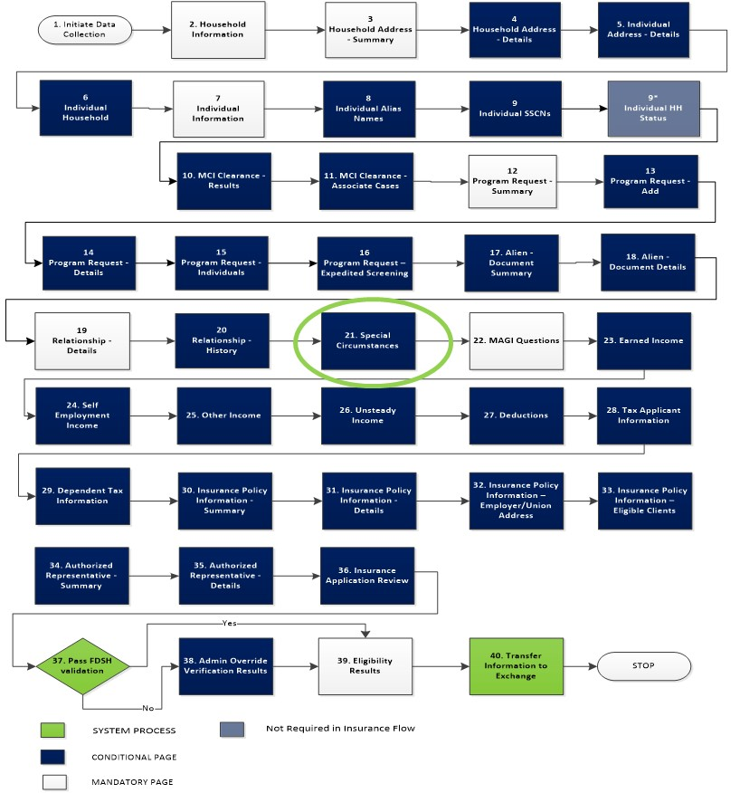

Below, is the Special Circumstances screen that pertains to MA - Chafee.

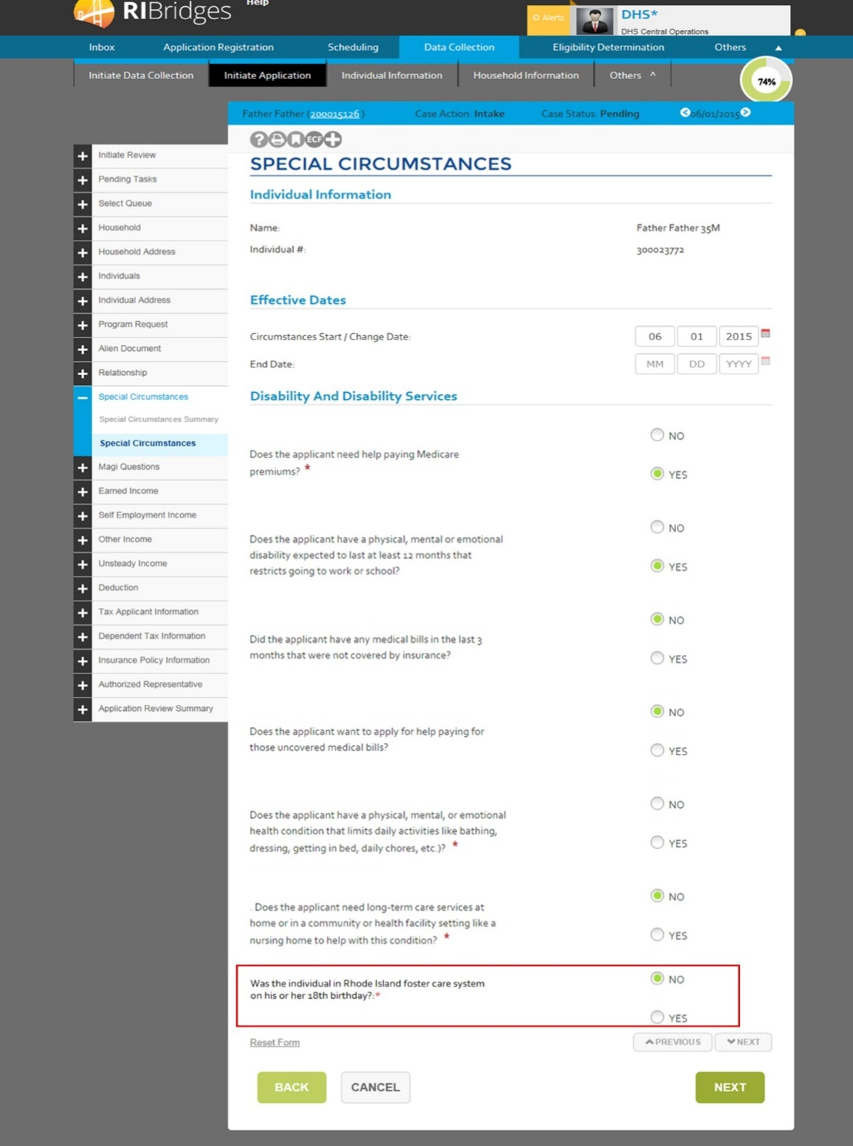

### Chafee Kids – Tasks & Mass update

* No additional tasks will be created as part of this change.
* No additional alerts will be created as part of this change.
* If a Chafee kid ages out of the program, the age-out batch will create a mass update trigger to close the MA – Chafee eligibility for the client. Details about the trigger are outlined in ***03.21-P2-Process Doc-Eligibility-Age Out Batch.***
* If a Chafee kid moves out of state before the age of 26, and the new address is determined in the system, a mass update trigger is created to close the MA – Chafee case. The effective date of the case closure will be identified as the end of the month they left the state (if recorded) or the end of the current month.

### Chafee Kids – Security

No security is expected to be impacted with this change.

## Katie Beckett Medicaid

A person is considered eligible for Katie Beckett Medicaid if they are under the age of 19 and have an impairment that is severe enough to put a significant burden on one’s ability to engage in age-appropriate activities according to the SSA Rules and Regulations. They also require a level of care that is typically provided in a hospital, nursing facility or an Intermediate Care Facility. An applicant is evaluated for Katie Beckett Medicaid as part of the complex Medicaid (DHS-2) workflow.

When a client ages out of the Katie Beckett Medicaid program, they will be automatically notified of their upcoming ineligibility. They will be eligible to apply for assistance with the DHS-2 application to be re-evaluated through the Medicaid Hierarchy cascade to identify the highest benefit they are now eligible for.

When an applicant or parent submits a health insurance application, they are initially evaluated within the MAGI Medicaid workflow for the target applicant. If the applicant is denied MAGI, they are given the option to enroll in private insurance as long as them meet the non-financial requirements for private insurance. Katie Beckett will no longer be a separate case. They will be part of the same Medicaid Account, however they will have DHS-2 application submitted. Existing Katie Beckett cases in InRhodes are standalone cases. They will continue to be a separate case. They will be flagged with Medicaid Type as “Katie Beckett”. However this option cannot be selected by Admin User/Worker. Whenever Application Type is “Katie Beckett” they will be evaluated only for Katie Beckett Medicaid.

If an applicant indicates that they have a disability and require long term support services, they are given the option to continue with a DHS-2 application to be evaluated for Katie Beckett (LTSS) Medicaid. If the applicant chooses to continue with a DHS-2 application and completes the application registration, (or a DHS-2 application is directly created in the worker portal), the following decisions occur:

* Has the applicant completed a DHS-2 application
* Is the applicant is under the age of 19
* Has the applicant been denied MAGI-Medicaid (This rule is not applicable for Converted Katie Beckett Cases)
* Is the applicant requesting long term support services and indicated that they have a disability.

If all the criteria above are met, a task is created for the Katie Beckett Unit to review the case for potential Katie Beckett eligibility. The Katie Beckett Unit can then initiate a Level of Care Assessment and a Disability Determination. When the DHS-2 application is submitted with a Pending Level of Care Assessment or a Pending Disability Determination, the system creates a Katie Beckett – Pending eligibility that overlaps with the QHP eligibility. Once the Level of Care Assessment is authorized and the Disability Determination is authorized, the system will authorize the Katie Beckett eligibility back to the date of application. If the authorization occurs before the 23rd of the month, a trigger is created to close QHP and disenroll the client as of the end of the month. If the authorization is recorded on or after the 23rd of the month and prior to the 1st of the following month, a task is created to the Contact Center to refund the client for the QHP amount. A trigger is also created to close the QHP and disenroll the client as of the end of the month. The Katie Beckett eligibility is created as of the date of application.

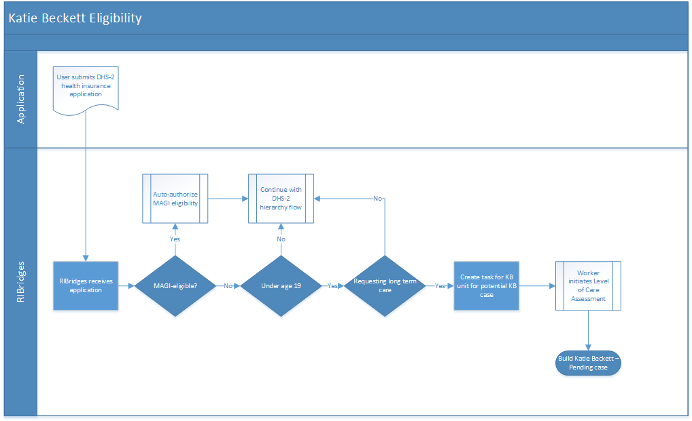

### Katie Beckett Medicaid – Group Composition

To be considered potentially eligible for Katie Beckett Medicaid, an applicant should meet the following criteria:

* Should be less than 19 years of age at the time of application and
* Should indicate that they require assistance for daily activities and long-term care services in the home or community to help with daily activities and
* Denied MAGI Medicaid (*This rule is not applicable for Converted cases, For converted cases the Medicaid Type should be “Katie Beckett”)* and
* Has a Level of Care in a Pending Status or Approved.[ If the client doesn’t meet the LOC requirement, a denial notice should be sent to client indicating the reason]

### Katie Beckett Medicaid – Non-Financial

Potentially Katie Beckett Medicaid applicants are evaluated on the following non-financial eligibility criteria:

* Must be a resident of Rhode Island and
* Must be a citizen of the United States or a lawfully present non-citizen and
* Must not be incarcerated and
* Must provide a valid SSN and
* Must report access to public or non-public MEC and
* Must have a Katie Beckett Review and
* Must have a Level of Care Determination.

### Level of Care Overall Process

A Level of Care Assessment is initiated for a Katie Beckett or Long-Term Services and Support case where a client is requesting long term support services and the EOHHS worker initiates a level of care assessment. The process flow describes how the level of care assessment status determines the case that is built for the client.



The Katie Beckett eligibility is considered as ‘Pending’ under the following conditions –

* Assessment Type is Katie Beckett and
* Assessment Status is Pending and
* Assessment Status Date is null and
* There is no Care Level indicated (Care Level is null) and
* Katie Beckett review is null or pending.

The Katie Beckett eligibility is considered as ‘Approved’ when –

* Assessment Type is Katie Beckett and
* Assessment Status is Approved and
* Assessment Status Date is not null and
* The Care Level is ICF-ID, Hospital or Nursing Home
* Care Start Date is equal to or greater than application begin date and
* Care End Date is null or greater than Care Start Date and
* Katie Beckett review is approved.

The Katie Beckett eligibility is ‘Denied’ when –

* Assessment Type is Katie Beckett and
* Assessment Status is Denied and
* Assessment Status Date is not null.
* If a Level of Care Assessment or
* Katie Beckett review is Denied.

The Katie Beckett – Pending case will be closed as of the date of assessment with an eligibility status of ‘Denied’. The system will also send the client an Adverse Action Notice to the client informing them of the denial of Katie Beckett eligibility. The status of the notice is updated to ‘Printed’ to ensure that there are no further notifications sent to the applicant. The QHP eligibility for the individual will continue as the ongoing case, based on the successful completion of QHP eligibility rules.

If a Katie Beckett child ages out of the eligibility criteria, and the Level of Care End Date is after the age-out date, a trigger is created to automatically evaluate the client through the Medicaid Hierarchy cascade to determine the highest benefit that they would be eligible for.

If the Level of Care End Date is prior to the redetermination date for the Katie Beckett case, the system will create a task for the Katie Beckett Unit to review and renew the Level of Care Assessment. This task will be created 90 days before the End Date of the Level of Care Assessment.

### Katie Beckett Medicaid –Financial

There are no expected changes in the financial eligibility as part of this change request for Katie Beckett eligibility. Only the child’s income (earned and unearned) and resources are considered for Katie Beckett determination. The income and resources of the parents are not considered for the child’s Katie Beckett financial eligibility.

### Katie Beckett Medicaid – Verifications

For Katie Beckett eligibility, the following data points have to be verified as part of the eligibility Verifications process.

| Data Point(s) | Verified for the Type of Assistance? |
| --- | --- |
| Name | Yes |
| Date of Birth | Yes |
| SSN | Yes |
| Citizenship | Yes |
| Immigration Status | Yes |
| Immigration – 5 Year Bar Met | Yes |
| Incarceration Status | Yes |
| Deceased Indicator | Yes |
| Current Income (Title II) | Yes |
| Current Income (Wages) | Yes |
| ESI MEC | No |
| Non-Employer Sponsored Insurance (ESI) Minimum Essential Coverage (MEC) | No |
| Rental Income | Yes |
| Other unearned Income | Yes |
| Self-Employment Income | Yes |
| Assets/Resources | Yes |
| Resource Transfer | Yes |

If all the data points for an applicant are verified through external data sources, they are automatically authorized for Katie Beckett Medicaid. The worker does not have to do a manual authorization of this case.

### Katie Beckett Medicaid – Renewals

Katie Beckett cases will need to be renewed annually. The Level of Care Assessment may be applicable for a longer period of time and may not require renewal. However, as part of the renewal process, services may need to be re-authorized when eligibility is re-determined.

All data points will not need to be re-verified as part of the renewal process. The particular data points that need to be re-verified are specified in ***03.19-P2-Process Doc-Eligibility-Passive Renewal.***

### Katie Beckett Medicaid – Screens and Tables

In order to process an application for Katie Beckett eligibility, the applicant needs to indicate their need for long term services through the Special Circumstances screen. This screen is accessed as part of the MAGI flow within the application.

If the applicant selects to continue with the DHS application after indicating that they require LTSS services, they will be guided to the Level of Care screens.

In particular, in the Special Circumstances screen, the highlighted questions lead to a person being evaluated as Katie Beckett:

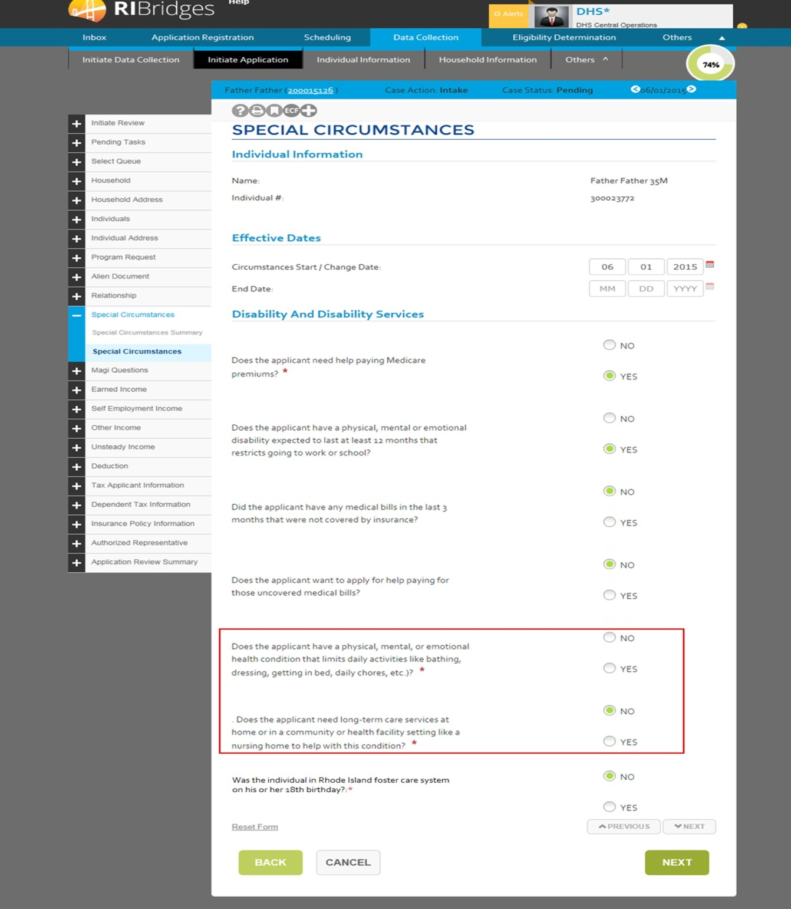

If the person answers ‘Yes’ to the question saying that the applicant needs long-term care services then, the Level of Care screens are queued up within the Non-Financial section of the DHS-2 application flow. The user is expected to access this information and enter the level of care as “Pending” during the clinical evaluation.



The Level of Care screens have been added to the Non-Financial workflow to capture the Level of Care information. Details of these screens are provided in the section on *Design Artifacts Inserted.*

### Katie Beckett – Tasks/Alerts/Mass Updates

* The following tasks will be created for Katie Beckett eligibility:
  + For a new DHS-2 Medicaid application, after eligibility determination for MAGI programs, if the client is determined potentially eligible for Katie Beckett (LTSS) Medicaid, then a task is created to the Katie Beckett Unit to evaluate the case.
  + System will send out Katie Beckett disability determination forms, 90 days prior to its periodic review date. All cases, doesn’t need to be periodically reviewed.
  + System will send out a Task to Katie Beckett Unit to initiate the Level of Care review for the clients, whose level of care needs to be reviewed in the next 90 days.
  + Katie Beckett unit will receive a task, whenever child’s individual or income/resource information is updated by other public assistance program worker or contact center worker. This is to review the new information reported and take appropriate actions.
* The following Mass Updates Triggers will be created for Katie Beckett eligibility:
  + Trigger is created to run eligibility, if the Katie Beckett determination review form is not received from client within 45 days from the sent date.
  + Trigger is created to run eligibility, if the Katie Beckett review is not completed within 90 days from the review initiated date or form sent date.

### Katie Beckett – Security

* The Katie Beckett Unit will have read-write access to the Level of Care screens.
* The Katie Beckett Unit will have read-write access to the Disability Determination screens.
* The Katie Beckett Unit will have the security to clear Katie Beckett tasks.

### Level of Care Screens – Security

The following user roles will have access to the Level of Care screens:

* Katie Beckett Unit – Read-Write access
* LTSS Unit – Read-Write access
* BHDDH – Read-Write access
* All other users who have read access to the data collection screens will have read-only access to the Level of Care screens.

### Age-Out Batch

The changes to the age-out batch for the Katie Beckett eligibility are detailed in ***03.21-P2-Process Doc-Eligibility-Age Out Batch.***

### MMIS Interface

There are no specific changes related to MMIS Interfaces for Katie Beckett Medicaid.

### Katie Beckett – Notices

The specifications for the age-out notice for Katie Beckett eligibility is detailed in the ***03.21-P2-Process Doc-Eligibility-Age Out Batch.***

The existing Katei Beckett notices will not be affected by the changes reflected here.

## SSI Medicaid

SSI Medicaid information is determined by and typically received from the Social Security Administration. This is received through the State Data Exchange (SDX) interface. Cases are automatically opened and updated for clients in RIBridges based on the information received from the SSI batch.

Clients can also apply for SSI Medicaid by taking their qualifying SSI information to a DHS office. In this instance, a worker opens an SSI Medicaid case using the authorizing information. If a client is applying for SSI Medicaid only, there is no financial or resource eligibility determination. It is expected that this information is further confirmed through the SDX interface during the following run.

Clients receiving SSI can also apply for and receive LTSS services. If they request for long term care assistance, they will be evaluated for LTSS based on the LTSS resource eligibility and Level of Care Assessment criteria.

### SSI Medicaid – Group Composition

A client receiving SSI-Medicaid will have an individual EDG built for their SSI type of assistance. An SSI Medicaid case will, most often, be created by the information received via the SDX interface. If the client is identified as receiving SSI income, the client will be considered eligible for SSI – Medicaid type of assistance. If the person does not receive SSI income, they will be considered eligible for SSI – 1619B type of assistance.

If a person eligible for SSI Medicaid is also applying for long term support services, the Group Composition rules for LTSS services will define the SSI – LTSS Medicaid Group Composition. *The group composition rules for LTSS clients are further defined in the LTSS section of this document.*

### SSI Ex-Parte/Termination Process

When a client no longer receives SSI income or are determined as closed for the SSI-1619B Medicaid, they will no longer be eligible for SSI Medicaid. The client will need to be ex-parte reviewed and then closed out of SSI Medicaid following the appropriate timeframes and procedures. The ex-parte process is initiated by a closure or termination received from SSA through the SDX batch. Below diagram depicts is the system process flow and details outlining the ex-parte process for terminating a client from SSI Medicaid.

When a client is ex-parte reviewed from SSI Medicaid and also receives LTSS, the termination notice they receive will include information on re-applying for LTSS Medicaid through the system.

Below is the high-level process flow for terminating SSI Medicaid. The details of the termination codes that require the ex-parte process and those that can be closed without an ex-parte are included in the Appendix.



The Payment Status Codes from the SDX interface indicates if an SSI client needs to be terminated from SSI-Medicaid in the system. The Payment Status Codes indicates if an ex-parte process is needed prior to terminating the SSI-Medicaid or if it can be terminated without an ex-parte process. If the code indicates that a client can be terminated without an ex-parte process, the SSI- Medicaid is closed as of the last day of the month that the SSI transaction is received. If the client should receive an ex-parte notice regarding the termination of their SSI-Medicaid, the SDX batch will trigger the Adverse Action Notice to provide the client with enough time to apply for regular Medicaid prior to the SSI-Medicaid closure. Once the client applies for Medicaid, the system will trigger the closure for the SSI-Medicaid while evaluating the application for Medicaid eligibility. If the client has a family case, they can be added to the existing family case as a requesting member and can be considered for eligibility when the eligibility is re-run for the case. The SSI case will be closed out.

### SSI Medicaid – Non-Financial

There are no expected changes in the Non-Financial eligibility as part of this change request for SSI eligibility.

If an SSI Medicaid client is also requesting for Long Term Support Services, they will be evaluated based on the LTSS criteria specific for long term services. Below is the list of LTSS non-financial criteria that need to be evaluated for SSI – LTSS clients.

|  |  |  |  |
| --- | --- | --- | --- |
| Non-Fin Information | Applicable for SSI – LTSS? | Applicable for LTSS? | Applicable for Sherlock LTSS? |
| Citizenship | No | Yes | Yes |
| Non-Citizen Status | No | Yes | Yes |
| Rhode Island Residency | Yes | Yes | Yes |
| SSN | No | Yes | Yes |
| Incarceration | Yes | Yes | Yes |
| Disability | No | Yes | Yes |
| Level of Care | Yes | Yes | Yes |
| Third Party Coverage | No | Yes | Yes |
| Premium Non-Payment Sanction | No | No | Yes |

As information regarding citizenship, non-citizen status, and disability are already verified by SSI prior to a person receiving MA – SSI, they will not need to be re-evaluated within RIBridges. The only data points that need to be triggered by the non-financial rules are based on the ones that are unique to LTSS like Level of Care assessment.

### SSI Medicaid – Financial

There are no expected changes in the financial eligibility as part of this change request for SSI eligibility.

If an SSI Medicaid client also requesting for Long Term Support Services, they will be evaluated based on LTSS criteria for Resource eligibility. *This is further defined in the Long Terms Support Services section of this document.*

### SSI Medicaid – Verifications

There are no expected changes in the verifications process for SSI Medicaid. If a client applies for SSI Medicaid from the DHS office, they will be subject to the verifications listed below. If a client also applies for LTSS, they will be subject to LTSS verifications process, where applicable. Detailed specifications of the verifications process is outlined in the *Verifications Design Document.*

|  |  |
| --- | --- |
| Data Point(s) | Verified for the Type of Assistance? |
| Name | No |
| Date of Birth | No |
| SSN | No |
| Citizenship | No |
| Immigration Status | No |
| Immigration – 5 Year Bar Met | No |
| Incarceration Status | No |
| Deceased Indicator | No |
| Current Income (Title II) | No |
| Current Income (Wages) | No |
| ESI MEC | No |
| Non-Employer Sponsored Insurance (ESI) Minimum Essential Coverage (MEC) | No |

### SSI Medicaid – Renewals

There are no expected impacts on SSI-Medicaid renewals process as part of this change request.

### SSI Medicaid – Screens and Tables

There are no expected changes to screens and tables that will impact SSI-Medicaid as part of this change request.

### SSI Medicaid – Tasks/Alerts/Mass Updates

The following new tasks will be generated for SSI Medicaid

1. ***Address Update***

If an address is updated through SNAP (or another DHS program), a task is created to the SSI Unit to update the mailing address in UHIP.

The worker will be able to update the Mailing Address for the person to ensure that the State SSI payments and cards go to the correct address. They will need to coordinate with SSA to update the Physical Address of the person.

1. ***Address Verification***

If the payment status code received from SDX is N54 (Unable to locate participant) or S06 (Suspended – Recipient’s address unknown), a task is generated to identify if the address of the client can be found through any other DHS program in the system.

1. ***Verification of Death***

If the payment status code received from SDX is S01 (Suspension of payment due to report of death by Treasure or potential automated death case), a task is created to the SSI Unit to review the death information received.

The SSI Unit will initiate the R-DOC and closure of the SSI-Medicaid if the death information is confirmed.

1. ***Exparte Review Required***

If the payment status code received from SDX identifies the case as ex-parte required, a task is created to the Supervisor queue requiring the supervisor to review the case and authorize closure.

### SSI Medicaid – Security

There are no expected changes to security as part of this change request that impacts SSI Medicaid.

### SSI Medicaid – Batches/Interfaces

The following batches/interfaces will be impacted by this change request:

#### SDX Interface

Based on the payment status code, the SDX interface creates triggers to close the SSI-Medicaid case or generate an ex-parte notice to the client. The case is closed based on the Denial Date received from the interface or at the end of month for which the interface is received.

For termination reasons that require an ex-parte notice, the SDX interface only creates the trigger to generate the notice to the client.

Below is the list of Termination Codes and how they should be treated for the ex-parte process:

#### SDX Termination and Suspension Codes

|  |  |  |  |
| --- | --- | --- | --- |
| SDX Code | Description | Ex-Parte Rules | Additional Business Rules* |
| N01 | Countable Income exceeds Title XVI federal benefit rate | Ex-parte required | Insert trigger to generate SSI exparte correspondence.  Insert trigger to process closure 30 days from current date for SSI case.  Create exparte record in Exparte screen. |
| N02 | Recipient is inmate of public institution | Ex-parte required | The system will verify if RIBridges has incarceration information from Dept. Of Corrections. If verified, the system will begin the ex-parte process. |
| N04 | Recipient's non-excludable resources exceed Title XVI limitations | Ex-parte required | Insert trigger to generate SSI exparte correspondence.  Insert trigger to process closure 30 days from current date for SSI case.  Create exparte record in Exparte screen. |
| N05 | Unable to determine if eligibility exists | Ex-parte required | Insert trigger to generate SSI exparte correspondence.  Insert trigger to process closure 30 days from current date for SSI case.  Create exparte record in Exparte screen. |
| N06 | Recipient failed to file for other benefits | Ex-parte required | Insert trigger to generate SSI exparte correspondence.  Insert trigger to process closure 30 days from current date for SSI case.  Create exparte record in Exparte screen. |
| N07 | Cessation of the recipient's disability | Ex-parte required | Insert trigger to generate SSI exparte correspondence.  Insert trigger to process closure 30 days from current date for SSI case.  Create exparte record in Exparte screen. |
| N08 | Cessation of the recipient's blindness | Ex-parte required | Insert trigger to generate SSI exparte correspondence.  Insert trigger to process closure 30 days from current date for SSI case.  Create exparte record in Exparte screen. |
| N09 | Recipient refused vocational rehabilitation without good cause | Ex-parte required | Insert trigger to generate SSI exparte correspondence.  Insert trigger to process closure 30 days from current date for SSI case.  Create exparte record in Exparte screen. |
| N10 | Recipient refused treatment for drug addiction | Ex-parte required | Insert trigger to generate SSI exparte correspondence.  Insert trigger to process closure 30 days from current date for SSI case.  Create exparte record in Exparte screen. |
| N11 | Recipient refused treatment for alcoholism | Ex-parte required | Insert trigger to generate SSI exparte correspondence.  Insert trigger to process closure 30 days from current date for SSI case.  Create exparte record in Exparte screen. |
| N12 | Recipient voluntarily withdrew from the program | Ex-parte required | Insert trigger to generate SSI exparte correspondence.  Insert trigger to process closure 30 days from current date for SSI case.  Create exparte record in Exparte screen. |
| N14 | Aged claim denied for age | Ex-parte required | Insert trigger to generate SSI exparte correspondence.  Insert trigger to process closure 30 days from current date for SSI case.  Create exparte record in Exparte screen. |
| N15 | Blind claim denied. Applicant not blind | Ex-parte required | Insert trigger to generate SSI exparte correspondence.  Insert trigger to process closure 30 days from current date for SSI case.  Create exparte record in Exparte screen. |
| N16 | Disability claim denied. Applicant not disabled. | Ex-parte required | Insert trigger to generate SSI exparte correspondence.  Insert trigger to process closure 30 days from current date for SSI case.  Create exparte record in Exparte screen. |
| N17 | Failure to pursue claim by the applicant | Ex-parte required | Insert trigger to generate SSI exparte correspondence.  Insert trigger to process closure 30 days from current date for SSI case.  Create exparte record in Exparte screen. |
| N19 | Recipient has voluntarily terminated participation in the SSI program | Ex-parte required. | Insert trigger to generate SSI exparte correspondence.  Insert trigger to process closure 30 days from current date for SSI case.  Create exparte record in Exparte screen. |
| N27 | Disability terminated due to a substantial gainful activity | Ex-parte required | Insert trigger to generate SSI exparte correspondence.  Insert trigger to process closure 30 days from current date for SSI case.  Create exparte record in Exparte screen. |
| N39 | Applicant willfully fails to follow prescribed treatment | Ex-parte required | Insert trigger to generate SSI exparte correspondence.  Insert trigger to process closure 30 days from current date for SSI case.  Create exparte record in Exparte screen. |
| N40 | Impairments(s) does not meet or equal listing (disabled child under age 18 only), no visual impairment | Ex-parte required | Insert trigger to generate SSI exparte correspondence.  Insert trigger to process closure 30 days from current date for SSI case.  Create exparte record in Exparte screen. |
| N41 | Slight impairment - medical condition alone, visual impairment | Ex-parte required | Insert trigger to generate SSI exparte correspondence.  Insert trigger to process closure 30 days from current date for SSI case.  Create exparte record in Exparte screen. |
| N42 | Capacity for substantial gainful activity - customary work, visual impairment | Ex-parte required | Insert trigger to generate SSI exparte correspondence.  Insert trigger to process closure 30 days from current date for SSI case.  Create exparte record in Exparte screen. |
| N43 | Capacity for substantial gainful activity other work, visual impairment | Ex-parte required | Insert trigger to generate SSI exparte correspondence.  Insert trigger to process closure 30 days from current date for SSI case.  Create exparte record in Exparte screen. |
| N45 | Impairment no longer severe at time of adjudication and did not last twelve months, visual impairment, or denial of child's claim | Ex-parte required | Insert trigger to generate SSI exparte correspondence.  Insert trigger to process closure 30 days from current date for SSI case.  Create exparte record in Exparte screen. |
| N46 | Impairment is severe at time of adjudication but no expected to last twelve months, visual impairment | Ex-parte required | Insert trigger to generate SSI exparte correspondence.  Insert trigger to process closure 30 days from current date for SSI case.  Create exparte record in Exparte screen. |
| N47 | Insufficient, or no, medical evidence furnished, visual impairment | Ex-parte required | Insert trigger to generate SSI exparte correspondence.  Insert trigger to process closure 30 days from current date for SSI case.  Create exparte record in Exparte screen. |
| N50 | Applicant willfully fails to follow prescribed treatment, visual impairment. | Ex-parte required | Insert trigger to generate SSI exparte correspondence.  Insert trigger to process closure 30 days from current date for SSI case.  Create exparte record in Exparte screen. |
| N51 | State to provide | Ex-parte required | Insert trigger to generate SSI exparte correspondence.  Insert trigger to process closure 30 days from current date for SSI case.  Create exparte record in Exparte screen. |
| N54 | D.O. unable to locate the participant. | Ex-parte required | Insert trigger to generate SSI exparte correspondence.  Insert trigger to process closure 30 days from current date for SSI case.  Create exparte record in Exparte screen. |

* If the same individual receives the same payment status code the following day, an exparte notice should not be generated to the individual.

#### MMIS Interface

The MMIS 4B Transaction will be sent to MMIS system to close SSI client’s SSI Medicaid based on the closure information received through SDX (SSA) interface.

### SSI Medicaid – Notices

There are no expected changes to notices with this change request that impacts SSI Medicaid.

## SSI Lookalikes

SSI Lookalikes cases are eligible for Medicaid even though they are not SSI-eligible based on the income criteria. They lose SSI Medicaid eligibility due to increases in SSI income based on specific factors like COLA increases or actuarial changes. These cases are received through the State Data Exchange (SDX) interface and are automatically opened and updated for clients in RIBridges based on the information received from the SSI batch.

Clients can also apply for SSI Lookalike Medicaid by taking their qualifying SSI information to a DHS office. In this instance, a worker opens an SSI Medicaid case using the authorizing information. It is expected that this information is further confirmed through the SDX interface during the following run.

Clients receiving SSI Lookalikes are considered disabled as they are receiving or have received SSI or RSDI – Disability benefits. They would require a MART Review only if they do not receive or have never received SSI or RSDI-Disability benefits.

Clients receiving some SSI Lookalike types of Medicaid can also apply for and receive LTSS services. If they request for long term care assistance, they will be evaluated for LTSS based on the LTSS resource eligibility and Level of Care Assessment criteria. The following are the SSI Lookalike programs in RIBridges -

* Pickle Amendment
* Disabled Adult Child
* SSI Inelig Actuar changes
* Protected Widow(er)
* Disabled Widow(er), Divorced Spouse

### Pickle Amendment

The Pickle Amendment protects low-income SSI recipients from losing benefits because of COLA increases in their SSI benefits. When a client receives both SSI and Medicaid because of their SSI income, they may lose Medicaid eligibility with a COLA increase in SSI or RSDI income. In this case, they are eligible through the Pickle Amendment and can use their original SSI income in determining continued Medicaid eligibility.

**Eligibility Requirements:**

In order to qualify for the Pickle Amendment, the client should –

* + - 1. Should have received SSI and RSDI income concurrently
      2. Currently receiving RSDI income
      3. Be closed to SSI because of a COLA increase in RSDI on or after April 1st, 1977
      4. Be determined aged, blind or disabled by SSI
      5. Have household resource value is less than or equal to $2000.
      6. The person’s resource value is <= $3,000 if the person’s spouse is part of the financial unit
      7. The person’s resource value is <= $2000 if the person’s spouse is not considered part of the financial unit

### Disabled Adult Child

The Disabled Adult Child (DAC) SSI lookalike provides income for disabled adult children who would lose their SSI income due to increases in RSDI income with a COLA increase. The DAC-SSI category protects their SSI-Medicaid coverage by protecting their SSI-Medicaid status. To be eligible for this status, a person should –

Be at least eighteen (18) years of age

Have disability onset date is before their 22nd birthday

Be denied SSI because of an increase in their RSDI due to COLA (denial reason code is due to increase in Child’s benefit (Title II-d).

Have lost SSI benefits only after July 1, 1987

For this group, the client applies for Medicaid through the DHS-2 form and passes all other requirements (residency, citizenship, enumeration etc). Their RSDI income is disregarded as countable income in identifying if they are SSI eligible.

### SSI Inelig Actuar Changes

SSI and RSDI recipients who received disabled widow(ers) benefits prior to the age of 60 lost SSI benefits due to changes in the actuarial reduction formula used to calculate their benefits. This change in calculation resulted in increases in their RSDI income to above the SSI standard, causing them to lose SSI benefits. In order to protect this population, the COBRA of 1985 reinstituted the categorically eligible status for the applicants.

**Eligibility Requirements:**

To be eligible under this coverage, the person should –

* + - 1. The person should have filed for Medicaid prior to July 1st, 1988 and
      2. They have been eligible for disabled widow(er) benefits as part of RSDI (Title II) as of December 1983 and
      3. They have received SSI benefits based on disability for January 1984 and
      4. They have become ineligible for SSI benefits after the increase in RSDI payments due to changes in the reduction factor formula and
      5. They continue to be eligible for RSDI Disabled Widow(er) benefits and
      6. They would be eligible for SSI if the COLAs were disregarded as countable income.
      7. All other conditions for SSI eligibility (except for RSDI income) should be met.

When determining if an applicant is categorically eligible for SSI – Inelig Actuarial Changes, the RSDI income of the client is not considered as part of the income calculations.

If a person does not meet other eligibility requirements, their RSDI income is used in determining if they are Medically Needy.

### Protected Widow(ers) Age 60 – 65

This SSI category provides disabled widow(ers) between the age of 60 and 65 who lose SSI benefits because of their entitlement to Protected Widow(er) benefits or a combination of Protected Widow(er) and RSDI benefits. Further, these applicants are entitled to Title II benefits and are not yet Medicare eligible.

**Eligibility Requirements:**

* The person loses SSI eligibility due to entitlement to widowers benefits and
* They are greater or equal to 60 years old and less than the age of 65 and
* They are currently receiving RSDI benefits and
* They are not entitled to Medicare and
* They have a disability determination per SSA

The person’s RSDI income is disregarded until the person reaches 65 or becomes Medicare eligible. If they are close to their 65th birthday, the redetermination is done one month prior to the client reaching the age of 65. If the client is not categorically needy, they will be evaluated for Medically Needy eligibility. All income will be included in determining medically needy eligibility.

### Disabled Widow(ers), Divorced Spouse

The Disabled Widow(er)/Divorced Spouse coverage group consists of disabled widow(ers) and disabled surviving spouses who lose SSI benefits or State Supplement due to the receipt of Title II Disabled Widow(er) benefits. For Medicaid purposes, these clients are deemed SSI eligible until they can receive Medicare.

**Eligibility Requirements:**

A person is considered eligibility for, Divorced Spouse if –

* They currently receive RSDI benefits and
* Their SSI was denied because of the Disabled Widower (RSDI Survivor) benefits they receive and
* They do not receive Medicare and
* They are not entitled to receive Medicare

## Emergency Medicaid (MAGI and ABD)

Emergency Medicaid helps cover emergency health coverage for expenses that have already occurred. This includes in-patient hospital services and emergency hospital services. It is provided to clients who meet all MAGI or ABD Medicaid criteria except the Citizenship/Non-Citizen requirements. If a person is not eligible for MAGI or ABD Medicaid only because they do not meet the Citizenship/Non-Citizen requirements, they can potentially be eligible for Emergency Medicaid. The system will not build retro-QHP coverage for the individual requesting coverage through Emergency Medicaid. If a person receives Emergency – ABD coverage, they either meet the age criteria for Aged (above the age of 65 years) or they are considered disabled through a MART review or have SSI/RSDI-Disability.

Emergency Medicaid is provided only for a specific period of time in the past. The client indicates the start and end dates of their emergency in the ‘Alien’ screen in the application. The Emergency Medicaid period is identified from the start and end date of the emergency indicated. If the emergency spans multiple months, multiple eligibility rows are created with a Start Date for the first eligibility period identified as the start date of the emergency and the End Date of the last eligibility period identified as the end date of emergency indicated. The Emergency period cannot span more than 90 days at a time. Ongoing approved eligibility is not created for Emergency Medicaid.

***Note: Emergency Medicaid is always for the past period. The worker needs to enter the application date and request date as past month for the Emergency Medicaid to be approved. The application date should reflect the emergency period that is being covered. Emergency Medicaid for ABD Group needs to be built with Medically Needy Group and client should have Medical expenses reported.***

***Scenario #1:*** An applicant applies for health insurance coverage. They indicate that they are a non-citizen and they have had a medical emergency. The start date of the medical emergency is 06/03/2015 and the end date of the medical emergency is 06/17/2015. They apply for assistance on 06/20/2015. The user would need to enter the Application Date as the Start Date of the emergency period, similar to current practice.

The eligibility determination results are displayed in the following manner –

|  |  |  |  |  |  |  |
| --- | --- | --- | --- | --- | --- | --- |
| Filing Unit # | Participant | TOA | Benefit Status | Benefit Start | Benefit End | Financial Unit |
| 121001 | James Jack 41M | MAGI – Emer | Approved | 06/03/2015 | 06/17/2015 | 1 |

***Scenario #2:*** An applicant applies for health insurance coverage. They indicate that they are a non-citizen and they have had a medical emergency. The start date of the medical emergency is 06/28/2015 and the end date of the medical emergency is 08/05/2015. They apply for assistance on 08/25/2015. The user would need to enter the Application Date as the Start Date of the emergency period, similar to current practice.

The eligibility determination results are displayed in the following manner –

|  |  |  |  |  |  |  |
| --- | --- | --- | --- | --- | --- | --- |
| Filing Unit # | Participant | TOA | Benefit Status | Benefit Start | Benefit End | Financial Unit |
| 121001 | James Jack 41M | MAGI – Emer | Approved | 06/28/2015 | 06/30/2015 | 1 |
| 121001 | James Jack 41M | MAGI – Emer | Approved | 07/01/2015 | 07/31/2015 | 1 |
| 121001 | James Jack 41M | MAGI – Emer | Approved | 08/01/2015 | 08/05/2015 | 1 |

***Scenario #3:*** An applicant applies for health insurance coverage. They indicate that they are a non-citizen and they have had a medical emergency. They start date of the medical emergency is 06/10/2015 and the end date of the medical emergency is 06/25/2015. They apply for assistance on 06/25/2015. They include their spouse in the application. The user would need to enter the Application Date as the Start Date of the emergency period, similar to current practice.

The eligibility determination results are displayed in the following manner –

|  |  |  |  |  |  |  |
| --- | --- | --- | --- | --- | --- | --- |
| Filing Unit # | Participant | TOA | Benefit Status | Benefit Start | Benefit End | Financial Unit |
| 121001 | James Jack 41M | MAGI – Emer | Approved | 06/10/2015 | 06/25/2015 | 2 |
| 121021 | Frances Jack 35F | MAGI | Approved | 06/01/2015 | 06/30/2015 | 2 |
| 121021 | Frances Jack 35F | MAGI | Approved | 07/01/2015 | Ongoing | 2 |

### Emergency Medicaid – Group Composition

The group composition will be created in the same manner as they are created for MAGI- Medicaid and ABD – Medicaid. The only categories of MAGI Medicaid that are applicable are –

* Parent/Caretaker
* Childless Adult
* Child
* Pregnant women

If a person is 65 years old or older (not parent/caretaker), they will be considered eligible for ABD – Emergency. Their group composition will be created under the rules for Community Medicaid.

### Emergency Medicaid – Non-Financial

There is no change in the non-financial eligibility requirements for Emergency Medicaid. For a person to be eligible for MA – Emergency, the following non-financial date points will need to be verified –

* Residency in Rhode Island and
* Not incarcerated at the time of application and
* Not dead at the time of application and
* Not a US citizen and
* Currently considered Undocumented or
* Does not meet five-year bar to be Lawfully Permanent Resident or
* Does not fall into one of the federal rules for eligible non-citizens exempt from five-year bar.

### Emergency Medicaid – Financial

There is no change in the financial eligibility requirements for Emergency Medicaid. For a person to be considered MAGI – Emergency Medicaid eligible, they will need to meet the MAGI financial criteria.

For a person to be considered ABD – Emergency Medicaid eligible, they will need to meet the ABD financial eligibility criteria. This includes both the income and resource eligibility criteria.

### Emergency Medicaid – Verifications

The following data points are verified for MA and ABD – Emergency applicants:

|  |  |
| --- | --- |
| Data Point(s) | Verified for the Type of Assistance? |
| Name | Yes |
| Date of Birth | No |
| SSN | No |
| Citizenship | No |
| Immigration Status | No |
| Immigration – 5 Year Bar Met | No |
| Incarceration Status | Yes |
| Deceased Indicator | Yes |
| Current Income (Title II) | Yes |
| Current Income (Wages) | Yes |
| ESI MEC | Yes |
| Non-Employer Sponsored Insurance (ESI) Minimum Essential Coverage (MEC) | Yes |
| Self-Employment | Yes |
| Unearned Income | Yes |
| Room/Rental Income | Yes |
| Assets/Resources | Yes (only for ABD. Not for MAGI) |

If all the data points for an applicant are verified through external data sources, they are authorized for MA – Emergency Medicaid. If the client has failed MAGI requirements and If the client has their Disability Determination Approved by the MART Review process, they can be determined for ABD – Emergency Medicaid. Further details on the verification process can be found in the verification design document*.*

### Emergency Medicaid – Renewals

As Emergency Medicaid is not an ongoing Medical coverage, renewals are not applicable for this benefit coverage.

### Emergency Medicaid – Screens and Tables

The Alien Details screen under Individual Information in Data Collection has been modified to include questions about whether an individual has a medical emergency. The user is asked to specify the emergency start and end dates.

If an individual does not qualify for MAGI or ABD Medicaid because of their non-citizen requirements, and medical emergency dates are populated, this information is used to build their eligibility periods.

Below, is a detailed description of the new fields added to the Alien Details screens as pertains to Emergency Medicaid.

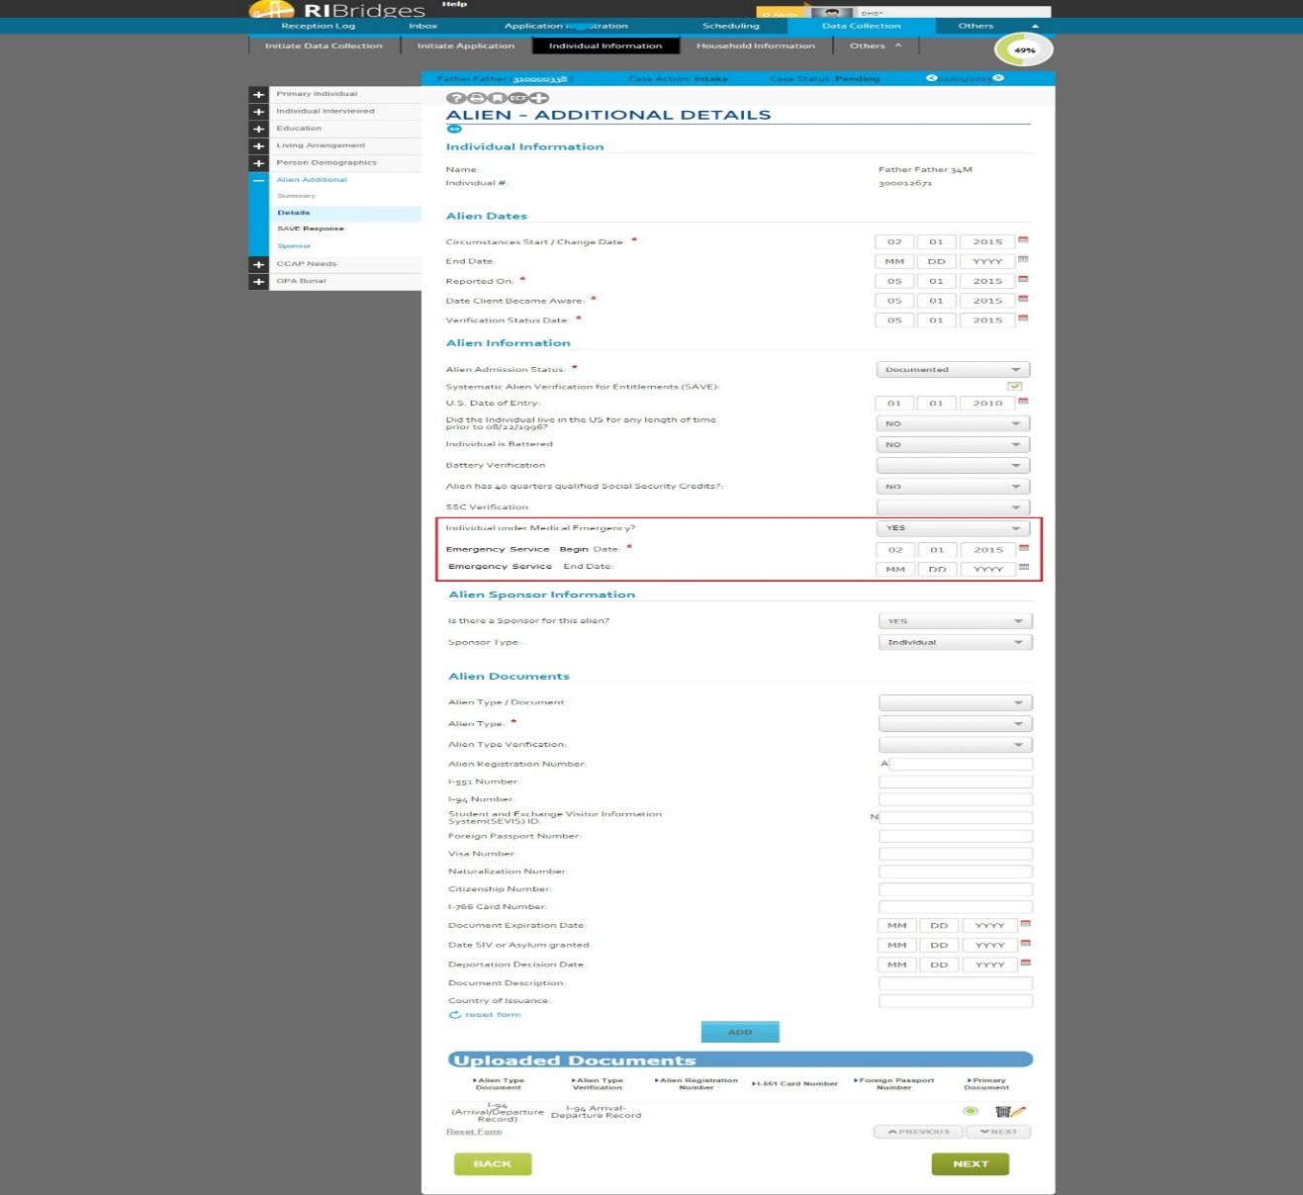

**Ref: 02.01.33_DC_Alien_Additional_Details: Data Table(relevant fields only)**

### Emergency Medicaid – Security

There are no expected changes to security as part of this change request that impacts Emergency Medicaid.

### Emergency Medicaid – Batches/Interfaces

* The new 2B transaction will be sent to MMIS to record the Emergency Medicaid transaction. This will detail both eligibility start and end dates. Details for this are in Section 3.16.
* There will be no 1B transaction sent for this type of assistance.

### Emergency Medicaid – Notices

There are no expected changes to Notices as part of this change request that impacts Emergency Medicaid.

## MA – Transitional Medicaid (MA-XMA)

Transitional Medicaid, or Extended Medicaid, is provided to families (parents) who are transitioning from welfare to work. It covers families who are participating in RI Works and families who forego cash assistance and have an income up to 110% of FPL at the time of eligibility determination. Families will be eligible for Extended Medicaid for up to twelve (12) months if they were to potentially lose health coverage due to one of the following reasons:

* Employment
* Increase in wages
* Increase in hours worked

A family can be approved for a period of six (6) months following their loss of coverage. At the end of six month period, the client has to provide an earned income report and necessary child care expenses. At this point, the client can be evaluated for the remaining six months of Extended Medicaid. The family can be eligible for Extended Medicaid again during their lifetime, if they were to come back into RIWorks.

**“Whenever TMA switch is turned off, system should evaluate them only for four month TMA period. If the client is already receiving TMA, then TMA should be denied beyond four months period. However, system needs to be provide adverse action notice.”**

### Extended/Transitional Medicaid – Group Composition

There is no change in the group composition for Extended Medicaid group composition. The group composition is created with the following characteristics:

* Family has a dependent child living at home who is less than 18 years old or
* Family has a dependent child between age 18 and 19 who is enrolled in full-time school or vocational/technical training and is expected to finish the program before or on their 19th birthday and
* Family is not eligible for other forms of Medicaid coverage and
* Family loses Medicaid coverage due to one of the following reasons:
  + Employment or
  + Increase in wages or
  + Increase in hours

The family members who will be included as part of the group composition include:

* Individuals who are living in the household and who were included in determining original Medicaid eligibility
* Individuals who would be included in determining Medicaid eligibility if the family were Medicaid eligible going forward.
  + If a new person were to be included in the household after the expiration of the Medicaid eligibility, this person will be included in assessing eligibility for Extended Medicaid as well.

### Initial Criteria for Extending Medicaid

At the time a family becomes ineligible for Section 1931 Medicaid benefits, the Medicaid agency must verify and confirm, whether:

1. The Family meets the all the requirements of 1931 Family Medicaid except Financial Eligibility.
2. 1931 Family Medicaid is lost due to earnings increase or employment or employment hours increase.

### Loss of Benefits Due to Employment

A required element for eligibility to receive extended Medicaid is employment of a parent / caretaker or other member(s) of the family whose earned income contributes to the family's loss of eligibility for Section 1931 Medicaid. Often employment linked with other changes, such as a parent returning to the home or a child turning eighteen, may combine to cause the loss of eligibility. While there must be a relationship between earned income and the loss of eligibility for Section 1931 Medicaid to qualify for extended Medicaid, the advent or increase in earned income need not be the only factor causing the loss.

### Individuals Eligible to be Included

The first month of extended Medicaid is the first full or partial month in which the family loses eligibility for Medicaid health care coverage under Section 1931, but only in those instances in which eligibility under any other Medicaid coverage group is unavailable. If the family is eligible for Medicaid State Plan or HCBS coverage, extended Medicaid will be denied. Extended Medicaid is provided to those individuals:

* who are living in the household, and whose needs and income were included in determining Section 1931 eligibility of the assistance unit at the time such benefits were discontinued;
* whose needs and income would be taken into account in determining Section 1931 Medicaid eligibility of the assistance unit if the family were applying for either of these programs in the current month

### Initial Receipt of Extended Medicaid

Extended Medicaid continues throughout the first seven months following the loss of Section 1931 Medicaid eligibility unless:

* No age-appropriate child is living in the family;
* The parent / caretaker refuses to apply for health coverage offered by the employer.

When it is determined that a family no longer has a child who meets the age requirements living in the home, Medicaid for all family members ends the last day of the month in which the family no longer includes such child.

### Continuing Receipt of Extended Medicaid

To continue to receive the remaining months of extended Medicaid, up to the limit of the full twelve months of the transitional medical program, families must:

* Include a child who meets the age requirement living in the household; and
* Timely file the earned income report when due in the seventh (7th) month; and
* Pass the 185% FPL earned income test; and
* Pass the parent / caretaker employment test. Additionally, an employed parent / caretaker must enroll in an employment-related health plan, if such plan is offered.

### Submitting the Earned Income Report

The extended Medicaid earned income reports are:

* an accounting of the family's total gross earned income and a parent / caretaker’s necessary child care expenses for month six (6) of extended benefits;
* Due by the 5th day of month six (6) respectively of extended benefits. On the 15th of each month, a reporting form is sent to any family who has reached month six (6) of extended Medicaid. Such a family must report the required income and necessary child care information by the 5th day of the following month.
* On the 7th day of each month, a reminder notice is sent to all extended Medicaid cases scheduled to report in the month. This is to encourage compliance by any family that has neglected to return the report by the due date (5th of the month)

### Extended/Transitional Medicaid – Non-Financial

There are no changes to non-financial requirements for Extended/Transitional Medicaid as part of these changes. It follows MAGI rules.

### Extended/Transitional Medicaid – Financial

There is no financial check for the Initial eligibility up to six (6) months. Once the client filed the earned income reporting then their countable income should up within 185% FPL. Otherwise, they are not eligible for TMA for the remaining six (6) months.

### Extended/Transitional Medicaid – Verifications

The following data points will be verified for Extended/Transitional Medicaid as part of the eligibility verifications process –

|  |  |
| --- | --- |
| Data Point(s) | Verified for the Type of Assistance? |
| Name | Yes |
| Date of Birth | Yes |
| SSN | Yes |
| Citizenship | Yes |
| Immigration Status | Yes |
| Immigration – 5 Year Bar Met | Yes |
| Incarceration Status | Yes |
| Deceased Indicator | Yes |
| Current Income (Title II) | No |
| Current Income (Wages) | No (Yes, during Earned Income Reporting Period) |
| ESI MEC | No |
| Non-Employer Sponsored Insurance (ESI) Minimum Essential Coverage (MEC) | No |

If all the data points for an applicant are verified through external data sources, they are automatically authorized for Extended Medicaid. The worker does not have to do a manual authorization of this case.

There is no post-eligibility verification for Extended Medicaid.

### Extended/Transitional Medicaid – Renewals

Extended Medicaid cases will come for Interim renewal six (6) months after it is created. The case can be created for another six (6) months to extend the total eligibility period to twelve (12) months. An earned income report is required before the eligibility is renewed for the following six (6) months. If a client does not submit an Earned Income Report within the 6th month of TMA, the client’s coverage through this TOA will be terminated.

### Extended/Transitional Medicaid – Screens and Tables

There are no screens or tables impacted with Extended/Transitional Medicaid.

### Extended/Transitional Medicaid – Tasks/Alerts/Mass Updates

* No additional Tasks will be created as part of this change.
* No additional Alerts will be created as part of this change.
* No additional Triggers will be created as part of this change.

### Extended/Transitional Medicaid – Security

There is no impact to security as a result of this type of assistance.

### Extended/Transitional Medicaid – Batches/Interfaces

Please refer to ***03.21-P2-ProcessDoc-Eligibility-Age Out Batch*** for information on how this type of assistance is closed if the youngest child in the household turns 18 years old.

### Extended/Transitional Medicaid – Notices

There is no impact to Notices as a result of this type of assistance.

## Long Term Services and Supports (LTSS) Medicaid

Long Term Services and Supports (LTSS) provide clients with assistance for self-care daily activities that they may not be able to perform for a short period of time or on an ongoing basis. It provides assistance to people with activities of daily living like eating, preparing meals, and housekeeping. LTSS can be delivered in institutional settings and within a home/community based setting as well. LTSS applicants will not need to go through a MART review to determine disability. However, they will have to go through a Level of Care Assessment in order to determine the services they can avail. The minimum age for LTSS clients is 18 years old with the exception of SSI – LTSS. For this type of assistance, there is no minimum age limit as the SSI criteria supersedes LTSS criteria.

LTSS clients can be MAGI-eligible, QHP-eligible, Sherlock-eligible, or receive SSI. A client can receive coverage through MAGI, QHP or SSI while they are awaiting the clinical review for level of care authorization.

Below is the overall process flow for an applicant requesting long-term care.



In RIBridges, an applicant is considered for Long-Term Support Services (LTSS) as part of the complex (DHS-2) Medicaid workflow. An applicant who indicates that they require assistance with daily living in the Special Circumstances screen will be prompted to proceed to the DHS-2 application to be evaluated for complex Medicaid.

If the client continues with the DHS-2 application and completes an application registration, the following decisions occur:

* Did the applicant complete a DHS-2 application
* Did the applicant request long-term support services

Following are the steps involved in LTSS determination:

* If the client requires support for daily living activities and DHS-2 application is submitted, then a task is created to LTSS unit to process the application.
* LTSS Unit uses the level of care work flow to initiate LOC review. At that point of time, if eligibility is run, system will show LTSS Medicaid in “Pending” status.
* Once the LOC determination is completed, the LTSS Unit logs that information in the system as either “Approved” or “Denied”. Based on this, eligibility determination results for LTSS can be either Approved or Denied.
* Care planning is required for authorization of services. If the Care Planning not completed, then system will show LTSS Medicaid as Approved, yet they are not authorized for any LTSS service. In these circumstance, post eligibility treatment of income will be not computed.

**Categories of LTSS:**

|  |  |  |  |  |  |  |
| --- | --- | --- | --- | --- | --- | --- |
| **Medicaid LTSS Eligibility Criteria** | | | | |  |  |
| **Eligibility Category** | **Income** | **Resource** | **Special Criteria** | **Insurance Exclusion** | **Personal Effects** | **Post Eligibility Treatment of Income** |
| SSI | SSI Level | N/A | Review Transfer of Assets | N/A | N/A | N/A |
| Special Income  42 CFR 435.236 | <= 300% SSI  42 CFR 435.1005 | $4000 | At least 30 days in institution | $4000 Face Value | $5000 | Yes |
| 217-look alike HCBS  42 CFR 435.217 | <= 300% SSI  42 CFR 435.1005 | $4000 | Would be eligible if in an institution or in absence of service would need institutional care  42 CFR 435.217 (a) (b) | $4000 Face Value | $5000 | HCBS Maintenance of Need at 100% FPL+$20 |
| Expansion (MAGI population) | <=133% FPL | $4000 | Not Medicare eligible or enrolled; Subject to transfer of assets | $4000 Face Value | $5000 | Yes |
| Medically Needy | <= 300% SSI  42 CFR 435.1005 | $4000 |  | $4000 Face Value | $5000 | HCBS Maintenance of Need at 100% FPL+$20 |

The Level of Care Assessment process flow described below is very similar to that for Katie Beckett. While an LTSS client does not require a MART review, they will need to have a Level of Care Assessment determined. Sherlock and SSI Medicaid clients who request LTSS will also have to meet the Level of Care Assessment criteria to receive LTSS benefits. A task will be generated for the LTSS Unit 90 days prior to the renewal date of the Level of Care. The system will not take any automatic action on the LTSS case even if the Level of Care Assessment has expired.

Below is the Level of Care Process flow which is similar to that for Katie Beckett -



### LTSS Medicaid – Group Composition

A client is considered to be applying for Medicaid-funded LTSS in the HCBS or institutional-setting, if they meet the following conditions:

* Has completed a DHS-2 application and
* Indicates that they need assistance in performing daily activities in the Special Circumstances screen in the MAGI flow and
* Is over the age of 18 (except for SSI – LTSS where there is no minimum age limit) and
* Has a Level of Care in a Pending Status

Only the LTSS applicant is considered in the LTSS EDG in determining their eligibility for LTSS. Their community partner, dependents and dependents of the community partner will be included as ‘excluded’ members of the EDG. As part of the post-eligibility financial determination, the LTSS applicant’s community partner and dependents will be included in determining their cost of care. If the community partner is on LTSS Medicaid or SSI Medicaid then their income and resources are not considered.

For MAGI LTSS applicant is considered in the LTSS EDG in determining their eligibility for MAGI LTSS. Their community partner, dependents and dependents of the community partner will be included as “Filing” unit members of the EDG. During Resource Eligibility only applicant’s resources are considered. They are eligible for CSRS deductions towards their resource countable value.

The LTSS EDG group is created when the user submits a DHS-2 application and runs eligibility determination. If the client is potentially LTSS-eligible, an LTSS – Pending case is created when the case is in Intake mode. An LTSS-Pending case can be created in the Case Change mode if a new Level of Care is initiated after the initial eligibility determination.

Following are the variants of LTSS Medicaid with some additional criteria that is required for building their group composition:

* SSI with LTSS
* Special Income (in addition to above group composition criteria, individual indicates that they are aged, blind or disabled).
* HCBS Waiver (in addition to above group composition criteria, individual indicates that they are aged, blind or disabled).
* Medically Needy (in addition to above group composition criteria, individual indicates that they are aged, blind or disabled).
* MAGI Expansion

A person is evaluated for LTSS – Special Income if

* + - 1. They have a Nursing Home or Hospital LOC and
      2. They have Highest or Hospital Care Level and
      3. They are in an Institutional program type or Unknown (no) program type.

In this situation, they would be living in a facility like a nursing home, hospital, private psychiatric hospital etc. They cannot be in multiple facilities at the same time. When a person moves from Institutional program to a non-institutional program, the TOA for the person will change from LTSS – Special Income to LTSS – HCBS (as long as they meet other criteria).

If a person is in the 217 – HCBS Waiver TOA, they need to have –

* + - 1. Any assessment type (except Katie Beckett) and
      2. Highest, High, Hospital or Preventive Care Level and
      3. Program type that is not institutional.

In this situation, the user could be living in an Assisted Living facility, Group Home, PACE, Hab Waiver etc. The user is able to enter multiple Plans of Care (non-overlapping) to record the client’s movements between programs. Within one plan of care, if the client is in the community, a client can receive multiple community services at the same time.

Their Financial pathway is discussed in detail in the below section.

### LTSS Medicaid – Non-Financial

Applicants are expected to meet the following non-financial characteristics in order to be determined eligible for LTSS Medicaid:

* Must be a resident of Rhode Island
* Must be a citizen of the United States or a Lawfully Present Non-Citizen
* Must not be incarcerated
* Must provide a valid SSN
* Must report access to public or non-public MEC
* Must have a level of care determination

*Note: LTSS clients are* ***not*** *subject to a MART disability determination process.*

### LTSS Medicaid – Financial

Only the LTSS client’s income and resources are used for the initial determination of financial eligibility. During Resource eligibility, community spouse resource allowance is deducted from the total countable asset value.

Following are the Eligibility path ways for LTSS Medicaid clients.

|  |  |
| --- | --- |
| **LTSS Medicaid Eligibility Path Ways** | |
| Current Medicaid Beneficiaries | Resource |
| SSI | N/A |
| Special Income  FPL <= 300% SSI) | $4000 |
| HCBS Waiver  (217-like)  (<= 300% SSI) | $4000 |
| Medically Needy / Flex  (> 300% SSI) | $4000 |
| MAGI Expansion  (≤ 133% FPL) | $4000 |

**MAGI – LTSS eligibility:** For a client to be considered MAGI – LTSS (Cat Elig or Med Needy), they will need to meet the MAGI income criteria. When evaluated for resources, they will need to meet the LTSS resources criteria.

**SSI – LTSS eligibility:** For a client to be considered SSI – LTSS eligible, they will need to meet the SSI income limits. This is determined by the Social Security Administration. Once they are approved as SSI-eligible, they will only be evaluated based on the LTSS resource criteria to be evaluated for SSI – LTSS eligibility.

At the point of application, the following incomes are considered as part of the income calculation for an individual –

* Earned Income
* Self-Employment Income
* Title II (Social Security Benefits)
* Rental Income
* Other Unearned Income

The following resources are considered as part of the resource calculation for an individual –

* Liquid
* Burial
* Vehicle
* Real Property
* Life Insurance
* Trust
* Lump sum

**Post-Eligibility Cost of Care:**

**“Cost of care calculations will be done only if the Level of Care Services are authorized. If the services are not authorized then cost of care calculation is not done by the system. It will display as $0.00. This information is not sent to MMIS.”**

All LTSS clients are responsible for a patient share portion for their cost of care. This monthly cost of care is calculated as part of the post-eligibility process. In the determination of patient share, the following people will be considered as part of the group composition –

* LTSS applicant
* Community spouse
* LTSS applicant’s dependents
* Community spouse’s dependents

In determining the patient share amount, the income and resources are taken into account, with certain allowable deductions and disregards. The remaining income will then be used to determine the patient share.

The allowable income deductions in calculating the cost of care are –

1. Personal Needs Deduction or $90 Reduced Pension Deductions
2. Community Spouse Allowance
3. Community Dependent Allowance
4. Medical Insurance Premiums
5. Medical/Remedial Items
6. Home Maintenance Deductions
7. First/Last Month Institutional Expenses

### LTSS Medicaid – Verifications

There are no expected changes in the verifications process for LTSS Medicaid. If a client also applies for LTSS, they will be subject to LTSS verifications process, where applicable. Detailed specifications of the verifications process is outlined in ***03 18-P2-Process Doc-Eligibility-Automation of Verification for Complex Medicaid.***

|  |  |
| --- | --- |
| Data Point(s) | Verified for the Type of Assistance? |
| Name | Yes |
| Date of Birth | Yes |
| SSN | Yes |
| Citizenship | Yes |
| Death Indicator | Yes |
| Immigration Status | Yes |
| Immigration – 5 Year Bar Met | Yes |
| Incarceration Status | Yes |
| Deceased Indicator | Yes |
| Current Income (Title II) | Yes |
| Current Income (Wages) | Yes |
| Unemployment Insurance | Yes |
| ESI MEC | No |
| Non-Employer Sponsored Insurance (ESI) Minimum Essential Coverage (MEC) | No |
| Resources/Assets (Liquid, Vehicle, Trust, Life Insurance, Burial and Lump sum) | Yes |
| Resource Transfer | Yes |
| Shelter Deductions | Yes |
| Support Expenses | Yes |
| Other Unearned Income | Yes |
| Rental Income | Yes |
| Standard Utility Deduction | Yes |

### LTSS Medicaid – Renewals

LTSS cases will be renewed annually. The LTSS worker will have to manually renew the Level of Care Assessment. Details for the renewal process can be found in the **03.19-P2-ProcessDoc-Eligibility-Passive Renewal.**

### LTSS Medicaid – Screens and Tables

The LTSS Unit will have access to initiate and edit the Level of Care Assessment screens. The Level of Care screens are included in the *Design Artifacts Inserted* Section of this document. The new tables developed to capture the Level of Care information is also included in the *Design Artifacts Inserted Section* of this document.

Once eligibility determination is run, LTSS Medicaid will also display the following post-eligibility screens. The post-eligibility screens are included in the *Design Artifacts Inserted* section of this document.

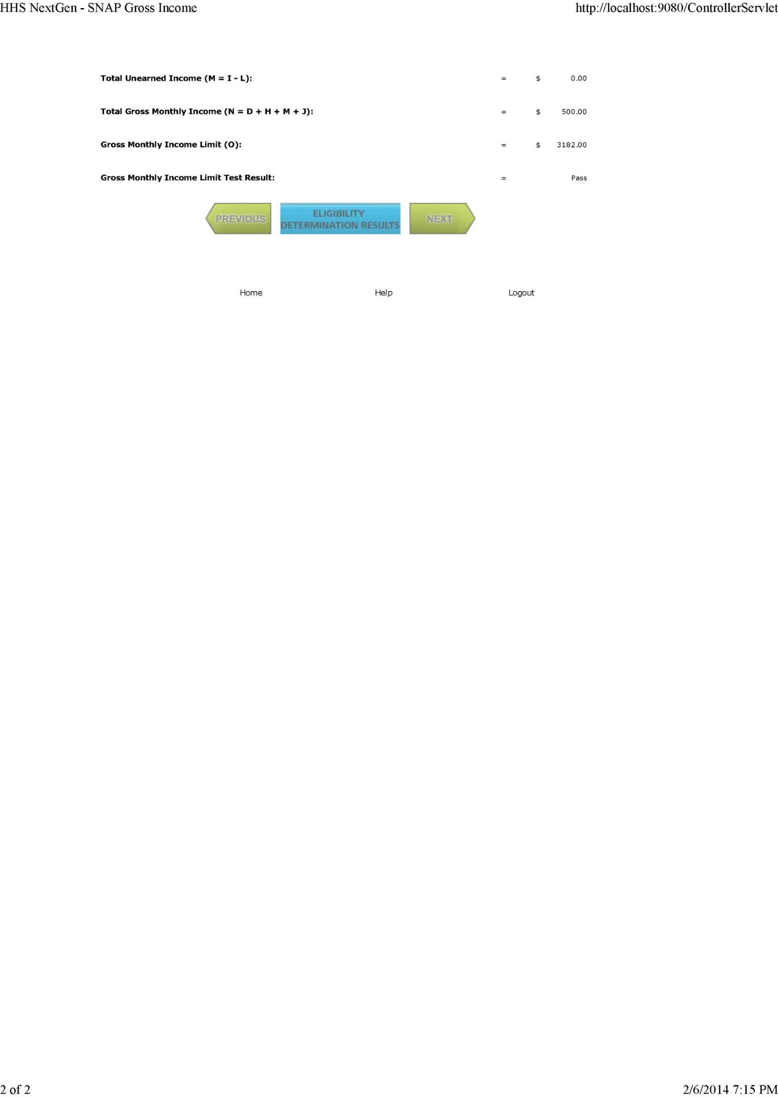

### LTSS Medicaid – Tasks/Alerts/Mass Updates

* For a new DHS-2 Medicaid application, after eligibility determination for MAGI programs, if the client is determined potentially eligible for LTSS Medicaid, a task is created to the LTSS Unit to evaluate the case.
* A task is created to the SSI Unit to close a SSI eligibility when the Level of Care is authorized and eligibility is run again.
* A task is created to the LTSS Unit 90 days before an authorized Level of Care Assessment is due to expire. \*\**Please note that no action will be taken on an LTSS case even if the Level of Care Assessment is past due.\*\**
* LTSS will be part of regular Medicaid case instead of separate case. When LTSS worker runs eligibility system will determine eligibility only for Medicaid and MPP program. If the same case has other public assistance programs a task will be generated to change queue to review information updated and determine eligibility public assistance programs.

### LTSS Medicaid – Security

* The LTSS Unit will have read-write access to the Level of Care screens.
* The LTSS Unit will have the security to clear LTSS tasks.
* Access to the Level of Care screens for other users is defined in the Level of Care section.
* LTSS will be part of regular Medicaid case instead of separate case. When LTSS worker runs eligibility system will allow LTSS Unit to Approve/Certify only for Medicaid and MPP program. If the same case has other public assistance programs a task will be generated to change queue to review information updated and determine eligibility public assistance programs.

### LTSS Medicaid – Batches/Interfaces

The following batches/interfaces will be impacted by this change:

### MMIS Interface

The MMIS interface will include information on Level of Care Assessment and Plan of Care Services being sent to MMIS. There are three transaction files impacted by the Level of Care and Plan of Care Services. They are –

* + - 1. E Transaction - The Level of Care information will be included as part of the E transaction.
      2. G Transaction - The Waiver Code and Plan of Care information will be included as part of the existing G transaction. In addition to this, the 1G transaction will contain a new Acuity Level field that will be send to MMIS.
      3. U Transaction – This is a new transaction that will include details for all authorized services for a plan of care. The U transaction is triggered when there is an addition or modification to specific Plan of Care Services only.

**1E Transaction:**

An MMIS “1E” transaction is triggered when a Level of Care Assessment is authorized and at least one of the institutional program has been authorized.

When the Level of Care Assessment end date has expired, it is expected that worker will update level of care assessment and reevaluate eligibility. RIBridges will trigger a new transaction being sent upon the renewal of the level of care assessment. If a Level of Care Assessment does not have an End Date, the LOC Assessment will remain open until the user changes it in RIBridges.

Listed below is the structure of the 1E transaction.

|  |  |  |  |
| --- | --- | --- | --- |
| Field Name | Format | Position | Description |
| Transaction Code |  | 1-4 | 1E00 –Add Long Term Care Facility Eligibility Segment |
| Process Date | N | 5-12 | The date the transaction was generated in CCYMMDD format |
| Process Time | N | 13-18 | The time the transaction was generated in HHMMSS format |
| MCI ID | N | 19-28 | The unique ID generated by UHIP system for the individual |
| Provider SAK |  | 29-35 | Long Term Care MMIS system assigned key number |
| Facility Start Date |  | 36-43 | Long Term Care eligibility Start Date in CCYYMMDD format |
| Facility End Date |  | 44-51 | Long Term Care eligibility Stop Date in CCYYMMDD format |
| Facility Care Level |  | 52-54 | Facility Level of Care code |

Facility Care Levels are listed below.

|  |  |  |
| --- | --- | --- |
| Code | Description | Logic |
| 001 | Medicare days | Nursing Home Settings.  And Payment Method as “Skilled”  And enrolled in Medicare |
| 002 | Nursing Facility Per/diem | Nursing Home Settings  And Payment Method as “Custodial” |
| 003 | Facility per diem | Eleanor Slater Hospital |
| 004 | Facility per diem | Eleanor Slater Hospital |
| 005 | Medicare Free day | Other than Nursing home and Hospice and Payment Method as “Skilled” |
| 006 | Hospice | Hospice setting |

**G Transactions:**

The G transaction has the following file structure. The system send out a 1G Transaction to MMIS whenever the Community-based Program Types (Waiver Codes) are added/updated. Additionally, the system send out 3G Transaction to MMIS whenever the Program Type (Waiver codes) are cancelled. If an individual is no longer eligible for LTSS then 4G Transaction is sent out.

|  |  |  |  |
| --- | --- | --- | --- |
| Field Name | Position | Description |  |
| Transaction Code | 1 - 4 | 1G00 – Add Long Term Care Waiver segment information |
| Process Date | 5 - 12 | The date the transaction was generated in CCYMMDD format |
| Process Time | 13 - 18 | The time the transaction was generated in HHMMSS format |
| MCI ID | 19 - 28 | The unique ID generated by UHIP system for the individual |
| Waiver Code | 29 - 30 | Waiver code indicating the type of waiver extended to the recipient |
| Waiver Start Date | 31 - 38 | Waiver segment Start Date in CCYYMMDD format |
| Waiver Stop Date | 39 - 46 | Waiver segment Stop Date in CCYYMMDD format |
| Diversion Code | 47 - 49 | Diversion/De-institutionalization Code (DVT/DIN) |
| Acuity Level | 50-51 | Acuity Level “01”,”02”,”03”,”04”,”05”,”06” will be sent. By default it’s Empty space |

The waiver codes that will be sent are the following –

|  |  |  |  |
| --- | --- | --- | --- |
| **MMIS Code** | **MMIS Description** | **UHIP CODE** | **UHIP Description** |
| 02 | DEA Community Services | C | HCBS Waiver and Agency = “DEA” |
| 03 | Intellectual Disability Srvcs | R  W | ID – HCBS  Intellectually Delayed Group Home |
| 04 | Self-Direction Community Svcs | P | Consumer Direction/Self-Directed |
| 07 | RI Housing Assisted Living | L | RIMFHC Assisted Living and LOC = ‘Nursing Home’ |
| 08 | Shared Living | B | [Rite@Home](mailto:Rite@Home)/Shared Loving |
| 09 | Core Community Services | C | HCBS Waiver and Agency = “DHS” |
| 10 | Habilitation Community Service | J | Habilitation HCBS |
| 11 | Habilitation Group Home Svcs | O | Habilitation Group Home |
| 12 | Preventive Community Services | T | Preventive Services |
| 13 | DEA Assisted Living | F | Assisted Living &  Agency Code =”DEA” |
| 67 | PACE | G | PACE |

**U Transactions:**

RIBRIDGES sends out 1U Transaction only when services are authorized or an authorized service is modified for LTSS Community Programs. It is triggered ONLY when the Prior Authorization Status for the particular service is ‘Authorized’. If the Prior Authorization Status ‘Not Required’ or blank, the service is not sent to MMIS through the 1U transaction. It is possible for an individual to have multiple services authorized for the same duration. The 1U transaction is applicable only to certain, pre-defined service types and the system will translate the Service Type and Frequency to determine the Procedure code to be sent to MMIS. The 1U transaction is triggered from both Data Collection screens as well as when there is a change to the Plan of Care Services from the main Menu bar through the ‘Others’ navigation. In this instance, the trigger is created through the Plan of Care – Details/Services screen and the user does not have to run eligibility to re-determine eligibility or to send the 1U transaction to MMIS.

Additionally, the system sends out 3U and 4U Transactions for cancellation and Terminations of LTSS Community Program services.

Below is the structure for the 1U, 3U and 4U transactions -

|  |  |  |  |
| --- | --- | --- | --- |
| Field Name | Position | Description |  |
| Transaction Code | 1 – 4 | 1U00 – Add Long Term Care Community Services Authorization information |
| Process Date | 5 – 12 | The date the transaction was generated in CCYMMDD format |
| Process Time | 13 - 18 | The time the transaction was generated in HHMMSS format |
| MCI ID | 19 – 28 | The unique ID generated by UHIP system for the individual |
| Service Code | 29 – 32 | Service code indicating the type of service extended to the recipient. |
| Service Begin Date | 33 – 40 | Service segment Start Date in CCYYMMDD format |
| Service End Date | 41 – 48 | Service segment Stop Date in CCYYMMDD format |
| Service Unit | 49 – 54 | This describes number of Number of Units Individual is authorized for the service. |
| Service Frequency | 55 – 57 | 001 - Hours Per Week  002 – Hours Per Month  003 – Hours Per Day  004 – Hours Per Bi-Weekly  005 – Visits |
| Service Provider SAK ID | 58 – 64 | Long Term Care MMIS system assigned key number |
| Acuity Level | 65 – 66 | Acuity Level “01”,”02”,”03”,”04”,”05”,”06” will be sent. By default it’s Empty space |
| Procedure Code | 67 – 74 | The MMIS procedure code associated with the service type and service frequency specified. |

The MMIS interface will translate the Procedure code to be sent in the following manner –

|  |  |  |  |  |
| --- | --- | --- | --- | --- |
| **Program Type** | **Authorizing Agency** | **Service Type** | **Frequency** | **Procedure Code** |
| Community | DHS | Personal Care | Hours per week | S5125 |
|  |  | Home Maker | Hours per week | S5130 |
|  |  | Combined Homecare/ Personal care | Hours per week | S5125 U1 |
|  |  | LPN | Hours per week | T1000 |
| Community | DEA | Personal Care | Hours per week | S5125 |
|  |  | Home Maker | Hours per week | S5130 |
|  |  | Combined Homecare/ Personal care | Hours per week | S5125 U1 |
| Preventive | Any (?) | Personal Care | Hours per week | S5125 |
|  |  | Home Maker | Hours per week | S5130 |
|  |  | Combined Homecare/ Personal care | Hours per week | S5125 U1 |
| Habilitation – Community Services | DHS | Personal Care | Hours per week | S5125 |
|  |  | Home Maker | Hours per week | S5130 |
|  |  | Combined Homecare/ Personal care | Hours per week | S5125 U1 |
|  |  | Private Duty Nursing | Hours per week | T1000 |
|  |  | Day Habilitation | Hours per week | T2021 |

### Batch – LOC Renewal

This batch will be used to create tasks for case workers when the level of care assessment is due for renewal.

**Batch Logic:**

1. Gather all the cases that have an approved Level of Care determination within 90 days of the batch run.
2. Verify that there is no existing level of care determination with a begin date greater than the selected level of care end date for the same client.
3. If the case is an LTSS case, create a task for the LTSS Unit worker for Level of Care renewal. The alert text should state “Level of Care determination for case due for renewal. Please review case and take the necessary action.”
4. If the case is a Katie Beckett case, and the level of care determination is due for renewal, create a task for the Katie Beckett Unit worker. The alert text should state “Level of Care determination for case due for renewal. Please review case and take the necessary action.”
5. At the end of the batch, create a log file to report the successful run of the batch.
6. End of batch.

### LTSS Medicaid – Notices

There are no expected changes to the Notices based on this type of assistance.

## Community Medicaid (ABD)

### Community Medicaid – Group Composition

Community Medicaid is determined if the client is residing in Community and Aged/Disabled.

A client is considered to be applying for Community Medicaid if they meet the following conditions:

* Has completed a DHS-2 application and
* Is above or equal to the age of 65 or
* Indicates that they have a disability and
* Has a MART review pending or approved for SSI or RSDI Disability benefits.
  + Or have one of the following SSI denial reasons:
    - * Lose SSI due to Title II-D benefits (DAC-eligible)
      * Lose SSI due to Widow(er) RSDI Survivor Entitlement (Disabled Widower Eligible)
      * Lose SSI due to RSDI COLA increase (Pickle eligible)
      * Lose SSI due to SSI Actuarial Changes (SSI Act-Change eligible)
      * Lose SSI due to Protected Widow(er) benefits (Protected Widower eligible)

While determining Medicaid group composition, client’s group budgeting includes only the client and community partner. Community partner’s resources are used in resource eligibility. Community partner’s income is used income eligibility.

Hierarchy of program evaluation is, as follows:

* AB - Blind: Deeming rules are applied for ABD - Blind. If there is a spouse then family size of 2 is used. A person is eligible for AB – Blind if they are identified with a disability of ‘Blind’. This is the primary non-financial criteria for a person to be eligible for this TOA. They will need to meet the Cat Needy Limits as part of their financial criteria.
* AD - Low Income: Deeming rules are applied for Low Income. Deeming rules are not applied if there is a spouse then family size of 2 is used. A person is eligible for AD – Low Income if they are aged or disabled and their disability is other than blindness. They need to meet the SSI Income Limits (100% FPL) as part of their financial criteria.
* ABD - Medically needy: Deeming rules are applied for Medically Needy.
* Flex: Whenever Medically Needy is denied due to excess income and Resource eligibility requirements are met.

**Community programs follow the deeming rules**:

If there is ineligible spouse or ineligible parent then deeming rules are used.

The definition of “ineligible” is as following. If the member meets all of the following conditions then they are considered as “ineligible” individual for Community program.

1. All of the following conditions should meet
   1. Client is not requesting for Medicaid.
   2. If the client is not eligible for SSI
   3. If the client is not eligible for RIW

If the Assistance Unit member is “ineligible spouse/parent”,

1. If there is income to be deemed then Family size of 2 to be applied in income calculation.
2. If there is resource to be deemed then Family size of 2 to be applied in resource calculation.
3. If there is no income or resources to be deemed and the member is requesting Medicaid then family size of 2 to be applied in income or resource calculation.
4. If there is no income or resources to be deemed and the member is not requesting Medicaid or then family size of 1 to be applied in income or resource calculation.

If the both the spouses/parent are determined MPP eligible then their income is NOT deemed. They are counted together and tested against the Family size of 2.

### Community Medicaid – Non-Financial

Following are the non-financial characteristics Community Medicaid clients are required to meet in order to be determined eligible for Community Medicaid.

* Name
* Date of Birth
* SSN/Enumeration
* Citizenship
* Immigration
* Incarceration
* Resident of Rhode Island
* Third Party Liability i.e., Access to Non-Public MEC or Public MEC
* Disability requirements through a MART review or through SSI/RSDI – Disability determination if the client is under 65 years of age.

### Community Medicaid – Financial

There are no changes to financial requirements for Community Medicaid as part of these changes.

### Community Medicaid – Verifications

The following data points will be verified for Community Medicaid as part of the eligibility verifications process –

|  |  |
| --- | --- |
| Data Point(s) | Verified for the Type of Assistance? |
| Name | Yes |
| Date of Birth | Yes |
| SSN | Yes |
| Citizenship | Yes |
| Immigration Status | Yes |
| Immigration – 5 Year Bar Met | Yes |
| Incarceration Status | Yes |
| Deceased Indicator | Yes |
| Current Income (Title II) | Yes |
| Current Income (Wages) | Yes |
| ESI MEC | No |
| Non-Employer Sponsored Insurance (ESI) Minimum Essential Coverage (MEC) | No |
| Unearned Income | Yes |
| Self-Employment Income | Yes |
| Resources | Yes |

If all the data points for an applicant are verified through external data sources, they are automatically authorized for Community Medicaid. The worker does not have to do a manual authorization of this case.

There is no post-eligibility verification for Community Medicaid.

### Community Medicaid – Renewals

Community Medicaid cases will come for renewal twelve (12) months after it is approved. Flex Programs are due by six (6) months. At the end of the six (6) months system shall close their Medicaid (Flex) ineligibility. Client needs to resubmit new Medicaid application for Flex clients.

### Community Medicaid – Screens and Tables

There are no screens or tables impacted with Community Medicaid.

### Community Medicaid – Tasks/Alerts/Mass Updates

* Whenever MART documents are received in the local office a Task is generated to MART Unit.
* Whenever MART is due for renewal before 90 days from renewal date system will create a task to the local DHS Unit to have the appropriate forms mailed to the client.
* Whenever MART form is not received from the client within 45 days from the form sent date, then system shall run eligibility through mass update and close Community Medicaid.
* Mass update is triggered at the sixth month for Flex clients to close flex eligibility.

## Sherlock Plan

Specifications for this Type of Assistance are detailed in the ***03.20-P2-Process Doc-Eligibility-Sherlock Changes****.*

## Medicare Premium Payment

MPP program is approved only if the client is enrolled or entitled to Part A and/or Part B Medicare programs. Hierarchy of program evaluation is as follows:

* Qualified Medicare Beneficiary (QMB)
* Specified Low Income Medicare Beneficiaries (SLMB)
* Qualified Individuals (QI-1)

**MPP programs follow the deeming rules**:

If there is ineligible spouse or ineligible parent then deeming rules are used.

The definition of “ineligible” is as following. If the member meets all of the following conditions then they are considered as “ineligible” individual for MPP program.

1. All of the following conditions should meet
   1. Client is not requesting for MPP assistance or Medicaid.
   2. If the client is not eligible for SSI
   3. If the client is not eligible for RIW

If the Assistance Unit member is “ineligible spouse/parent”,

1. If there is income to be deemed then Family size of 2 to be applied in income calculation.
2. If there is resource to be deemed then Family size of 2 to be applied in resource calculation. I
3. If there is no income or resources to be deemed and the member is requesting Medicaid or MPP then family size of 2 to be applied in income or resource calculation.
4. If there is no income or resources to be deemed and the member is not requesting Medicaid or MPP then family size of 1 to be applied in income or resource calculation.

If the both the spouses/parent are determined MPP eligible then their income is NOT deemed. They are counted together and tested against the Family size of 2.

***Note: If the spouse/parent is Long Term Care client or Community/HCBS client then there is no deeming of their income and resources towards the eligible spouse/child.***

* QMB Eligibility is determined from the next month of application date. For new applications, for the month of application, we should not be cascading down the eligibility to SLMB to QI-1 if their income is under 100% FPL. Retro Medicaid coverage cannot be requested for QMB.
* SLMB Eligibility is determined from the application month. Retro Medicaid coverage can be requested for SLMB.
* QI-1 Eligibility is determined from the application month, however if the application date is prior to calendar year then eligibility is determined from the Calendar year begin date. Client who is not eligible for Medicaid is evaluated for QI-1. If the client is determined Medicaid eligible, then they are not eligible for QI-1.

For example: if the application date is 12/02/2014 and eligibility is determined on 01/15/2014 then individual is determined eligible only from 01/01/2014.

Retro Medicaid coverage can be requested for QI-1. However it can be requested only within a calendar year. If the application date is 02/02/2014 then Retro coverage can be requested only from 01/01/2014.

*During Eligibility determination, if the client is not eligible for QMB because their application month is denied due to the reason that they cannot receive QMB for application month. However, they meet all the criteria’s of QMB eligibility then, system should not cascade down to SLMB or QI-1. It should not show any records for application month.*

*Note*: *SSI clients will have their QMB approved in SSI case, if they meet the QMB criteria.*

*Individuals and spouses income and resources are considered during group composition.*

## DCYF Medicaid

DCYF administrates five different kinds of Medicaid. Namely,

* Adoption Subsidy with Title IV-E
* Adoption Subsidy without Title IV-E
* Foster Care with Title IV-E
* Foster Care without Title IV-E
* State Adoption Subsidy
* MA - Chafee

Whenever application type is selected as “DCYF Medicaid” in program request screen then system shall evaluate for following categories of assistance.

### Adoption Subsidy with Title IV-E

This coverage group include the adopted children under 18, who are eligible for Title IV-E adoption subsidy program. Child becomes ineligible under the following circumstances.

* Child is aged out.
* Child is removed from DCYF Adoption Subsidy program.
* Child is deceased.
* Child is moved out of the state.

### Foster Care with Title IV-E

This coverage group include the foster children under 21, who are eligible for Title IV-E for foster care maintenance program.

### Adoption Subsidy without Title IV-E

This coverage group include the adopted children under 21, who are eligible for department ward adoption subsidy program. Child becomes ineligible under the following circumstances.

* Child is aged out.
* Child is removed from DCYF Adoption Subsidy program.
* Child is deceased.
* Child is moved out of the state.

### Foster Care without Title IV-E

This coverage group includes foster children under 21 who are eligible for department ward for foster care maintenance program.

### State Adoption Subsidy

This coverage group is for children between the age of 18 and 21 who have been adopted and not eligible for federal subsidies.

### Other Rules

There is no Financial or Verification requirement for DCYF Medicaid. The system will generate notices when a case is approved or closed in RIBridges. These are Shell cases to issue Medical Benefits for DCYF children.

## Creation of Duplicate Accounts

The system currently does not allow individuals to get health insurance coverage simultaneously across two different accounts/cases. This ensures that an individual does not get double-coverage of subsidized health insurance. However, there are some situations where individuals should be allowed to have active coverage across two separate cases. This is particularly true when a parent is court-ordered to provide unsubsidized coverage for a child who has subsidized health insurance in another case. Similarly, the system currently does not will allow an individual active on a SHOP account through the Exchange to apply for benefits through an independent individual account simultaneously.

In order for the system to ensure that a client receives sufficient but not duplicate coverage, the system will have to make the following changes –

1. The customer portal will need to allow for an individual to exist in multiple active accounts across account types, as detailed below.
2. The worker portal will need to allow an admin user to override the restriction for a client to get health coverage across two individual accounts.
3. Eligibility will need to ensure that a person does not have subsidized health coverage simultaneously across two separate accounts/cases.
4. Eligibility will need to allow for a person to have subsidized and unsubsidized health coverage simultaneously across two separate accounts/cases.

### Screen Edits across Customer and Worker Portal

1. Customer Portal –

In the customer portal, the ‘You and Your Family Members’ page currently has an edit that prevents users from creating and being active in multiple accounts based on their SSN. If a user tries to add someone who already exists in the system with the same SSN, the client gets an edit stating that the person with the same SSN already receives benefits. This prevents the client from adding this person to the second account.

This edit needs to be relaxed under certain circumstances. The types of accounts where a client can exist in more than one account are –

|  |  |  |  |  |
| --- | --- | --- | --- | --- |
|  | **SHOP Account** | **Individual Account** | **Broker Account** | **Navigator Account** |
| **SHOP Account** | NOT ALLOWED | ALLOWED | ALLOWED | ALLOWED |
| **Individual Account** | ALLOWED | NOT ALLOWED | ALLOWED | ALLOWED |
| **BROKER Account** | ALLOWED | ALLOWED | NOT ALLOWED | ALLOWED |
| **Navigator Account** | ALLOWED | ALLOWED | ALLOWED | NOT ALLOWED |

In other words, a person cannot be active in two SHOP accounts, or two individual accounts etc. In these circumstances, the screen will throw an edit stating that the person already exists. However, if a person in a SHOP account attempts to be included in an individual account, the system will not prevent them from being active recipients in two separate accounts. Similarly, in the worker portal, the system will not prevent a user from being added in the Program Request screen.

If a user tries to create an account in one of the ‘Not Allowed’ conditions, the system will display an error message for a duplicate account.

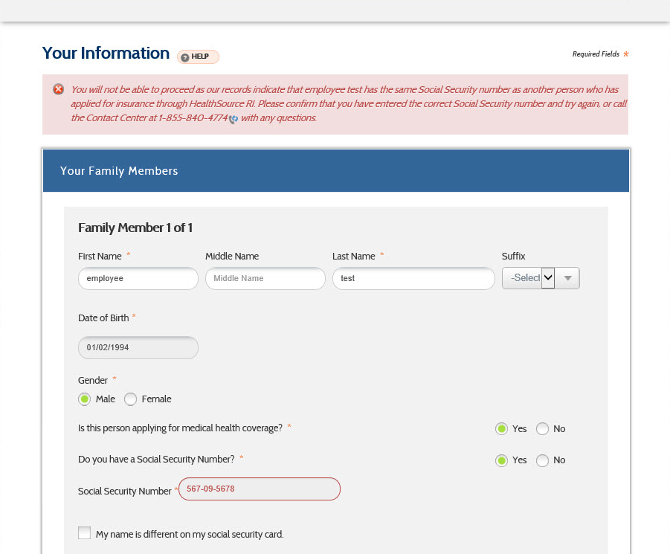

### Modification in Eligibility Determination:

Currently, eligibility rules ensure that a person does not get coverage for the same program across multiple accounts/cases for the same period of time. This ensures that the person does not get duplicate coverage across accounts. This rule will continue in effect for all programs, **including private insurance**. A person cannot get overlapping coverage for subsidized private insurance or Medicaid across accounts/cases.

A client can get duplicate coverage across accounts/cases simultaneously under very specific scenarios. If the client can request for coverage across two independent accounts (getting through the screen edits which allows a client to request coverage only in certain circumstances), eligibility will further ensure that they do not get duplicate coverage. The only circumstance in which they get duplicate coverage is if they are applying for health insurance in one account and unsubsidized health insurance in the second account. To do this, they would have not selected the ‘Requesting Financial Assistance’ checkbox in the Program Request screen. This implies that they client requests unsubsidized health coverage. Similarly, if they exist in one account with unsubsidized health coverage, they can be found eligible for Medicaid or subsidized QHP in the other account.

The table below illustrates the type of medical insurance an individual can be eligible for across two different accounts.

|  |  |  |  |
| --- | --- | --- | --- |
|  | **Medicaid(MAGI and Complex)** | **Subsidized QHP** | **Unsubsidized QHP** |
| **Medicaid(MAGI and Complex)** | NOT ALLOWED | NOT ALLOWED | ALLOWED |
| **Subsidized QHP** | NOT ALLOWED | NOT ALLOWED | ALLOWED |
| **Unsubsidized QHP** | ALLOWED | ALLOWED | ALLOWED |

When the user runs eligibility, the system will have an edit to check for the combination of coverage across multiple accounts. If the client has Medicaid in the first account and are eligible for Medicaid for subsidized QHP in the second account as well, they will be denied benefits with the notice text as ‘Individual is already receiving health coverage in another account.’

If the client has Medicaid or subsidized QHP in the first account, they will be allowed to receive unsubsidized QHP in the second account. Similarly, if the client has unsubsidized QHP in the first account, they will be allowed to receive subsidized QHO or Medicaid in the second account.

## Other Miscellaneous Changes

The following changes need to be made in order to accommodate additional requirements reqarding processing eligibility in RIBridges.

### Task Generation Functionality

The system will allow and accommodate for workers identified as requiring further supervision. These workers will not be able to authorize any eligibility unless there is second party/supervisory review. The workers are identified as needing second party review in their user profiles. Based on this identification, they will be able to run eligibility in a case but will not be able to authorize the eligibility. Once supervisory approval has been received, the users will be able to authorize eligibility.

The Eligibility process will use the flag in the worker profile to identify if the Authorize button on the Finalize Eligibility screen will be displayed. If the worker is identified as requiring second party review, the eligibility process will display or not display the Authorize button.

### Partial Authorization/Disposition

The system will enforce the partial disposition of cases based on the user profile and security profile of the logged in user. The following conditions are enforced to ensure that specialized cases are authorized only by particular units –

* 1. An LTSS program can be authorized only by a user identified as belonging to the LTC unit. This is based on their security profile identified. If a case has both LTSS and a DHS program or a non-LTSS health insurance, the LTSS Unit will be able to authorize only the LTSS eligibility. The other programs will not be authorized by the LTSS unit.
  2. A Katie Becket program can be authorized only by a user identified as belonging to the Katie Beckett unit. This is based on their identified security profile. If a case has both Katie Beckett and another DHS program or a non-Katie Beckett health insurance, the Katie Beckett worker can authorize only the Katie Beckett eligibility.
  3. Contact Center workers will be identified by their security profiles. Users belonging to this security profile can authorize only MAGI and private health insurance. They will not be able to authorize other DHS programs.
  4. Eligibility Technicians will be able to authorize all programs except for LTSS and Katie Beckett.

### Excluding Specified Individuals from Medicaid

The system will prevent or close eligibility of certain ‘banned’ individuals from receiving Medicaid. In certain situations, CMS notifies the agency of individuals who have been committing Medicaid fraud and should be banned from receiving Medicaid during the timeframe that they are banned. The Admin will be able to use the Fraud Request screens in RIBridges to indicate that the person has committed fraud. The Sanction Start and End Dates indicate the period of time that the individual is banned from being eligible for Medicaid. The updated eligibility information is sent to MMIS accordingly.

If the person has existing Medicaid eligibility, the Admin will use the Eligibility Override functionality to close the individual’s eligibility. This will override the system-calculated eligibility and the client will be closed. The system will trigger the CNE and Medicaid Termination Notices. The individual can be evaluated for QHP/APTC/CSR eligibility. When the eligibility for the individual is re-run, the rules will consider that this individual is ‘banned’ from Medicaid and deny Medicaid until the sanction end date, if applicable.

If CMS provides the agency with a client who is not currently receiving or enrolled in Medicaid, the system will allow the user to create the individual in the system. If the client were to apply for Medicaid, they should not be eligible for Medicaid based on the indicator that they are banned from Medicaid for fraud.

Adverse Action for Medicaid Termination – if an individual is identified for fraud, the individual is given 15 days for adverse action prior to their Medicaid termination date.

* If the fraud is reported before the 15th of the month, the Medicaid eligibility is terminated as of the end of the month.
  + For example if the Sanction Start Date is November 13th, the Medicaid eligibility is terminated as of November 30th.
* If the fraud is reported after the 15th of the month, the Medicaid eligibility is terminated as of the end of the following month, giving them 15 days of adverse action.
  + For example, if the Sanction Start Date is November 15th, the Medicaid eligibility is terminated as of December 31st.
* If an excluded person has their sanction reversed, they would now have a Sanction End Date on their Fraud Request record. If the Sanction End Date is prior to the 15th of the month, they can be Medicaid eligible as of the 1st of the same month.
  + For example, if the Sanction End Date is identified as November 13th, they can be made Medicaid Eligible as of November 1st.
* If the person has a Sanction End Date on the 15th or later, the person will be Medicaid eligible as of the 1st of the next month.
  + For example, if the Sanction End Date is identified as November 15th they can be Medicaid eligible as of December 1st.

The screens for identifying the individuals banned from being eligible for Medicaid will be recorded in the ***05 11 02_SF_FM_FMCBR_CreateFraudBenefitRequest.***

Below is the process flow for identifying and processing who should be excluded from Medicaid –



## Design Artifacts Inserted (otherwise refer to attachment)

Please note that wireframes contained in this document may be subject to change as a result of text updates that were made associated with Deloitte’s response to the State’s comments.

### 02.03.10: Level of Care Summary

The Level of Care Summary screen is accessed from the Non-Financial flow of the DHS-2 application. It is enabled only if the client indicates that they need long-term support and services in the Special Circumstances screen. The Level of Care Summary screen provides an overview of the level of care details that have been entered. It also allows the user to access the Level of Care –Details screen. When the user initially accesses the Level of Care – Summary screen, they will not see any data. Clicking the Add button on this screen will open the Level of Care Details screen for the user.

### 02.03.10: Wireframe

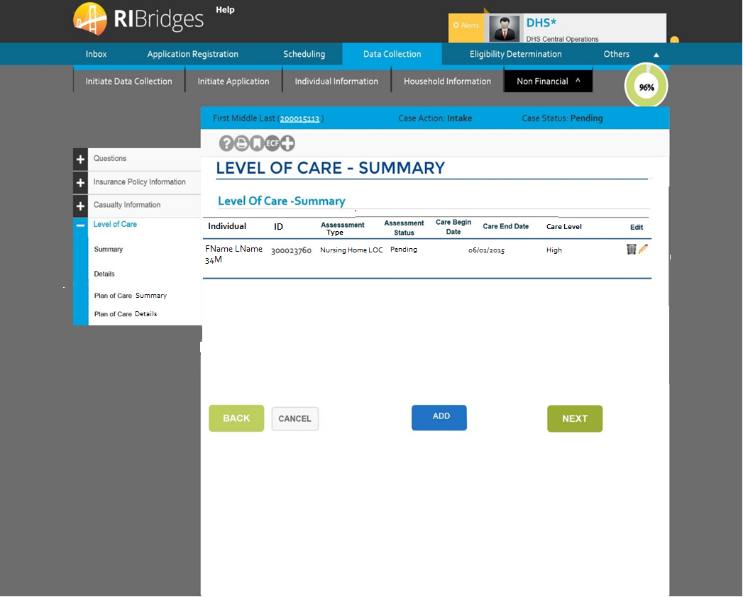

Please refer to Widget 02.03.10 for more details on this screen.

### Level of Care Details

This screen allows the user to initiate, approve and deny a Level of Care Assessment. It also allows the user to identify the Care Level that has been authorized, the dates of care and other details regarding their level of care. The Level of Care Details screen is enabled when the user clicks ‘Add’ on the Level of Care – Summary screen.

### 02.03.09: Wireframe

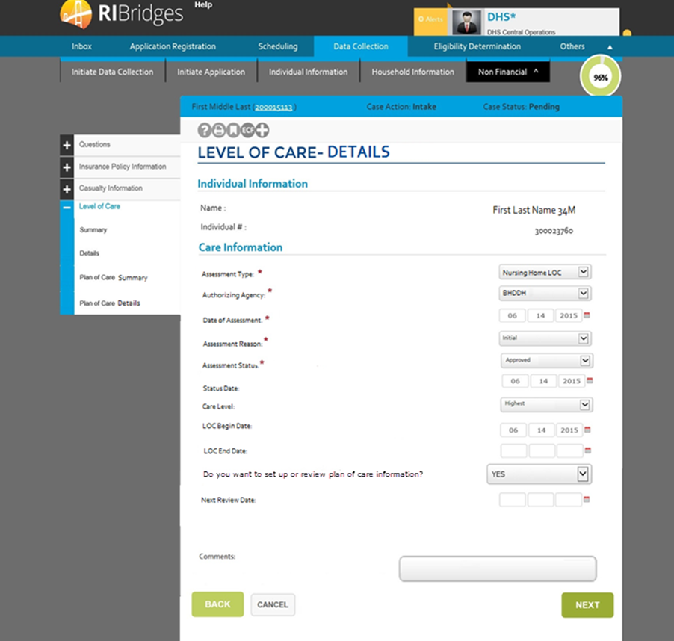

Please refer to Widget 02.03.09_DC_Level of Care Details for more details on this screen.

### Plan of Care Summary

The Plan of Care Summary screen is accessed when a Level of Care is Approved on the Details screen. It can be accessed if the user clicks Add (if the Plan of Care has not been initiated) or if the user clicks Next (if there is an existing Plan of Care). The Plan of Care Summary screen provides summary information on the Plans of Care associated with the particular level of care. It will lead to the Plan of Care Details screen.

### 02.03.12: Wireframe

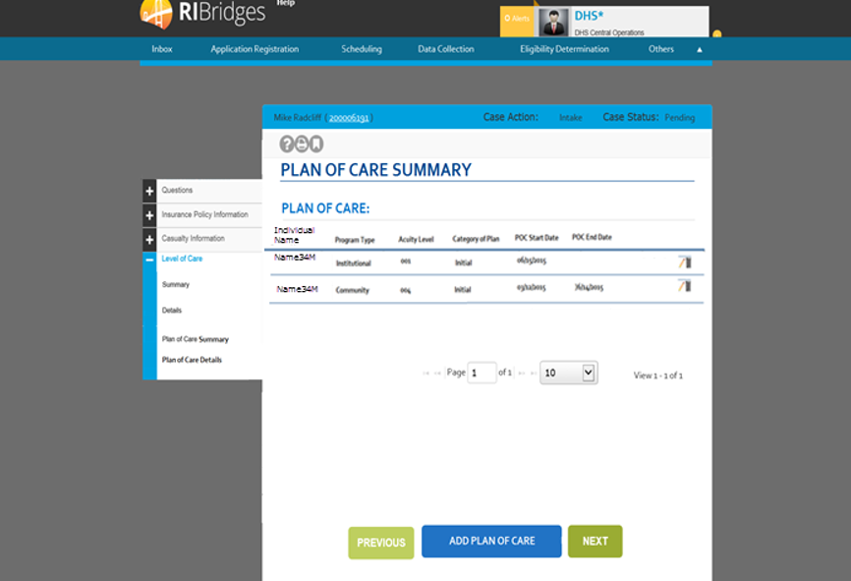

Please refer to Widget 02.03.12_DC_Plan_Of_Care_Summary for more details on this screen.

### Plan of Care Details

The Plan of Care Details screen is used to capture information on the particular Plan of Care authorized at the Level of Care. It also captures the facilities or services the client is authorized for based on their clinical and functional evaluation. The Plan of Care Details screen is enabled when the Level of Care Assessment Status is “Approved”.

The user will be able to enter a Plan of Care without specifying a facility or services. They will be able to come at a later point and add new or modify existing facilities or services. If the ‘Program Type’ defined is ‘Community’, the user will be able to provide multiple details in the Services section. The fields displayed in the table are dynamically changed to reflect service-specific fields. If the Program Type is defined as ‘Institutional’, the user will be able to provide facility-related information for the client. The user will be able to add multiple Plans of Care in order to reflect both Institutional and HCBS services provided. The wireframes below display the fields as they will appear for a ‘Community’ program type and an ‘institutional’ program type.

### 02.03.11: Wireframe

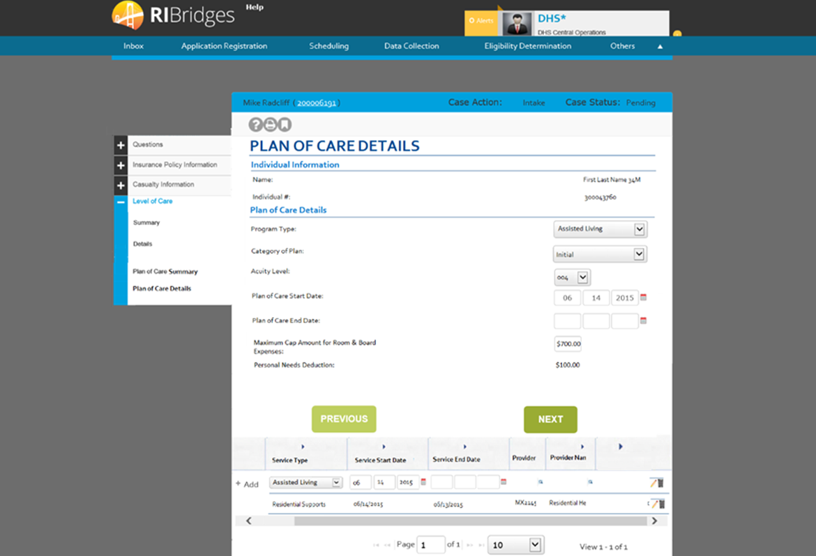

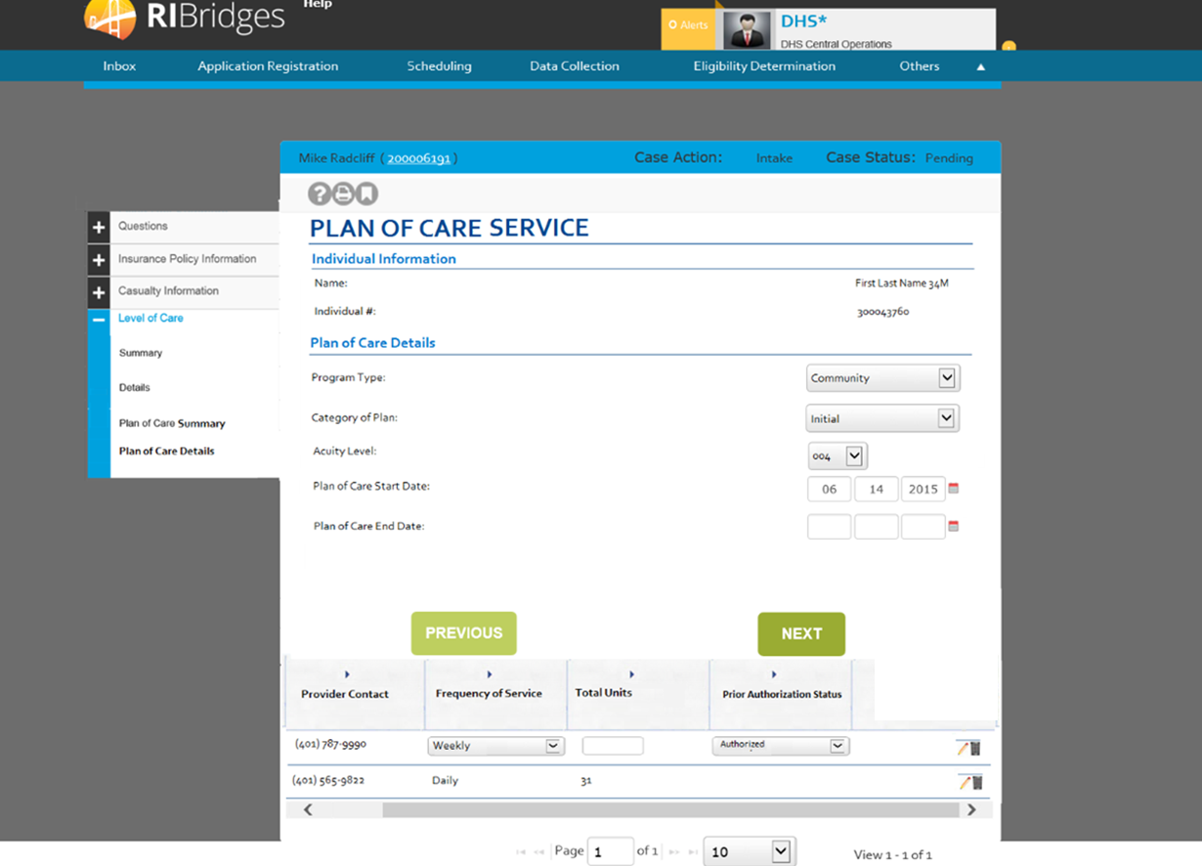

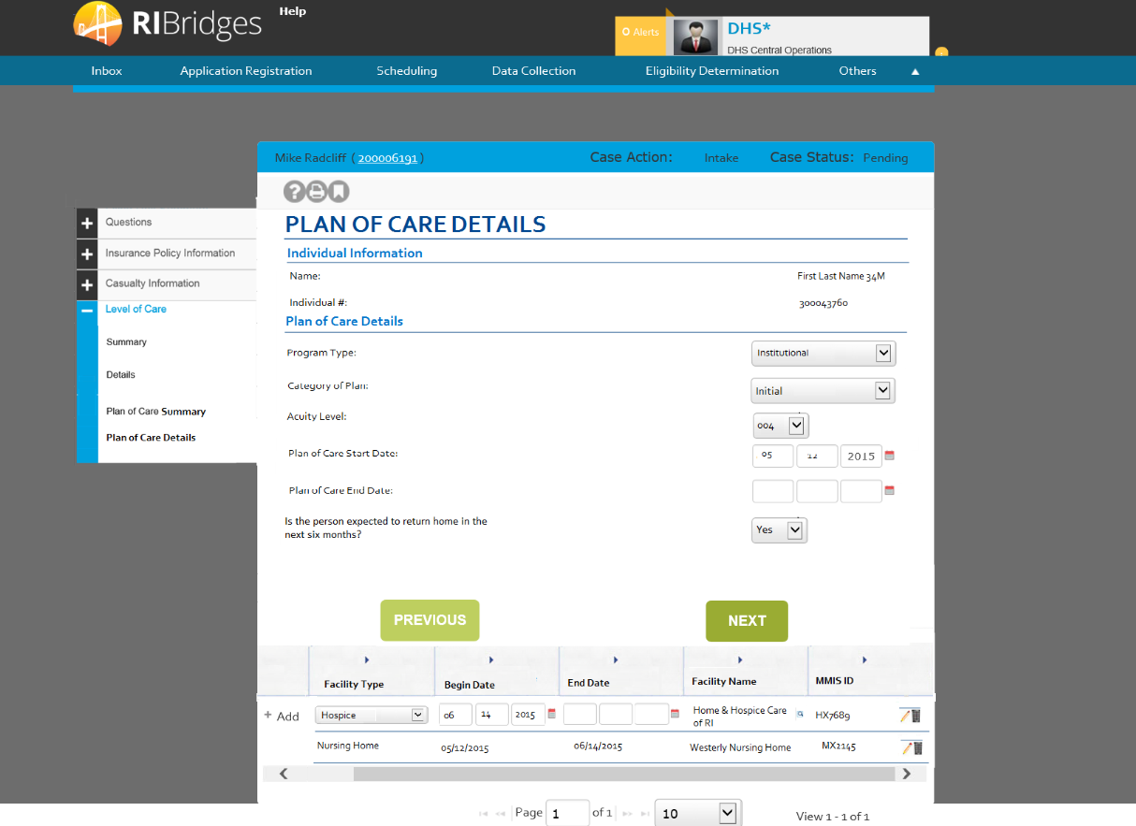

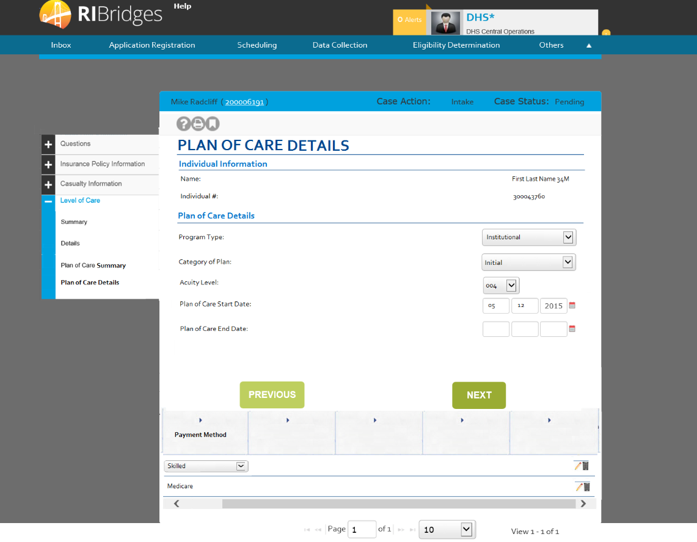

Please refer to Widget 02.03.11_DC_Plan_Of_Care_Details for more details on this screen.

### Missing Verification Checklist:

This screen is displayed when there is missing verifications after the initial MAGI eligibility is run. The user can access it by clicking on the Missing Verification link on the left navigation or clicking on the eye glasses icon from the eligibility results screen.

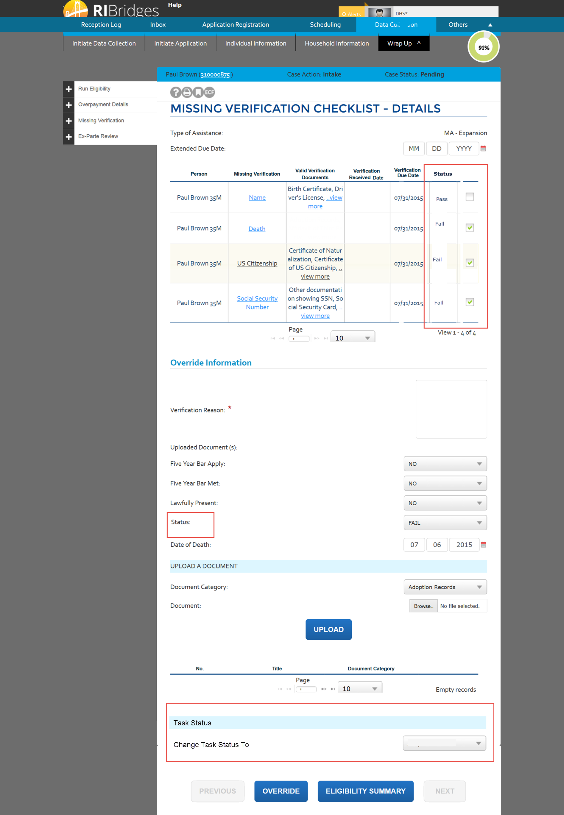

| **Field Name** | **Field Type** | **Format** | **Req** | **Default Value** | **Reference Table Name** | **Event/ Business Logic** |
| --- | --- | --- | --- | --- | --- | --- |
| Missing Verification Checklist - Details | Screen | N/A | N/A | N/A | N/A | This page is displayed on clicking the verification eye glass icon on the eligibility results screen |
| Summary | Tab |  |  |  |  | This tab is a hyperlink to the 'Summary' screen and is active and enabled |
| Details | Tab |  |  |  |  | This tab is a hyperlink to the 'Details' Screen. This hyperlink is disabled, when there is no VCL. |
| Type of Assistance: | Label | Alphanumeric |  |  |  | The Program type selected from the results displayed in 'Eligibility Summary' page associated with the EDG number would be displayed in this field. |
| Extended Due Date | Label – Date Range | MM/DD/YYYY |  |  |  | This field is to override the verification due date for all the missing verification. Upon submitting the page, this date entered is updated in the database. |
| Person | Column Header | Alphanumeric |  |  |  | The person for whom the VCL is requested. If Person ID is not found, then Case Name is displayed here. |
| Missing Verification | Column Header | Alphanumeric |  |  |  | Using Reference table column 'CODE' display the DESCRIPTION in this field. |
| Valid Verification Documents | Column Header | Alphanumeric |  |  |  | Using Reference table column 'CODE', Get the REFERENCETABLEID. Then go to the corresponding Reference table returned by Reference Table ID and display the one's with PRINTSW set as "Yes". Each documentation is comma seperated in a separate Line Item. |
| Verification Received Date | Column Header | MM/DD/YYYY |  |  |  | Date the verification is received |
| Verification Due Date | Column Header | MM/DD/YYYY |  |  |  | Date the Verification is Due. |
| Self Attested Information | Column Header | Alphanumeric |  |  |  | This is displayed only for MAGI programs. |
| Status | Column Header | Alphanumeric |  |  |  | This column displays trhe status of the data point. |
| Overide | Column Header | Alphanumeric |  |  |  | Contains icon to click if override is desired Multiple data points can be selected at a time. The reason provided and document uploaded is associated to each of the data point selected. |
| Override | Icon |  |  |  |  | This is enabled for all the MAGI programs verification. Whenever a MAGI program VCL is overriden, then is overriden flag is persisted in the database. On click of this Icon, the data is pre-filled in Override section and user can override and submit their overriden information. |
| Override Information | Section Header |  |  |  |  | N/A |
| Verification Reason | Label | Alphanumeric |  |  |  | Verification reason comments. |
| Five Year Bar Apply?  Five Year Bar Met? | Drop down | Alphanumeric |  |  |  | Displays whether the 5 year bar is applicable for this Immigration Verification. This Question is mandatory only when the verification type is "Immigration" |
| Lawfully Present ? | Drop down | Alphanumeric |  |  |  | Displays the Immigrant is Lawfully present. This Question is mandatory whenever the Verification type is "Immigration" |
| Verification Status | Drop down | Alphanumeric |  |  |  | Displays the status for the verification code |
| Date of Death | Date | MM/DD/YYYY |  |  |  | Capture the date of death if the verification type is death. Prefill it initially with the deceased date provided in the individual information screen. |
| Document Upload | Section Header |  |  |  |  |  |
|  | Text Box |  |  |  |  | System should persist the Overriden Verification Information in ED_VERIFICATIOn_MASTER and ED_VERIFICATION_CHECKLIST. This Button is enabled, only when you're overriding the Verification. |
| Browse |  |  |  |  |  |  |
| Document Category | Dropdown |  |  |  |  | MAGIACCEPTABLEVRF |
| Number |  |  |  |  |  |  |
| Title |  |  |  |  |  |  |
| Document Category |  |  |  |  |  |  |
| Uploaded Document | Label | Alphanumeric |  |  |  | This is displayed only for MAGI programs. All the documentations uploaded will be Hyperlinked in this section. When you click on the documentation, it opens the Pop-up with the content of the uploaded document. |
| Task Status | Section Header |  |  |  |  |  |
| Change Task Status To | Section Header |  |  |  |  | The field allows the user to change the task status value. The value is populated based on the current status as documented in the work flow section. Example - when task status is review in progress, user can update status to Document Requested and Closed Verified. When task status is closed - verified, all fields on the screen are disabled |
| Upload | Button |  |  |  |  | Upload the selected document. |
| Override | Button |  |  |  |  | Persists the override information to he database. Eligibility is rerun each time a data point is overridden |
| Previous | Button |  |  |  |  | Go to the previous page in the driver flow. |
| Next | Button |  |  |  |  | Go to the next page in the driver flow. When the status of the task is flipped to document requested, the task is unassigned from the assigned user and assigned back to the general queue. Workers monitoring the queue will see these tasks in the order of priority and are required to sort through these tasks and pick other tasks with status as new. When a client uploads documents, the task will remain in the generic queue |

### Filing Unit Summary

This screen is displayed when the post-eligibility under the following circumstances:

1. When a DHS-2 application has been submitted and an LTSS case has been built.
2. Whenever the user uses the ‘Eligibility Search’ functionality to view the eligibility results of a case.

The user should have an LTSS case in one of the following statuses for any of the LTSS TOAs:

1. Client has an LTSS – Pending Case
2. Client has an LTSS – Approved Case
3. Client has an LTSS – Denied Case

#### 03.12.04: Wireframe

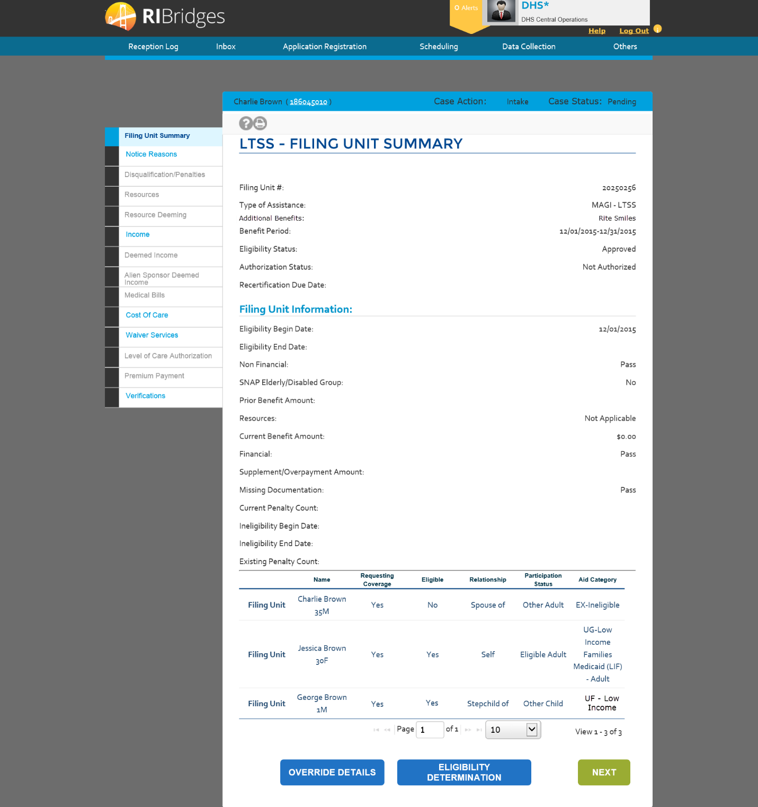

#### 03.12.04: Data Table

| **Field Name** | **Field Type** | **Format** | **Req** | **Default Value** | **Reference Table Name** | **Event/ Business Logic** |
| --- | --- | --- | --- | --- | --- | --- |
| LTSS Medicaid - Filing Unit Summary | Screen | N/A | N/A | N/A | N/A | This page is navigated if the user click on 'Filing Unit Summary' tab on the Filing Unit Summary screen. This page displays more detailed information for the filing unit regarding the eligibility determination results. |
| Filing Unit Summary | Tab | N/A | N/A | N/A | N/A | This tab is enabled and active. |
| Notice Reasons | Tab | N/A | N/A | N/A | N/A | This tab is enabled. |
| Disqualification/Penalties | Tab | N/A | N/A | N/A | N/A | This tab is enabled. |
| Resources | Tab | N/A | N/A | N/A | N/A | This tab is enabled. |
| Resource Deeming | Tab | N/A | N/A | N/A | N/A | This tab is enabled. |
| Income | Tab | N/A | N/A | N/A | N/A | This tab is enabled. |
| Deemed Income | Tab | N/A | N/A | N/A | N/A | This tab is enabled. |
| Alien Sponsor Deemed Income | Tab | N/A | N/A | N/A | N/A | This tab is enabled. |
| Level of Care Authorization | Tab | N/A | N/A | N/A | N/A | This tab is enabled. |
| Medical Bills | Tab | N/A | N/A | N/A | N/A | This tab is enabled. |
| Service Authorization | Tab | N/A | N/A | N/A | N/A | This tab is enabled. |
| Cost Of Care | Tab | N/A | N/A | N/A | N/A | This tab is enabled. |
| Premium Payment | Tab | N/A | N/A | N/A | N/A | This tab is enabled. |
| Case Name | Label | Alphanumeric | N/A | N/A | N/A | Specifies the name of the primary individual registered in the case. |
| Case # | Label - Hyperlink | Numeric | N/A | N/A | N/A | N/A |
| Case Action | Label | Alphanumeric | N/A | N/A | CASEACTION | Specifies the action being performed on the case. |
| Case Status | Label | Alphanumeric | N/A | N/A | DICASESTATUS | Specifies the status of the case. |
| Filing Unit #: | Label | Numeric | N/A | N/A | N/A | This is a system generated number which is generated when the eligibility is run for a program requested for the case number entered in 'Eligibility Determination Details' page. |
| Type of Assistance: | Label | Alphanumeric | N/A | N/A | EDTOA | The Type of Assistance selected from the results displayed in 'Eligibility Summary' page associated with the EDG number would be displayed in this field. |
| Additional Benefits: | Label | Alphanumeric | N/A | N/A | N/A | Displays the text of additional benefits, if applicable. If Rite Smiles eligible, will display Rite Smiles. |
| Benefit Period: | Label-Date range | MM/DD/YYYY | N/A | N/A | N/A | The Benefit Period listed for the record selected form the results displayed in 'Eligibility Summary' page would be displayed in this field. |
| Eligibility Status: | Label | Alphanumeric | N/A | N/A | EDEDBCACTION | The Eligibility Status of the record selected in 'Eligibility Determination Details' page would be displayed in this field. |
| Authorization Status: | Label | Alphanumeric | N/A | N/A | EDCURRIND | The authorization status would be displayed in this field based on the record selected in 'Eligibility Determination Details' page. It is based upon the Eligibility Status. |
| Renewal Date | Label | MM/DD/YYYY | N/A | N/A | N/A | The Renewal Date displayed on this field is based on the record selected in the 'Eligibility Determination Details' page. |
|  | | | | | | |
| Filing Unit Information | Section Header | N/A | N/A | N/A | N/A | N/A |
| Eligibility Begin Date: | Label-Date | MM/DD/YYYY | N/A | N/A | N/A | This field displays the first date of benefit eligibility for the selected Benefit period. |
| Eligibility End Date: | Label-Date | MM/DD/YYYY | N/A | N/A | N/A | This field displays the last date of eligibility for the selected Benefit period, if applicable. |
| Non Financial: | Label | Alphanumeric | N/A | N/A | EDRESULT | This field displays the eligibility results for non-financial eligibility factors as either Pass or Fail for the case number selected. |
| Resources: | Label | Alphanumeric | N/A | N/A | EDRESULT | This field displays the eligibility results for the Resources as either Pass or Fail for the case number selected. |
| Financial: | Label | Alphanumeric | N/A | N/A | EDRESULT | This field displays the eligibility results as either Pass or Fail for the case number selected. |
| Missing Documentation: | Label | Alphanumeric | N/A | N/A | EDRESULT | This field displays the eligibility results for verification factors based on the record selected in 'Eligibility Determination Details' page. |
| Spend Down: | Label | Alphanumeric | N/A | N/A | N/A | This field indicates whether an Individual is in a Spend down with values ‘Yes’ or ‘No’ |
| Spend Down Met: | Label | Alphanumeric | N/A | N/A | N/A | This field is populated with Yes or No based on whether the Spend Down is met or not. |
| Spend Down Met Date: | Label | MM/DD/YYYY | N/A | N/A | N/A | This field will be populated based on the record selected in 'Eligibility Determination Details' page. |
| Filing Unit | Row Header | Alphanumeric | N/A | N/A | N/A | N/A |
| Name | Column Header | Alphanumeric | N/A | N/A | N/A | This column lists household members who were either evaluated for eligibility or whose information was factored into eligibility determinations. On clicking the hyperlink, the user would be navigated to 'FMA Individual Notice Reasons' page. |
| Requesting Coverage | Column Header | Alphanumeric | N/A | N/A | N/A | This column is populated with Yes or No whether the household member of the Filing Unit is requesting coverage or not. |
| Eligibile | Column Header | Alphanumeric | N/A | N/A | N/A | This field would be populated with “Yes” or “No” for the Target Member. Other members it will appear as “N/A” |
| Aid Category | Column Header | Alphanumeric | N/A | N/A | N/A | This field contains the aid category of Medicaid the filing unit is receiving. The aid category code will be included as well as the description of the aid category. |
| Override Details | Button | N/A | N/A | N/A | N/A | On load, this button is disabled. If the record has been overridden once, then this button would be enabled and by clicking this button the user could see the details of the override information. |
| Eligibility Determination Results | Button | N/A | N/A | N/A | N/A | On click, the user will be navigating to the 'Eligibility Determination Results' page. |
| Next | Button | N/A | N/A | N/A | N/A | On click, the user will be navigating to the next page in the driver flow. |

* Please note – The ABAWD indicator will be displayed only for the SNAP Filing Unit. It will not be displayed for other programs. The TSSI indicator has been removed.

### Notice Reasons

This screen appears in the LUW of the program being reviewed. It provides the denial/closure reasons.

#### 

#### 03.12.05: Wireframe

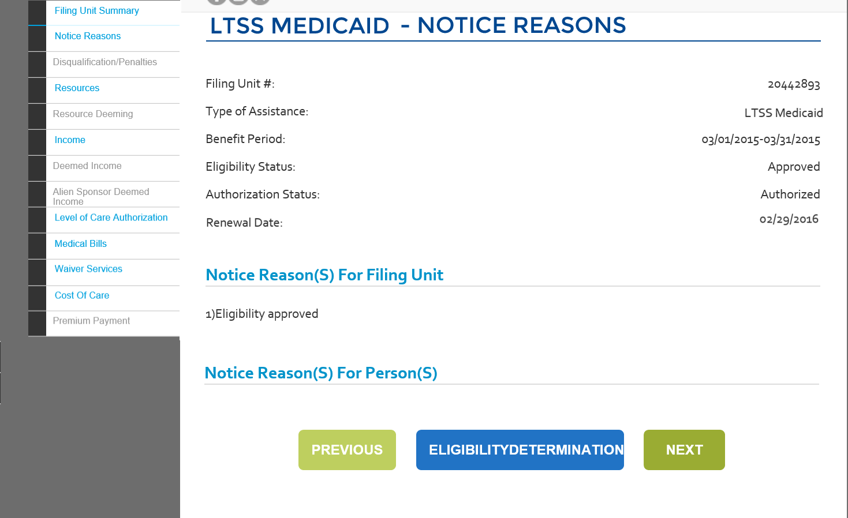

#### 03.12.05: Data Table

| **Field Name** | **Control Type** | **Format** | **Req.** | **Read Only** | **Default Value**  **(if pre-populated)** | **Comments** |
| --- | --- | --- | --- | --- | --- | --- |
| Filing Unit # | Label | Alpha | N/A | Y | N/A | This is a system-generated number that is generated when the eligibility is run for a program requested for the case number entered in the Eligibility Determination Details page. |
| Type of Assistance | Label | Alpha | N/A | Y | N/A | The Type of Assistance selected from the results displayed in the Eligibility Summary page associated with the EDG number is displayed in the field.  EDTOA |
| Benefit Period | Label | Alpha | N/A | Y | N/A | The Benefit Period listed for the record selected from the results displayed in the Eligibility Summary page. |
| Eligibility Status | Label | Alpha | N/A | Y | N/A | The eligibility status of the record.  EDBCACTION |
| Authorization Status | Label | Alpha | N/A | Y | N/A | The authorization status of the record.  EDCURRIND |
| Renewal Date | Label | Date | N/A | Y | N/A | The renewal date for the particular eligibility. |
| Notice Reasons for Filing Unit | Section Header | Alphanumeric | N/A | Y | N/A |  |
| Name: Notice Reason | Label | Alphanumeric | N/A | Y | N/A | The notice reason is populated based on the results of the eligibility determination details for each Target Member. Non-Target member’s notice reasons are not displayed. |
| Previous | Button |  | N/A | Y | N/A | On click, the user is navigated to the previous page of the driver flow. |
| Eligibility Determination Results | Button |  | N/A | Y | N/A | On click, the user will be navigated to the Eligibility Determination Results screen. |
| Next | Button |  | N/A | Y | N/A | On click, the user will be navigated to the next page in the driver flow. |

### 

### 03.12.06: Resources

#### 03.12.06: Wireframe

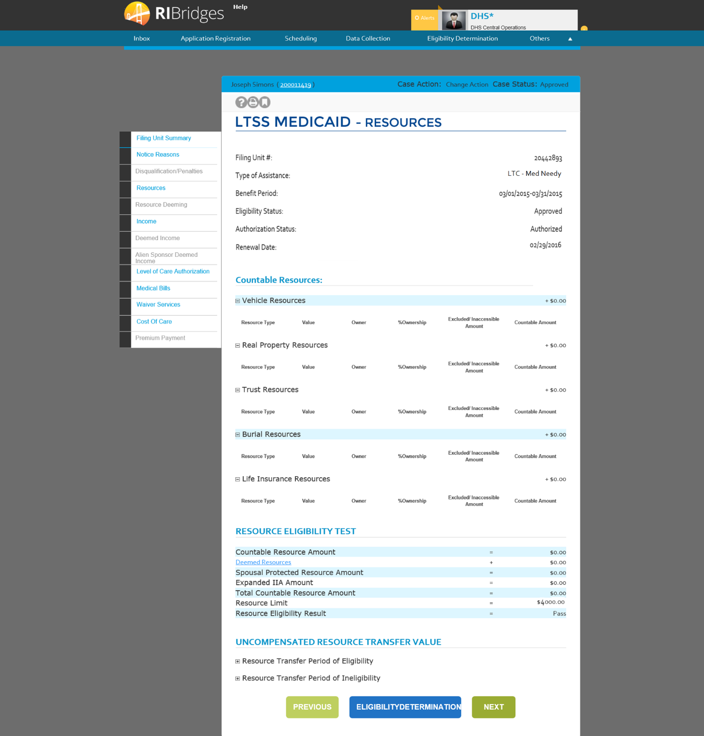

#### 03.12.06: Data Table

| **Field Name** | **Field Type** | **Format** | **Mandatory** | **Default Value** | **Reference Table Name** | **Event/ Business Logic** | **Validation Code** |
| --- | --- | --- | --- | --- | --- | --- | --- |
| Resources | Screen | N/A | N/A | N/A | N/A | This page is navigated if the user click on 'Resources' tab on the Filing Unit Summary screen. This page displays the countable resources, the uncompensated resource transfer value, and the resource eligibility result for the filing unit. | N/A |
| Filing Unit Summary | Tab | N/A | N/A | N/A | N/A | This tab is enabled. | N/A |
| Notice Reasons | Tab | N/A | N/A | N/A | N/A | This tab is enabled. | N/A |
| Resources | Tab | N/A | N/A | N/A | N/A | This tab is enabled and active. | N/A |
| Resource Deeming | Tab | N/A | N/A | N/A | N/A | This tab is disabled. | N/A |
| Income | Tab | N/A | N/A | N/A | N/A | This tab is enabled. | N/A |
| Deemed Income | Tab | N/A | N/A | N/A | N/A | This tab is enabled when there is Deemed Income. | N/A |
| Alien Sponsor Deemed Income | Tab | N/A | N/A | N/A | N/A | This tab is enabled only non-citizen deeming is applicable. | N/A |
| Medical Bills | Tab | N/A | N/A | N/A | N/A | This tab is enabled for Flex and Medically Needy | N/A |
| Cost Of Care | Tab | N/A | N/A | N/A | N/A | This tab is enabled for LTSS | N/A |
| Service Authorization | Tab | N/A | N/A | N/A | N/A | This tab is enabled for LTSS | N/A |
| Level of Care Authorization | Tab | N/A | N/A | N/A | N/A | This tab is enabled for LTSS | N/A |
| Disqualification/Penalties | Tab | N/A | N/A | N/A | N/A | This tab is enabled only when there is a Penalty | N/A |
| Sherlock Premium Amount | Tab | N/A | N/A | N/A | N/A | This tab is enabled only for Sherlock. | N/A |
| Case Name | Label | Alphanumeric | N/A | N/A | N/A | Specifies the name of the primary individual registered in the case. | N/A |
| Case # | Label - Hyperlink | Numeric | N/A | N/A | N/A | N/A | N/A |
| Case Action | Label | Alphanumeric | N/A | N/A | CASEACTION | Specifies the action being performed on the case. | N/A |
| Case Status | Label | Alphanumeric | N/A | N/A | DICASESTATUS | Specifies the status of the case. | N/A |
| Filing Unit #: | Label | Numeric | N/A | N/A | N/A | This is a system generated number which is generated when the eligibility is run for a program requested for the case number entered in 'Eligibility Determination Details' page. | N/A |
| Type of Assistance: | Label | Alphanumeric | N/A | N/A | EDTOA | The Program type selected from the results displayed in 'Eligibility Summary' page associated with the EDG number would be displayed in this field. | N/A |
| Benefit Period: | Label-Date range | MM/DD/YYYY | N/A | N/A | N/A | The Benefit period listed for the record selected form the results displayed in 'Eligibility Summary' page would be displayed in this field. | N/A |
| Eligibility Status: | Label | Alphanumeric | N/A | N/A | EDEDBCACTION | The Eligibility Status of the record selected in 'Eligibility Determination Details' page would be displayed in this field. | N/A |
| Authorization Status: | Label | Alphanumeric | N/A | N/A | EDCURRELIGIND | The authorization status would be displayed in this field based on the record selected in 'Eligibility Determination Details' page. It is based upon the Eligibility Status. | N/A |
| Renewal Date | Label-Date | MM/DD/YYYY | N/A | N/A | N/A | The date in this field is calculated and displayed when Eligibility Status of the case number selected is Approved. | N/A |
| Semi Annual Review/Mid Cert End Date: | Label-Date | MM/DD/YYYY | N/A | N/A | N/A | The date in this field is calculated and displayed when Eligibility Status of the case number selected is Approved. | N/A |
| Countable Resources | Section Header | N/A | N/A | N/A | N/A | N/A | N/A |
| Expand/Collapse (+/- icon) | Button | Image | N/A | N/A | N/A | On clicking this image, all information (Resource Type, Value, Owner, %Ownership, Excluded/Inaccessible Amount, Countable Amount) corresponding to Vehicle Resources is displayed/ hidden in the form of table with complete details. | N/A |
| Vehicle Resources | Label | Currency | N/A | <Sum of countable amounts in the table> | N/A | Populates based on the total sum of the countable amount in the table. | N/A |
| Resource Type | Column Header | Alphanumeric | N/A | N/A | N/A | Lists down the resource types. On click of the sort arrow button, the records in the table are sorted based on the 'Individual' column values. | N/A |
| Value | Column Header | Alphanumeric | N/A | N/A | N/A | An amount is entered based on the value of the mentioned resource | N/A |
| Owner | Column Header | Alphanumeric | N/A | N/A | N/A | Lists down the individual names and the owner can be selected for the specific resource. | N/A |
| % Ownership | Column Header | Alphanumeric | N/A | N/A | N/A | Displays the percentage of the resource owned by the listed owner. | N/A |
| Excluded/ Inaccessible Amount | Column Header | Currency | N/A | N/A | N/A | Displays the amount excluded or inaccessible. | N/A |
| Countable Amount ($) | Column Header | Currency | N/A | N/A | N/A | Lists down the amount resulted as countable after exclusions earned by the corresponding individual in the record. On click of the sort arrow button, the records in the table are sorted based on the 'Countable Amount ($)' column values. | N/A |
| Expand/Collapse (+/- icon) | Button | Image | N/A | N/A | N/A | On clicking this image, all information (Resource Type, Value, Owner, %Ownership, Excluded/Inaccessible Amount, Countable Amount) corresponding to Real Property Resources is displayed/ hidden in the form of table with complete details. | N/A |
| Real Property Resources | Label | Currency | N/A | <Sum of countable amounts in the table> | N/A | Populates based on the total sum of the countable amount in the table. | N/A |
| Resource Type | Column Header | Alphanumeric | N/A | N/A | N/A | Lists down the resource types On click of the sort arrow button, the records in the table are sorted based on the 'Individual' column values. | N/A |
| Value | Column Header | Alphanumeric | N/A | N/A | N/A | An amount is entered based on the value of the mentioned resource | N/A |
| Owner | Column Header | Alphanumeric | N/A | N/A | N/A | Lists down the individual names and the owner can be selected for the specific resource. | N/A |
| % Ownership | Column Header | Alphanumeric | N/A | N/A | N/A | Displays the percentage of the resource owned by the listed owner. | N/A |
| Excluded/ Inaccessible Amount | Column Header | Currency | N/A | N/A | N/A | Displays the amount excluded or inaccessible. | N/A |
| Countable Amount ($) | Column Header | Currency | N/A | N/A | N/A | Lists down the amount resulted as countable after exclusions earned by the corresponding individual in the record. On click of the sort arrow button, the records in the table are sorted based on the 'Countable Amount ($)' column values. | N/A |
| Expand/Collapse (+/- icon) | Button | Image | N/A | N/A | N/A | On clicking this image, all information (Resource Type, Value, Owner, %Ownership, Excluded/Inaccessible Amount, Countable Amount) corresponding to Liquid Resources is displayed/ hidden in the form of table with complete details. | N/A |
| Liquid Resources | Label | Currency | N/A | <Sum of countable amounts in the table> | N/A | Populates based on the total sum of the countable amount in the table. | N/A |
| Resource Type | Column Header | Alphanumeric | N/A | N/A | N/A | Lists down the resource types. On click of the sort arrow button, the records in the table are sorted based on the 'Individual' column values. | N/A |
| Value | Column Header | Alphanumeric | N/A | N/A | N/A | An amount is entered based on the value of the mentioned resource | N/A |
| Owner | Column Header | Alphanumeric | N/A | N/A | N/A | Lists down the individual names and the owner can be selected for the specific resource. | N/A |
| % Ownership | Column Header | Alphanumeric | N/A | N/A | N/A | Displays the percentage of the resource owned by the listed owner. | N/A |
| Excluded/ Inaccessible Amount | Column Header | Currency | N/A | N/A | N/A | Displays the amount excluded or inaccessible. | N/A |
| Countable Amount ($) | Column Header | Currency | N/A | N/A | N/A | Lists down the amount resulted as countable after exclusions earned by the corresponding individual in the record. On click of the sort arrow button, the records in the table are sorted based on the 'Countable Amount ($)' column values. | N/A |
| Expand/Collapse (+/- icon) | Button | Image | N/A | N/A | N/A | On clicking this image, all information (Resource Type, Value, Owner, %Ownership, Excluded/Inaccessible Amount, Countable Amount) corresponding to Trust Resources is displayed/ hidden in the form of table with complete details. | N/A |
| Trust Resources | Label | Currency | N/A | <Sum of countable amounts in the table> | N/A | Populates based on the total sum of the countable amount in the table. | N/A |
| Resource Type | Column Header | Alphanumeric | N/A | N/A | N/A | Lists down the resource types. On click of the sort arrow button, the records in the table are sorted based on the 'Individual' column values. | N/A |
| Value | Column Header | Alphanumeric | N/A | N/A | N/A | An amount is entered based on the value of the mentioned resource | N/A |
| Owner | Column Header | Alphanumeric | N/A | N/A | N/A | Lists down the individual names and the owner can be selected for the specific resource. | N/A |
| % Ownership | Column Header | Alphanumeric | N/A | N/A | N/A | Displays the percentage of the resource owned by the listed owner. | N/A |
| Excluded/ Inaccessible Amount | Column Header | Currency | N/A | N/A | N/A | Displays the amount excluded or inaccessible. | N/A |
| Countable Amount ($) | Column Header | Currency | N/A | N/A | N/A | Lists down the amount resulted as countable after exclusions earned by the corresponding individual in the record. On click of the sort arrow button, the records in the table are sorted based on the 'Countable Amount ($)' column values. | N/A |
|  |  |  |  |  |  |  |  |
| Expand/Collapse (+/- icon) | Button | Image | N/A | N/A | N/A | On clicking this image, all information (Resource Type, Value, Owner, %Ownership, Excluded/Inaccessible Amount, Countable Amount) corresponding to Burial Resources is displayed/ hidden in the form of table with complete details. | N/A |
| Burial Resources | Label | Currency | N/A | <Sum of countable amounts in the table> | N/A | Populates based on the total sum of the countable amount in the table. | N/A |
| Resource Type | Column Header | Alphanumeric | N/A | N/A | N/A | Lists down the resource types earning self employment income eligible for earned income deductions. On click of the sort arrow button, the records in the table are sorted based on the 'Individual' column values. | N/A |
| Value | Column Header | Alphanumeric | N/A | N/A | N/A | An amount is entered based on the value of the mentioned resource | N/A |
| Owner | Column Header | Alphanumeric | N/A | N/A | N/A | Lists down the individual names and the owner can be selected for the specific resource. | N/A |
| % Ownership | Column Header | Alphanumeric | N/A | N/A | N/A | Displays the percentage of the resource owned by the listed owner. | N/A |
| Excluded/ Inaccessible Amount | Column Header | Currency | N/A | N/A | N/A | Displays the amount excluded or inaccessible. | N/A |
| Countable Amount ($) | Column Header | Currency | N/A | N/A | N/A | Lists down the amount resulted as countable after exclusions earned by the corresponding individual in the record. On click of the sort arrow button, the records in the table are sorted based on the 'Countable Amount ($)' column values. | N/A |
|  |  |  |  |  |  |  |  |
| Expand/Collapse (+/- icon) | Button | Image | N/A | N/A | N/A | On clicking this image, all information (Resource Type, Value, Owner, %Ownership, Excluded/Inaccessible Amount, Countable Amount) corresponding to Life Insurance Resources is displayed/ hidden in the form of table with complete details. | N/A |
| Life Insurance Resources | Label | Currency | N/A | <Sum of countable amounts in the table> | N/A | Populates based on the total sum of the countable amount in the table. | N/A |
| Resource Type | Column Header | Alphanumeric | N/A | N/A | N/A | Lists down the resource types. On click of the sort arrow button, the records in the table are sorted based on the 'Individual' column values. | N/A |
| Value | Column Header | Alphanumeric | N/A | N/A | N/A | An amount is entered based on the value of the mentioned resource FDD. It always displays Face Value of Insurance Policies. | N/A |
| Owner | Column Header | Alphanumeric | N/A | N/A | N/A | Lists down the individual names and the owner can be selected for the specific resource. | N/A |
| % Ownership | Column Header | Alphanumeric | N/A | N/A | N/A | Displays the percentage of the resource owned by the listed owner. | N/A |
| Excluded/ Inaccessible Amount | Column Header | Currency | N/A | N/A | N/A | Displays the amount excluded or inaccessible. | N/A |
| Countable Amount ($) | Column Header | Currency | N/A | N/A | N/A | Lists down the amount resulted as countable after exclusions earned by the corresponding individual in the record. On click of the sort arrow button, the records in the table are sorted based on the 'Countable Amount ($)' column values. | N/A |
| Resource Eligibility Result | Section Header | N/A | N/A | N/A | N/A | N/A | N/A |
| Countable Resource Amount | Label | Currency | N/A | <Sum of countable resources> | N/A | Displays the total countable resource amount. | N/A |
| Deemed Resources | Label - Hyperlink | Currency | N/A | N/A | N/A | Displays the deemed resources amount.  Clicking the link directs to the Deemed Resources tab. | N/A |
| Community Spouse Resource Allowance | Label | Currency | N/A | N/A | N/A | Displays the spousal protected resource allowance | N/A |
| Expanded CSRA Amount | Label | Currency | N/A | N/A | N/A | Displays the expanded CSRA amount. | N/A |
| Total Countable Resource Amount | Label | Currency | N/A | N/A | N/A | Displays the total countable resource amount. | N/A |
| Resource Limit | Label | Currency | N/A | N/A | N/A | Displays the resource limit amount. | N/A |
| Resource Eligibility Result | Label | Alphanumeric | N/A | N/A | N/A | Displays the filing unit's resource eligibility result. | N/A |
| Uncompensated Resource Transfer Value | Section Header | N/A | N/A | N/A | N/A | This section is enabled for LTSS Medicaid. | N/A |
| Expand/Collapse (+/- icon) | Button | Image | N/A | N/A | N/A | On clicking this image, all information (Resource Description, Uncompensated Resource Amount) corresponding to the resource transfer period of eligibility is displayed/ hidden in the form of table with complete details. | N/A |
| Resource Transfer Period of Eligibility | Label | Alphanumeric | N/A | N/A | N/A | This section is enabled for LTSS Medicaid. | N/A |
| Resource Description | Column Header | Alphanumeric | N/A | N/A | N/A | Lists down the resource description. On click of the sort arrow button, the records in the table are sorted based on the 'Resource Description' column values. | N/A |
| Uncompensated Resource Amount | Column Header | Currency | N/A | N/A | N/A | An amount is entered based on the value of the uncompensated resource amount. | N/A |
| Expand/Collapse (+/- icon) | Button | Image | N/A | N/A | N/A | On clicking this image, all information (Individual, Penalty Begin Date, Penalty End Date, Base Line Date) corresponding to resource transfer period of ineligibility is displayed/ hidden in the form of table with complete details. | N/A |
| Resource Transfer Period of Ineligibility | Label | Currency | N/A | N/A | N/A | This section is enabled for LTSS Medicaid. | N/A |
| Individual Name | Column Header | Alphanumeric | N/A | N/A | N/A | Lists down the resource types earning self employment income eligible for earned income deductions. On click of the sort arrow button, the records in the table are sorted based on the 'Individual' column values. | N/A |
| Penalty Begin Date | Column Header | MM/DD/YYYY | N/A | N/A | N/A | Displays the begin date for the period of ineligibility. | N/A |
| Penalty End Date | Column Header | MM/DD/YYYY | N/A | N/A | N/A | Displays the end date for the period of ineligibility. | N/A |
| Base Line Date | Column Header | MM/DD/YYYY | N/A | N/A | N/A | Displays the base line date. | N/A |
| Previous | Button | N/A | N/A | N/A | N/A | On click, the user will be navigating to the previous page in the driver flow. | N/A |
| Eligibility Determination Results | Button | N/A | N/A | N/A | N/A | On click, the user will be navigating to the 'Eligibility Determination Results' page. | N/A |
| Next | Button | N/A | N/A | N/A | N/A | On click, the user will be navigating to the next page in the driver flow. | N/A |

### Resources Deeming

#### 03.12.164: Wireframe

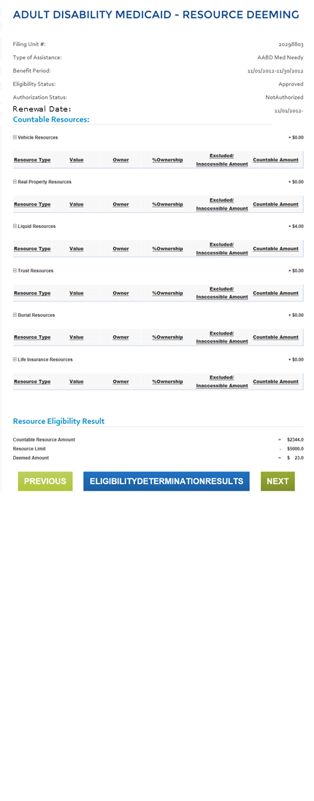

#### 03.12.164: Data Table

| **Field Name** | **Field Type** | **Format** | **Mandatory** | **Default Value** | **Reference Table Name** | **Event/ Business Logic** | **Validation Code** |
| --- | --- | --- | --- | --- | --- | --- | --- |
| Resource Deeming | Screen | N/A | N/A | N/A | N/A | This page is navigated if the user click on 'Resource Deeming' tab on the Filing Unit Summary screen. This page displays the countable resources and the resource eligibility result for the filing unit. | N/A |
| Filing Unit Summary | Tab | N/A | N/A | N/A | N/A | This tab is enabled. | N/A |
| Notice Reasons | Tab | N/A | N/A | N/A | N/A | This tab is enabled. | N/A |
| Resources | Tab | N/A | N/A | N/A | N/A | This tab is enabled. | N/A |
| Resource Deeming | Tab | N/A | N/A | N/A | N/A | This tab is enabled and active. | N/A |
| Income | Tab | N/A | N/A | N/A | N/A | This tab is enabled. | N/A |
| Deemed Income | Tab | N/A | N/A | N/A | N/A | This tab is enabled. | N/A |
| Alien Sponsor Deemed Income | Tab | N/A | N/A | N/A | N/A | This tab is enabled. | N/A |
| Medical Bills | Tab | N/A | N/A | N/A | N/A | This tab is enabled. | N/A |
| Cost Of Care | Tab | N/A | N/A | N/A | N/A | This tab is enabled. | N/A |
| Service Authorization | Tab | N/A | N/A | N/A | N/A | This tab is enabled. | N/A |
| Level of Care Authorization | Tab | N/A | N/A | N/A | N/A | This tab is enabled. | N/A |
| Disqualification/Penalties | Tab | N/A | N/A | N/A | N/A | This tab is enabled. | N/A |
| Sherlock Premium | Tab | N/A | N/A | N/A | N/A | This tab is disabled. | N/A |
| Case Name | Label | Alphanumeric | N/A | N/A | N/A | Specifies the name of the primary individual registered in the case. | N/A |
| Case # | Label - Hyperlink | Numeric | N/A | N/A | N/A | N/A | N/A |
| Case Action | Label | Alphanumeric | N/A | N/A | CASEACTION | Specifies the action being performed on the case. | N/A |
| Case Status | Label | Alphanumeric | N/A | N/A | DICASESTATUS | Specifies the status of the case. | N/A |
| Filing Unit #: | Label | Numeric | N/A | N/A | N/A | This is a system generated number which is generated when the eligibility is run for a program requested for the case number entered in 'Eligibility Determination Details' page. | N/A |
| Type of Assistance: | Label | Alphanumeric | N/A | N/A | EDTOA | The Program type selected from the results displayed in 'Eligibility Summary' page associated with the EDG number would be displayed in this field. | N/A |
| Benefit Period: | Label-Date range | MM/DD/YYYY | N/A | N/A | N/A | The Benefit period listed for the record selected form the results displayed in 'Eligibility Summary' page would be displayed in this field. | N/A |
| Eligibility Status: | Label | Alphanumeric | N/A | N/A | EDEDBCACTION | The Eligibility Status of the record selected in 'Eligibility Determination Details' page would be displayed in this field. | N/A |
| Authorization Status: | Label | Alphanumeric | N/A | N/A | EDCURRIND | The authorization status would be displayed in this field based on the record selected in 'Eligibility Determination Details' page. It is based upon the Eligibility Status. | N/A |
| Renewal Date | Label-Date | MM/DD/YYYY | N/A | N/A | N/A | The date in this field is calculated and displayed when Eligibility Status of the case number selected is Approved. | N/A |
| Countable Resources | Section Header | N/A | N/A | N/A | N/A | N/A | N/A |
| Expand/Collapse (+/- icon) | Button | Image | N/A | N/A | N/A | On clicking this image, all information (Resource Type, Value, Owner, %Ownership, Excluded/Inaccessible Amount, Countable Amount) corresponding to Vehicle Resources is displayed/ hidden in the form of table with complete details. | N/A |
| Vehicle Resources | Label | Currency | N/A | <Sum of countable amounts in the table> | N/A | Populates based on the total sum of the countable amount in the table. | N/A |
| Resource Type | Column Header | Alphanumeric | N/A | N/A | N/A | Lists down the resource types earning self employment income eligible for earned income deductions. On click of the sort arrow button, the records in the table are sorted based on the 'Individual' column values. | N/A |
| Value | Column Header | Alphanumeric | N/A | N/A | N/A | An amount is entered based on the value of the mentioned resource | N/A |
| Owner | Column Header | Alphanumeric | N/A | N/A | N/A | Lists down the individual names and the owner can be selected for the specific resource. | N/A |
| % Ownership | Column Header | Alphanumeric | N/A | N/A | N/A | Displays the percentage of the resource owned by the listed owner. | N/A |
| Excluded/ Inaccessible Amount | Column Header | Currency | N/A | N/A | N/A | Displays the amount excluded or inaccessible. | N/A |
| Countable Amount ($) | Column Header | Currency | N/A | N/A | N/A | Lists down the amount resulted as countable after exclusions earned by the corresponding individual in the record. On click of the sort arrow button, the records in the table are sorted based on the 'Countable Amount ($)' column values. | N/A |
|  | | | | | | | |
| Expand/Collapse (+/- icon) | Button | Image | N/A | N/A | N/A | On clicking this image, all information (Resource Type, Value, Owner, %Ownership, Excluded/Inaccessible Amount, Countable Amount) corresponding to Real Property Resources is displayed/ hidden in the form of table with complete details. | N/A |
| Real Property Resources | Label | Currency | N/A | <Sum of countable amounts in the table> | N/A | Populates based on the total sum of the countable amount in the table. | N/A |
| Resource Type | Column Header | Alphanumeric | N/A | N/A | N/A | Lists down the resource types. On click of the sort arrow button, the records in the table are sorted based on the 'Individual' column values. | N/A |
| Value | Column Header | Alphanumeric | N/A | N/A | N/A | An amount is entered based on the value of the mentioned resource | N/A |
| Owner | Column Header | Alphanumeric | N/A | N/A | N/A | Lists down the individual names and the owner can be selected for the specific resource. | N/A |
| % Ownership | Column Header | Alphanumeric | N/A | N/A | N/A | Displays the percentage of the resource owned by the listed owner. | N/A |
| Excluded/ Inaccessible Amount | Column Header | Currency | N/A | N/A | N/A | Displays the amount excluded or inaccessible. | N/A |
| Countable Amount ($) | Column Header | Currency | N/A | N/A | N/A | Lists down the amount resulted as countable after exclusions earned by the corresponding individual in the record. On click of the sort arrow button, the records in the table are sorted based on the 'Countable Amount ($)' column values. | N/A |
|  | | | | | | | |
| Expand/Collapse (+/- icon) | Button | Image | N/A | N/A | N/A | On clicking this image, all information (Resource Type, Value, Owner, %Ownership, Excluded/Inaccessible Amount, Countable Amount) corresponding to Liquid Resources is displayed/ hidden in the form of table with complete details. | N/A |
| Liquid Resources | Label | Currency | N/A | <Sum of countable amounts in the table> | N/A | Populates based on the total sum of the countable amount in the table. | N/A |
| Resource Type | Column Header | Alphanumeric | N/A | N/A | N/A | Lists down the resource types. On click of the sort arrow button, the records in the table are sorted based on the 'Individual' column values. | N/A |
| Value | Column Header | Alphanumeric | N/A | N/A | N/A | An amount is entered based on the value of the mentioned resource | N/A |
| Owner | Column Header | Alphanumeric | N/A | N/A | N/A | Lists down the individual names and the owner can be selected for the specific resource. | N/A |
| % Ownership | Column Header | Alphanumeric | N/A | N/A | N/A | Displays the percentage of the resource owned by the listed owner. | N/A |
| Excluded/ Inaccessible Amount | Column Header | Currency | N/A | N/A | N/A | Displays the amount excluded or inaccessible. | N/A |
| Countable Amount ($) | Column Header | Currency | N/A | N/A | N/A | Lists down the amount resulted as countable after exclusions earned by the corresponding individual in the record. On click of the sort arrow button, the records in the table are sorted based on the 'Countable Amount ($)' column values. | N/A |
|  | | | | | | | |
| Expand/Collapse (+/- icon) | Button | Image | N/A | N/A | N/A | On clicking this image, all information (Resource Type, Value, Owner, %Ownership, Excluded/Inaccessible Amount, Countable Amount) corresponding to Trust Resources is displayed/ hidden in the form of table with complete details. | N/A |
| Trust Resources | Label | Currency | N/A | <Sum of countable amounts in the table> | N/A | Populates based on the total sum of the countable amount in the table. | N/A |
| Resource Type | Column Header | Alphanumeric | N/A | N/A | N/A | Lists down the resource types earning self employment income eligible for earned income deductions. On click of the sort arrow button, the records in the table are sorted based on the 'Individual' column values. | N/A |
| Value | Column Header | Alphanumeric | N/A | N/A | N/A | An amount is entered based on the value of the mentioned resource | N/A |
| Owner | Column Header | Alphanumeric | N/A | N/A | N/A | Lists down the individual names and the owner can be selected for the specific resource. | N/A |
| % Ownership | Column Header | Alphanumeric | N/A | N/A | N/A | Displays the percentage of the resource owned by the listed owner. | N/A |
| Excluded/ Inaccessible Amount | Column Header | Currency | N/A | N/A | N/A | Displays the amount excluded or inaccessible. | N/A |
| Countable Amount ($) | Column Header | Currency | N/A | N/A | N/A | Lists down the amount resulted as countable after exclusions earned by the corresponding individual in the record. On click of the sort arrow button, the records in the table are sorted based on the 'Countable Amount ($)' column values. | N/A |
|  | | | | | | | |
| Expand/Collapse (+/- icon) | Button | Image | N/A | N/A | N/A | On clicking this image, all information (Resource Type, Value, Owner, %Ownership, Excluded/Inaccessible Amount, Countable Amount) corresponding to Burial Resources is displayed/ hidden in the form of table with complete details. | N/A |
| Burial Resources | Label | Currency | N/A | <Sum of countable amounts in the table> | N/A | Populates based on the total sum of the countable amount in the table. | N/A |
| Resource Type | Column Header | Alphanumeric | N/A | N/A | N/A | Lists down the resource types . On click of the sort arrow button, the records in the table are sorted based on the 'Individual' column values. | N/A |
| Value | Column Header | Alphanumeric | N/A | N/A | N/A | An amount is entered based on the value of the mentioned resource | N/A |
| Owner | Column Header | Alphanumeric | N/A | N/A | N/A | Lists down the individual names and the owner can be selected for the specific resource. | N/A |
| % Ownership | Column Header | Alphanumeric | N/A | N/A | N/A | Displays the percentage of the resource owned by the listed owner. | N/A |
| Excluded/ Inaccessible Amount | Column Header | Currency | N/A | N/A | N/A | Displays the amount excluded or inaccessible. | N/A |
| Countable Amount ($) | Column Header | Currency | N/A | N/A | N/A | Lists down the amount resulted as countable after exclusions earned by the corresponding individual in the record. On click of the sort arrow button, the records in the table are sorted based on the 'Countable Amount ($)' column values. | N/A |
|  | | | | | | | |
| Expand/Collapse (+/- icon) | Button | Image | N/A | N/A | N/A | On clicking this image, all information (Resource Type, Value, Owner, %Ownership, Excluded/Inaccessible Amount, Countable Amount) corresponding to Life Insurance Resources is displayed/ hidden in the form of table with complete details. | N/A |
| Life Insurance Resources | Label | Currency | N/A | <Sum of countable amounts in the table> | N/A | Populates based on the total sum of the countable amount in the table. | N/A |
| Resource Type | Column Header | Alphanumeric | N/A | N/A | N/A | Lists down the resource types earning self employment income eligible for earned income deductions. On click of the sort arrow button, the records in the table are sorted based on the 'Individual' column values. | N/A |
| Value | Column Header | Alphanumeric | N/A | N/A | N/A | An amount is entered based on the value of the mentioned resource | N/A |
| Owner | Column Header | Alphanumeric | N/A | N/A | N/A | Lists down the individual names and the owner can be selected for the specific resource. | N/A |
| % Ownership | Column Header | Alphanumeric | N/A | N/A | N/A | Displays the percentage of the resource owned by the listed owner. | N/A |
| Excluded/ Inaccessible Amount | Column Header | Currency | N/A | N/A | N/A | Displays the amount excluded or inaccessible. | N/A |
| Countable Amount ($) | Column Header | Currency | N/A | N/A | N/A | Lists down the amount resulted as countable after exclusions earned by the corresponding individual in the record. On click of the sort arrow button, the records in the table are sorted based on the 'Countable Amount ($)' column values. | N/A |
|  | | | | | | | |
| Resource Eligibility Result | Section Header | N/A | N/A | N/A | N/A | N/A | N/A |
| Countable Resource Amount | Label | Currency | N/A | <Sum of countable resources> | N/A | Displays the total countable resource amount. | N/A |
| Resource Limit | Label | Currency | N/A | N/A | N/A | Displays the resource limit amount. | N/A |
| Deemed Amount | Label | Currency | N/A | N/A | N/A | Displays the deemed amount. | N/A |
|  | | | | | | | |
| Previous | Button | N/A | N/A | N/A | N/A | On click, the user will be navigating to the previous page in the driver flow. | N/A |
| Eligibility Determination Results | Button | N/A | N/A | N/A | N/A | On click, the user will be navigating to the 'Eligibility Determination Results' page. | N/A |
| Next | Button | N/A | N/A | N/A | N/A | On click, the user will be navigating to the next page in the driver flow. | N/A |

### Income

#### 03.12.09: Wireframe

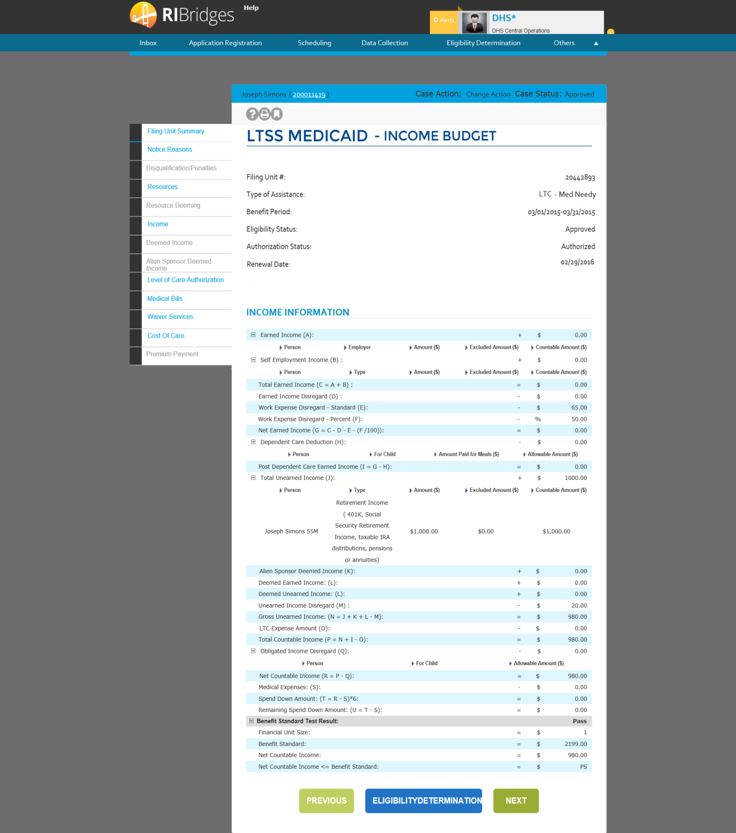

#### 03.12.09: Data Table

| **Field Name** | **Field Type** | **Format** | **Mandatory** | **Default Value** | **Reference Table Name** | **Event/ Business Logic** | **Validation Code** |
| --- | --- | --- | --- | --- | --- | --- | --- |
| Income | Screen | N/A | N/A | N/A | N/A | This page is navigated if the user click on 'Income' tab on the Filing Unit Summary screen. This page displays detailed income information for the filing unit. | N/A |
| Filing Unit Summary | Tab | N/A | N/A | N/A | N/A | This tab is enabled. | N/A |
| Notice Reasons | Tab | N/A | N/A | N/A | N/A | This tab is enabled. | N/A |
| Resources | Tab | N/A | N/A | N/A | N/A | This tab is enabled. | N/A |
| Resource Deeming | Tab | N/A | N/A | N/A | N/A | This tab is enabled for Community Medicaid | N/A |
| Income | Tab | N/A | N/A | N/A | N/A | This tab is enabled and active. | N/A |
| Deemed Income | Tab | N/A | N/A | N/A | N/A | This tab is enabled for Community Medicaid | N/A |
| Alien Sponsor Deemed Income | Tab | N/A | N/A | N/A | N/A | This tab is enabled for Community Medicaid when Non-Citizen Sponsor Deeming is applicable. | N/A |
| Medical Bills | Tab | N/A | N/A | N/A | N/A | This tab is enabled for Flex and Medically Needy. | N/A |
| Cost Of Care | Tab | N/A | N/A | N/A | N/A | This tab is enabled for LTSS | N/A |
| Service Authorization | Tab | N/A | N/A | N/A | N/A | This tab is enabled for LTSS | N/A |
| Level of Care Authorization | Tab | N/A | N/A | N/A | N/A | This tab is enabled for LTSS | N/A |
| Disqualification/Penalties | Tab | N/A | N/A | N/A | N/A | This tab is enabled. | N/A |
| Sherlock Premium | Tab | N/A | N/A | N/A | N/A | This tab is disabled. | N/A |
| Case Name | Label | Alphanumeric | N/A | N/A | N/A | Specifies the name of the primary individual registered in the case. | N/A |
| Case # | Label - Hyperlink | Numeric | N/A | N/A | N/A | N/A | N/A |
| Case Action | Label | Alphanumeric | N/A | N/A | CASEACTION | Specifies the action being performed on the case. | N/A |
| Case Status | Label | Alphanumeric | N/A | N/A | DICASESTATUS | Specifies the status of the case. | N/A |
| Filing Unit #: | Label | Numeric | N/A | N/A | N/A | This is a system generated number which is generated when the eligibility is run for a program requested for the case number entered in 'Eligibility Determination Details' page. | N/A |
| Type of Assistance: | Label | Alphanumeric | N/A | N/A | EDTOA | The Program type selected from the results displayed in 'Eligibility Summary' page associated with the EDG number would be displayed in this field. | N/A |
| Benefit Period: | Label-Date range | MM/DD/YYYY | N/A | N/A | N/A | The Benefit period listed for the record selected form the results displayed in 'Eligibility Summary' page would be displayed in this field. | N/A |
| Eligibility Status: | Label | Alphanumeric | N/A | N/A | EDEDBCACTION | The Eligibility Status of the record selected in 'Eligibility Determination Details' page would be displayed in this field. | N/A |
| Authorization Status: | Label | Alphanumeric | N/A | N/A | EDCURRIND | The authorization status would be displayed in this field based on the record selected in 'Eligibility Determination Details' page. It is based upon the Eligibility Status. | N/A |
| Renewal Date: | Label-Date | MM/DD/YYYY | N/A | N/A | N/A | The date in this field is calculated and displayed when Eligibility Status of the case number selected is Approved. | N/A |
| Income Information | Section Header | N/A | N/A | N/A | N/A | N/A | N/A |
| Expand/Collapse (+/- icon) | Button | Image | N/A | N/A | N/A | On clicking this image, all information (Person, Employer, Amount, Excluded Amount, Countable Amount) corresponding to employment income eligible for earned income deduction is displayed/ hidden in the form of table with complete details. | N/A |
| Earned Income(A): * | Label | Currency | N/A | <Sum of countable amounts in the table> | N/A | Populates based on the total sum of the countable income in the table. | N/A |
| Person * | Column Header | Alphanumeric | N/A | N/A | N/A | Lists down the individual names earning self employment income eligible for earned income deductions. On click of the sort arrow button, the records in the table are sorted based on the 'Individual' column values. | N/A |
| Employer * | Column Header | Alphanumeric | N/A | N/A | N/A | Lists down the person's employer for the corresponding individuals in the record. | N/A |
| Amount ($) * | Column Header | Currency | N/A | N/A | N/A | Lists down the amounts earned by the corresponding individual in the record. On click of the sort arrow button, the records in the table are sorted based on the 'Amount ($)' column values. | N/A |
| Excluded Amount ($) * | Column Header | Currency | N/A | N/A | N/A | Lists down the amount excluded from self employment income for the corresponding individual in the record.. On click of the sort arrow button, the records in the table are sorted based on the 'Excluded Amount ($)' column values. | N/A |
| Countable Amount ($) * | Column Header | Currency | N/A | N/A | N/A | Lists down the amount resulted as countable after exclusions earned by the corresponding individual in the record. On click of the sort arrow button, the records in the table are sorted based on the 'Countable Amount ($)' column values. | N/A |
| Expand/Collapse (+/- icon) | Button | Image | N/A | N/A | N/A | On clicking this image, all information (Individual, Type, Amount, Excluded Amount, Countable Amount) corresponding to self employment income ineligible for earned income deduction is displayed/ hidden in the form of table with complete details. | N/A |
| Self employment Income (B) * | Label | Currency | N/A | <Sum of countable amounts in the table> | N/A | Populates based on the total sum of the countable income in the table. | N/A |
| Person * | Column Header | Alphanumeric | N/A | N/A | N/A | Lists down the individual names earning self employment income eligible for earned income deductions. On click of the sort arrow button, the records in the table are sorted based on the 'Individual' column values. | N/A |
| Type * | Column Header | Alphanumeric | N/A | N/A | N/A | Lists down the type of income. | N/A |
| Amount ($) * | Column Header | Currency | N/A | N/A | N/A | Lists down the amounts earned by the corresponding individual in the record. On click of the sort arrow button, the records in the table are sorted based on the 'Amount ($)' column values. | N/A |
| Excluded Amount ($) * | Column Header | Currency | N/A | N/A | N/A | Lists down the amount excluded from self employment income for the corresponding individual in the record.. On click of the sort arrow button, the records in the table are sorted based on the 'Excluded Amount ($)' column values. | N/A |
| Countable Amount ($) * | Column Header | Currency | N/A | N/A | N/A | Lists down the amount resulted as countable after exclusions earned by the corresponding individual in the record. On click of the sort arrow button, the records in the table are sorted based on the 'Countable Amount ($)' column values. | N/A |
| Total Earned Income ( C = A + B ): * | Label | Currency | N/A | <Based on the calculation specified> | N/A | Displays the total earned income for the benefit period after the exclusions and loss. | N/A |
| Work Expense Disregard - Standard (D): * | Label | Currency | N/A | <Based on the calculation specified> | N/A |  |  |
| Work Expense Disregard - Percent ( E ): * | Label | Percent | N/A | <Based on the calculation specified> | N/A |  |  |
| Net Earned Income = (F = C - D - (E / 100)): * | Label | Currency | N/A | <Based on the calculation specified> | N/A | Displays the net earned income as calculated for the household | N/A |
| Expand/Collapse (+/- icon) | Button | Image | N/A | N/A | N/A | On clicking this image, all information (Person, For Child, Amount Paid for Meals, Allowable Amount) corresponding to dependent care deduction. | N/A |
| Dependent Care Deduction * | Label | Currency | N/A | <Sum of countable amounts in the table> | N/A | Populates based on the total sum of the countable income in the table. | N/A |
| Person * | Column Header | Alphanumeric | N/A | N/A | N/A | Lists down the individual names earning income eligible for child care deductions. On click of the sort arrow button, the records in the table are sorted based on the 'Person' column values. | N/A |
| For Child | Column Header | Alphanumeric | N/A | N/A | N/A |  | N/A |
| Amount Paid for Meals ($) * | Column Header | Currency | N/A | N/A | N/A | Lists down the amounts paid for meals by the individual. On click of the sort arrow button, the records in the table are sorted based on the 'Amount ($)' column values. | N/A |
| Allowable Amount ($) * | Column Header | Currency | N/A | N/A | N/A | Lists the amount allowable to be deducted as dependent care. On click of the sort arrow button, the records in the table are sorted based on the 'Allowable Amount ($)' column values. | N/A |
| Post Dependent Care Earned Income ( H = F - G ) * | Label | Currency | N/A | <Based on the calculation specified> | N/A | Displays the post dependent care earned income as calculated for the household | N/A |
| Expand/Collapse (+/- icon) | Button | Image | N/A | N/A | N/A | On clicking this image, all information (Person, Type, Amount, Excluded Amount, Countable Amount) corresponding to unearned income is displayed/ hidden in the form of table with complete details. | N/A |
| Total Unearned Income( A ) * | Label | Currency | N/A | N/A | N/A | Populates based on the total sum of the unearned income in the record | N/A |
| Person * | Column Header | Alphanumeric | N/A | N/A | N/A | Lists down the individual names earning self employment receiving unearned income On click of the sort arrow button, the records in the table are sorted based on the 'Person' column values. | N/A |
| Type * | Column Header | Alphanumeric | N/A | N/A | N/A | Lists down the type of income. | N/A |
| Amount ($) * | Column Header | Currency | N/A | N/A | N/A | Lists down the amounts earned by the corresponding individual in the record. On click of the sort arrow button, the records in the table are sorted based on the 'Amount ($)' column values. | N/A |
| Excluded Amount ($) * | Column Header | Currency | N/A | N/A | N/A | Lists down the amount excluded from unearned income for the corresponding individual in the record. On click of the sort arrow button, the records in the table are sorted based on the 'Excluded Amount ($)' column values. | N/A |
| Countable Amount ($) * | Column Header | Currency | N/A | N/A | N/A | Lists down the amount resulted as countable after exclusions earned by the corresponding individual in the record. On click of the sort arrow button, the records in the table are sorted based on the 'Countable Amount ($)' column values. | N/A |
| Alien Sponsor Deemed Income * | Label - Hyperlink | Currency | N/A | N/A | N/A | Displays the non-citizen sponsor’s deemed income. Clicking the link will direct to the Alien Sponsor Deemed Income screen. | N/A |
| Deemed Unearned Income (K): * | Label - Hyperlink | Currency | N/A | N/A | N/A | Displays the deemed unearned income. Click the link directs to the Deemed Income screen. | N/A |
| Gross Unearned Income: (L = I + J + K): * | Label | Currency | N/A | <Based on the calculation specified> | N/A | Displays the calculated gross unearned income. | N/A |
| Total Countable Income (M = L + F): * | Label | Currency | N/A | <Based on the calculation specified> | N/A | Displays the calculated total calculated income. | N/A |
| Expand/Collapse (+/- icon) | Button | Image | N/A | N/A | N/A | On clicking this image, all information (Person, For Child, Allowable Amount) corresponding to obligated income disregard. | N/A |
| Obligated Income Disregard (N): * | Label | Currency | N/A | <Sum of countable amounts in the table> | N/A | Populates based on the total sum of the available amount in the table. | N/A |
| Person * | Column Header | Alphanumeric | N/A | N/A | N/A | Lists down the individual names earning income obligated to be deducted. On click of the sort arrow button, the records in the table are sorted based on the 'Person' column values. | N/A |
| For Child | Column Header | Alphanumeric | N/A | N/A | N/A |  | N/A |
| Allowable Amount ($) * | Column Header | Currency | N/A | N/A | N/A | Lists the allowable obligated income disregard. On click of the sort arrow button, the records in the table are sorted based on the 'Allowable Amount ($)' column values. | N/A |
| Net Countable Income (O = M - N): * | Label | Currency | N/A | <Based on the calculation specified> | N/A | Displays the calculated net countable income. | N/A |
| Medical Expenses(P): * | Label - Hyperlink | Currency | N/A | N/A | N/A | Displays the medical expenses amount. Clicking the link will direct to the Medical Bills screen | N/A |
| Spend Down Amount: (Q = O - P): * | Label | Currency | N/A | <Based on the calculation specified> | N/A | Displays the calculated spend down amount which is the net countable with medical expenses subtracted. | N/A |
|  | | | | | | | |
| Expand/Collapse (+/- icon) | Button | Image | N/A | N/A | N/A | On clicking this image, all information (assistance unit size, benefit standard, net countable income) corresponding to the benefit standard test result. | N/A |
| Benefit Standard Test Result: | Label | Alphanumeric | N/A | N/A | N/A | Displays whether or not the filing unit has passed the benefit standard test. | N/A |
| Assistance Unit Size: | Label | Alphanumeric | N/A | N/A | N/A | Displays the size of the assistance unit. | N/A |
| Benefit Standard: | Label | Alphanumeric | N/A | N/A | N/A |  | N/A |
| Net Countable Income: | Label | Alphanumeric | N/A | N/A | N/A | Displays the net countable income. | N/A |
| Net Countable Income <= Benefit Standard: * | Label | Alphanumeric | N/A | N/A | N/A | Displays whether or not the net countable income is less than or equal to the benefit standard. | N/A |
|  |  |  |  |  |  |  |  |
| Previous | Button | N/A | N/A | N/A | N/A | On click, the user will be navigating to the previous page in the driver flow. | N/A |
| Eligibility Determination Results | Button | N/A | N/A | N/A | N/A | On click, the user will be navigating to the 'Eligibility Determination Results' page. | N/A |
| Next | Button | N/A | N/A | N/A | N/A | On click, the user will be navigating to the next page in the driver flow. | N/A |

* In Income Data shows FTI, Income Data must be masked. Should be viewable only per security matrix.

### Deemed Income

#### 03.12.10: Wireframe

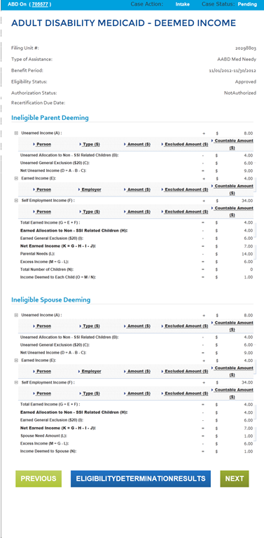

### Cost of Care

#### 03.12.08: Wireframe

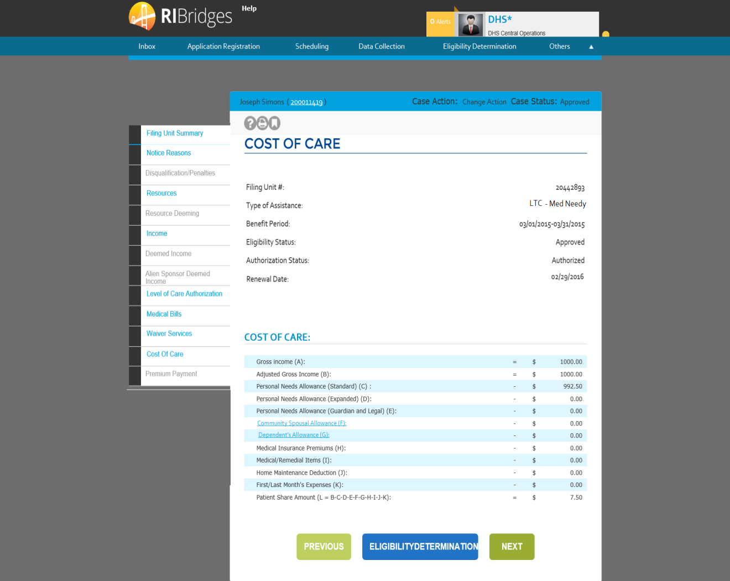

#### 03.12.08: Data Table

| **Field Name** | **Field Type** | **Format** | **Mandatory** | **Default Value** | **Reference Table Name** | **Event/ Business Logic** | | | **Validation Code** | |
| --- | --- | --- | --- | --- | --- | --- | --- | --- | --- | --- |
| Cost of Care | Screen | N/A | N/A | N/A | N/A | | This page is navigated if the user click on 'Cost Of Care' tab on the Filing Unit Summary screen. This page displays the cost of care information. | N/A | |
| Filing Unit Summary | Tab | N/A | N/A | N/A | N/A | | This tab is enabled. | N/A | |
| Notice Reasons | Tab | N/A | N/A | N/A | N/A | | This tab is enabled. | N/A | |
| Resources | Tab | N/A | N/A | N/A | N/A | | This tab is enabled. | N/A | |
| Resource Deeming | Tab | N/A | N/A | N/A | N/A | | This tab is enabled. | N/A | |
| Income | Tab | N/A | N/A | N/A | N/A | | This tab is enabled. | N/A | |
| Deemed Income | Tab | N/A | N/A | N/A | N/A | | This tab is enabled. | N/A | |
| Alien Sponsor Deemed Income | Tab | N/A | N/A | N/A | N/A | | This tab is enabled. | N/A | |
| Medical Bills | Tab | N/A | N/A | N/A | N/A | | This tab is enabled. | N/A | |
| Cost Of Care | Tab | N/A | N/A | N/A | N/A | | This tab is enabled and active. | N/A | |
| Service Authorization | Tab | N/A | N/A | N/A | N/A | | This tab is enabled. | N/A | |
| Level of Care Authorization | Tab | N/A | N/A | N/A | N/A | | This tab is enabled. | N/A | |
| Disqualification/Penalties | Tab | N/A | N/A | N/A | N/A | | This tab is enabled. | N/A | |
| Sherlock Premium | Tab | N/A | N/A | N/A | N/A | | This tab is disabled. | N/A | |
| Case Name | Label | Alphanumeric | N/A | N/A | N/A | | Specifies the name of the primary individual registered in the case. | N/A | |
| Case # | Label - Hyperlink | Numeric | N/A | N/A | N/A | | N/A | N/A | |
| Case Action | Label | Alphanumeric | N/A | N/A | CASEACTION | | Specifies the action being performed on the case. | N/A | |
| Case Status | Label | Alphanumeric | N/A | N/A | DICASESTATUS | | Specifies the status of the case. | N/A | |
| Filing Unit #: | Label | Numeric | N/A | N/A | N/A | | This is a system generated number which is generated when the eligibility is run for a program requested for the case number entered in 'Eligibility Determination Details' page. | N/A | |
| Type of Assistance: | Label | Alphanumeric | N/A | N/A | EDTOA | | The Program type selected from the results displayed in 'Eligibility Summary' page associated with the EDG number would be displayed in this field. | N/A | |
| Benefit Period: | Label-Date range | MM/DD/YYYY | N/A | N/A | N/A | | The Benefit period listed for the record selected form the results displayed in 'Eligibility Summary' page would be displayed in this field. | N/A | |
| Eligibility Status: | Label | Alphanumeric | N/A | N/A | EDEDBCACTION | | The Eligibility Status of the record selected in 'Eligibility Determination Details' page would be displayed in this field. | N/A | |
| Authorization Status: | Label | Alphanumeric | N/A | N/A | EDCURRIND | | The authorization status would be displayed in this field based on the record selected in 'Eligibility Determination Details' page. It is based upon the Eligibility Status. | N/A | |
| Renewal Date | Label-Date | MM/DD/YYYY | N/A | N/A | N/A | | The date in this field is calculated and displayed when Eligibility Status of the case number selected is Approved. | N/A | |
| Cost of Care | Section Header | N/A | N/A | N/A | N/A | | N/A | N/A | |
| Gross Income (A) * | Label | Currency | N/A | N/A | N/A | | On clicking this image, all information (Person, Employer, Amount, Excluded Amount, Countable Amount) corresponding to employment income eligible for earned income deduction is displayed/ hidden in the form of table with complete details. | N/A | |
| Adjusted Gross Income (B) * | Label | Currency | N/A | N/A | N/A | | Populates based on the total sum of the countable income in the table. | N/A | |
| Personal Need Allowance (Standard) (C ) | Label | Currency | N/A | N/A | N/A | | Displays Rules engine determined PNA Standard Allowance which is $50.00 | N/A | |
| Personal Need Allowance (Expanded) (D ) * | Label | Currency | N/A | N/A | N/A | | Displays Rules engine determined PNA Expanded Allowance | N/A | |
| Personal Need Allowance (Guardian and Legal) (E ) * | Label | Currency | N/A | N/A | N/A | | Displays Rules engine determined Guardianship/Conservator Expenses | N/A | |
| Community Spouse Allowance (F): | Label | Currency | N/A | N/A | N/A | | On Click of this details of the Community Spousal Allowance Calculations are displayed as a Pop-Up | N/A | |
| Community Spouse Allowance (D): | Label | Currency | N/A | N/A | N/A | | On Click of this details of the Dependent Allowance Calculations are displayed as a Pop-Up | N/A | |
| Medical Insurance Premium(F) | Label | Currency | N/A | N/A | N/A | | Displays Rules engine determined Medical Insurance Premiums | N/A | |
| Home Maintenance Deduction (G): | Label | Currency | N/A | N/A | N/A | | Displays Rules engine determined Home Maintenance Allowance | N/A | |
| First/Last Month Expense (H) | Label | Currency | N/A | N/A | N/A | | Populates based on the First/Last Month Expenses reported in the System. This is always $0. |  | |
| Patient Share Calculation (I) | Label | Currency | N/A | N/A | N/A | | Total Cost of Care determined by Rules engine | N/A | |
| Previous | Button | N/A | N/A | N/A | N/A | | On click, the user is navigated to the previous page in the driver flow. | N/A | |
| Eligibility Determination Results | Button | N/A | N/A | N/A | N/A | | On click, the user will be navigating to the 'Eligibility Determination Results' page. | N/A | |
| Next | Button | N/A | N/A | N/A | N/A | | On click, the user is navigated to the next page in the driver flow. | N/A | |

*\* If Income Data shows FTI, Income Data must be masked. Should be viewable only per security matrix.*

### Community Spouse Allowance

#### 03.12.171: Wireframe

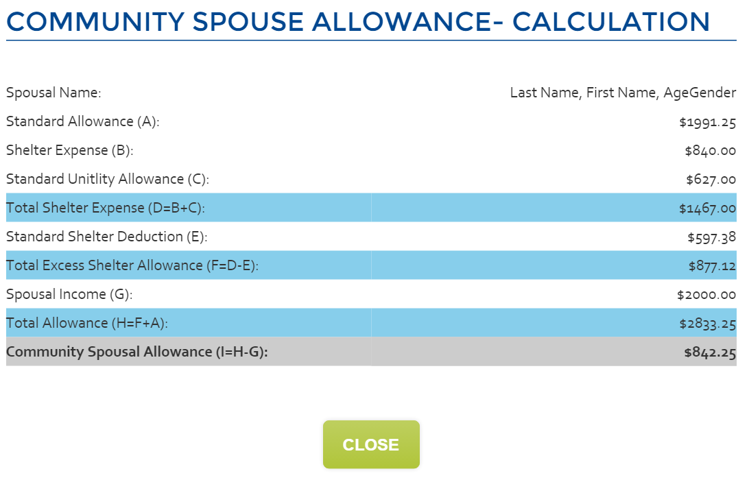

#### 03.12.171: Data Table

| **Field Name** | **Field Type** | **Format** | **Mandatory** | **Default Value** | **Reference Table Name** | **Event/ Business Logic** | **Validation Code** |
| --- | --- | --- | --- | --- | --- | --- | --- |
| Spouse Name | Alpha Numeric | Label | N/A | N/A | N/A | Name of the Community Partner living in Community | N/A |
| Standard Allowance (A) | Currency | Label | N/A | N/A | N/A | Basic Allowance | N/A |
| Shelter Expenses (B ) | Currency | Label | N/A | N/A | N/A | Rules engine calculated countable Shelter expenses | N/A |
| Standard Utility Allowance (C) | Currency | Label | N/A | N/A | N/A | SUA of $627.00 | N/A |
| Total Shelter Expense (D = B+C) | Currency | Label | N/A | N/A | N/A | Rules engine calculated Total Shelter Expense | N/A |
| Standard Shelter Deduction (E) | Currency | Label | N/A | N/A | N/A | Rules engine calculated Standard Shelter Deduction | N/A |
| Total Excess Shelter Allowance (F = D – E) | Currency | Label | N/A | N/A | N/A | Rules engine calculated Total Excess Shelter Allowance | N/A |
| Spousal Income (G) * | Currency | Label | N/A | N/A | N/A | Rules engine calculated Spousal Income | N/A |
| Total Allowance (H=F+A) | Currency | Label | N/A | N/A | N/A | Rules engine calculated Total Allowance | N/A |
| Community Spouse Allowance (I = H-G) | Currency | Label | N/A | N/A | N/A | Rules engine calculated Community Spouse Allowance | N/A |

* If Income Data shows FTI, Income Data must be masked. Should be viewable only per security matrix.

### Dependent Allowance

This screen shows up when the community partner is not in home then dependent allowance calculation is shown as mentioned below.

#### 03.12.172: Wireframe

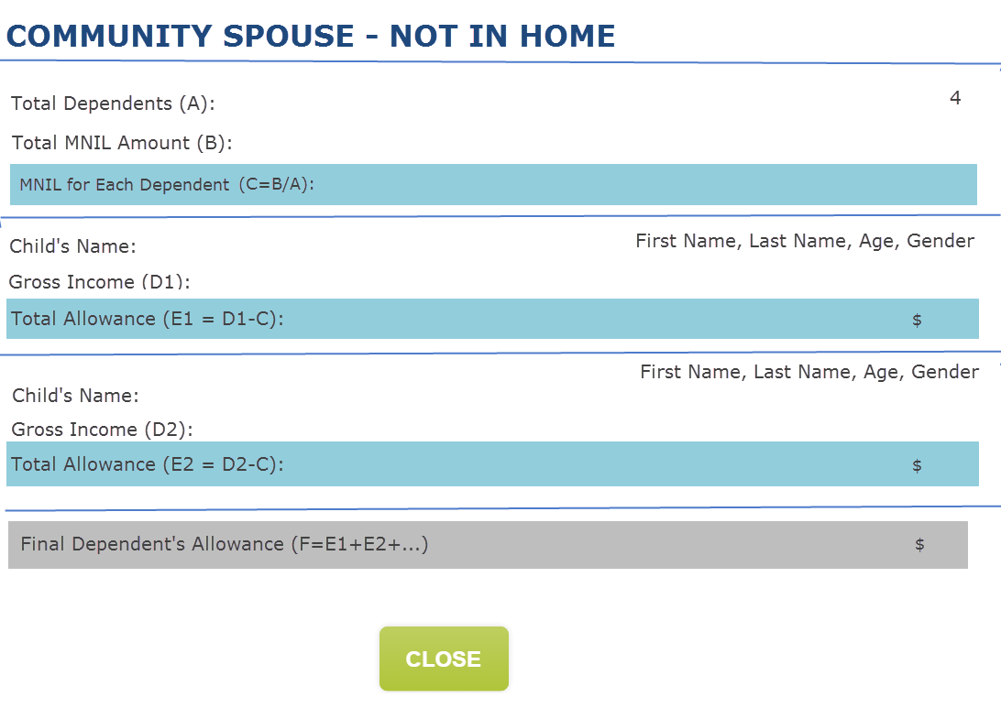

#### 03.12.172: Data Table

| **Field Name** | **Field Type** | | **Format** | **Mandatory** | **Default Value** | **Reference Table Name** | **Event/ Business Logic** | **Validation Code** |
| --- | --- | --- | --- | --- | --- | --- | --- | --- |
| Total Dependents | Numeric | | Label | N/A | N/A | N/A | Total Dependents calculated by Rules engine | N/A |
| Total MNIL Amount | Currency | | Label | N/A | N/A | N/A | Rules engine determined Total Monthly Minimum Maintenance Need Allowance(MNIL) | N/A |
| MNIIL for each dependent | Currency | | Label | N/A | N/A | N/A | Rules engine calculated Minimum Maintenance Need Allowance(MNIL) for each dependents | N/A |
| This below mentioned section is repeated for each dependent | | | | | | | | |
| Child Name | | Currency | Label | N/A | N/A | N/A | Dependent Name | N/A |
| Total Gross Income * | | Currency | Label | N/A | N/A | N/A | Dependent’s Gross Income | N/A |
| Total Allowance | | Currency | Label | N/A | N/A | N/A | Total Allowance for the Child | N/A |
|  | | | | | | | | |
| Total Dependent Allowance | | Currency | Label | N/A | N/A | N/A | Rules engine calculated Total Dependent Allowance for each dependents | N/A |
| Close | | Label | Button | N/A | N/A | N/A | Closes the pop-up window | N/A |

* If Income Data shows FTI, Income Data must be masked. Should be viewable only per security matrix.

### Dependent Allowance

This screen shows up when the community partner is in home then dependent allowance calculation is shown as mentioned below.

#### 03.12.173: Wireframe

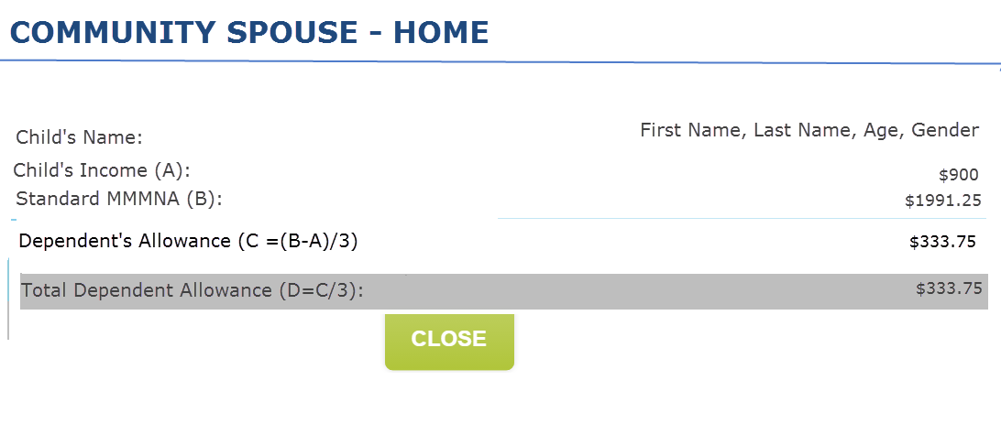

#### 03.12.173: Data Table

| **Field Name** | **Field Type** | **Format** | **Mandatory** | **Default Value** | **Reference Table Name** | **Event/ Business Logic** | **Validation Code** |
| --- | --- | --- | --- | --- | --- | --- | --- |
| This below mentioned section is repeated for each dependents | | | | | | | |
| Child’s Name | Currency | Label | N/A | N/A | N/A | Dependent Name | N/A |
| Child’s Income (B) * | Currency | Label | N/A | N/A | N/A | Dependent’s Gross Income | N/A |
| Standard MMNA | Currency | Label | N/A | N/A | N/A | Standard Monthly Maintenance Need Allowance | N/A |
| Dependent’s Allowance (C= (B-A)/3) | Currency | Label | N/A | N/A | N/A | Child’s dependent’s Allowance | N/A |
|  | | | | | | | |
| Total Dependent Allowance | Currency | Label | N/A | N/A | N/A | Rules engine calculated Total Dependent Allowance for each dependents | N/A |
| Close | Label | Button | N/A | N/A | N/A | Closes the pop-up window | N/A |

* If Income Data shows FTI, Income Data must be masked. Should be viewable only per security matrix.

### Level of Care Authorization

#### 03.12.161: Wireframe

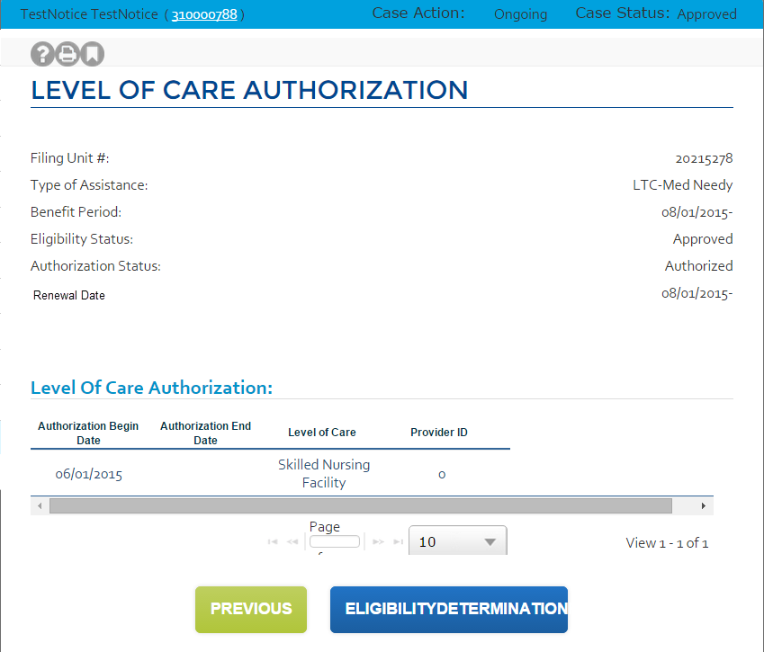

#### 

#### 03.12.161: Data Table

| **Field Name** | **Field Type** | **Format** | **Mandatory** | **Default Value** | **Reference Table Name** | **Event/ Business Logic** | **Validation Code** |
| --- | --- | --- | --- | --- | --- | --- | --- |
| Level of Care Authorization | Screen | N/A | N/A | N/A | N/A | This page is navigated if the user click on 'Level of Care Authorization' tab on the Filing Unit Summary screen. This page displays the level of care authorized for the filing unit during specified periods. | N/A |
| Filing Unit Summary | Tab | N/A | N/A | N/A | N/A | This tab is enabled. | N/A |
| Ineligibility Reasons | Tab | N/A | N/A | N/A | N/A | This tab is enabled. | N/A |
| Resources | Tab | N/A | N/A | N/A | N/A | This tab is enabled. | N/A |
| Resource Deeming | Tab | N/A | N/A | N/A | N/A | This tab is disabled. | N/A |
| Income | Tab | N/A | N/A | N/A | N/A | This tab is enabled. | N/A |
| Deemed Income | Tab | N/A | N/A | N/A | N/A | This tab is enabled. | N/A |
| Alien Sponsor Deemed Income | Tab | N/A | N/A | N/A | N/A | This tab is enabled. | N/A |
| Medical Bills | Tab | N/A | N/A | N/A | N/A | This tab is enabled. | N/A |
| Cost of Care | Tab | N/A | N/A | N/A | N/A | This tab is enabled. |  |
| Service Authorization | Tab | N/A | N/A | N/A | N/A | This tab is enabled. | N/A |
| Level of Care Authorization | Tab | N/A | N/A | N/A | N/A | This tab is enabled and active. | N/A |
| Disqualification/Penalties | Tab | N/A | N/A | N/A | N/A | This tab is enabled. |  |
| Sherlock Premium | Tab | N/A | N/A | N/A | N/A | This tab is disabled. |  |
| Case Name | Label | Alphanumeric | N/A | N/A | N/A | Specifies the name of the primary individual registered in the case. | N/A |
| Case # | Label - Hyperlink | Numeric | N/A | N/A | N/A | N/A | N/A |
| Case Action | Label | Alphanumeric | N/A | N/A | CASEACTION | Specifies the action being performed on the case. | N/A |
| Case Status | Label | Alphanumeric | N/A | N/A | DICASESTATUS | Specifies the status of the case. | N/A |
| Filing Unit #: | Label | Numeric | N/A | N/A | N/A | This is a system generated number which is generated when the eligibility is run for a program requested for the case number entered in 'Eligibility Determination Details' page. | N/A |
| Type of Assistance: | Label | Alphanumeric | N/A | N/A | EDTOA | The Program type selected from the results displayed in 'Eligibility Summary' page associated with the EDG number would be displayed in this field. | N/A |
| Benefit Period: | Label-Date range | MM/DD/YYYY | N/A | N/A | N/A | The Benefit period listed for the record selected form the results displayed in 'Eligibility Summary' page would be displayed in this field. | N/A |
| Eligibility Status: | Label | Alphanumeric | N/A | N/A | EDEDBCACTION | The Eligibility Status of the record selected in 'Eligibility Determination Details' page would be displayed in this field. | N/A |
| Authorization Status: | Label | Alphanumeric | N/A | N/A | EDCURRIND | The authorization status would be displayed in this field based on the record selected in 'Eligibility Determination Details' page. It is based upon the Eligibility Status. | N/A |
| Renewal Date | Label-Date | MM/DD/YYYY | N/A | N/A | N/A | The date in this field is calculated and displayed when Eligibility Status of the case number selected is Approved. | N/A |
|  | | | | | | | |
| Level of Care Authorization | Section Header | N/A | N/A | N/A | N/A | N/A | N/A |
| Authorization Begin Date | Column Header | MM/DD/YYYY | N/A | N/A | N/A | This field displays the begin date for the specified period. | N/A |
| Authorization End Date | Column Header | MM/DD/YYYY | N/A | N/A | N/A | This field displays the end date for the specified period. | N/A |
| Level of Care | Column Header | Alphanumeric | N/A | N/A | N/A | This field describes the level of care for the specified period whether Institutional, Community, Katie Beckett and DD Program. | N/A |
| Provider ID | Column Header | Alphanumeric | N/A | N/A | N/A | This field displays the provider ID. | N/A |
| Previous | Button | N/A | N/A | N/A | N/A | On click, the user will be navigated to the previous page in the driver flow. | N/A |
| Eligibility Determination Results | Button | N/A | N/A | N/A | N/A | On click, user will be navigated to the 'Eligibility Determination Results' page. | N/A |
| Next | Button | N/A | N/A | N/A | N/A | On click, the user will be navigated to the next page in the driver flow. | N/A |

## Interfaces – MMIS

As part of MMIS Eligibility Transaction, a new transaction called as “2B” is added in addition to existing “1B” ,”3B” and “4B” transaction.

2B Transaction is used to send the historic (retro Medicaid) coverage to MMIS system, whenever the client doesn’t have eligibility for the historic period. Expectation is to have the Eligibility Begin Date and End Date in the past period as part of the 2B Transaction.

**Scenario 1**: Client is applying for Medicaid with Application date of 04/10/2015 and determined eligible on 04/10/2015. 1B Transaction is sent to MMIS with Eligibility Start Date as 04/01/2015. Later on client continued to apply for Retro coverage for prior month’s i.e, Jan 2015, Feb 2015 and March 2015 through DHS-2 application/Health Insurance application. Worker processed the retro coverage on 04/20/2015. In this case only Retro Months (01/2015,02/2015,03/2015) should be sent as ‘2B’ to MMIS.

|  |  |  |  |  |  |  |
| --- | --- | --- | --- | --- | --- | --- |
| Day# | Transaction# | Elig Start Date | Stop Date | Aid Category Code | Description | Transaction |
| 04/10/2015 | 1 | 4/1/2015 |  | CX | Childless Adult Medicaid | 1B |
| 04/20/2015 | 1 | 1/1/2015 | 3/31/2015 | MA |  | 2B |

**Scenario 2**: Client is applying for MAGI and determined eligible. However requested Retro coverage. Worker is processing retro coverage on **same day**. In this scenario only Retro Months should be sent as 2B along 1B to MMIS. The HP enrollment system (MMIS) will accept two ‘B’ transactions on same day as long as one of the transaction is ongoing with no end date whereas the other retro has start and end dates which do not overlap with the ongoing transaction. Application date here is some date in 3rd month hence MAGI starts prospectively from 1st of 4th month.

|  |  |  |  |  |  |  |
| --- | --- | --- | --- | --- | --- | --- |
| Day# | Transaction# | Elig Start Date | Stop Date | Aid Category Code | Description | Transaction |
| 1 | 1 | 1/1/2015 | 3/31/2015 | MA |  | 2B |
| 1 | 2 | 4/1/2015 |  | CX |  | 1B |

**Scenario 3:** Client is eligible for MAGI Medicaid on the current month which is 3rd month. The dependent children are aging out. Hence the parents move to CX effective next (4th month) month. That means LIF aid category code for the parents closes end of the month in which dependents age out.

|  |  |  |  |  |  |  |
| --- | --- | --- | --- | --- | --- | --- |
| Day# | Transaction# | Elig Start Date | Stop Date | Aid Category Code | Description | Transaction |
| 1 | 1 | 3/1/2015 | 3/31/2015 | UF | Low Income Families | 2B |
| 1 | 2 | 4/1/2015 |  | CX | Childless Adult Medicaid | 1B |

**Scenario 4:** Client is currently eligible for MAGI Medicaid as CHIP effective 07/1/2014. Client has reported a change as well as aging out of the system effective 08/01/2015. In this scenario New Aid Category should be set prospectively.

|  |  |  |  |  |  |  |
| --- | --- | --- | --- | --- | --- | --- |
| Day# | Transaction# | Elig Start Date | Stop Date | Aid Category Code | Description | Transaction |
| 1 | 1 | 6/1/2015 | 7/31/2015 | UJ | CHIP | 2B |
| 1 | 2 | 8/1/2015 |  | CX | Childless Adult Medicaid | 1B |

As part of MMIS Demographics (“1A00” – Transaction) following are the additional fields added to the existing story boards.

* 1. US Entry Date: Date Non-Citizen entered US. This is used by MMIS to consider these individuals as Refugee, if the recipient entered U.S in the last eight (8) months.
  2. Email Address: Email address of the recipient or primary applicant.

|  |  |  |  |
| --- | --- | --- | --- |
| Field Name | Format | Position | Description |
| Email Address | Alphanumeric | 232-281 | Email address of the applicant. This field can be blank. |
| US Entry Date | Numeric | 282-289 | US Entry Date in CCYYMMDD format. If this is not applicable, the system will send the date as 00/00/0000. |

## Business Rules Listings

The following section describes the OPA rules used for evaluating an applicant’s Medicaid eligibility. This includes the rules that drives the evaluation of a person’s MAGI eligibility, complex Medicaid eligibility and private insurance eligibility, based on the cascading logic of the Medicaid Hierarchy.

### Group Composition

the person (the other person) is a member of the person's tax household members if

any

all

the person is a tax filer

the person is not claimed as a dependent

either

the next person is claimed as a dependent of the target person

the other person is a member of the person's dependents

the other person is the person

both

the person is claimed as a dependent

either

the next person is the tax filer that claims the target person

the other person is a member of the person's tax filers

the next person is a member of the target's tax filer's tax household

for at least one of the person's tax filers (the tax filer)

the other person is a member of the tax filer's dependents

all

the other person is a member of the person's spouse

the target person and the next person are filing jointly

the other person is a member of the person's joint tax filer

the person is below the age requirement if

the person's age (for Medicaid) < 19

the person satisfies a MAGI Medicaid household exception if

the person is claimed as a dependent and

either

both

the target person's tax filer is not the target person's biological, adopted or step parent From here on all types of parents are generalized to only parents

the person's tax filer is not the person's parents

the person's tax filer is not the person's spouse

all

the person is below the age requirement

the person's tax filer is the person's parents

either

both

the person lives with both parents

the person's parents are not filing jointly

the person's tax filer is the person's non-custodial parents

the person's tax filer is the person's parents if

the number of the person's tax filers > 0 and

for at least one of the person's tax filers (the tax filer)

the tax filer is a member of the person's parents

the person's tax filer is the person's non-custodial parents if

the number of the person's tax filers > 0 and

for at least one of the person's tax filers (the tax filer)

the tax filer is a member of the person's non-custodial parents

the person lives with both parents if

the number of the person's parents > 1 and

for each of the person's parents (the parent)

the parent is a member of the person's cohabitants

the person's parents are filing jointly if

the number of the person's parents > 0 and

for each of the person's parents (the parent)

the parent is a tax filer and

the number of the parent's joint tax filer > 0 and

for each of the parent's joint tax filer (the joint filer)

the joint filer is a member of the person's parents

the person's tax filer is the person's spouse if

the number of the person's tax filers > 0 and

for at least one of the person's tax filers (the tax filer)

the tax filer is a member of the person's spouse

the person's MAGI Medicaid household is not built with tax rules if

either

both

the person is not a tax filer

the person is not claimed as a dependent

the person satisfies a MAGI Medicaid household exception

the person (the other person) is a member of the person's MAGI Medicaid household members if

the other person is the person or

all

the person's MAGI Medicaid household is built with tax rules

either

the other person is a member of the person's tax household members

the other person is a member of the person's spouse

or

all

the person's MAGI Medicaid household is not built with tax rules

either

the person lives with the primary applicant

the person is a primary applicant

the person is not the other person

either

the other person lives with the primary applicant

the other person is a primary applicant

any

the other person is a member of the person's spouse

both

the next person is the target person's natural, adopted, or step child

the other person is a member of the person's children

the other person is below the age requirement

both

the person is below the age requirement

the next person is the target person's natural, adopted, or step parent

the other person is a member of the person's parents

all

the person is below the age requirement

the next person is the target person's natural, adoptive, or step sibling below the age requirement

the other person is a member of the person's siblings

the other person is below the age requirement

the person's MAGI Medicaid household size = the total members in the person's MAGI Medicaid household + the person's MAGI Medicaid household member's number of expected children

the total members in the person's MAGI Medicaid household = the number of the person's MAGI Medicaid household members

the person's MAGI Medicaid household member's number of expected children = the person's number of expected children totalled for all of the person's MAGI Medicaid household members for which it is the case that the person is a pregnant

Policy Reference (IRS Code): 26 USC 36B(e)(1)(B)(i)(I)

the person's tax household size = the number of the person's tax household members

the person has a valid relationship with primary applicant for MAGI Medicaid if

any

the person is related to primary applicant

for at least one of the person's children(the child)

the child is related to primary applicant

for at least one of the person's parents (the parent)

the parent is related to primary applicant

for at least one of the person's siblings (the sibling)

the sibling is related to primary applicant

the sibling is not an adult

for at least one of the person's spouse (the spouse)

the spouse is related to primary applicant

for at least one of the person's relationships

the relationship type = "Domestic partner" and

for at least one of the relationship's target person(the other person)

the other person is related to primary applicant

the person is related to primary applicant if

any

the person is a domestic partner of the primary applicant

the person is a parent/caretaker of the primary applicant

the primary applicant is the parent/caretaker of the person

for at least one of the person's relationships

for at least one of the relationship's target person(the other person)

the other person is a primary applicant

and

any

the person is a spouse of the primary applicant

the relationship type ="Spouse"

the person is a natural, adopted, step, foster, and biological parent of the primary applicant

the person is a parent's domestic partner of the primary applicant

the relationship type ="Parent"

the person is a natural, adopted, step, foster, and child of the primary applicant

the person is a child of domestic partner of the primary applicant

the relationship type ="Child"

the person is a natural, adoptive, or step sibling below the age requirement of the primary applicant

the relationship type ="Sibling"

the person is an uncle/aunt of the primary applicant

the relationship type ="Uncle/aunt"

the person is a nephew/niece of the primary applicant

the relationship type ="Nephew/niece"

the person is a first cousin of the primary applicant

the relationship type ="First Cousin"

the person is a grandparent of the primary applicant

the relationship type ="Grandparent"

the person is a guardian of the primary applicant

the relationship type ="Guardian"

the person is a sponsored dependent of the primary applicant

the relationship type ="Sponsored Dependent"

the person is a trustee of the primary applicant

the relationship type ="Trustee"

the person is a ward of the primary applicant

the relationship type ="Ward"

the person is a non-relative caretaker of the primary applicant

the relationship type ="Non-relative caretaker"

Refer to Citizenship/Immigration section for the citizenship/immigration status codes

the person is a domestic partner of the primary applicant if

for at least one of the person's relationships

the relationship type = "Domestic partner" and

for at least one of the relationship's target person (the other person)

the other person is a primary applicant

the person (the other person) is a member of the person's Community Medicaid household members if

the other person is the person or

all

the other person is a member of the person's spouse

the other person lives with the primary applicant

either

the other person is not receiving Social Security Income (SSI)

the other person is not eligible for Long Term Care Services

the person (the other person) is a member of the person's LTSS Medicaid household members if

the other person is the person

the person is a spouse of the primary applicant if

for at least one of the person's relationships

the relationship type = "Spouse" and

for at least one of the relationship's target person (the other person)

the other person is a primary applicant

the person is a parent/caretaker of the primary applicant if

either

both

the number of the person's children > 0 and

the person’s youngest child is a dependent child

for at least one of the person's children (the child)

the child is a primary applicant and

the child is not an adult and

for at least one of the person's relationships

the relationship's target is under the care of the person and

for at least one of the relationship's target person (the other person)

the other person is a primary applicant and

the other person is not an adult and

the other person is a dependent child and

either

the number of the other person's parents = 0

for all of the other person's parents (the parent)

the parent is not a member of the other person's cohabitants

the primary applicant is the parent/caretaker of the person if

either

all

the person is not an adult and

the number of the person's parents > 0 and

for at least one of the person's parents (the parent)

the parent is a primary applicant and

the parent’s youngest child is a dependent child

all

the person is not an adult and

the person is a dependent child and

for at least one of the household members (the other person)

the other person is a primary applicant and

either

the number of the person's parents = 0

for all of the person's parents (the parent)

the parent is not a member of the other person's cohabitants

and

for at least one of the other person's relationships

the relationship's target is under the care of the person and

the person is a member of the relationship's target person

the person's Medicaid inconsistency period has been elapsed if

either

all

the person's Medicaid inconsistency notification has been sent

any

the person needs to provide income documentation (for Medicaid)

the person needs to provide SSN documentation (for Medicaid)

the person needs to provide DOB documentation (for Medicaid)

the person needs to provide Name documentation (for Medicaid)

the person needs to provide public MEC documentation (for Medicare)

the person needs to provide death data documentation (for Medicaid)

the eligibility determination date > the person's Medicaid inconsistency period end date

all

it is currently known whether the eligibility is run through Medicaid Verification Batch

the eligibility is run through Medicaid Verification Batch

it is currently known whether the person's Medicaid inconsistency period has been elapsed through Medicaid Verification Batch

the person's Medicaid inconsistency period has been elapsed through Medicaid Verification Batch

the person's Community Medicaid inconsistency period has been elapsed if

either

all

the person's Community Medicaid inconsistency notification has been sent

any

the person needs to provide income documentation (for Medicaid)

the person needs to provide SSN documentation (for Medicaid)

the person needs to provide DOB documentation (for Medicaid)

the person needs to provide Name documentation (for Medicaid)

the person needs to provide public MEC documentation (for Medicare)

the person needs to provide death data documentation (for Medicaid)

the person needs to provide Incarceration

the person needs to provide disability determination MART documentation (for Traditional Medicaid)

the person needs to provide self-employment income documentation (for Traditional Medicaid)

the person needs to provide rental income documentation (for Traditional Medicaid)

the person needs to provide additional unearned income documentation (for Traditional Medicaid)

the person needs to provide resource documentation (for Traditional Medicaid)

the person needs to provide expense documentation (for Traditional Medicaid)

the eligibility determination date > the person's Medicaid inconsistency period end date

all

it is currently known whether the eligibility is run through Medicaid Verification Batch

the eligibility is run through Medicaid Verification Batch

it is currently known whether the person's Medicaid inconsistency period has been elapsed through Medicaid Verification Batch

the person's Medicaid inconsistency period has been elapsed through Medicaid Verification Batch

the person's Medicaid inconsistency notification has not been sent if

the person's Medicaid inconsistency notification sent date is unknown or

the person's Medicaid inconsistency notification sent date is currently unknown or

the person's Medicaid inconsistency notification sent date is uncertain

the person's Medicaid inconsistency period end date = AddDays(the person's Medicaid inconsistency notification sent date, the person’s MAGI Medicaid inconsistency period)

the person is eligible for Low Income Families Medicaid (LIF) if

all

the person's benefit period being evaluated is applicable for MAGI

the person is requesting coverage

the person's Medicaid inconsistency period has not been elapsed

the person's citizenship/immigration status inconsistency period has not been elapsed - VRF

the household is requesting insurance affordability program

the person is not denied because of immigration status

the person is not denied due to lawful presence verification code

the person is not denied Medicaid because of death indicator during PEV

either

the person is a primary applicant

both

the person lives with the primary applicant

the person has a valid relationship with primary applicant for MAGI Medicaid

the person is not enrolled in Medicaid in other states

the person is a member of the person's MAGI Medicaid household members

any

both

the person is an adult

either

both

the person is a pregnant

the eligibility determination date <= two months after the pregnancy due date

both

the person is not a pregnant

the person had the baby

all

the person is not a pregnant

the person’s pregnancy end date is currently known

the eligibility determination date <= two months after the pregnancy end date

both

the person is an adult

the person is a parent/caretaker

both

the person is not an adult

the person's age (for Medicaid) <65

either

the person's citizenship/immigration status (for Medicaid) = "CIT"

the person's citizenship/immigration status (for Medicaid) = "LWP"

the person is a resident of Rhode Island

the person does not have ABDF in InRhodes

(the person's MAGI Medicaid household income*12) <= the person's MAGI Medicaid household income level at 116 percent of the Federal Poverty Level (FPL) with disregards

the person is eligible for Deemed Newborn Medicaid if

all

the person's benefit period being evaluated is applicable for MAGI

the person is requesting coverage

the person's Medicaid inconsistency period has not been elapsed

the person's citizenship/immigration status inconsistency period has not been elapsed

the household is requesting insurance affordability program

the person is not denied because of immigration status

the person is not denied due to lawful presence verification code

the person is not denied Medicaid because of death indicator during PEV

either

either

the person is a primary applicant

both

the person lives with the primary applicant

the person has a valid relationship with primary applicant for MAGI Medicaid

the person is a Newborn (for Medicaid)

the person is not enrolled in Medicaid in other states

the person's age (for Medicaid) < 1

for at least one of the person's parents (the parent)

the parent is female and

either

the parent is receiving MAGI Medicaid at the birth month

the parent is receiving Medicaid in InRhodes at the birth month

the person is a member of the person's MAGI Medicaid household members

the person is a resident of Rhode Island

the person does not have ABDF in InRhodes

either

In the case of the person’s parent (the mom)

(the mom’s income *12 <= the mom’s income level at 253 percent of the Federal Poverty Level (FPL) with disregards

the person is eligible for RIte Care Children under 1 Medicaid if

all

the person's benefit period being evaluated is applicable for MAGI

the person is requesting coverage

the person's Medicaid inconsistency period has not been elapsed

the person's citizenship/immigration status inconsistency period has not been elapsed

the household is requesting insurance affordability program

the person is not denied because of immigration status

the person is not denied due to lawful presence verification code

the person is not denied Medicaid because of death indicator during PEV

either

the person is a primary applicant

both

the person lives with the primary applicant

the person has a valid relationship with primary applicant for MAGI Medicaid

the person's age (for Medicaid) < 1

the person is not enrolled in Medicaid in other states

the person is a member of the person's MAGI Medicaid household members

either

the person's citizenship/immigration status (for Medicaid) = "CIT"

the person's citizenship/immigration status (for Medicaid) = "LWP"

the person is a resident of Rhode Island

the person does not have ABDF in InRhodes

(the person's MAGI Medicaid household income *12) <= the person's MAGI Medicaid household income level at 190 percent of the Federal Poverty Level (FPL) with disregards

the person is eligible for RIte Care Children under 6 Medicaid if

all

the person's benefit period being evaluated is applicable for MAGI

the person is requesting coverage

the person's Medicaid inconsistency period has not been elapsed

the person's citizenship/immigration status inconsistency period has not been elapsed

the household is requesting insurance affordability progra

the person is not denied because of immigration status

the person is not denied due to lawful presence verification code

the person is not denied Medicaid because of death indicator during PEV

either

the person is a primary applicant

both

the person lives with the primary applicant

the person has a valid relationship with primary applicant for MAGI Medicaid

the person's age (for Medicaid) >= 1

the person's age (for Medicaid) < 6

the person is not enrolled in Medicaid in other states

the person is a member of the person's MAGI Medicaid household members

either

the person's citizenship/immigration status (for Medicaid) = "CIT"

the person's citizenship/immigration status (for Medicaid) = "LWP"

the person is a resident of Rhode Island

the person does not have ABDF in InRhodes

(the person's MAGI Medicaid household income *12) <= the person's MAGI Medicaid household income level at 142 percent of the Federal Poverty Level (FPL) with disregards

the person is eligible for RIte Care Children 6 to 18 type 1 if

all

the person's benefit period being evaluated is applicable for MAGI

the person is requesting coverage

the person's Medicaid inconsistency period has not been elapsed

the person's citizenship/immigration status inconsistency period has not been elapsed

the household is requesting insurance affordability program

the person is not denied because of immigration status

the person is not denied due to lawful presence verification code

the person is not denied Medicaid because of death indicator during PEV

either

the person is a primary applicant

both

the person lives with the primary applicant

the person has a valid relationship with primary applicant for MAGI Medicaid

the person's age (for Medicaid) >=6

the person's age (for Medicaid) < 19

the person is not enrolled in Medicaid in other states

the person is a member of the person's MAGI Medicaid household members

either

the person's citizenship/immigration status (for Medicaid) = "CIT"

the person's citizenship/immigration status (for Medicaid) = "LWP"

the person is a resident of Rhode Island

the person does not have ABDF in InRhodes

(the person's MAGI Medicaid household income *12) >= the person's MAGI Medicaid household income level at 109 percent of the Federal Poverty Level (FPL)

(the person's MAGI Medicaid household income *12) <= the person's MAGI Medicaid household income level at 142 percent of the Federal Poverty Level (FPL) with disregards

the person is eligible for RIte Care Children 6 to 18 type 2 if

all

the person's benefit period being evaluated is applicable for MAGI

the person is requesting coverage

the person's Medicaid inconsistency period has not been elapsed

the person's citizenship/immigration status inconsistency period has not been elapsed

the household is requesting insurance affordability program

the person is not denied because of immigration status

the person is not denied due to lawful presence verification code

the person is not denied Medicaid because of death indicator during PEV

either

the person is a primary applicant

both

the person lives with the primary applicant

the person has a valid relationship with primary applicant for MAGI Medicaid

the person's age (for Medicaid) >=6

the person's age (for Medicaid) < 19

the person is not enrolled in Medicaid in other states

the person is a member of the person's MAGI Medicaid household members

either

the person's citizenship/immigration status (for Medicaid) = "CIT"

the person's citizenship/immigration status (for Medicaid) = "LWP"

the person is a resident of Rhode Island

the person does not have ABDF in InRhodes

(the person's MAGI Medicaid household income *12) > the person's MAGI Medicaid household income level at 142 percent of the Federal Poverty Level (FPL)

(the person's MAGI Medicaid household income *12) <= the person's MAGI Medicaid household income level at 190 percent of the Federal Poverty Level (FPL) with disregards

the person is eligible for RIte Care Pregnant Women Medicaid if

all

the person's benefit period being evaluated is applicable for MAGI

the person is requesting coverage

the person's Medicaid inconsistency period has not been elapsed

the person's citizenship/immigration status inconsistency period has not been elapsed

the household is requesting insurance affordability program

the person is not denied because of immigration status

the person is not denied due to lawful presence verification code

the person is not denied Medicaid because of death indicator during PEV

either

the person is a primary applicant

both

the person lives with the primary applicant

the person has a valid relationship with primary applicant for MAGI Medicaid

the person is not enrolled in Medicaid in other states

the person is a member of the person's MAGI Medicaid household members

either

all

the eligibility is run through batch

either

both

the person is a pregnant

the eligibility determination date <= one month after the pregnancy due date

both

the person is not a pregnant

the person had the baby

all

the person is not a pregnant

the person’s pregnancy end date is currently known

the eligibility determination date <= one month after the pregnancy end date

both

the eligibility is not run through batch

either

both

the person is a pregnant

the eligibility determination date <= two months after the pregnancy due date

both

the person is not a pregnant

the person had the baby

all

the person is not a pregnant

the person’s pregnancy end date is currently known

the eligibility determination date <= two months after the pregnancy end date

either

the person's citizenship/immigration status (for Medicaid) = "CIT"

the person's citizenship/immigration status (for Medicaid) = "LWP"

the person is a resident of Rhode Island

the person does not have ABDF in InRhodes

(the person's MAGI Medicaid household income *12) <= the person's MAGI Medicaid household income level at 190 percent of the Federal Poverty Level (FPL) with disregards

the person is a parent/caretaker if

either

both

the number of the person's children > 0

for at least one of the person's children (the child)

the child is a member of the person's cohabitants and

the child is a dependent child

for at least one of the person's relationships

the relationship's target is under the care of the person and

for at least one of the relationship's target person (the other person)

the other person is a dependent child and

the other person is a member of the person's cohabitants and

either

the number of the other person's parents = 0

for all of the other person's parents (the parent)

the parent does not live with the primary applicant

the person is a spouse of the parent/caretaker if

all

any

the person lives with the primary applicant

the person is a primary applicant

for at least one of the person's spouse (the spouse)

the spouse is a parent/caretaker

the person is an adult if

the person’s age (for Medicaid) >= 19

~~either~~

~~both~~

~~the person's age (for Medicaid) >=19~~

~~the person's age (for Medicaid) < 65~~

~~all~~

~~the person's age (for Medicaid) >=18~~

~~the person's age (for Medicaid) <19~~

~~both~~

~~the person is a full-time student~~

~~the person is not expected to graduate before the 19th birth day~~

the person’s youngest child is a dependent child if

either

the person’s age (for Medicaid) < 18 or

all

the person’s age (for Medicaid) >= 18 and

the person's age (for Medicaid) <19 and

the person is a full-time student

the person is a Newborn (for Medicaid) if

all

the person is requesting coverage

the household is requesting insurance affordability program

either

the person is a primary applicant

both

the person lives with the primary applicant

the person has a valid relationship with primary applicant for MAGI Medicaid

the person’s age (for Medicaid) < 1

for at least one of the person’s parents(the parent)

the parent is female and

either

the parent is receiving MAGI Medicaid at the birth month

the parent is receiving Medicaid in InRhodes at the birth month

the person is a member of the person's MAGI Medicaid household members

the person is a resident of Rhode Island

the person is eligible for Parent/Caretaker Category if

all

the person's benefit period being evaluated is applicable for MAGI

the person is requesting coverage

the person's Medicaid inconsistency period has not been elapsed

the person's citizenship/immigration status inconsistency period has not been elapsed

the person is not denied because of immigration status

the person is not denied due to lawful presence verification code

the person is not denied Medicaid because of death indicator during PEV

the household is requesting insurance affordability program

either

the person is a primary applicant

both

the person lives with the primary applicant

the person has a valid relationship with primary applicant for MAGI Medicaid

the person is not enrolled in Medicaid in other states

the person's age (for Medicaid) >=19

the person is a member of the person's MAGI Medicaid household members

either

the person is a parent/caretaker

the person is a spouse of the parent/caretaker

either

the person's citizenship/immigration status (for Medicaid) = "CIT"

the person's citizenship/immigration status (for Medicaid) = "LWP"

the person is a resident of Rhode Island

the person does not have ABDF in InRhodes

(the person's MAGI Medicaid household income *12) <= the person's MAGI Medicaid household income level at 136 percent of the Federal Poverty Level (FPL) with disregards

the person is eligible for CHIP Pregnant Women Medicaid if

all

the person's benefit period being evaluated is applicable for MAGI

the person is requesting coverage

the person's Medicaid inconsistency period has not been elapsed

the person's citizenship/immigration status inconsistency period has not been elapsed

the person is not denied because of immigration status

the person is not denied due to lawful presence verification code

the person is not denied Medicaid because of death indicator during PEV

the household is requesting insurance affordability program

either

the person is a primary applicant

both

the person lives with the primary applicant

the person has a valid relationship with primary applicant for MAGI Medicaid

the person is not enrolled in Medicaid in other states

the person is a member of the person's MAGI Medicaid household members

either

all

the eligibility is run through batch

either

both

the person is a pregnant

the eligibility determination date <= one month after the pregnancy due date

both

the person is not a pregnant

the person had the baby

all

the person is not a pregnant

the person’s pregnancy end date is currently known

the eligibility determination date <= one month after the pregnancy end date

both

the eligibility is not run through batch

either

both

the person is a pregnant

the eligibility determination date <= two months after the pregnancy due date

both

the person is not a pregnant

the person had the baby

all

the person is not a pregnant

the person’s pregnancy end date is currently known

the eligibility determination date <= two months after the pregnancy end date

either

the person's citizenship/immigration status (for Medicaid) = "CIT"

the person's citizenship/immigration status (for Medicaid) = "LWP"

the person is a resident of Rhode Island

the person does not have ABDF in InRhodes

(the person's MAGI Medicaid household income *12) > the person's MAGI Medicaid household income level at 190 percent of the Federal Poverty Level (FPL)

(the person's MAGI Medicaid household income *12) <= the person's MAGI Medicaid household income level at 253 percent of the Federal Poverty Level (FPL) with disregards

the person is eligible for CHIP 1 Category Medicaid if

all

the person's benefit period being evaluated is applicable for MAGI

the person is requesting coverage

the person's Medicaid inconsistency period has not been elapsed

the person's citizenship/immigration status inconsistency period has not been elapsed

the person is not denied Medicaid because of death indicator during PEV

the person is not denied due to lawful presence verification code

the household is requesting insurance affordability program

either

the person is a primary applicant

both

the person lives with the primary applicant

the person has a valid relationship with primary applicant for MAGI Medicaid

the person is not enrolled in Medicaid in other states

the person is a member of the person's MAGI Medicaid household members

the person's age (for Medicaid) < 8

either

the person's citizenship/immigration status (for Medicaid) = "CIT"

the person's citizenship/immigration status (for Medicaid) = "LWP"

the person is a resident of Rhode Island

the person does not have ABDF in InRhodes

(the person's MAGI Medicaid household income *12) <= the person's MAGI Medicaid household income level at 261 percent of the Federal Poverty Level (FPL) with disregards

the person is eligible for CHIP 2 Category Medicaid if

all

the person's benefit period being evaluated is applicable for MAGI

the person is requesting coverage

the person's Medicaid inconsistency period has not been elapsed

the person's citizenship/immigration status inconsistency period has not been elapsed

the person is not denied Medicaid because of death indicator during PEV

the person is not denied due to lawful presence verification code

the household is requesting insurance affordability program

either

the person is a primary applicant

both

the person lives with the primary applicant

the person has a valid relationship with primary applicant for MAGI Medicaid

the person is a member of the person's MAGI Medicaid household members

the person is not enrolled in Medicaid in other states

the person's age (for Medicaid) >= 8

the person's age (for Medicaid) < 19

either

the person's citizenship/immigration status (for Medicaid) = "CIT"

the person's citizenship/immigration status (for Medicaid) = "LWP"

the person is a resident of Rhode Island

the person does not have ABDF in InRhodes

(the person's MAGI Medicaid household income *12) <= the person's MAGI Medicaid household income level at 261 percent of the Federal Poverty Level (FPL) with disregards

the person is eligible for Unborn CHIP Medicaid if

all

the person's benefit period being evaluated is applicable for MAGI

the person is requesting coverage

the person's Medicaid inconsistency period has not been elapsed

the person's citizenship/immigration status inconsistency period has elapsed

the person is not denied Medicaid because of death indicator during PEV

the household is requesting insurance affordability program

either

the person is a primary applicant

both

the person lives with the primary applicant

the person has a valid relationship with primary applicant for MAGI Medicaid

the person is a member of the person's MAGI Medicaid household members

the person is not enrolled in Medicaid in other states

either

all

the eligibility is run through batch

either

both

the person is a pregnant

the eligibility determination date <= one month after the pregnancy due date

both

the person is not a pregnant

the person had the baby

all

the person is not a pregnant

the person’s pregnancy end date is currently known

the eligibility determination date <= one month after the pregnancy end date

both

the eligibility is not run through batch

either

both

the person is a pregnant

the eligibility determination date <= two months after the pregnancy due date

both

the person is not a pregnant

the person had the baby

all

the person is not a pregnant

the person’s pregnancy end date is currently known

the eligibility determination date <= two months after the pregnancy end date

any

the person's citizenship/immigration status (for Medicaid) = "LWP"

the person's citizenship/immigration status (for Medicaid) = "UND"

the person is a resident of Rhode Island

the person does not have ABDF in InRhodes

(the person's MAGI Medicaid household income *12) <= the person's MAGI Medicaid household income level at 253 percent of the Federal Poverty Level (FPL) with disregards

the person is eligible for Childless Adult Medicaid if

all

the person's benefit period being evaluated is applicable for MAGI

the person's age (for Medicaid) >=19

the person's age (for Medicaid) < 65

the person's Medicaid inconsistency period has not been elapsed

the person's citizenship/immigration status inconsistency period has not been elapsed

the person is not denied because of immigration status

the person is not denied due to lawful presence verification code

the person is not denied Medicaid because of death indicator during PEV

the person is requesting coverage

the household is requesting insurance affordability program

either

the person is a primary applicant

both

the person lives with the primary applicant

the person has a valid relationship with primary applicant for MAGI Medicaid

either

for all of the person's insurance policies

the insurance policy type is not Medicare

the person does not attest that they have access to public MEC

the person is a member of the person's MAGI Medicaid household members

the person is not enrolled in Medicaid in other states

the person is not a parent/caretaker

the person is not a spouse of the parent/caretaker

either

the person is not a pregnant

both

the person is a pregnant

the eligibility determination date > two months after the pregnancy due date

all

the person is a pregnant

the person’s pregnancy end date is currently known

the eligibility determination date > two months after the pregnancy end date

either

the person's citizenship/immigration status (for Medicaid) = "CIT"

the person's citizenship/immigration status (for Medicaid) = "LWP"

the person is a resident of Rhode Island

the person does not have ABDF in InRhodes

(the person's MAGI Medicaid household income *12) <= the person's MAGI Medicaid household income level at 133 percent of the Federal Poverty Level (FPL) with disregards

the person had the baby if

the person is female and

for at least one of the person's relationships

the relationship type = "Parent" and

for at least one of the relationship's target person (the other person)

the other person's age (for Medicaid) < 1 and

the other person's birth life event change effective date is known and

the other person's birth life event change effective date is currently known and

the other person's birth life event change effective date is certain and

either

all

the eligibility is run through batch

the eligibility determination date <= the date 1 days before MakeDate(ExtractYear(the date 2 months after the other person’s birth life event change effective date), ExtractMonth(the date 2 months after the other person’s birth life event change effective date),01)

all

the eligibility is not run through batch

the eligibility determination date <= the date 1 days before MakeDate(ExtractYear(the date 3 months after the other person’s birth life event change effective date), ExtractMonth(the date 3 months after the other person’s birth life event change effective date),01)

two months after the pregnancy due date = the date 1 day before MakeDate(ExtractYear(the date 3 months after the person's pregnancy due date),ExtractMonth(the date 3 months after the person's pregnancy due date),01)

two months after the pregnancy end date = the date 1 day before MakeDate(ExtractYear(the date 3 months after the person's pregnancy end date),ExtractMonth(the date 3 months after the person's pregnancy end date),01)

one month after the pregnancy due date = the date 1 day before MakeDate(ExtractYear(the date 2 months after the person's pregnancy due date),ExtractMonth(the date 2 months after the person's pregnancy due date),01)

one month after the pregnancy end date = the date 1 day before MakeDate(ExtractYear(the date 2 months after the person's pregnancy end date),ExtractMonth(the date 2 months after the person's pregnancy end date),01)

the person is eligible for RIte Care Extended Family Planning LT 190 w/ Fed Match if

all

the person is requesting coverage

the person is not eligible for MAGI Medicaid

the person’s previous eligibility was MAGI Medicaid pregnant category

the person’s extended family planning coverage begin date is not passed 2 years

the household is requesting insurance affordability program

the person's Medicaid inconsistency period has not been elapsed

the person is not denied Medicaid because of death indicator during PEV

the person is not denied due to lawful presence verification code

the person is female

either

the person is a primary applicant

both

the person lives with the primary applicant

the person has a valid relationship with primary applicant for MAGI Medicaid

either

all

the eligibility is run through batch

any

both

the person is a pregnant

the eligibility determination date >= one month after the pregnancy due date

both

the person is not a pregnant

the person had the baby

all

the person is not a pregnant

the person’s pregnancy end date is currently known

the eligibility determination date >= one month after the pregnancy end date

both

the eligibility is not run through batch

any

both

the person is a pregnant

the eligibility determination date >= two months after the pregnancy due date

both

the person is not a pregnant

the person had the baby

all

the person is not a pregnant

the person’s pregnancy end date is currently known

the eligibility determination date >= two months after the pregnancy end date

either

the person's citizenship/immigration status (for Medicaid) = "CIT"

the person's citizenship/immigration status (for Medicaid) = "LWP"

the person is not denied because of immigration status

the person is a resident of Rhode Island

(the person's MAGI Medicaid household income *12) <= the person's MAGI Medicaid household income level at 190 percent of the Federal Poverty Level (FPL) with disregards

the person is eligible for RIte Care Extended Family Planning GT 190 and LT 253 w/ Fed Match if

all

the person is requesting coverage

the person is not eligible for MAGI Medicaid

the person’s previous eligibility was MAGI Medicaid pregnant category

the person’s extended family planning coverage begin date is not passed 2 years

the household is requesting insurance affordability program

the person's Medicaid inconsistency period has not been elapsed

the person is not denied Medicaid because of death indicator during PEV

the person is female

either

the person is a primary applicant

both

the person lives with the primary applicant

the person has a valid relationship with primary applicant for MAGI Medicaid

either

all

the eligibility is run through batch

any

both

the person is a pregnant

the eligibility determination date >= one month after the pregnancy due date

both

the person is not a pregnant

the person had the baby

all

the person is not a pregnant

the person’s pregnancy end date is currently known

the eligibility determination date >= one month after the pregnancy end date

both

the eligibility is not run through batch

any

both

the person is a pregnant

the eligibility determination date >= two months after the pregnancy due date

both

the person is not a pregnant

the person had the baby

all

the person is not a pregnant

the person’s pregnancy end date is currently known

the eligibility determination date >= two months after the pregnancy end date

either

the person's citizenship/immigration status (for Medicaid) = "CIT"

the person's citizenship/immigration status (for Medicaid) = "LWP"

the person’s citizenship/immigration status (for Medicaid) = “UND”

the person is a resident of Rhode Island

(the person's MAGI Medicaid household income *12) > the person's MAGI Medicaid household income level at 190 percent of the Federal Poverty Level (FPL)

(the person's MAGI Medicaid household income *12) <= the person's MAGI Medicaid household income level at 253 percent of the Federal Poverty Level (FPL) with disregards

the person is eligible for RIte Care Extended Family Planning LT 190 – State Funded if

all

the person is requesting coverage

the person is not eligible for MAGI Medicaid

the person’s previous eligibility was MAGI Medicaid pregnant category

the person’s extended family planning coverage begin date is not passed 2 years

the household is requesting insurance affordability program

the person's Medicaid inconsistency period has not been elapsed

the person is not denied Medicaid because of death indicator during PEV

the person is not denied due to lawful presence verification code

the person is female

either

the person is a primary applicant

both

the person lives with the primary applicant

the person has a valid relationship with primary applicant for MAGI Medicaid

either

all

the eligibility is run through batch

any

both

the person is a pregnant

the eligibility determination date >= one month after the pregnancy due date

both

the person is not a pregnant

the person had the baby

all

the person is not a pregnant

the person’s pregnancy end date is currently known

the eligibility determination date >= one month after the pregnancy end date

both

the eligibility is not run through batch

any

both

the person is a pregnant

the eligibility determination date >= two months after the pregnancy due date

both

the person is not a pregnant

the person had the baby

all

the person is not a pregnant

the person’s pregnancy end date is currently known

the eligibility determination date >= two months after the pregnancy end date

the person is a resident of Rhode Island

(the person's MAGI Medicaid household income *12) <= the person's MAGI Medicaid household income level at 190 percent of the Federal Poverty Level (FPL) with disregards

the person is eligible for RIte Care Extended Family Planning GT 190 and LT 253 – State Funded if

all

the person is requesting coverage

the person is not eligible for MAGI Medicaid

the person’s previous eligibility was MAGI Medicaid pregnant category

the person’s extended family planning coverage begin date is not passed 2 years

the household is requesting insurance affordability program

the person's Medicaid inconsistency period has not been elapsed

the person is not denied Medicaid because of death indicator during PEV

the person is not denied due to lawful presence verification code

the person is female

either

the person is a primary applicant

both

the person lives with the primary applicant

the person has a valid relationship with primary applicant for MAGI Medicaid

either

all

the eligibility is run through batch

any

both

the person is a pregnant

the eligibility determination date >= one month after the pregnancy due date

both

the person is not a pregnant

the person had the baby

all

the person is not a pregnant

the person’s pregnancy end date is currently known

the eligibility determination date >= one month after the pregnancy end date

both

the eligibility is not run through batch

any

both

the person is a pregnant

the eligibility determination date >= two months after the pregnancy due date

both

the person is not a pregnant

the person had the baby

all

the person is not a pregnant

the person’s pregnancy end date is currently known

the eligibility determination date >= two months after the pregnancy end date

the person is a member of the person’s MAGI Medicaid household members

the person is a resident of Rhode Island

(the person's MAGI Medicaid household income *12) > the person's MAGI Medicaid household income level at 190 percent of the Federal Poverty Level (FPL)

(the person's MAGI Medicaid household income *12) <= the person's MAGI Medicaid household income level at 253 percent of the Federal Poverty Level (FPL) with disregards

the person’s extended family planning coverage begin date is passed 2 years if

all

the person’s extended family initial begin date is currently known

the eligibility determination date >= the date 2 years after the person’s extended family initial begin date

the person is eligible for RIte Smiles if

all

the person is eligible for MAGI Medicaid

the person is not an adult

the person’s date of birth >= 2000-05-01

The person eligible for Optional State Supplement Medicaid within SSI limit as categorically eligible

all

the person is requesting coverage and

the household is requesting insurance affordability program and

the person's Medicaid inconsistency period has not been elapsed and

the person is not denied Medicaid because of death indicator during PEV and

the person is not denied due to lawful presence verification code and

the person’s disability is not due to blind

either

the person is aged or

the person is disabled

and

either

the person is a primary applicant or

both

the person lives with the primary applicant

the person has a valid relationship with primary applicant for MAGI Medicaid

the person is a member of the person’s Community Medicaid household members and

the person is a resident of Rhode Island and

either

the person's citizenship/immigration status (for Medicaid) = "CIT" or

the person's citizenship/immigration status (for Medicaid) = "LWP"

the person’s medicaid meets the renewal requirements and

either

both

the person's Community Medicaid household income <=The Individual Standard amount for Categorically Needy Net Monthly Income Limits and

the person’s spouse is considered part of financial unit

both

the person's Community Medicaid household income <= The Couple Standard amount for Categorically Needy Net Monthly Income Limits and

the person’s spouse is considered part of financial unit

either

both

the person’s spouse is considered part of financial unit and

the person’s SSI Related Coverage household resources value <=$3000

or

both

the person’s spouse is not considered part of financial unit and

the person’s SSI Related Coverage household resources value <=$2000

0370.30 Blind Only

The person eligible for Aged and Blind Medicaid within SSI limit as categorically needy as categorically

all

the person is requesting coverage and

the household is requesting insurance affordability program and

the person's Medicaid inconsistency period has not been elapsed and

the person is not denied Medicaid because of death indicator during PEV and

the person is not denied due to lawful presence verification code and

the person’s disability is due to blind

and

either

the person is a primary applicant or

both

the person lives with the primary applicant

the person has a valid relationship with primary applicant for MAGI Medicaid

the person is a member of the person’s Community Medicaid household members and

the person is a resident of Rhode Island and

either

the person's citizenship/immigration status (for Medicaid) = "CIT" or

the person's citizenship/immigration status (for Medicaid) = "LWP"

the person’s medicaid meets the renewal requirements and

the person's Community Medicaid household <=100% SSI Income Limit

either

both

the person’s spouse is considered part of financial unit and

the person’s SSI related coverage household resources value<=$3000

or

both

the person’s spouse is not considered part of financial unit and

the person’s SSI related coverage household resources value<=$2000

the person is eligible for Low Income for Aged and Disabled Medicaid if

all

the person is requesting coverage

the person has submitted DHS-2 application

the person is not disabled due to blind-only

any

the person is not eligible for MAGI Medicaid

any

all

the person is eligible for MAGI Medicaid

the person has physical or mental condition which lasts at least 12 months prevents them from working or going to school

the person has unpaid medical bills on the past three (3) months

the household is requesting insurance affordability program

the person's Medicaid inconsistency period has not been elapsed

the person is not denied Medicaid because of death indicator during PEV

the person is not denied due to lawful presence verification code

either

the person is a primary applicant

both

the person lives with the primary applicant

the person has a valid relationship with primary applicant for MAGI Medicaid

either

the person’s age (for Medicaid) >= 65

all

the person’s age (for Medicaid) >=19

the person’s age (for Medicaid) < 65

the person’s disability is not due to blindness

any

the person’s disability is due to physical conditions

the person’s disability is due to mental conditions

the person’s disability is due to other conditions

either

the person is approved for Social Security Income (SSI)

the person is approved for Retirement Survivors Disability Insurance (RSDI Disability)

the person meets the MART disability requirements

the person is a member of the person’s Community Medicaid household members

the person is a resident of Rhode Island

either

the person's citizenship/immigration status (for Medicaid) = "CIT"

the person's citizenship/immigration status (for Medicaid) = "LWP"

the person’s medicaid meets the renewal requirements

(the person's Community Medicaid household income *12) <= the person's Community Medicaid household income level at 100 percent of the Federal Poverty Level (FPL) with disregards

the person’s Community Medicaid household resource value< The person’s Community Medicaid household resource level for Medically Needy

the person is eligible for Community Medicaid as Medically Needy if

all

the person is requesting coverage

the person has submitted DHS-2 application

any

the person is not eligible for MAGI Medicaid

any

all

the person is eligible for MAGI Medicaid

the person has physical or mental condition which lasts at least 12 months prevents them from working or going to school

the person has unpaid medical bills on the past three (3) months

the household is requesting insurance affordability program

the person's Medicaid inconsistency period has not been elapsed

the person is not denied Medicaid because of death indicator during PEV

the person is not denied due to lawful presence verification code

either

the person is a primary applicant

both

the person lives with the primary applicant

the person has a valid relationship with primary applicant for MAGI Medicaid

either

the person’s age (for Medicaid) >= 65

all

the person’s age (for Medicaid) >=19

the person’s age (for Medicaid) < 65

either

the person is approved for Retirement Survivors Disability Insurance (RSDI Disability)

the person is approved for Retirement Survivors Disability Insurance (RSDI Blind)

the person meets the MART disability requirements

the person is a member of the person’s Community Medicaid household members

the person is a resident of Rhode Island

either

the person's citizenship/immigration status (for Medicaid) = "CIT"

the person's citizenship/immigration status (for Medicaid) = "LWP"

the person’s medicaid meets the renewal requirements

the person's Community Medicaid household income > the person's Community Medicaid household income level at 100 percent of the Federal Poverty Level (FPL) with disregards

the person’s Community Medicaid household resource value<= The person’s Community Medicaid household resource level for Medically Needy

any

the person’s community Medicaid remaining spend down amount = 0

all

the person’s community Medicaid spend down is met

the person’s community Medicaid spend down amount is met in the last 6 months

the person is eligible as Flex if

all

the person is requesting coverage

the person has submitted DHS-2 application

the person is not eligible for MAGI Medicaid

the household is requesting insurance affordability program

the person's Medicaid inconsistency period has not been elapsed

the person is not denied Medicaid because of death indicator during PEV

the person is not denied due to lawful presence verification code

either

the person is a primary applicant

both

the person lives with the primary applicant

the person has a valid relationship with primary applicant for MAGI Medicaid

either

the person’s age (for Medicaid) >= 65

all

the person’s age (for Medicaid) >=19

the person’s age (for Medicaid) < 65

either

the person is approved for Retirement Survivors Disability Insurance (RSDI Disability)

the person meets the MART disability requirements

the person is approved for Retirement Survivors Disability Insurance (RSDI Blind)

the person is a member of the person’s Community Medicaid household members

the person is a resident of Rhode Island

either

the person's citizenship/immigration status (for Medicaid) = "CIT"

the person's citizenship/immigration status (for Medicaid) = "LWP"

the person’s medicaid meets the renewal requirements

the person's Community Medicaid household income > the person's Community Medicaid household income level at 100 percent of the Federal Poverty Level (FPL) with disregards

the person’s Community Medicaid household resource value< The person’s Community Medicaid household resource level for Medically Needy

the person’s community Medicaid remaining spend down amount > 0

the person is eligible for SSI Medicaid if

all

the person is requesting coverage and

the person is approved for SSI through Social Security Administration and

the person’s medicaid application type is SSI Medicaid and

the person is a resident of Rhode Island and

the person is not denied Medicaid because of death indicator during PEV

0370.05 SSI-Related Recipients, 0370.10 Deemed SSI-Recipients Under 1619 (B)

the person is eligible for SSI Medicaid with long term care services if

all

the person is requesting coverage and

the person is approved for SSI through Social Security Administration and

the person’s medicaid application type is SSI Medicaid and

the person's Medicaid inconsistency period has not been elapsed and

the person is not denied due to lawful presence verification code and

either

the person is a primary applicant or

both

the person lives with the primary applicant

the person has a valid relationship with primary applicant for MAGI Medicaid

the person meets level of care determination and

the person is a member of the person’s LTSS Medicaid household members and

the person is a resident of Rhode Island and

either

the person's citizenship/immigration status (for Medicaid) = "CIT" or

the person's citizenship/immigration status (for Medicaid) = "LWP"

the person’s medicaid meets the renewal requirements and

the person is approved for SSI through Social Security Administration if

all

the person’s SSI benefit status is approved and

the person’s SSI approval is received through SDX interface and

either

both

either

the person’s SSI medicaid status = “Y” or

the person’s SSI medicaid status = “C”

and

the person’s SSI payment status code = “C01” or

the person’s SSI payment status code =”C02” or

the person’s SSI payment status code =”M01” or

the person’s SSI payment status code = “M02”

or

both

the person’s SSI medicaid status code = “G” and

either

the person’s SSI payment status code <>”N22” or

the person’s SSI payment status code starts with “N”

0370.15 Pickle Amendment Eligible

0370.15 Pickle Amendment Eligible

the person is eligible for Pickle Medicaid if

all

the person is requesting coverage and

the household is requesting insurance affordability program and

the person is denied SSI and

the person’s SSI is denied on or after April 1st 1977 and

the person is currently receiving RSDI income and

the person’s SSI denial reason is due to RSDI COLA increase and

the person's Medicaid inconsistency period has not been elapsed

the person is not denied Medicaid because of death indicator during PEV and

the person is not denied due to lawful presence verification code and

either

the person is aged or

the person is blind or

the person is disabled or

the person meets SSI related Medicaid disability criteria

and

either

the person is a primary applicant or

both

the person lives with the primary applicant

the person has a valid relationship with primary applicant for MAGI Medicaid

the person is a member of the person’s Community Medicaid household members and

the person is a resident of Rhode Island and

either

the person's citizenship/immigration status (for Medicaid) = "CIT" or

the person's citizenship/immigration status (for Medicaid) = "LWP"

the person’s medicaid meets the renewal requirements and

the person's Pickle Medicaid household income <=100% Federal Poverty Limit and

either

both

the person’s spouse is considered part of financial unit and

the person’s SSI Related Coverage household resources value <=$2000

or

both

the person’s spouse is not considered part of financial unit and

the person’s SSI Related Coverage household resources value <=$3000

0370.25 Disabled Adult Children

the person is eligible for Disabled Adult Child (DAC) Medicaid if

all

the person is requesting coverage and

the household is requesting insurance affordability program and

the person is denied SSI and

the person’s age >= 18 and

the person’s disability start date or disability onset date is before the person’s twenty-second (22) birthday and

the person’s SSI is denied on or after July 1st 1987 and

the person is currently receiving RSDI income and

the person’s SSI denial reason is due to RSDI Child’s benefits(Title II-d) and

the person's Medicaid inconsistency period has not been elapsed and

the person is not denied Medicaid because of death indicator during PEV and

the person is not denied due to lawful presence verification code and

either

the person is aged or

the person is blind or

the person is disabled or

the person meets SSI related Medicaid disability criteria

and

either

the person is a primary applicant or

both

the person lives with the primary applicant

the person has a valid relationship with primary applicant for MAGI Medicaid

the person is a member of the person’s Community Medicaid household members and

the person is a resident of Rhode Island and

either

the person's citizenship/immigration status (for Medicaid) = "CIT" or

the person's citizenship/immigration status (for Medicaid) = "LWP"

the person’s medicaid meets the renewal requirements and

the person's Pickle Medicaid household income <=100% Federal Poverty Limit and

either

both

the person’s spouse is considered part of financial unit and

the person’s SSI Related Coverage household resources value <=$6000

or

both

the person’s spouse is not considered part of financial unit and

the person’s SSI Related Coverage household resources value <=$4000

0370.45.10 SSI Inelig Actuar Changes

the person is eligible for SSI Inelig Actuar changes Medicaid if

all

the person is requesting coverage and

the household is requesting insurance affordability program and

the person is denied SSI and

the person’s SSI is denied on or after Feb 1st 1984 and

the person’s SSI denial reason is due to change in Actuarial formula and

the person is currently receiving RSDI income and

The person is approved for Title II disabled widower benefits and

the person's Medicaid inconsistency period has not been elapsed and

the person is not denied Medicaid because of death indicator during PEV and

the person is not denied due to lawful presence verification code and

either

the person is aged or

the person is blind or

the person is disabled or

the person meets SSI related Medicaid disability criteria

and

either

the person is a primary applicant or

both

the person lives with the primary applicant

the person has a valid relationship with primary applicant for MAGI Medicaid

the person is a member of the person’s Community Medicaid household members and

the person is a resident of Rhode Island and

either

the person's citizenship/immigration status (for Medicaid) = "CIT" or

the person's citizenship/immigration status (for Medicaid) = "LWP"

the person’s medicaid meets the renewal requirements and

the person's SSI Inelig Actuar changes household income <=100% Federal Poverty Limit

either

both

the person’s spouse is considered part of financial unit and

the person’s SSI Related Coverage household resources value<=$6000

or

both

the person’s spouse is not considered part of financial unit and

the person’s SSI Related Coverage household resources value<=$4000

0370.55 Disabled Widower,Divorced Spouse

the person is eligible for Disabled Widower, Divorced spouse Medicaid if

all

the person is requesting coverage and

the household is requesting insurance affordability program and

the person is denied SSI and

either

the person is not enrolled in Medicare Part A or

the person is not entitled to Medicare Part A or

the person is not entitled to Medicare Part B or

the person is not enrolled in Medicare Part B or

the person is currently receiving RSDI income and

The person is approved for Title II Disabled Widowers Benefits (RSDI Survivor)

the person’s SSI denial reason is due to receipt of Tittle II Disabled Widowers Benefits

the person's Medicaid inconsistency period has not been elapsed and

the person is not denied Medicaid because of death indicator during PEV and

the person is not denied due to lawful presence verification code and

either

the person is aged or

the person is blind or

the person is disabled or

the person meets SSI related Medicaid disability criteria

and

either

the person’s age (for Medicaid) >= 65 or

all

the person’s age (for Medicaid) < 65 and

the person is disabled and

any

the person is approved for Social Security Income (SSI) or

the person is approved for Retirement Survivors Disability Insurance (RSDI Disability) or

the person is approved for Retirement Survivors Disability Insurance (RSDI Blind)

or

the person meets the MART disability requirements and

either

the person is a primary applicant or

both

the person lives with the primary applicant

the person has a valid relationship with primary applicant for MAGI Medicaid

the person is a member of the person’s Community Medicaid household members and

the person is a resident of Rhode Island and

either

the person's citizenship/immigration status (for Medicaid) = "CIT" or

the person's citizenship/immigration status (for Medicaid) = "LWP"

the person’s medicaid meets the renewal requirements and

the person's Disabled Widower Medicaid household income <=100% Federal Poverty Limit

either

both

the person’s spouse is considered part of financial unit and

the person’s SSI Related Coverage household resources value <=$6000

or

both

the person’s spouse is not considered part of financial unit and

the person’s SSI Related Coverage household resources value <=$4000

0370.50 Protected Widower, Age 60-65

the person is eligible for Protected Widower Medicaid if

all

the person is requesting coverage and

the household is requesting insurance affordability program and

the person is denied SSI and

the person’s SSI denial reason is due to entitlement to Widower’s benefits under section 202(e) or (f) or the social security act

the person’s age (for Medicaid) < 65 and

the person’s age (for Medicaid) >= 60 and

the person is currently receiving RSDI income and

either

the person is not enrolled in Medicare Part A or

the person is not entitled to Medicare Part A or

the person is not entitled to Medicare Part B or

the person is not enrolled in Medicare Part B or

the person's Medicaid inconsistency period has not been elapsed and

the person is not denied Medicaid because of death indicator during PEV and

the person is not denied due to lawful presence verification code and

either

the person is aged or

the person is blind or

the person is disabled or

the person meets SSI related Medicaid disability criteria

and

either

the person’s age (for Medicaid) >= 65 or

all

the person’s age (for Medicaid) < 65 and

the person is disabled and

any

the person is approved for Social Security Income (SSI) or

the person is approved for Retirement Survivors Disability Insurance (RSDI Disability) or

the person is approved for Retirement Survivors Disability Insurance (RSDI Blind)

or

the person meets the MART disability requirements and

either

the person is a primary applicant or

both

the person lives with the primary applicant

the person has a valid relationship with primary applicant for MAGI Medicaid

the person is a member of the person’s Community Medicaid household members and

the person is a resident of Rhode Island and

either

the person's citizenship/immigration status (for Medicaid) = "CIT" or

the person's citizenship/immigration status (for Medicaid) = "LWP"

the person’s medicaid meets the renewal requirements and

the person's Protected Widower Medicaid household income <=100% Federal Poverty Limit

either

both

the person’s spouse is considered part of financial unit and

the person’s SSI Related Coverage household resources value <=$6000

or

both

the person’s spouse is not considered part of financial unit and

the person’s SSI Related Coverage household resources value <=$4000

0370.30 Optional State Supplemental Recipients

The person eligible for Optional State Supplement Medicaid within SSI limit as categorically eligible

all

the person is requesting coverage and

the household is requesting insurance affordability program and

the person's Medicaid inconsistency period has not been elapsed and

the person is not denied Medicaid because of death indicator during PEV and

the person is not denied due to lawful presence verification code and

the person’s disability is not solely due to blind

either

the person is aged or

the person is disabled

and

either

the person is a primary applicant or

both

the person lives with the primary applicant

the person has a valid relationship with primary applicant for MAGI Medicaid

the person is a member of the person’s Community Medicaid household members and

the person is a resident of Rhode Island and

either

the person's citizenship/immigration status (for Medicaid) = "CIT" or

the person's citizenship/immigration status (for Medicaid) = "LWP"

the person’s medicaid meets the renewal requirements and

either

both

the person's Community Medicaid household income <=The Individual Standard amount for Categorically Needy Net Monthly Income Limits and

the person’s spouse is considered part of financial unit

both

the person's Community Medicaid household income <= The Couple Standard amount for Categorically Needy Net Monthly Income Limits and

the person’s spouse is considered part of financial unit

either

both

the person’s spouse is considered part of financial unit and

the person’s SSI Related Coverage household resources value <=$3000

or

both

the person’s spouse is not considered part of financial unit and

the person’s SSI Related Coverage household resources value <=$2000

0370.30 Blind Only

The person eligible for Aged and Blind Medicaid within SSI limit as categorically needy as categorically

all

the person is requesting coverage and

the household is requesting insurance affordability program and

the person's Medicaid inconsistency period has not been elapsed and

the person is not denied Medicaid because of death indicator during PEV and

the person is not denied due to lawful presence verification code and

the person’s disability is not solely due to blind

either

the person is aged or

the person is disabled

and

either

the person is a primary applicant or

both

the person lives with the primary applicant

the person has a valid relationship with primary applicant for MAGI Medicaid

the person is a member of the person’s Community Medicaid household members and

the person is a resident of Rhode Island and

either

the person's citizenship/immigration status (for Medicaid) = "CIT" or

the person's citizenship/immigration status (for Medicaid) = "LWP"

the person’s medicaid meets the renewal requirements and

the person's Community Medicaid household <=100% SSI Income Limit

either

both

the person’s spouse is considered part of financial unit and

the person’s SSI related coverage household resources value<=$3000

or

both

the person’s spouse is not considered part of financial unit and

the person’s SSI related coverage household resources value<=$2000

the person is eligible for Long Term Care Services as Special Income if

all

the person is requesting coverage and

the household is requesting insurance affordability program and

the person's Medicaid inconsistency period has not been elapsed and

the person is not denied Medicaid because of death indicator during PEV and

the person is not denied due to lawful presence verification code and

either

the person is a primary applicant or

both

the person lives with the primary applicant and

the person has a valid relationship with primary applicant for MAGI Medicaid

the person meets level of care determination and

the person is in institution and

the person’s age (for Medicaid) >= 19 and

the person is a member of the person’s LTSS Medicaid household members and

the person is a resident of Rhode Island and

either

the person's citizenship/immigration status (for Medicaid) = "CIT" or

the person's citizenship/immigration status (for Medicaid) = "LWP"

the person’s medicaid meets the renewal requirements and

the person's LTSS Medicaid household income <= 300% SSI Limit and

the person’s LTSS Medicaid household resources value<=$4000

the person is eligible for Long Term Care Services as HCBS Waiver (217-Like) if

all

the person is requesting coverage and

the household is requesting insurance affordability program and

the person's Medicaid inconsistency period has not been elapsed and

the person is not denied Medicaid because of death indicator during PEV and

the person is not denied due to lawful presence verification code and

either

the person is a primary applicant or

both

the person lives with the primary applicant and

the person has a valid relationship with primary applicant for MAGI Medicaid

the person meets level of care determination and

the person is in community and

the person’s age (for Medicaid) >= 19 and

the person is a member of the person’s LTSS Medicaid household members and

the person is a resident of Rhode Island and

either

the person's citizenship/immigration status (for Medicaid) = "CIT" or

the person's citizenship/immigration status (for Medicaid) = "LWP"

the person’s medicaid meets the renewal requirements and

the person's LTSS Medicaid household income <= 300% SSI Limit and

the person’s LTSS Medicaid household resources value<=$4000

the person is eligible for Long Term Care Services as Medically Needy if

all

the person is requesting coverage

the household is requesting insurance affordability program

the person's Medicaid inconsistency period has not been elapsed

the person is not denied Medicaid because of death indicator during PEV

the person is not denied due to lawful presence verification code

the person’s medicaid meets the renewal requirements and

either

the person is a primary applicant

both

the person lives with the primary applicant

the person has a valid relationship with primary applicant for MAGI Medicaid

the person meets level of care determination

the person’s age (for Medicaid) >=19

the person is a member of the person’s LTSS Medicaid household members

the person is a resident of Rhode Island

either

the person's citizenship/immigration status (for Medicaid) = "CIT"

the person's citizenship/immigration status (for Medicaid) = "LWP"

the person's LTSS Medicaid household income > 300% SSI Limit and

Cost Neutrality Requirements

the person’s LTSS Medicaid household income after applying LTC Expenses of Nursing Home < 300% SSI Limit

the person’s LTSS Medicaid household resources value <= $4000

The person is in institutional settings

Either

All

The person is approved for Clinical Level of Care

The person is approved for highest level of care or

The person is approved for Hospital level of care

All

The person is pending for Clinical Level of Care and

The level of care assessment is type is for Nursing Home or Hospital

The person is in community settings

Either

All

The person is approved for Clinical Level of Care

Either

The person’s plan of care program is Community

The person’s plan of care program is Assisted Living

The person’s plan of care program is Group Home

The person’s plan of care program is Rite@Home

The person’s plan of care program is Hab Waiver

The person’s plan of care program is Hab Group Home

The person’s plan of care program is DD Waiver

The person’s plan of care program is DD Group Home

The person’s plan of care program is PACE

The person’s plan of care program is RIMFHC

The person’s plan of care program is Consumer Direction/Self-Directed

The person is pending for Clinical Level of Care

The person is in institution

Either

All

The person is approved for Clinical Level of Care

The person is approved for highest level of care and

Either

The person’s plan of care program is Institutional

The person’s plan of care program is Unknown

All

The person is pending for Clinical Level of Care and

The level of care assessment type is for Nursing Home or Hospital

The person is in community

Either

All

The person is approved for Clinical Level of Care

Either

The person’s plan of care program is Community

The person’s plan of care program is Assisted Living

The person’s plan of care program is Group Home

The person’s plan of care program is Rite@Home

The person’s plan of care program is Hab Waiver

The person’s plan of care program is Hab Group Home

The person’s plan of care program is DD Waiver

The person’s plan of care program is DD Group Home

The person’s plan of care program is PACE

The person’s plan of care program is RIMFHC

The person’s plan of care program is Consumer Direction/Self-Directed

The person is pending for Clinical Level of Care

the person is eligible for Katie Beckett Services if

all

the person is requesting coverage

the household is requesting insurance affordability program

the person's Medicaid inconsistency period has not been elapsed

the person is not denied Medicaid because of death indicator during PEV

the person is not denied due to lawful presence verification code

either

the person is a primary applicant

both

the person lives with the primary applicant

the person has a valid relationship with primary applicant for MAGI Medicaid

the person meets level of care determination

the person meets Katie Beckett Clinical review determination

the person is not eligible for MAGI Medicaid

all

the person is currently enrolled in Medicaid

the person’s Medicaid is overdue for renewals

the person’s Medicaid renewal form is not received

the person’s Medicaid can be closed due to failure to return recertification packet

the person’s MAGI Medicaid is denied due to MAGI Income requirements

the person is disabled

the person’s age (for Medicaid) < 19

the person is a member of the person’s LTSS Medicaid household members

the person is a resident of Rhode Island

either

the person's citizenship/immigration status (for Medicaid) = "CIT"

the person's citizenship/immigration status (for Medicaid) = "LWP"

the person's LTSS Medicaid household income <= $2199

the person’s LTSS Medicaid household resources value< The person’s LTSS Medicaid household resource level

the person’s assets are not transferred/divested

the person is eligible for Sherlock Plan (Community Medicaid) if

all

the person is requesting coverage

the household is requesting insurance affordability program

the person's Medicaid inconsistency period has not been elapsed

the person is not denied Medicaid because of death indicator during PEV

the person is not denied due to lawful presence verification code

either

the person is a primary applicant

both

the person lives with the primary applicant

the person has a valid relationship with primary applicant for MAGI Medicaid

either

the person is employed

both

the person is no longer employed

the person’s employment is terminated in the last 3 months

the person is currently enrolled in Sherlock Plan

the person is a resident of Rhode Island

either

the person’s age (for Medicaid) >= 65

both

the person’s age (for Medicaid) < 65

the person’s age (for Medicaid) >=19

either

the person is approved for Social Security Income (SSI)

the person is approved for Retirement Survivors Disability Insurance (RSDI Disability)

the person meets the MART disability requirements

either

the person's citizenship/immigration status (for Medicaid) = "CIT"

the person's citizenship/immigration status (for Medicaid) = "LWP"

either

the person is not currently enrolled in Sherlock Plan

all

the person is enrolled in Sherlock Plan

the person is non-cooperating with sherlock premium payment program

the person doesn’t have any good cause

the person doesn’t comply with sherlock premium payment program after initial notification

all

the person is currently enrolled in Medicaid

the person’s Medicaid is overdue for renewals

the person’s Medicaid renewal form is not received

the person’s Medicaid can be closed due to failure to return recertification packet

the person’s Sherlock Medicaid household earned income < the person's Community Medicaid household income level at 100 percent of the Federal Poverty Level (FPL) with disregards

the person’s Sherlock Medicaid household resources value < $10,000

the person is eligible for Sherlock Plan (LTSS Medicaid) if

all

the person is requesting coverage

the household is requesting insurance affordability program

the person's Medicaid inconsistency period has not been elapsed

the person is not denied Medicaid because of death indicator during PEV

the person is not denied due to lawful presence verification code

either

the person is a primary applicant

both

the person lives with the primary applicant

the person has a valid relationship with primary applicant for MAGI Medicaid

either

the person is employed

both

the person is no longer employed

the person’s employment is terminated in the last 3 months

the person is currently enrolled in Sherlock Plan

the person is a resident of Rhode Island

either

the person's citizenship/immigration status (for Medicaid) = "CIT"

the person's citizenship/immigration status (for Medicaid) = "LWP"

the person’s age (for Medicaid) >=19

the person meets the level of care determination

either

the person is not currently enrolled in Sherlock Plan

all

the person is enrolled in Sherlock Plan

the person is non-cooperating with sherlock premium payment program

the person doesn’t have any good cause

the person doesn’t comply with sherlock premium payment program after initial notification

all

the person is currently enrolled in Medicaid

the person’s Medicaid is overdue for renewals

the person’s Medicaid renewal form is not received

the person’s Medicaid can be closed due to failure to return recertification packet

the person’s Sherlock Medicaid household income < the person's Community Medicaid household income level at 100 percent of the Federal Poverty Level (FPL) with disregards

the person’s Sherlock Medicaid household resources value < $10,000

the person is eligible for Emergency Medical based on MAGI rules if

all

the person is requesting coverage

the household is requesting insurance affordability program

the person's Medicaid inconsistency period has not been elapsed

the person is not denied Medicaid because of death indicator during PEV

the person is denied due to lawful presence verification code

either

the person is a primary applicant

both

the person lives with the primary applicant

the person has a valid relationship with primary applicant for MAGI Medicaid

any

the person is an adult

both

the person is an adult

either

both

the person is a pregnant

the eligibility determination date >=two months after the pregnancy due date

both

the person is not a pregnant

the person had the baby

all

the person is not a pregnant

the person’s pregnancy end date is currently known

the eligibility determination date > two months after the pregnancy end date

both

the person is an adult

the person is a parent/caretaker

both

the person is not an adult

the person's age (for Medicaid) <65

the person is a resident of Rhode Island

the person is not eligible for MAGI Medicaid

Either

the person's citizenship/immigration status (for Medicaid) = "UND" OR

the person is subject to five (5) year bar restrictions

all

the person is in medical emergency condition

the person has unpaid medical bills approved by worker either

any

both

(the person's MAGI Medicaid household income *12) > the person's MAGI Medicaid household income level at 138 percent of the Federal Poverty Level (FPL)

The person is not a parent/caretaker

both

(the person's MAGI Medicaid household income *12) > the person's MAGI Medicaid household income level at 141 percent of the Federal Poverty Level (FPL)

The person is a parent/caretaker

Both

The person is not an adult

The person is not a parent/caretaker

The person’s age (for Medicaid) <19

(the person's MAGI Medicaid household income *12) <= the person's MAGI Medicaid household income level at 261 percent of the Federal Poverty Level (FPL) with disregards

the person is eligible for Emergency Medical based on Community Medicaid rules if

all

the person is requesting coverage

the household is requesting insurance affordability program

the person's Medicaid inconsistency period has not been elapsed

the person is not denied Medicaid because of death indicator during PEV

the person is denied due to lawful presence verification code

either

the person is a primary applicant

both

the person lives with the primary applicant

the person has a valid relationship with primary applicant for MAGI Medicaid

the person is a resident of Rhode Island

either

the person’s age (for Medicaid) >= 65

both

the person’s age (for Medicaid) < 65

the person’s age (for Medicaid) >=19

either

the person is approved for Social Security Income (SSI)

the person is approved for Retirement Survivors Disability Insurance (RSDI Disability)

the person meets the MART disability requirements

Either

the person's citizenship/immigration status (for Medicaid) = "UND"

the person is subject to five (5) year bar restrictions

all

the person is in medical emergency condition

the person has unpaid medical bills approved by worker

either

both

the person's Community Medicaid household income <=The Individual Standard amount for Categorically Needy Net Monthly Income Limits and

the person’s spouse is considered part of financial unit

both

the person's Community Medicaid household income <= The Couple Standard amount for Categorically Needy Net Monthly Income Limits and

the person’s spouse is considered part of financial unit

either

both

the person’s spouse is considered part of financial unit and

the person’s SSI Related Coverage household resources value <=$3000

or

both

the person’s spouse is not considered part of financial unit and

the person’s SSI Related Coverage household resources value <=$2000

the person is eligible for Cancer Treatment program

all

the person is requesting coverage and

the person is applying for Women’s cancer screening programs and

the household is requesting insurance affordability program and

the person is not denied Medicaid because of death indicator during PEV and

the person is approved for Cancer Treatment Program in special medicaid approval screen and

the person is not enrolled in Medicare or

the person does not receive any other form of health insurance and

the person is not denied due to lawful presence verification code

the person’s medicaid meets the renewal requirements and

either

the person is a primary applicant

both

the person lives with the primary applicant

the person has a valid relationship with primary applicant for MAGI Medicaid

the person’s age (for Medicaid) >=19

the person’s age (for Medicaid) < 65

the person is a resident of Rhode Island

either

the person's citizenship/immigration status (for Medicaid) = "CIT"

the person's citizenship/immigration status (for Medicaid) = "LWP"

the person is eligible for Pre-cancer Treatment program if

all

the person is requesting coverage and

the person is applying for Women’s cancer screening programs and

the household is requesting insurance affordability program and

the person is not denied Medicaid because of death indicator during PEV and

the person is approved for Pre-cancer Treatment Program in special medicaid approval screen and

the person is not enrolled in Medicare and

the person is not denied due to lawful presence verification code and

the person’s medicaid meets the renewal requirements and

either

the person is a primary applicant or

both

the person lives with the primary applicant and

the person has a valid relationship with primary applicant for MAGI Medicaid

the person’s age (for Medicaid) >=19 and

the person’s age (for Medicaid) < 65 and

the person is a resident of Rhode Island and

either

the person's citizenship/immigration status (for Medicaid) = "CIT" or

the person's citizenship/immigration status (for Medicaid) = "LWP"

the person is eligible for Intellectually Delayed Special Program if

all

the person is requesting coverage and

the person is applying for Intellectually Delayed Special program and

the household is requesting insurance affordability program and

the person is not denied Medicaid because of death indicator during PEV and

the person is approved for Intellectually Delayed Special program in special medicaid approval screen and

the person is not denied due to lawful presence verification code and

the person’s medicaid meets the renewal requirements and

either

the person is a primary applicant or

both

the person lives with the primary applicant and

the person has a valid relationship with primary applicant for MAGI Medicaid

the person is a resident of Rhode Island and

either

the person's citizenship/immigration status (for Medicaid) = "CIT" or

the person's citizenship/immigration status (for Medicaid) = "LWP"

the person is eligible for Court Ordered Services for Children Special Program if

all

the person is requesting coverage and

the person is applying for Drug Court Special Program and

the household is requesting insurance affordability program and

the person is not denied Medicaid because of death indicator during PEV and

the person is approved for Court Ordered Services for Children Special program in special medicaid approval screen and

the person is not denied due to lawful presence verification code and

either

the person is a primary applicant or

both

the person lives with the primary applicant and

the person has a valid relationship with primary applicant for MAGI Medicaid

the person is a resident of Rhode Island and

the person’s age (for Medicaid) < 19

either

the person's citizenship/immigration status (for Medicaid) = "CIT" or

the person's citizenship/immigration status (for Medicaid) = "LWP"

the person is eligible for DEA (Department of Elderly Affairs) COPAY 1 individuals for Special Program if

all

the person is requesting coverage and

the person is applying for Department of Elderly Copay Program and

the household is requesting insurance affordability program and

the person is not denied Medicaid because of death indicator during PEV and

the person is approved for DEA Copay 1 Special program in special medicaid approval screen and

the person is not denied due to lawful presence verification code and

either

the person is a primary applicant or

both

the person lives with the primary applicant and

the person has a valid relationship with primary applicant for MAGI Medicaid

the person is a resident of Rhode Island and

either

the person's citizenship/immigration status (for Medicaid) = "CIT" or

the person's citizenship/immigration status (for Medicaid) = "LWP"

the person is eligible for DEA (Department of Elderly Affairs) COPAY 2 individuals for Special Program if

all

the person is requesting coverage and

the person is applying for Department of Elderly Copay Program and

the household is requesting insurance affordability program and

the person is not denied Medicaid because of death indicator during PEV and

the person is approved for DEA Copay 2 Special program in special medicaid approval screen and

the person is not denied due to lawful presence verification code and

either

the person is a primary applicant or

both

the person lives with the primary applicant and

the person has a valid relationship with primary applicant for MAGI Medicaid

the person is a resident of Rhode Island and

either

the person's citizenship/immigration status (for Medicaid) = "CIT" or

the person's citizenship/immigration status (for Medicaid) = "LWP"

the person is eligible for Former Foster Child (“Chafee Kids”) over age 18, but not yet age 26 if

all

the person is requesting coverage and

the household is requesting insurance affordability program and

the person is not denied Medicaid because of death indicator during PEV and

the person is not denied due to lawful presence verification code and

the person is a resident of Rhode Island and

the person’s age (for Medicaid) > 18 and

the person’s age (for Medicaid) < 26 and

either

the person's citizenship/immigration status (for Medicaid) = "CIT" or

the person's citizenship/immigration status (for Medicaid) = "LWP"

either

the person is a primary applicant or

both

the person lives with the primary applicant and

the person has a valid relationship with primary applicant for MAGI Medicaid

either

both

the person is applying for DCYF Medicaid and

the person is approved for Chafee Kids Medicaid program by DCYF Unit

all

the person is applying for regular Medicaid and

the person is a resident of State of Rhode Island foster care system at the age of eighteen(18) and

the person has received DCYF Medicaid at the age of eighteen(18)

0342.70 ADOPTION SUBSIDY/IV-E FOSTER CHILD/GUARDIANSHIP

the persons is eligible for Adoption subsidy/IV-E Foster Child/Guardianship

all

the person is requesting coverage and

the person is applying for DCYF Medicaid and

the household is requesting insurance affordability program and

the person is not denied Medicaid because of death indicator during PEV and

the person is a resident of Rhode Island and

either

the person’s age (for Medicaid) <21

and

either

the person is a primary applicant or

both

the person lives with the primary applicant and

the person has a valid relationship with primary applicant for MAGI Medicaid

and

the person is approved for Adoption Subsidy/IV-E Foster Child/Guardianship Assistance program by DCYF Unit in Special Medicaid Approval Screen

0342.75 NON IV-E FOSTER CHILD UNDER 18

the persons is eligible for Non IV-E Foster Child if

all

the person is requesting coverage and

the person is applying for DCYF Medicaid and

the household is requesting insurance affordability program and

the person is not denied Medicaid because of death indicator during PEV and

the person is a resident of Rhode Island and

the person’s age (for Medicaid) <19 and

either

the person is a primary applicant or

both

the person lives with the primary applicant and

the person has a valid relationship with primary applicant for MAGI Medicaid

either

both

the person is applying for DCYF Medicaid and

the person is approved for Adoption Subsidy/IV-E Foster Child/Guardianship Assistance program by DCYF Unit in Special Medicaid Approval Screen

and

the person is approved for Non IV-E Foster Child by DCYF Unit in Special Medicaid Approval Screen

0342.80 NON IV-E, OLDER THAN 18 BUT NOT 21

the persons is eligible for Non IV-E, Older than nineteen (19) but not twenty one(21) if

all

the person is requesting coverage and

the person is applying for DCYF Medicaid and

the household is requesting insurance affordability program and

the person is not denied Medicaid because of death indicator during PEV and

the person is a resident of Rhode Island and

the person’s age (for Medicaid) >19 and

the person’s age (for Medicaid) < 21 and

either

the person is a primary applicant or

both

the person lives with the primary applicant and

the person has a valid relationship with primary applicant for MAGI Medicaid

either

both

the person is applying for DCYF Medicaid and

the person is approved for Adoption Subsidy/IV-E Foster Child/Guardianship Assistance program by DCYF Unit in Special Medicaid Approval Screen

and

the person is approved for Non IV-E, Older than eighteen(18) but not twenty one(21) by DCYF Unit in Special Medicaid Approval Screen

0342.85 NON IV-E, STATE SUB ADOPT/GUARDIANSHIP ASSIS

the persons is eligible for Non IV-E, State Subsidy Adoption or Guardianship Assistance if

all

the person is requesting coverage and

the person is applying for DCYF Medicaid and

the household is requesting insurance affordability program and

the person is not denied Medicaid because of death indicator during PEV and

the person is a resident of Rhode Island and

the person’s age (for Medicaid) < 21 and

either

the person is a primary applicant or

both

the person lives with the primary applicant and

the person has a valid relationship with primary applicant for MAGI Medicaid

either

both

the person is applying for DCYF Medicaid and

the person is approved for Non IV-E, State Subsidy Adoption or Guardianship Assistance program by DCYF Unit in Special Medicaid Approval Screen

and

the person is approved for Non IV-E, Older than eighteen(18) but not twenty one(21) by DCYF Unit in Special Medicaid Approval Screen

PCPA Eligibility

the person is eligible for Parent/Caretaker Premium Assistance if

the person is eligible for Qualified Health Plan (QHP) and

the person has agreed to consent for use of income data and

the person’s age (for QHP) >= 19 and

either

the person is a parent/caretaker

the person is a spouse of the parent/caretaker

the person is a resident of Rhode Island and

either

for at least one of the person's children (the child)

the child is a member of the person's cohabitants and

the child is not an adult and

the child is a dependent child and

the child is eligible for Medicaid and

either

the child’s eligibility status (for Medicaid) =”Approved”

the child’s eligibility status (for Medicaid) =”Eligible but needs to provide documentation”

for at least one of the person's relationships

the relationship's target is under the care of the person and

for at least one of the relationship's target person (the other person)

the other person is not an adult and

the other person is a dependent child and

the other person is a member of the person's cohabitants and

the other person is eligible for Medicaid and

either

the other person’s eligibility status (for Medicaid) =”Approved”

the other person’s eligibility status (for Medicaid) =”Eligible but needs to provide documentation”

either

the number of the other person's parents = 0

for all of the other person's parents (the parent)

the parent does not live with the primary applicant

the person's MAGI tax household income >= the person's tax household income level at 142 percent of the Federal Poverty Level (FPL)

the person's MAGI tax household income <= the person's tax household income level at 179 percent of the Federal Poverty Level (FPL)

|  |  |
| --- | --- |
| the person’s parent/caretaker premium assistance amount | |
| $39 | the person's tax household size = 2 and  the person's MAGI tax household income <= the person's tax household income level at 150 percent of the Federal Poverty Level (FPL) |
| $49 | the person's tax household size = 3 and  the person's MAGI tax household income <= the person's tax household income level at 150 percent of the Federal Poverty Level (FPL) |
| $59 | the person's tax household size = 4 and  the person's MAGI tax household income <= the person's tax household income level at 150 percent of the Federal Poverty Level (FPL) |
| $69 | the person's tax household size = 5 and  the person's MAGI tax household income <= the person's tax household income level at 150 percent of the Federal Poverty Level (FPL) |
| $79 | the person's tax household size > 5 and  the person's MAGI tax household income <= the person's tax household income level at 150 percent of the Federal Poverty Level (FPL) |
| $28 | the person's tax household size = 2 and  the person's MAGI tax household income <= the person's tax household income level at 179 percent of the Federal Poverty Level (FPL) |
| $43 | the person's tax household size = 3 and  the person's MAGI tax household income <= the person's tax household income level at 179 percent of the Federal Poverty Level (FPL) |
| $58 | the person's tax household size = 4 and  the person's MAGI tax household income <= the person's tax household income level at 179 percent of the Federal Poverty Level (FPL) |
| $73 | the person's tax household size = 5 and  the person's MAGI tax household income <= the person's tax household income level at 179 percent of the Federal Poverty Level (FPL) |
| $88 | the person's tax household size > 5 and  the person's MAGI tax household income <= the person's tax household income level at 179 percent of the Federal Poverty Level (FPL) |
| $0 | Otherwise |

### Non-Financial

Other Health Insurances Rules

[b1] the person has access to other Minimum Essential Coverage if

[b2] the person has access to public MEC or

[b3] the person has access to affordable non-public MEC

Policy Reference (HIX Final Rule): 45 CFR 155.320(b)

[b2] the person has access to public MEC if

[b4] the person attests that they have access to public MEC or

both

[b5] the person's FDSH public MEC response indicates that they have access to public MEC

[not b6] the person does not need to provide public MEC documentation

[b34] the person has insurance policies if

[InstanceCount(personsinsurancepolicies) > 0] the number of the person's insurance policies > 0

[b4] the person attests that they have access to public MEC if

[not unknown b34] it is currently known whether the person has insurance policies and

[ExistsScope(personsinsurancepolicies)] for at least one of the person's insurance policies

any

[b7] the insurance policy type is Veterans Health Insurance

[b33] the insurance policy type is Peace Corps

[b9] the insurance policy type is Medicare

[b36] the insurance policy type is Tricare

[b5] the person's FDSH public MEC response indicates that they have access to public MEC if

[b11] the person's FDSH public MEC response verification code is yes and

[p1 >= p2] the eligibility determination date >= the person's FDSH public MEC response benefit start date and

[p1 < p3] the eligibility determination date < the person's FDSH public MEC response benefit end date

[b6] the person needs to provide public MEC documentation if

[not b4] the person does not attest that they have access to public MEC and

[b5] the person's FDSH public MEC response indicates that they have access to public MEC and

[not b12] the person's public MEC documentation has not been manually verified

the person's public MEC verification inconsistency period has not been elapsed if

the person's public MEC inconsistency notification has not been sent or

the eligibility determination date is earlier than the person's Public MEC inconsistency period end date

the person's public MEC inconsistency notification has not been sent if

the person's public MEC inconsistency notification sent date is unknown or

the person's public MEC inconsistency notification sent date is currently unknown or

the person's public MEC inconsistency notification sent date is uncertain

the person's public MEC inconsistency period end date = AddDays(the person's public MEC inconsistency notification sent date, the QHP inconsistency period)

Note: AddDays (date, number) adds the number of days to date

[b29] the person needs to provide public MEC documentation (for Medicare) if

all

[not b4] the person does not attest that they have access to public MEC

[b5] the person's FDSH public MEC response indicates that they have access to public MEC

[b32] the person's FDSH public MEC response indicates Medicare insurance policy

[not b12] the person's public MEC documentation has not been manually verified

the person's public MEC verification inconsistency period has not been elapsed (for Medicare) if

the person's public MEC inconsistency notification has not been sent or

the eligibility determination date is earlier than the person's Public MEC inconsistency period end date (for Medicare)

the person's public MEC inconsistency period end date (for Medicare) = AddDays(the person's public MEC inconsistency notification sent date, the Medicare inconsistency period)

Note: AddDays (date, number) adds the number of days to date

Policy Reference (HIX Final Rule): 45 CFR 155.320(b)

[b3] the person has access to affordable non-public MEC if

either

[b15] the person attests that they have access to non-public MEC

both

[b22] the person's FDSH non-public MEC response indicates that they have access to non-public MEC

[not b23] the person does not need to provide non-public MEC documentation (for QHP)

[b15] the person attests that they have access to non-public MEC if

[not unknown b34] it is currently known whether the person has insurance policies and

[ExistsScope(personsinsurancepolicies)] for at least one of the person's insurance policies

any

[b16] the insurance policy type is ESI

[b17] the insurance policy type is COBRA

[b18] the insurance policy type is Retiree Plan

and

[b26] the person's insurance policy is affordable

[b26] the person's insurance policy is affordable if

[p9 >= p10] the person's lowest cost self-only plan premium threshold >= the person's employer's lowest cost self-only plan premium

[b22] the person's FDSH non-public MEC response indicates that they have access to non-public MEC if

[b28] the person's FDSH non-public MEC response verification code is yes and

[p1 >= p12] the eligibility determination date >= the person's FDSH non-public MEC response benefit start date and

[p1 < p13] the eligibility determination date < the person's FDSH non-public MEC response benefit end date

[b23] the person needs to provide non-public MEC documentation (for QHP) if

[not b15] the person does not attest that they have access to non-public MEC and

[b22] the person's FDSH non-public MEC response indicates that they have access to non-public MEC

Institutional Settings

|  |  |
| --- | --- |
| The person’s level of care status for institutional settings | |
| “Approved” | For at least one of the person’s assessment  The person’s assessment status is approved  either  All  The assessment type is nursing home  Either  The assessment current living arrangement is nursing home  The assessment current living arrangement is hospice  The person’s assessment care level is highest  The person’s care begin date is on or before benefit month and  Either  The person’s care end date is unknown  The person’s care end date is on or after benefit month  All  Either  The assessment current living arrangement is nursing home  The assessment current living arrangement is hospice  The assessment type is hospital  The person’s assessment care level is hospital  The person’s care begin date is on or before benefit month and  Either  The person’s care end date is unknown  The person’s care end date is on or after benefit month |
| “Pending” | For at least one of the person’s assessment  The person’s assessment status is pending  either  All  The assessment type is nursing home  Either  The assessment current living arrangement is nursing home  The assessment current living arrangement is hospice  The person’s assessment care level is unknown  The person’s assessment care level is known  All  Either  The assessment current living arrangement is nursing home  The assessment current living arrangement is hospice  The assessment type is hospital  The person’s assessment care level is unknown |
| “Closed” | For at least one of the person’s assessment  The person’s assessment status is closed and  The person’s assessment status date is known and  The person’s assessment status is not notified to the client and  either  All  The assessment type is nursing home  Either  The assessment current living arrangement is nursing home  The assessment current living arrangement is hospice  The person’s assessment care level is highest  The person’s care begin date is on or before benefit month and  Any  The person’s care end date is unknown  The person’s care end date is on or after benefit month  All  Either  The assessment current living arrangement is nursing home  The assessment current living arrangement is hospice  The assessment type is hospital  The person’s assessment care level is hospital  The person’s care begin date is on or after benefit month and  Any  The person’s care end date is unknown  The person’s care end date is on or after benefit month |
| “Denied” | For at least one of the person’s assessment  The person’s assessment status is denied and  The person’s assessment status date is known and  The person’s assessment status is not notified to the client and  either  both  The assessment type is nursing home  The assessment current living arrangement is not nursing home  The assessment current living arrangement is not hospital  The assessment current living arrangement is not hospital  both  The assessment type is hospital  The assessment current living arrangement is hospital |
| “Not Applicable” | Otherwise |

Community Settings

|  |  |
| --- | --- |
| The person’s level of care status for community settings | |
| “Approved” | For at least one of the person’s assessment  Either  all  the person’s assessment status is approved and  either  the assessment type is nursing home or  the assessment type is hospital  and  any  the person’s assessment care level is highest or  the person’s assessment care level is hospital or  the person’s assessment care level is high or  the person’s assessment care level is preventive  and  the person’s care begin date is on or before benefit month and  either  the person’s care end date is unknown or  the person’s care end date is on or after benefit month  Or  all  The person’s assessment status is approved and  The person’s assessment type is ICF-ID and  The person’s care begin date is on or before benefit month and  Either  The person’s care end date is unknown or  The person’s care end date is on or after benefit month |
| “Pending” | For at least one of the person’s assessment  The person’s assessment status is pending  Any  The assessment type is nursing home  The assessment type is hospital  The assessment type is ICF-ID |
| “Closed” | For at least one of the person’s assessment  The person’s assessment status is closed and  The person’s current living arrangement is not hospital and  The person’s current living arrangement is not nursing home |
| “Denied” | For at least one of the person’s assessment  The person’s assessment status is denied and  The person’s current living arrangement is not hospital and  The person’s current living arrangement is not nursing home and  The person’s assessment status is not notified to the client and  The assessment current program type is community |
| “Not Applicable” | Otherwise |

The person’s assessment status is not notified to the client

The assessment status is known and

The assessment status date is later of the latest Medicaid eligibility decision notice sent date

|  |  |
| --- | --- |
| The person’s care type or waiver code | |
| “X”  “Hospice in Nursing Facility” | The person is approved for Highest level of care and  The person is in institutional settings and  The person’s plan of care program name is Institutional and  The person’s facility type is Hospice |
| “H”  Public Hospital (Lake View Hospital, Elenator Slator Hospital) | The person is approved for hospital level of care and  The person is in institutional settings and  The person’s plan of care program name is Institutional and  The person’s facility type is Public Hospital |
| “I”  “ICF-ID” and  “TAVARES Child” | The person is approved for Highest level of care and  The person is in institutional settings and  The person’s plan of care program name is Institutional and  The person’s facility type is ICF-ID |
| “N”  Nursing Home | The person is approved for Highest level of care and  The person is in institutional settings and  The person’s plan of care program name is Institutional and  The person’s facility type is Nursing home |
| “S”  Private Psychiatric Hospital | The person is approved for Highest level of care and  The person is in institutional settings and  The person’s plan of care program name is Institutional and  The person’s facility type is Private Psychiatric Hospital |
| “B”  Rite@Home | The person is in community settings and  The person’s plan of care program type is Rite@Home/Shared Living |
| “F”  Assisted Living | The person is in community settings and  The person’s plan of care program type is assisted living |
| “G”  PACE | Either  The person is approved for Highest level of care or  The person is approved for High level of care  And  Either  The person is in institutional settings or  The person is in community settings  And  The person’s plan of care program name is PACE |
| “J”  Habilitation HCBS Community | The person is in community settings and  The person’s plan of care program type is Hab Community and  The person is approved for Hospital level of care |
| “K”  Katie Beckett | The person’s assessment type is Katie Beckett and  any  The person is approved for nursing home level of care or  The person is approved for hospital level of care or  The person is approved for ICF-ID level of care  And  The person’s program type is community and  The person is determined eligible for Katie Beckett Medicaid |
| “O”  Habilitation HCBS Group Home | The person is in community settings  And  The person’s plan of care program type is Group Home |
| “P”  Personal Choice/Self-Direction | The person is in community settings  and  The person’s plan of care program type is Consumer Direction/Self-Directed |
| “R”  Intellectually Delayed HCBS | The person’s assessment type is ICF-ID and  The person is in community settings and  The person’s plan of care program type is community |
| “T”  Preventive Services | The person’s level of care is Preventive and  The person is in community settings and  The person’s plan of care program type is community |
| “W”  Intellectually Delayed Group Home | The person’s assessment type is ICF-ID and  The person is in community settings and  The person’s plan of care program type is Group home |
| “C”  HCBS | The person is in community settings  And  any  The person’s level of care is Highest or  The person’s level of care is High or  The person’s level of care is Hospital  The person’s plan of care program type is community |
| “L”  RIMFHC | The person is in community settings  And  The person’s plan of care program type is RIMFHC |
| “Unknown” | Otherwise |

Katie Beckett

|  |  |
| --- | --- |
| The person’s level of care status for Katie Beckett | |
| “Approved” | For at least one of the person’s assessment  The person’s assessment status is approved  The person’s assessment type is katie beckett  The assessment program type is community  Any  The person’s assessment care level is ICF-ID  The person’s assessment care level is hospital  The person’s assessment care level is nursing home  **The person’s care begin date is on or after benefit month** and  Any  The person’s care end date is unknown  The person’s care end date is on or after benefit month |
| “Pending” | For at least one of the person’s assessment  The person’s assessment status is pending  The person’s assessment type is katie beckett  The assessment current living arrangement is community |
| “Closed” | For at least one of the person’s assessment  The person’s assessment type is katie beckett and  The assessment program type is community and  The person’s assessment status is closed and  The person’s assessment status date is known and  The person’s assessment status is not notified to the client and  Any  The person’s assessment care level is ICF-ID  The person’s assessment care level is hospital  The person’s assessment care level is nursing home  The person’s care begin date is on or after benefit month and  Any  The person’s care end date is unknown  The person’s care end date is on or after benefit month |
| “Denied” | For at least one of the person’s assessment  The person’s assessment status is denied and  The person’s assessment type is katie beckett and  The person’s assessment status date is known and  The person’s assessment status is not notified to the client |
| “Not Applicable” | Otherwise |

|  |  |
| --- | --- |
| The person’s Katie Beckett review status | |
| “Deferred” | Either  The person is approved for Social Security Income (SSI) benefits  The person is approved for RSDI Disability benefits |
| “Approved” | the person has provided mandatory Katie Beckett documentation and  the person meets definition of disability based on Katie Beckett review |
| “Pending from Worker” | the person has not provided mandatory Katie Beckett documentation and  the person has not received request to submit Katie Beckett documentation |
| “Pending from Client” | the person has not provided mandatory Katie Beckett documentation  the person’s Katie Beckett documentation has been sent  the person has not elapsed 45 days inconsistency period to submit Katie Beckett documentation |
| “Pending from Katie Beckett” | the person has provided mandatory Katie Beckett documentation and  the person’s Katie Beckett documentation has been sent and  the worker is awaiting response from Katie Beckett team to complete disability determination and  the Katie Beckett review has not elapsed 90 days review period and |
| “Denied by Katie Beckett” | the person has provided mandatory Katie Beckett documentation and  the person does not meet definition of disability based on Katie Beckett review |
| “Denied because client failed to submit Katie Beckett documentation” | the person has not provided mandatory Katie Beckett documentation  the person’s Katie Beckett documentation has been sent  the person has elapsed 45 days inconsistency period to submit Katie Beckett documentation |
| “Denied because 90 day clock expired” | the person has provided mandatory Katie Beckett documentation  the person’s Katie Beckett documentation has been sent  the Katie Beckett review has elapsed 90 days review period |
| “Unknown” | otherwise |

|  |  |
| --- | --- |
| The program’s Katie determination status | |
| “PS”  Pass | The program is Katie Beckett Medicaid and  For at least one of the program members  The program member is certified member  In the case of the person associated with the program members  Any  The person’s Katie Beckett review status =”Deferred”  The person’s Katie Beckett review status = “Approved” |
| “PE”  Pending | The program is Katie Beckett Medicaid and  For at least one of the program members  The program member is certified member  In the case of the person associated with the program members  Any  The person’s Katie Beckett review status =” Pending from Worker”  The person’s Katie Beckett review status = “Pending from Client”  The person’s Katie Beckett review status = “Pending from Katie Beckett” |
| “FL”  Failed | The program is Katie Beckett Medicaid and  For at least one of the program members  The program member is certified member  In the case of the person associated with the program members  Any  The person’s Katie Beckett review status =” Denied by Katie Beckett”  The person’s Katie Beckett review status = “Denied because client failed to submit Katie Beckett documentation”  The person’s Katie Beckett review status =”Denied because 90 day clock expired” |
| “NA”  Not Applicable | otherwise |

the person’s meets the definition of SSA disability standards(SNAP)

the person meets the definition of disability established by SSA for SNAP program purposes and

the person’s disability standard is verified and

any

the person’s disability is verified through physician statement

the person’s disability is verified through other acceptable documentation

the person’s disability is verified through receipt of SSI or RSDI benefits

Death Data

[b1] the person’s death data is verified if

either

both

[not unknown p4] the person’s worker override death indicator is currently known

[p4 = "N"] the person’s worker override death indicator =”N”

all

[unknown p4] the person’s worker override death indicator is currently unknown

[p1 = "N"] the person’s SSA death data response = “N”

[p2 = "N"] the person’s MCI death data response = “N”

[p3 = "N"] the person’s DOH death data response = “N”

[b2] the person needs to provide death data documentation (for Medicaid) if

[ExistsScope(personsmagimedicaidhouseholdmembers)] for at least one of the person’s MAGI Medicaid household members

[not b1] the person’s death data is not verified

[b3] the person needs to provide death data documentation (for QHP) if

[ExistsScope(personstaxhouseholdmembers)] for at least one of the person’s tax household members

[not b1] the person’s death data is not verified

[b6] the person is denied Medicaid because of death indicator during PEV if

all

[not unknown b5] it is currently known whether the eligibility is run through Post Eligibility Verification

[b5] the eligibility is run through Post Eligibility Verification

[ExistsScope(householdmembers)] for at least one of the household members

[not b1] the person’s death data is not verified

[b7] the person is denied QHP because of death indicator during PEV if

all

[not unknown b5] it is currently known whether the eligibility is run through Post Eligibility Verification

[b5] the eligibility is run through Post Eligibility Verification

[ExistsScope(householdmembers)] for at least one of the household members

[not b1] the person’s death data is not verified

Name, SSN and DOB

the person's DOB is verified if

any

the person's self-attested DOB matches with FDSH information

the person does not need to provide DOB documentation (for QHP)

the person does not need to provide DOB documentation (for Medicaid)

the person’s self-attested DOB matches with SSA information

the person’s DOB is verified if

any

the person’s self-attested DOB matches with FDSH information

the person does not need to provide DOB documentation (for QHP)

the person does not need to provide DOB documentation (for Medicaid)

the person’s self-attested DOB matches with SSA information

the person’s self-attested DOB is verified by worker through acceptable documentation

the person’s self-attested DOB is overridden by worker through missing verification

the person needs to provide DOB documentation (for QHP) if

the person's self-attested DOB does not match with FDSH information

the person needs to provide DOB documentation (for Medicaid) if

the person is not a pregnant and

the person is not a deemed Newborn (for Medicaid) and

the person's self-attested DOB does not match with FDSH information

the person's Name is verified if

any

the person's self-attested Name matches with FDSH information

the person does not need to provide Name documentation (for QHP)

the person does not need to provide Name documentation (for Medicaid)

the person needs to provide Name documentation (for QHP) if

the person's self-attested Name does not match with FDSH information

the person needs to provide Name documentation (for Medicaid) if

the person is not a pregnant and

the person is not a deemed Newborn (for Medicaid) and

the person's self-attested Name does not match with FDSH information

[b3] the person's SSN is verified if

any

[b4] the person's self-attested SSN matches with FDSH information

[b13] the person's SSN documentation has been manually verified

[not b14] the person does not need to provide SSN documentation (for QHP)

[not b15] the person does not need to provide SSN documentation (for Medicaid)

[b14] the person needs to provide SSN documentation (for QHP) if

[not b13] the person's SSN documentation has not been manually verified and

[not b4] the person's self-attested SSN does not match with FDSH information

[b15] the person needs to provide SSN documentation (for Medicaid) if

[not b13] the person's SSN documentation has not been manually verified and

[not b22] the person is not a pregnant and

[not b4] the person's self-attested SSN does not match with FDSH information and

[not b25] the person is not a deemed Newborn (for Medicaid)

the person's SSN inconsistency notification period has not been elapsed (for Medicaid)

the person's SSN inconsistency notification has not been sent if

the person's SSN inconsistency notification sent date is unknown or

the person's SSN inconsistency notification sent date is currently unknown or

the person's SSN inconsistency notification sent date is uncertain

the person's SSN inconsistency notification period has not been elapsed (for Medicaid) if

the person's SSN inconsistency notification has not been sent or

the eligibility determination date is earlier than the person's SSN inconsistency notification period end date (for Medicaid)

the person's SSN inconsistency notification period end date (for Medicaid) = AddDays(the person's SSN inconsistency notification sent date, the MAGI Medicaid inconsistency period)

Note: AddDays (date, number) adds the number of days to date

the person's SSN inconsistency notification period has not been elapsed (for QHP) if

the person's SSN inconsistency notification has not been sent or

the eligibility determination date is earlier than the person's SSN inconsistency notification period end date (for QHP)

the person's SSN inconsistency notification period end date (for QHP) = AddDays(the person's SSN inconsistency notification sent date, the QHP inconsistency period)

Note: AddDays (date, number) adds the number of days to date

Incarceration Rules

[b1] the person's attestation is accepted for incarceration if

[b2] the person attests that he/she is incarcerated

FDSH Incarceration Status Code: 1 – Inmate is possibly confined

0 – SSA does not show the inmate as confined

DOC Incarceration Status Code: 02 – Sentenced

55 – Alternate Custody

57 – Escaped

Table: The person's FDSH Incarceration Response

|  |  |
| --- | --- |
| [p1] the person's FDSH incarceration response | |
| ["Not Incarcerated"] "Not Incarcerated" | both  [not unknown p2] the person’s FDSH incarceration status code is currently known  [p2 = "0"] the person's FDSH incarceration status code = "0" |
| ["Incarcerated"] "Incarcerated" | both  [not unknown p2] the person’s FDSH incarceration status code is currently known  [p2 = "1"] the person's FDSH incarceration status code = "1" |
| ["Unable to Verify"] "Unable to Verify" | Otherwise |

Table: The person's DOC Incarceration Response

|  |  |
| --- | --- |
| [p3] the person's DOC incarceration response | |
| ["Not Incarcerated"] "Not Incarcerated" | All  [unknown p2] the person's FDSH incarceration status code is unknown  [p4 <> "02"] the person's DOC incarceration status code <> "02"  [p4 <> "55"] the person's DOC incarceration status code <>"55"  [p4 <> "57"] the person's DOC incarceration status code <> "57" |
| ["Incarcerated"] "Incarcerated" | Both  [unknown p2] the person's FDSH incarceration status code is unknown  any  [p4 = "02"] the person's DOC incarceration status code = "02"  [p4 = "55"] the person's DOC incarceration status code = "55"  [p4 = "57"] the person's DOC incarceration status code = "57" |
| ["Unable to Verify"] "Unable to Verify" | Otherwise |

[not b6] the person is not incarcerated (for MAGI Medicaid) if

both

[not b2] the person does not attest that he/she is incarcerated

either

[p1 = "Not Incarcerated"] the person's FDSH incarceration response = "Not Incarcerated"

[p3 = "Not Incarcerated"] the person's DOC incarceration response = "Not Incarcerated"

Policy Reference (HIX Final Rule): 4 CFR 155.305(a)(2)

[not b7] the person is not incarcerated (for QHP) if

both

[not b2] the person does not attest that he/she is incarcerated

any

[p1 = "Not Incarcerated"] the person's FDSH incarceration response = "Not Incarcerated"

[p3 = "Not Incarcerated"] the person's DOC incarceration response = "Not Incarcerated"

[b8] the person's incarceration documentation has been manually verified (for QHP)

[b9] the person needs to provide incarceration documentation (for QHP)

the person's incarceration status inconsistency notification has not been sent if

the person's incarceration status inconsistency notification sent date is unknown or

the person's incarceration status inconsistency notification sent date is currently unknown or

the person's incarceration status inconsistency notification sent date is uncertain

[b9] the person needs to provide incarceration documentation (for QHP) if

all

[not b2] the person does not attest that he/she is incarcerated

either

[p1 = "Incarcerated"] the person's FDSH incarceration response = "Incarcerated"

[p3 = "Incarcerated"] the person's DOC incarceration response = "Incarcerated"

[not b8] the person's incarceration documentation has not been manually verified (for QHP)

the person's incarceration status inconsistency period (for QHP) has not been elapsed if

the person's incarceration status inconsistency notification has not been sent or

the eligibility determination date is earlier than the person's QHP incarceration status inconsistency period end date

Implementation Commentary: whether the person's incarceration status notification has been sent will be derived from the person's incarceration status inconsistency notification sent date

the person's QHP incarceration status inconsistency period end date = AddDays(the person's incarceration status inconsistency notification sent date, the QHP inconsistency period)

Note: AddDays (date, number) adds the number of days to date

Table: Person's approved auth code

|  |  |
| --- | --- |
| [p9] the person's approved auth code | |
| ["32P"] "32P" | [b12] the person is eligible for MAGI Medicaid and  either  [b2] the person attests that he/she is incarcerated  both  [not b2] the person does not attest that he/she is incarcerated  either  [p1 = "Incarcerated"] the person's FDSH incarceration response = "Incarcerated"  [p3 = "Incarcerated"] the person's DOC incarceration response = "Incarcerated" |
| [uncertain] uncertain | otherwise |

[b21] the person's approved auth code is 32P if

all

either

[b2] the person attests that he/she is incarcerated

both

[not b2] the person does not attest that he/she is incarcerated

[not b23] the person's incarceration documentation has not been manually verified (for Medicaid)

[not unknown p9] the person's approved auth code is currently known

[known p9] the person's approved auth code is known

[certain p9] the person's approved auth code is certain

[p9 = "32P"] the person's approved auth code = "32P"

Table: Person's auth begin date

|  |  |
| --- | --- |
| [p10] the person's Auth begin date | |
| [p11] the person's Incarcerated date | [b21] the person's approved auth code is 32P |
| [uncertain] Uncertain | otherwise |

|  |  |
| --- | --- |
| [p12] the person's Auth end date | |
| [p13] the person's Release date | any  both  [b21] the person's approved auth code is 32P  either  [p1 = "Not Incarcerated"] the person's FDSH incarceration response = "Not Incarcerated"  [p3 = "Not Incarcerated"] the person's DOC incarceration response = "Not Incarcerated"  [unknown p9] the person's approved auth code is unknown  [unknown p9] the person's approved auth code is currently unknown  [uncertain p9] the person's approved auth code is uncertain |
| [uncertain] Uncertain | otherwise |

[b26] the person is denied QHP because of incarcerated indicator during PEV if

all

[not unknown b27] it is currently known whether the eligibility is run through Post Eligibility Verification

[b27] the eligibility is run through Post Eligibility Verification

any

[b2] the person attests that he/she is incarcerated

[p1 = "Incarcerated"] the person's FDSH incarceration response = "Incarcerated"

[p3 = "Incarcerated"] the person's DOC incarceration response = "Incarcerated"

[not b8] the person's incarceration documentation has not been manually verified (for QHP)

Citizenship and Immigration Status Rules

the person is lawfully present if

the person's citizenship/immigration status = "CIT" or

the person's citizenship/immigration status = "LWP" or

both

the person attests that he/she is lawfully present

either

the person's citizenship/immigration status is verified

the person needs to provide citizenship/immigration status documentation

[b3] the person's citizenship/immigration status is verified if

any

[b6] the person's attested citizenship/immigration status matches the FDSH status

[b7] the person's citizenship/immigration documentation has been manually verified

[p2 = "UND"] the person's attested citizenship/immigration status = "UND"

both

[not unknown b24] it is currently known whether the person’s citizenship status is verified through external sources or admin override

[b24] the person’s citizenship status is verified through external sources or admin override

|  |  |
| --- | --- |
| [p21] the person's citizenship/immigration status (for Medicaid) | |
| [p3] the person's worker override citizenship/immigration status | Note: the worker override status will only be "currently known" if a worker has entered an override status.  [not unknown p3] the person's worker override citizenship/immigration status is currently known and  [known p3] the person's worker override citizenship/immigration status is known and  [certain p3] the person's worker override citizenship/immigration status is certain |
| ["CIT"] "CIT"  Citizen/National | [p2 = "CIT"] the person's attested citizenship/immigration status="CIT" and  either  [b3] the person's citizenship/immigration status is verified  [b19] the person needs to provide citizenship/immigration status documentation (for Medicaid) |
| ["LWP"] "LWP"  Lawfully Present | [p2 = "LWP"] the person's attested citizenship/immigration status = "LWP" and  either  [b3] the person's citizenship/immigration status is verified  [b19] the person needs to provide citizenship/immigration status documentation (for Medicaid) |
| ["UND"] "UND"  Undocumented | [p2 = "UND"] the person's attested citizenship/immigration status = "UND" |
| ["Unable to verify"] "Unable to verify" | otherwise |

|  |  |
| --- | --- |
| [p22] the person's citizenship/immigration status (for QHP) | |
| [p3] the person's worker override citizenship/immigration status | Note: the worker override status will only be "currently known" if a worker has entered an override status.  [not unknown p3] the person's worker override citizenship/immigration status is currently known and  [known p3] the person's worker override citizenship/immigration status is known and  [certain p3] the person's worker override citizenship/immigration status is certain |
| ["CIT"] "CIT"  Citizen/National | [p2 = "CIT"] the person's attested citizenship/immigration status="CIT" and  either  [b3] the person's citizenship/immigration status is verified  [b21] the person needs to provide citizenship/immigration status documentation (for QHP) |
| ["LWP"] "LWP"  Lawfully Present | [p2 = "LWP"] the person's attested citizenship/immigration status = "LWP" and  either  [b3] the person's citizenship/immigration status is verified  [b21] the person needs to provide citizenship/immigration status documentation (for QHP) |
| ["UND"] "UND"  Undocumented | [p2 = "UND"] the person's attested citizenship/immigration status = "UND" |
| ["Unable to verify"] "Unable to verify" | otherwise |

[b6] the person's attested citizenship/immigration status matches the FDSH status if

[certain p2] the person's attested citizenship/immigration status is certain and

[certain p4] the person's FDSH response citizenship/immigration status is certain and

[p2 = p4] the person's attested citizenship/immigration status = the person's FDSH response citizenship/immigration status

[b8] the person's FDSH response indicates lawful presence if

[not unknown p5] the person's FDSH response lawfully present flag value is currently known and

[b9] the person's FDSH response lawfully present flag value is yes

[b10] the person's FDSH response indicates citizenship if

[not unknown p6] the person's FDSH response citizenship verified flag value is currently known and

[b11] the person's FDSH response citizenship verified flag value is yes

|  |  |
| --- | --- |
| [p4] the person's FDSH response citizenship/immigration status | |
| ["CIT"] "CIT"  Citizen/National | [b10] the person's FDSH response indicates citizenship |
| ["LWP"] "LWP"  Lawfully Present | [b8] the person's FDSH response indicates lawful presence  any  the person's FDSH five year bar apply indicator ="No"  both  the person's FDSH five year bar apply indicator ="Yes"  the person's FDSH five year bar met indicator = "Yes"  the person's age < 18 |
| [uncertain] Uncertain | Otherwise |

|  |  |
| --- | --- |
| [p2] the person's attested citizenship/immigration status | |
| ["CIT"] "CIT"  Citizen/National | [not unknown b12] it is currently known whether or not the person attests that he/she is a citizen/national and  [b12] the person attests that he/she is a citizen/national |
| ["LWP"] "LWP"  Lawfully Present | [not unknown b2] it is currently known whether or not the person attests that he/she is lawfully present and  [b2] the person attests that he/she is lawfully present |
| ["UND"] "UND"  Undocumented | otherwise |

[b19] the person needs to provide citizenship/immigration status documentation (for Medicaid) if

all

either

[p2 = "CIT"] the person's attested citizenship/immigration status = "CIT"

[p2 = "LWP"] the person's attested citizenship/immigration status = "LWP"

[not b3] the person's citizenship/immigration status is not verified

[not b20] the person is not a deemed Newborn (for Medicaid)

[b21] the person needs to provide citizenship/immigration status documentation (for QHP) if

all

either

[p2 = "CIT"] the person's attested citizenship/immigration status = "CIT"

[p2 = "LWP"] the person's attested citizenship/immigration status = "LWP"

[not b3] the person's citizenship/immigration status is not verified

[not b22] the person is not a Newborn (for QHP)

[b16] the person passed the 5 year bar condition for QHP if

[p2 = "LWP"] the person's attested citizenship/immigration status = "LWP" and

[b8] the person's FDSH response indicates lawful presence

[b15] the person is denied because of immigration status if

[p2 = "LWP"] the person's attested citizenship/immigration status = "LWP" and

either

all

either

[unknown p18] the person's worker override five year bar apply indicator is currently unknown

[unknown p19] the person's worker override five year bar met indicator is currently unknown

[p8 = "Yes"] the person's FDSH five year bar apply indicator = "Yes"

[p9 = "No"] the person's FDSH five year bar met indicator = "No"

[not b17] the person is not a pregnant and

The person is not in the post-partum pregnancy period

[p23 >= 18] the person's age (for Medicaid) >= 18

[p17 = "No"] the person's worker override lawfully presence flag = "No"

all

[not unknown p18] the person's worker override five year bar apply indicator is currently known

[not unknown p19] the person's worker override five year bar met indicator is currently known

[p18 = "Yes"] the person's worker override five year bar apply indicator = "Yes"

[p19 = "No"] the person's worker override five year bar met indicator = "No"

[not b17] the person is not a pregnant

[p23 >= 18] the person's age (for Medicaid) >= 18

[b13] the person's citizenship/immigration status inconsistency period has been elapsed if

[b14] the person's citizenship/immigration status inconsistency notification has been sent and

[p15 > p12] the eligibility determination date > the person's citizenship/immigration status inconsistency period end date

Implementation Commentary: whether the person's citizenship/immigration status inconsistency notification has been sent will be derived from the person's citizenship/immigration status inconsistency notification sent date

[not b14] the person's citizenship/immigration status inconsistency notification has not been sent if

[unknown p13] the person's citizenship/immigration status inconsistency notification sent date is unknown or

[unknown p13] the person's citizenship/immigration status inconsistency notification sent date is currently unknown or

[uncertain p13] the person's citizenship/immigration status inconsistency notification sent date is uncertain

[p12 = AddDays(p13,p25)] the person's citizenship/immigration status inconsistency period end date = AddDays(the person's citizenship/immigration status inconsistency notification sent date, the person’s citizenship/immigration inconsistency period)

Note: AddDays (date, number) adds the number of days to date

[b23] the person is denied due to lawful presence verification code if

all

[p2 = "LWP"] the person's attested citizenship/immigration status = "LWP"

[p24 = "N"] the person’s lawful presence verification code =”N”

both

[not b17] the person is not a pregnant

The person is not in the 60- day post-partum pregnancy period

[not b7] the person's citizenship/immigration documentation has not been manually verified

### Financial

Income Calculation - MAGI Medicaid

Policy Reference (Medicaid Final Rule): 42 CFR 435.603(e)

|  |  |
| --- | --- |
| the person's MAGI Medicaid household income | |
| (the person's total yearly income amount /12) - the person's total Medicaid deductions | the person's total yearly income amount is known and  the person's total yearly income amount is certain and  the person's total yearly income amount is currently known |
| the person's calculated MAGI Medicaid household income | Otherwise |

The following rule determines the household income by totaling incomes for each of the individual's in the MAGI Medicaid household whose income is counted. Whether a household member's income is counted is determined in the first rule of the Income Calculation Section (42 CFR 435.603(d)(2))

the person's calculated MAGI Medicaid household income = the person's total calculated Medicaid income totalled for all of the person's MAGI Medicaid household income contributors

[p1 = InstanceSum(personsmagimedicaidhouseholdincomecontributors, p4)] the person's MAGI Medicaid household income = the person's total calculated Medicaid income totalled for all of the person's MAGI Medicaid household income contributors

the person's total calculated Medicaid income = the person's total Medicaid earned income + the person's total Medicaid unearned income – the person's total Medicaid deductions

|  |  |
| --- | --- |
| [p4] the person's total calculated Medicaid income | |
| [p52] the person’s calculated Medicaid income | [known p52] the person’s calculated Medicaid income is known and  [certain p52] the person’s calculated Medicaid income is certain and  [not unknown p52] the person’s calculated Medicaid income is currently known  [p52 > 0] the person’s calculated Medicaid income > 0 |
| [0] 0 | otherwise |

[p52 = p5 + p6 - p7] the person’s calculated Medicaid income = the person's total Medicaid earned income + the person's total Medicaid unearned income – the person's total Medicaid deductions

[p5 = p8 + p9] the person's total Medicaid earned income = the person's Medicaid job income + the person's Medicaid self-employment income

Policy Reference (Medicaid Final Rule): 42 CFR 435.603(e)(3) – Excluding AI/AN Distributions

Note: The individual's total Medicaid unearned income does not include Distributions from American Indian/Alaskan Native sources.

[p6 = p10 + p11 + p43 + p44 + p13 + p14 + p15 + p45 + p17 + p46 + p53 + p21] the person's total Medicaid unearned income = the person's Medicaid rental income + the person's Medicaid unemployment income + the person's Medicaid pension income + the person's Medicaid retirement income + the person's Medicaid alimony income + the person's Medicaid interest income + the person's Medicaid dividends income + the person's Medicaid farming or fishing income + the person's Medicaid capital gains income + the person's Medicaid investment income + the person's Medicaid social security disability income + the person's Medicaid other income

[p7 = p47 + p48 + p49 + p31 + p55 + p56 + p57 + p58 + p59 + p60 + p61 + p62 + p63 + p64 + p65 + p66 + p67 + p68] the person's total Medicaid deductions = the person's Medicaid self-employment deduction + the person's Medicaid alimony paid deduction + the person's Medicaid other deduction + the person's Medicaid student loan interest deduction + the person's Medicaid business expense deduction + the person's Medicaid domestic product activities deduction + the person's Medicaid educator expense deduction + the person's Medicaid health savings account deduction + the person's Medicaid IRA/401K deduction + the person's Medicaid moving expenses deduction + the person's Medicaid penalties paid deduction + the person's Medicaid self-employment retirement plans and health insurance deduction + the person's Medicaid self-employment tax deduction + the person's Medicaid tuition and fees paid deduction + the person's Medicaid rental loss deduction + the person's Medicaid farming/fishing loss deduction + the person's Medicaid Self-employment loss deduction + the person's Medicaid Capital Gains/Income loss deduction

Earned Income

Earned income is captured both for the current time frame and the total year. For Medicaid, we will be looking at the current time frame as opposed to total year.

[p8 = InstanceSumIf(personsincomes, p33, b2)] the person's Medicaid job income = the current monthly income amount totalled for all of the person's incomes for which it is the case that the income type is job

[p9 = InstanceSumIf(personsincomes, p33, b3)] the person's Medicaid self-employment income = the current monthly income amount totalled for all of the person's incomes for which it is the case that the income type is self-employment

Unearned Income

[p10 = InstanceSumIf(personsincomes, p33, b4)] the person's Medicaid rental income = the current monthly income amount totalled for all of the person's incomes for which it is the case that the income type is rental

[p11 = InstanceSumIf(personsincomes, p33, b5)] the person's Medicaid unemployment income = the current monthly income amount totalled for all of the person's incomes for which it is the case that the income type is unemployment

[p43 = InstanceSumIf(personsincomes, p33, b35)] the person's Medicaid pension income = the current monthly income amount totalled for all of the person's incomes for which it is the case that the income type is pension

[p44 = InstanceSumIf(personsincomes, p33, b36)] the person's Medicaid retirement income = the current monthly income amount totalled for all of the person's incomes for which it is the case that the income type is retirement

[p13 = InstanceSumIf(personsincomes, p33, b7)] the person's Medicaid alimony income = the current monthly income amount totalled for all of the person's incomes for which it is the case that the income type is alimony

[p14 = InstanceSumIf(personsincomes, p33, b8)] the person's Medicaid interest income = the current monthly income amount totalled for all of the person's incomes for which it is the case that the income type is interest

[p15 = InstanceSumIf(personsincomes, p33, b9)] the person's Medicaid dividends income = the current monthly income amount totalled for all of the person's incomes for which it is the case that the income type is dividends

[p45 = InstanceSumIf(personsincomes, p33, b37)] the person's Medicaid farming or fishing income = the current monthly income amount totalled for all of the person's incomes for which it is the case that the income type is farming or fishing

[p17 = InstanceSumIf(personsincomes, p33, b11)] the person's Medicaid capital gains income = the current monthly income amount totalled for all of the person's incomes for which it is the case that the income type is capital gains

[p46 = InstanceSumIf(personsincomes, p33, b38)] the person's Medicaid investment income = the current monthly income amount totalled for all of the person's incomes for which it is the case that the income type is investment

the person's Medicaid Social Security income = the current monthly income amount totalled for all of the person's incomes for which it is the case that the income type is Social Security

[p21 = InstanceSumIf(personsincomes, p33, b15)] the person's Medicaid other income = the current monthly income amount totalled for all of the person's incomes for which it is the case that the income type is other

|  |  |
| --- | --- |
| [p53] the person’s Medicaid social security disability income | |
| [InstanceSumIf(personsincomes, p33, b46)] the current monthly income amount totalled for all of the person's incomes for which it is the case that the income type is social security disability income | [ExistsScope(personsincomes)] for at least one of the person’s incomes  [b46] the income type is social security disability income |
| [InstanceSumIf(personsincomes, p33, b13)] the current monthly income amount totalled for all of the person's incomes for which it is the case that the income type is Social Security | both  [ForAllScope(personsincomes)] for all of the person’s incomes  [not b46] the income type is not social security disability income  [ExistsScope(personsincomes)] for at least one of the person’s incomes  [b13] the income type is Social Security |
| [0] 0 | otherwise |

Deductions

[p47 = InstanceSumIf(personsdeductions, p34, b39)] the person's Medicaid self-employment deduction = the current monthly deduction amount totalled for all of the person's deductions for which it is the case that the deduction type is self-employment

[p48 = InstanceSumIf(personsdeductions, p34, b40)] the person's Medicaid alimony paid deduction= the current monthly deduction amount totalled for all of the person's deductions for which it is the case that the deduction type is alimony paid

[p31 = InstanceSumIf(personsdeductions, p34, b25)] the person's Medicaid student loan interest deduction = the current monthly deduction amount totalled for all of the person's deductions for which it is the case that the deduction type is student loan interest

[p55 = InstanceSumIf(personsdeductions, p34, b47)] the person's Medicaid business expense deduction = the current monthly deduction amount totalled for all of the person's deductions for which it is the case that the deduction type is business expense

[p49 = InstanceSumIf(personsdeductions, p34, b41)] the person's Medicaid other deduction = the current monthly deduction amount totalled for all of the person's deductions for which it is the case that the deduction type is other

[p56 = InstanceSumIf(personsdeductions, p34, b48)] the person's Medicaid domestic product activities deduction = the current monthly deduction amount totalled for all of the person's deductions for which it is the case that the deduction type is domestic product activities

[p57 = InstanceSumIf(personsdeductions, p34, b49)] the person's Medicaid educator expense deduction = the current monthly deduction amount totalled for all of the person's deductions for which it is the case that the deduction type is educator expense

[p58 = InstanceSumIf(personsdeductions, p34, b50)] the person's Medicaid health savings account deduction = the current monthly deduction amount totalled for all of the person's deductions for which it is the case that the deduction type is health savings account

[p59 = InstanceSumIf(personsdeductions, p34, b51)] the person's Medicaid IRA/401K deduction = the current monthly deduction amount totalled for all of the person's deductions for which it is the case that the deduction type is IRA/401K

[p60 = InstanceSumIf(personsdeductions, p34, b52)] the person's Medicaid moving expenses deduction = the current monthly deduction amount totalled for all of the person's deductions for which it is the case that the deduction type is moving expenses

[p61 = InstanceSumIf(personsdeductions, p34, b53)] the person's Medicaid penalties paid deduction = the current monthly deduction amount totalled for all of the person's deductions for which it is the case that the deduction type is penalties paid

[p62 = InstanceSumIf(personsdeductions, p34, b54)] the person's Medicaid self-employment retirement plans and health insurance deduction = the current monthly deduction amount totalled for all of the person's deductions for which it is the case that the deduction type is self-employment retirement plans and health insurance

[p63 = InstanceSumIf(personsdeductions, p34, b55)] the person's Medicaid self-employment tax deduction = the current monthly deduction amount totalled for all of the person's deductions for which it is the case that the deduction type is self-employment tax

[p64 = InstanceSumIf(personsdeductions, p34, b56)] the person's Medicaid tuition and fees paid deduction = the current monthly deduction amount totalled for all of the person's deductions for which it is the case that the deduction type is tuition and fees paid

[p65 = InstanceSumIf(personsdeductions, p34, b57)] the person's Medicaid rental loss deduction = the current monthly deduction amount totalled for all of the person's deductions for which it is the case that the deduction type is rental loss

[p66 = InstanceSumIf(personsdeductions, p34, b58)] the person's Medicaid farming/fishing loss deduction = the current monthly deduction amount totalled for all of the person's deductions for which it is the case that the deduction type is farming/fishing loss

[p67 = InstanceSumIf(personsdeductions, p34, b59)] the person's Medicaid Self-employment loss deduction = the current monthly deduction amount totalled for all of the person's deductions for which it is the case that the deduction type is self-employment loss

[p68 = InstanceSumIf(personsdeductions, p34, b60)] the person's Medicaid Capital Gains/Income loss deduction = the current monthly deduction amount totalled for all of the person's deductions for which it is the case that the deduction type is Capital Gains/Income loss

Note: Deductions are always going to come across as annual, so they will be divided by 12.

[p34 = p35 / 12] the current monthly deduction amount = the deduction amount / 12

The Current Monthly Income Amount

Policy Reference (Medicaid Final Rule): 42 CFR 435.603(e)(1) – Lump sum treatment

|  |  |
| --- | --- |
| [p33] the current monthly income amount | |
| [p36] the income amount | [b3] the income type is self-employment |
| [p36 / 12] the income amount/12 | [b45] the income frequency is yearly |
| [p36] the income amount | [b28] the income frequency is monthly |
| [p36 * 2.1667] the income amount * 2.1667 | [b42] the income frequency is every 2 weeks |
| [p36 * 4.3333] the income amount * 4.3333 | [b33] the income frequency is weekly |
| [p36 * 30.41667] the income amount * 30.41667 | [b43] the income frequency is daily |
| [p36 * p42 * 4.3333] the income amount * average number of hours worked for the income * 4.3333 | [b44] the income frequency is hourly |
| [0] 0 | otherwise |

Income Calculation - QHP

Policy Reference (HIX Final Rule): 42 CFR 155.300(a)

|  |  |
| --- | --- |
| the person's MAGI tax household income | |
| the person's total yearly income amount - the person's total QHP deductions | the person's total yearly income amount is known and  the person's total yearly income amount is certain and  the person's total yearly income amount is currently known |
| the person's calculated MAGI tax household income | otherwise |

The following rule determines the household income by totaling the MAGI incomes for each of the individual's in the tax household whose income is counted. Whether a household member's income is counted is determined in the first rule of the Income Calculation Section (42 CFR 435.603(d)(2))

[p1 = InstanceSum(personstaxhouseholdincomecontributors, p4)] the person's MAGI tax household income = the person's total calculated QHP income totalled for all of the person's tax household income contributors

the person's total calculated QHP income = the person's total QHP earned income + the person's total QHP unearned income – the person's total QHP deductions

|  |  |
| --- | --- |
| [p4] the person's total calculated QHP income | |
| [p48 + p54] the person's total yearly income amount + the person’s supplemental security income amount | [known p48] the person's total yearly income amount is known and  [certain p48] the person's total yearly income amount is certain and  [not unknown p48] the person's total yearly income amount is currently known and  [p48 > 0] the person's total yearly income amount > 0 |
| [p49 * 12] the person's total calculated Medicaid income * 12 | otherwise |

|  |  |
| --- | --- |
| [p48] the person’s total yearly income amount | |
| [p53] the person’s annual income amount | [known p53] the person’s annual income amount is known and  [not unknown p53] the person’s annual income amount is currently known and  [certain p53] the person’s annual income amount is certain and  [p53 > 0] the person’s annual income amount > 0 |
| [0] 0 | otherwise |

[p54 = ((InstanceSumIf(personsincomes, p55, b42)) * 12)] the person’s supplemental security income amount = ((the current monthly income amount totalled for all of the person's incomes for which it is the case that the income type is supplemental security income) * 12)

the person's total QHP earned income = the person's QHP job income + the person's QHP self-employment income

the person's total QHP unearned income = the person's QHP rental income + the person's QHP unemployment income + the person's QHP pension income + the person's QHP retirement income + the person's QHP alimony income + the person's QHP interest income + the person's QHP dividends income + the person's QHP farming or fishing income + the person's QHP capital gains income + the person's QHP investment income + the person's QHP Social Security income + the person's QHP other income

[p52 = p45 + p46 + p32 + p47 + p56 + p57 + p58 + p59 + p60 + p61 + p62 + p63 + p64 + p65 + p67 + p68 + p69 + p70] the person's total QHP deductions = the person's QHP self-employment deduction + the person's QHP alimony paid deduction + the person's QHP student loan interest deduction + the person's QHP other deduction + the person's QHP business expense deduction + the person's QHP domestic product activities deduction + the person's QHP educator expense deduction + the person's QHP health savings account deduction + the person's QHP IRA/401K deduction + the person's QHP moving expenses deduction + the person's QHP penalties paid deduction + the person's QHP self-employment retirement plans and health insurance deduction + the person's QHP self-employment tax deduction + the person's QHP tuition and fees paid deduction+ the person's QHP rental loss deduction + the person's QHP farming/fishing loss deduction + the person's QHP Self-employment loss deduction + the person's QHP Capital Gains/Income loss deduction

Earned Income

Earned income is captured both for the current time frame and the total year, for QHP we will be looking at total year as opposed to the current time frame.

the person's QHP job income = the annual income amount totalled for all of the person's incomes for which it is the case that the income type is job

the person's QHP self-employment income = the annual income amount totalled for all of the person's incomes for which it is the case that the income type is self-employment

Unearned Income

the person's QHP rental income = the annual income amount totalled for all of the person's incomes for which it is the case that the income type is rental

the person's QHP unemployment income = the annual income amount totalled for all of the person's incomes for which it is the case that the income type is unemployment

the person's QHP pension income = the annual income amount totalled for all of the person's incomes for which it is the case that the income type is pension

the person's QHP retirement income = the annual income amount totalled for all of the person's incomes for which it is the case that the income type is retirement

the person's QHP alimony income = the annual income amount totalled for all of the person's incomes for which it is the case that the income type is alimony

the person's QHP interest income = the annual income amount totalled for all of the person's incomes for which it is the case that the income type is interest

the person's QHP dividends income = the annual income amount totalled for all of the person's incomes for which it is the case that the income type is dividends

the person's QHP farming or fishing income = the annual income amount totalled for all of the person's incomes for which it is the case that the income type is farming or fishing

the person's QHP capital gains income = the annual income amount totalled for all of the person's incomes for which it is the case that the income type is capital gains

the person's QHP investment income = the annual income amount totalled for all of the person's incomes for which it is the case that the income type is investment

the person's QHP Social Security income = the annual income amount totalled for all of the person's incomes for which it is the case that the income type is Social Security

the person's QHP other income = the annual income amount totalled for all of the person's incomes for which it is the case that the income type is other

Deductions

[p45 = InstanceSumIf(personsdeductions, p35, b39)] the person's QHP self-employment deduction= the deduction amount totalled for all of the person's deductions for which it is the case that the deduction type is self-employment

[p46 = InstanceSumIf(personsdeductions, p35, b40)] the person's QHP alimony paid deduction = the deduction amount totalled for all of the person's deductions for which it is the case that the deduction type is alimony paid

[p32 = InstanceSumIf(personsdeductions, p35, b26)] the person's QHP student loan interest deduction = the deduction amount totalled for all of the person's deductions for which it is the case that the deduction type is student loan interest

[p47 = InstanceSumIf(personsdeductions, p35, b41)] the person's QHP other deduction = the deduction amount totalled for all of the person's deductions for which it is the case that the deduction type is other

[p56 = InstanceSumIf(personsdeductions, p35, b43)] the person's QHP business expense deduction = the deduction amount totalled for all of the person's deductions for which it is the case that the deduction type is business expense

[p57 = InstanceSumIf(personsdeductions, p35, b44)] the person's QHP domestic product activities deduction = the deduction amount totalled for all of the person's deductions for which it is the case that the deduction type is domestic product activities

[p58 = InstanceSumIf(personsdeductions, p35, b45)] the person's QHP educator expense deduction = the deduction amount totalled for all of the person's deductions for which it is the case that the deduction type is educator expense

[p59 = InstanceSumIf(personsdeductions, p35, b46)] the person's QHP health savings account deduction = the deduction amount totalled for all of the person's deductions for which it is the case that the deduction type is health savings account

[p60 = InstanceSumIf(personsdeductions, p35, b47)] the person's QHP IRA/401K deduction = the deduction amount totalled for all of the person's deductions for which it is the case that the deduction type is IRA/401K

[p61 = InstanceSumIf(personsdeductions, p35, b48)] the person's QHP moving expenses deduction = the deduction amount totalled for all of the person's deductions for which it is the case that the deduction type is moving expenses

[p62 = InstanceSumIf(personsdeductions, p35, b49)] the person's QHP penalties paid deduction = the deduction amount totalled for all of the person's deductions for which it is the case that the deduction type is penalties paid

[p63 = InstanceSumIf(personsdeductions, p35, b50)] the person's QHP self-employment retirement plans and health insurance deduction = the deduction amount totalled for all of the person's deductions for which it is the case that the deduction type is self-employment retirement plans and health insurance

[p64 = InstanceSumIf(personsdeductions, p35, b51)] the person's QHP self-employment tax deduction = the deduction amount totalled for all of the person's deductions for which it is the case that the deduction type is self-employment tax

[p65 = InstanceSumIf(personsdeductions, p35, b52)] the person's QHP tuition and fees paid deduction = the deduction amount totalled for all of the person's deductions for which it is the case that the deduction type is tuition and fees paid

[p67 = InstanceSumIf(personsdeductions, p35, b53)] the person's QHP rental loss deduction = the deduction amount totalled for all of the person's deductions for which it is the case that the deduction type is rental loss

[p68 = InstanceSumIf(personsdeductions, p35, b54)] the person's QHP farming/fishing loss deduction = the deduction amount totalled for all of the person's deductions for which it is the case that the deduction type is farming/fishing loss

[p69 = InstanceSumIf(personsdeductions, p35, b55)] the person's QHP Self-employment loss deduction = the deduction amount totalled for all of the person's deductions for which it is the case that the deduction type is self-employment loss

[p70 = InstanceSumIf(personsdeductions, p35, b56)] the person's QHP Capital Gains/Income loss deduction = the deduction amount totalled for all of the person's deductions for which it is the case that the deduction type is Capital Gains/Income loss

The Annual Income Amount

|  |  |
| --- | --- |
| the annual income amount | |
| the income amount * 12 | the income type is self-employment |
| the income amount | the income frequency is yearly |
| the income amount * 12 | the income frequency is monthly |
| the income amount * 26 | the income frequency is every 2 weeks |
| the income amount * 52 | the income frequency is weekly |
| the income amount * 365 | the income frequency is daily |
| the income amount * average number of hours worked for the income * 52 | the income frequency is hourly |
| uncertain | otherwise |

  Income Calculation – Cost of Care

Policy 0392 – Institutional Cost of Care

Policy Ref: 0396 – HCBS Policy

|  |  |
| --- | --- |
| the patient pay amount | |
| the Sherlock plan’s premium amount | the program assistance code type is Sherlock Plan |
| the greater of (The cost of care group's total income - the cost of care group's total personal needs deduction amount - the cost of care group's guardianship fee amount - the cost of care group's community spouse's allowance - the cost of care group's community dependent's allowance - the cost of care group's medical insurance premium deduction - the cost of care group's medical/remedial deduction - the cost of care group's Home Maintenance Deduction - the cost of care group's first/last month institutionalization deduction) and 0 | it is currently known whether or not the number of the cost of care income contributors > 0 and  the number of the cost of care income contributors > 0 |
| 0 | otherwise |

Cost of Care Relationships

the person is a member of the cost of care income contributors if

the person is in institution or community care program

the person is in an institution, community care program or is a community spouse if

the person is in institution or community care program or

The person is a community spouse

Note: 'the program member is an eligible adult' comes from SSI Medicaid Budgeting Rules

the person is in institution or community care program

In the case of the person associated with the eligibility determination group member

all

Any

The program member is in Long term care facility or

The program member is in community care

The program member’s group indicator =”C”

The program member is an eligible adult

the person is a community spouse if

all

the person is not in institution or community care program

either

the person's eligibility status = "E"

the person's eligibility status = "X"

For at least one of the person’s spouse (the spouse)

the spouse is in institution or community care program

the person is a member of the community spouse if

the person is a community spouse

The person is a dependent of the community spouse or institutionalized individual

all

the person is not in institution or community care program

the person is not a community spouse

either

the person's eligibility status = "E"

the person's eligibility status = "X"

any

for at least one of the person's parents(the parent)

all

the person's age <= 18 and

in the case of the parent associated to the cost of care

the parent is in an institution, community care program or is a community spouse

for at least one of the parent's tax dependents (the dependent)

the dependent's id = the person's id

for at least one of the person's children (the child)

all

in the case of the child associated to the cost of care

the child is in an institution, community care program or is a community spouse

for at least one of the child's tax dependents (the dependent)

the dependent's id = the person's id

for at least one of the person's siblings (the sibling)

all

in the case of the sibling associated to the cost of care

the sibling is in an institution, community care program or is a community spouse

for at least one of the sibling's tax dependents (the dependent)

the dependent's id = the person's id

the person is a member of the dependents if

The person is a dependent of the community spouse or institutionalized individual

the program’s month start of the eligibility determination date = MakeDate(ExtractYear(the eligibility determination date),ExtractMonth(the eligibility determination date),1)

the person’s month start of facility entry date = MakeDate(ExtractYear(the person's facility entry date),ExtractMonth(the person's facility entry date),1)

the person’s month start of facility leaving date = MakeDate(ExtractYear(the person's facility leaving date),ExtractMonth(the person's facility leaving date),1)

the person will be in a facility for the entire month if

for at least one of the person’s groups

either

all

the person's facility entry date <> the program’s month start of the eligibility determination date

the person’s month start of facility entry date <> the program’s month start of the eligibility determination date

All

the person's facility leaving date <> the date 1 day before the date 1 month after the program’s month start of the eligibility determination date

the person's facility leaving date <> highDate

the person’s month start of facility leaving date <> the program’s month start of the eligibility determination date

Gather Incomes

The following are expected outputs from SSI MA Budgeting that are missing (program member level):

1. The eligible adult's earned income after applying all deductions
2. The eligible adult's self-employment income after applying all deductions
3. The eligible adult's unearned income after applying all deductions

The cost of care income contributor's earned income = InstanceValueIf(the person associated with the eligibility determination group member, the EDG Individual's gross earned income amount, the person is in institution or community care program)

The cost of care income contributor's self-employment income = InstanceValueIf(the person associated with the eligibility determination group member, the program member's self-employment income,the person is in institution or community care program)

The cost of care income contributor's unearned income = InstanceValueIf(the person associated with the eligibility determination group member, the program member's gross unearned income, the person is in institution or community care program)

The cost of care income contributor's gross earned income = The cost of care income contributor's earned income

|  |  |
| --- | --- |
| The cost of care group's earned income | |
| the Sherlock plan’s gross earned income | the program assistance code type is Sherlock Plan |
| InstanceSum(the cost of care income contributors, The cost of care income contributor's earned income) | it is currently known whether or not the number of the cost of care income contributors > 0 and  the number of the cost of care income contributors > 0 |
| 0 | otherwise |

|  |  |
| --- | --- |
| The cost of care group's self-employment income | |
| the Sherlock plan’s gross self-employment income | the program assistance code type is Sherlock Plan |
| InstanceSum(the cost of care income contributors, The cost of care income contributor's self-employment income) | it is currently known whether or not the number of the cost of care income contributors > 0 and  the number of the cost of care income contributors > 0 |
| 0 | otherwise |

|  |  |
| --- | --- |
| The cost of care group's gross unearned income | |
| the Sherlock plan’s gross unearned income | the program assistance code type is Sherlock Plan |
| InstanceSum(the cost of care income contributors, The cost of care income contributor's unearned income) | it is currently known whether or not the number of the cost of care income contributors > 0 and  the number of the cost of care income contributors > 0 |
| 0 | otherwise |

The cost of care group's gross earned income = The cost of care group's earned income + The cost of care group's self-employment income

The cost of care group's total income = The cost of care group's gross earned income + The cost of care group's gross unearned income

Apply guardianship/conservator fees

**Personal Needs Deduction**

|  |  |
| --- | --- |
| person's personal needs deduction amount | |
| The personal needs deduction for people who do not receive the veteran's new improved pension  $50 regular PND | Any  the person is eligible for Long Term Care Services as Medically Needy  the person is eligible for Long Term Care Services as Categorically Needy  any  the person is in institutional settings  the person will be in a facility for the entire month  the person is not receiving the veteran’s new improved pension |
| SHARED LIVING PERSONAL NEEDS DEDUCTION | Any  the person is eligible for Long Term Care Services as Medically Needy  the person is eligible for Long Term Care Services as Categorically Needy  the person is approved for shared living program |
| PACE PERSONAL NEEDS DEDUCTION | Any  the person is eligible for Long Term Care Services as Medically Needy  the person is eligible for Long Term Care Services as Categorically Needy  the person is approved for PACE program |
| ASSISTED LIVING PERSONAL NEEDS DEDUCTION | Any  the person is eligible for Long Term Care Services as Medically Needy  the person is eligible for Long Term Care Services as Categorically Needy  the person is approved for Assisted living program |
| (THE HABILITATIVE PROGRAM PERSONAL NEEDS DEDUCTION*12)/ The number of days in the year | Any  the person is eligible for Long Term Care Services as Medically Needy  the person is eligible for Long Term Care Services as Categorically Needy  the person is approved for Hab Group home |
| THE BHDDH PERSONAL NEEDS DEDUCTION | Any  the person is eligible for Long Term Care Services as Medically Needy  the person is eligible for Long Term Care Services as Categorically Needy  the person is approved for DD group home |
| 0 | otherwise |

|  |  |
| --- | --- |
| The person's personal needs deduction for the new improved veteran's pension | |
| The personal needs deduction for people who receive the veteran's new improved pension | the person’s eligibility status is Certified and  the person will be in a facility for the entire month and  for at least one of the person associated with the eligibility determination group member  the program member is receiving the veteran's new improved pension |
| 0 | otherwise |

the program member is receiving the veteran's new improved pension if

for at least one of the eligibility determination group member

for at least one of the person’s income

the income description is Veterans New/Improved Pensions

The number of days in the year = DayDifferenceInclusive(YearStart(the global eligibility determination month),YearEnd(the global eligibility determination month))

|  |  |
| --- | --- |
| the person's expanded personal needs deduction amount | |
| Minimum(the maximum personal needs deduction- the person's personal needs deduction amount, the expanded personal needs deduction amount+ (the expanded personal needs deduction percent disregard/100) * The cost of care income contributor's earned income) | the person’s eligibility status is Certified and  the person is employed in a job for therapeutic reasons and  the person's employment is included in a written plan to gain independence |
| 0 | otherwise |

|  |  |
| --- | --- |
| the person's personal needs deduction for clothing | |
| THE BHDDH Q1 CLOTHING ALLOWANCE  90 | the person’s eligibility status is Certified and  in the case of the person associated with the eligibility determination group member  in the case of the program member associated with the program  the program’s special Medicaid type is Mentally Retarded Group Home and  any  ExtractMonth(the global eligibility determination month) = 1  ExtractMonth(the global eligibility determination month) = 2  ExtractMonth(the global eligibility determination month) = 3 |
| THE BHDDH Q2 CLOTHING ALLOWANCE  91 | the person’s eligibility status is Certified and  in the case of the person associated with the eligibility determination group member  in the case of the program member associated with the program  the program’s special Medicaid type is Mentally Retarded Group Home and  any  ExtractMonth(the global eligibility determination month) = 4  ExtractMonth(the global eligibility determination month) = 5  ExtractMonth(the global eligibility determination month) = 6 |
| THE BHDDH Q3 CLOTHING ALLOWANCE  92 | the person’s eligibility status is Certified and  in the case of the person associated with the eligibility determination group member  in the case of the program member associated with the program  the program’s special Medicaid type is Mentally Retarded Group Home and  any  ExtractMonth(the global eligibility determination month) = 7  ExtractMonth(the global eligibility determination month) = 8  ExtractMonth(the global eligibility determination month) = 9 |
| THE BHDDH Q4 CLOTHING ALLOWANCE  92 | the person’s eligibility status is Certified and  in the case of the person associated with the eligibility determination group member  in the case of the program member associated with the program  the program’s special Medicaid type is Mentally Retarded Group Home and  any  ExtractMonth(the global eligibility determination month) = 10  ExtractMonth(the global eligibility determination month) = 11  ExtractMonth(the global eligibility determination month) = 12 |
| 0 | otherwise |

Guardianship/Conservatorship Costs

|  |  |
| --- | --- |
| the cost of care group's guardianship fee amount | |
| 0 | the program assistance code type is Sherlock Plan |
| total for all the cost of care income contributors, the person's total Guardian/Conservator costs | it is currently known whether or not the number of the cost of care income contributors > 0 and  the number of the cost of care income contributors > 0 |
| 0 | otherwise |

Total Personal Needs Deduction Amount

The person's total personal needs deduction amount = the person's personal needs deduction amount + The person's personal needs deduction for the new improved veteran's pension + the person's expanded personal needs deduction amount + the person's personal needs deduction for clothing

|  |  |
| --- | --- |
| the cost of care group's total personal needs deduction amount | |
| 0 | the program assistance code type is Sherlock Plan |
| total for all the cost of care income contributors, The person's total personal needs deduction amount + the cost of care group's guardianship fee amount | it is currently known whether or not the number of the cost of care income contributors > 0 and  the number of the cost of care income contributors > 0 |
| 0 | otherwise |

Community Spouse Allowance

Question - What about spousal support?

The following are expected outputs from SSI MA Budgeting that are missing (program member level):

1. The 'InEDG' member's earned income. Currently, deductions are only being applied to the 'eligible' person in SSI MA Budgeting. The rule below needs to be updated when this input is calculated

The community spouse's earned income = the person's total earned income

The community spouse's self-employment income = the person's self-employment income

The community spouse's unearned income = the person's total unearned income

the cost of care group's community spouse gross income = total for all the community spouse, The community spouse's earned income + total for all the community spouse, The community spouse's self-employment income + total for all the community spouse, The community spouse's unearned income

the cost of care group's actual utility expense amount = the program's total actual utility expense

the cost of care group's housing expense amount =the program's total Aged/Disability Medicaid Shelter Deduction Amount

the cost of care group's Excess Shelter Allowance = InstanceValueIf(the program's cost of care,the program's total Aged/Disability Medicaid Excess Shelter Allocation Amount,true)

|  |  |
| --- | --- |
| the cost of care group's community spouse's allowance | |
| 0 | the program assistance code type is sherlock plan |
| The overridden community spousal allowance | the person’s community spousal allowance is overridden by worker through court order |
| Maximum(0, the cost of care group's community spouse gross income – the basic allowance for a community spouse - the cost of care group's Excess Shelter Allowance - the cost of care group's actual utility expense amount) | the cost of care group's Excess Shelter Allowance + the cost of care group's actual utility expense amount > the excess shelter allowance threshold for MA |
| Maximum(0, the cost of care group's community spouse gross income – the basic allowance for a community spouse) | the cost of care group's Excess Shelter Allowance + the cost of care group's actual utility expense amount <= the excess shelter allowance threshold for MA |
| 0 | otherwise |

the excess shelter allowance threshold for MA – RT Value

Community Dependent Allowance

the cost of care group's community dependent gross earned income = InstanceSum(the dependents, the person's total earned income)

the number of the ineligible dependents for the medically needy lookup = the number of the people in the case for which it is the case that the person is a dependent of the community spouse or institutionalized individual

|  |  |
| --- | --- |
| the cost of care group's community dependent's allowance | |
| the cost of care allowance for a dependent with no income | the cost of care group's community dependent gross earned income = 0 and  it is currently known whether or not the number of the community spouse > 0 and  the number of the community spouse > 0 and  it is currently known whether or not the number of the dependents > 0 and  the number of the dependents > 0 |
| Maximum(0,(the basic allowance for a community spouse - the cost of care group's community dependent gross earned income)/3)  This needs to be at dependent level rather than at group level. Total dependent allowance is sum of the dependent allowance for all the dependents in the household | the cost of care group's community dependent gross earned income > 0 and  it is currently known whether or not the number of the community spouse > 0 and  the number of the community spouse > 0 and  it is currently known whether or not the number of the dependents >0 and  the number of the dependents > 0 |
| Maximum(0, the medically needy limit for the ineligible children - the cost of care group's community dependent gross earned income) | lookup the correct medically needy amount based off of the number of inelig children  it is currently known whether or not the number of the community spouse = 0 and  the number of the community spouse = 0 and  it is currently known whether or not the number of the dependents >0 and  the number of the dependents > 0 |
| 0 | Otherwise |

the cost of care allowance for a dependent with no income – RT Value TBD

Medical Insurance Premiums

|  |  |
| --- | --- |
| the cost of care group's medical insurance premium deduction | |
| InstanceSumIf(the people in the group, the person's Total Aged/Disability Medicaid Insurance Premium Considered Expense amount, the person is a part of the Sherlock Plan premium calculation) | the program assistance code type is Sherlock Plan |
| total for all the cost of care income contributors, the person's Total Aged/Disability Medicaid Insurance Premium Considered Expense amount | it is currently known whether or not the number of the cost of care income contributors > 0 and  the number of the cost of care income contributors > 0 |
| 0 | otherwise |

Medical/Remedial Items

|  |  |
| --- | --- |
| the cost of care group's medical/remedial deduction | |
| InstanceSumIf(the people in the group, the person's Total Medical Expense amount, the person is a part of the Sherlock Plan premium calculation) | the program assistance code type is Sherlock Plan |
| total for all the cost of care income contributors, the person's Total Medical Expense amount | it is currently known whether or not the number of the cost of care income contributors > 0 and  the number of the cost of care income contributors > 0 |
| 0 | otherwise |

**Home Maintenance Deduction**

|  |  |
| --- | --- |
| the cost of care group's Home Maintenance Deduction | |
| 0 | the program assistance code type is Sherlock Plan |
| total for all the cost of care income contributors, the person's Total Home Maintenance Deduction amount | it is currently known whether or not the number of the cost of care income contributors > 0 and  the number of the cost of care income contributors > 0 |
| 0 | Otherwise |

Pseudo Code - 0392.15.50 First/Last Months of Institutional Expenses

First/Last Month Institutionalization Expenses

|  |  |
| --- | --- |
| the cost of care group's first/last month institutionalization deduction | |
| the first/last month institutionalization expense | The person is in institutionalized settings and  the person is in nursing home and  either  the person’s is in the first month in the facility  the person is in the last month in the facility |
| 0 | otherwise |

the person’s is in the first month in the facility if

for at least one of the person’s groups

the person’s month start of facility entry date = the program’s month start of the eligibility determination date

the person is in the last month in the facility if

for at least one of the person’s groups

the person’s month start of facility leaving date = the program’s month start of the eligibility determination date

**Cost of Care Outputs**

The cost of care group's count of prorated days = 0

The cost of care group's daily rate = 0

The cost of care group's client co-payment amount = the patient pay amount

The cost of care group's calculated co-payment amount = the patient pay amount

The cost of care group's maximum client co-payment amount = the patient pay amount

|  |  |
| --- | --- |
| The cost of care group's other unearned income | |
| InstanceSumIf(the people in the group, the person's total other unearned income, the person is a part of the Sherlock Plan premium calculation) | the program assistance code type is Sherlock Plan |
| InstanceSumIf(the cost of care income contributors, the person's total other unearned income, the person is a member of the cost of care income contributors) | it is currently known whether or not the number of the cost of care income contributors > 0 and  the number of the cost of care income contributors > 0 |
| 0 | Otherwise |

|  |  |
| --- | --- |
| The cost of care group's child support income | |
| InstanceSumIf(the people in the group, the person's total Child Support unearned income, the person is a part of the Sherlock Plan premium calculation) | the program assistance code type is Sherlock Plan |
| InstanceSumIf(the cost of care income contributors, the person's total Child Support unearned income, the person is a member of the cost of care income contributors) | it is currently known whether or not the number of the cost of care income contributors > 0 and  the number of the cost of care income contributors > 0 |
| 0 | otherwise |

The cost of care group's other veteran income = InstanceSumIf(the cost of care income contributors, the person's total veteran's other income, the person is a member of the cost of care income contributors)

The cost of care group's personal expense amount = 0

The cost of care group's prorated co-payment amount = the patient pay amount

The cost of care group's prorated personal needs deduction amount = the cost of care group's total personal needs deduction amount

The cost of care group's room and board allowance amount = 0

The cost of care group's room and board cost amount = 0

The cost of care group's room and board deduction amount = 0

|  |  |
| --- | --- |
| The cost of care group's COLA exclusion amount | |
| InstanceSumIf(the people in the group, the person's total COLA exclusion amount, the person is a part of the Sherlock Plan premium calculation) | the program assistance code type is Sherlock Plan |
| InstanceSumIf(the cost of care income contributors, the person's total COLA exclusion amount, the person is a member of the cost of care income contributors) | it is currently known whether or not the number of the cost of care income contributors > 0 and  the number of the cost of care income contributors > 0 |
| 0 | otherwise |

|  |  |
| --- | --- |
| The cost of care group's RSDI income amount | |
| InstanceSumIf(the people in the group, the person's total RSDI income, the person is a part of the Sherlock Plan premium calculation) | the program assistance code type is Sherlock Plan |
| InstanceSumIf(the cost of care income contributors, the person's total RSDI income, the person is a member of the cost of care income contributors) | it is currently known whether or not the number of the cost of care income contributors > 0 and  the number of the cost of care income contributors > 0 |
| 0 | otherwise |

|  |  |
| --- | --- |
| The cost of care group's railroad retirement board benefits income | |
| InstanceSumIf(the people in the group, the person's railroad retirement board benefits income amount, the person is a part of the Sherlock Plan premium calculation) | the program assistance code type is Sherlock Plan |
| InstanceSumIf(the cost of care income contributors, the person's railroad retirement board benefits income amount, the person is a member of the cost of care income contributors) | it is currently known whether or not the number of the cost of care income contributors > 0 and  the number of the cost of care income contributors > 0 |
| 0 | otherwise |

|  |  |
| --- | --- |
| The cost of care group's SSI income | |
| InstanceSumIf(the people in the group, the person's SSI income, the person is a part of the Sherlock Plan premium calculation) | the program assistance code type is Sherlock Plan |
| InstanceSumIf(the cost of care income contributors, the person's SSI income, the person is a member of the cost of care income contributors) | it is currently known whether or not the number of the cost of care income contributors > 0 and  the number of the cost of care income contributors > 0 |
| 0 | otherwise |

|  |  |
| --- | --- |
| The cost of care group's TANF Grant amount | |
| InstanceSumIf(the people in the group, the person's TANF grant amount, the person is a part of the Sherlock Plan premium calculation) | the program assistance code type is Sherlock Plan |
| InstanceSumIf(the cost of care income contributors, the person's TANF grant amount, the person is a member of the cost of care income contributors) | it is currently known whether or not the number of the cost of care income contributors > 0 and  the number of the cost of care income contributors > 0 |
| 0 | otherwise |

|  |  |
| --- | --- |
| The cost of care group's veteran's compensation income | |
| InstanceSumIf(the people in the group, the person's total veteran's compensation income, the person is a part of the Sherlock Plan premium calculation) | the program assistance code type is Sherlock Plan |
| InstanceSumIf(the cost of care income contributors, the person's total veteran's compensation income, the person is a member of the cost of care income contributors) | it is currently known whether or not the number of the cost of care income contributors > 0 and  the number of the cost of care income contributors > 0 |
| 0 | otherwise |

|  |  |
| --- | --- |
| The cost of care group's veteran's pension income | |
| InstanceSumIf(the people in the group, the person's total veteran's pension income, the person is a part of the Sherlock Plan premium calculation) | the program assistance code type is Sherlock Plan |
| InstanceSumIf(the cost of care income contributors, the person's total veteran's pension income, the person is a member of the cost of care income contributors) | it is currently known whether or not the number of the cost of care income contributors > 0 and  the number of the cost of care income contributors > 0 |
| 0 | otherwise |

|  |  |
| --- | --- |
| The cost of care group's workers' compensation income | |
| InstanceSumIf(the people in the group, the person's total worker compensation income, the person is a part of the Sherlock Plan premium calculation) | the program assistance code type is Sherlock Plan |
| InstanceSumIf(the cost of care income contributors, the person's total worker compensation income, the person is a member of the cost of care income contributors) | it is currently known whether or not the number of the cost of care income contributors > 0 and  the number of the cost of care income contributors > 0 |
| 0 | otherwise |

|  |  |
| --- | --- |
| The cost of care group's unemployment income | |
| InstanceSumIf(the people in the group, the person's unemployment income amount, the person is a part of the Sherlock Plan premium calculation) | the program assistance code type is Sherlock Plan |
| InstanceSumIf(the cost of care income contributors, the person's unemployment income amount, the person is a member of the cost of care income contributors) | it is currently known whether or not the number of the cost of care income contributors > 0 and  the number of the cost of care income contributors > 0 |
| 0 | otherwise |

|  |  |
| --- | --- |
| the cost of care group's living arrangement | |
| InstanceValueIf(the people in the group,the person's living arrangement type code, the person is eligible for the Sherlock Plan) | the program assistance code type is Sherlock Plan and  for at least one of the people in the group  the person is eligible for the Sherlock Plan |
| InstanceValueIf(the cost of care income contributors,the person's living arrangement type code,the person is in institution or community care program) | for at least one of the cost of care income contributors  the person is in institution or community care program |
| “NA” | otherwise |

the cost of care group's LTC budget code = the program budgeting code

the cost of care group’s net countable income amount = the patient pay amount

|  |  |
| --- | --- |
| the cost of care group's net countable income amount | |
| the Sherlock plan’s total countable income | the program assistance code type is Sherlock Plan |
| The cost of care group's earned income after $65 and ½ Deductions + The cost of care group' unearned income after the $20 deduction | it is currently known whether or not the number of the cost of care income contributors > 0 and  the number of the cost of care income contributors > 0 |
| 0 | otherwise |

the cost of care group's net copay amount = the patient pay amount

|  |  |
| --- | --- |
| the cost of care group’s veteran’s special needs amount | |
| 0 | the program assistance code type is Sherlock Plan |
| InstanceSumIf(the cost of care income contributors, the person's VA pension income amount, the person is a member of the cost of care income contributors) - the cost of care group’s veteran’s special needs excluded amount | it is currently known whether or not the number of the cost of care income contributors > 0 and  the number of the cost of care income contributors > 0 |
| 0 | otherwise |

|  |  |
| --- | --- |
| the cost of care group’s veteran’s special needs excluded amount | |
| 0 | the program assistance code type is Sherlock Plan |
| InstanceSumIf(the cost of care income contributors, the person's expanded personal needs deduction amount, the person is a member of the cost of care income contributors) | it is currently known whether or not the number of the cost of care income contributors > 0 and  the number of the cost of care income contributors > 0 |
| 0 | otherwise |

# Technical Design

## Introduction

The purpose of this section is to define the technical design specifications for the functionality of Medicaid Integration.

## Design

### User Interface Design

Below is a listing of the user interface design directly associated with Medicaid Hierarchy. Details of the user interface technical design, describing the role played by JSPs and how pages are organized can be found in the Architecture Technical Bulletin - [RI Technical Design](https://consulting.global.deloitteonline.com/sites/stateofrhodeislanduhipproject/Deliverables/Work%20Products%20(For%20Review)/Release%207/CCI/Reference%20Documents/RI%20Technical%20Design.docx).

| Task ID | Screen ID/Name | Name | Type | Description |
| --- | --- | --- | --- | --- |
| 1 | Alien Sponsor Deemed Income | /IEWebApp/WebContent/jsp/ed/AlienSponsorDeemedIncome.jsp | JSP | Page displays the alien sponsor deemed income. |
| 2 | APTC Calculation | /IEWebApp/WebContent/jsp/ed/ APTCCalculation.jsp | JSP | Page displays the APTC calculation for individual and household level. |
| 3 | APTC Details | /IEWebApp/WebContent/jsp/ed/APTCDetails.jsp | JSP | Page shows the APTC details for a given coverage period. |
| 4 | APTC Inquiry | /IEWebApp/WebContent/jsp/ed/APTCInquiry.jsp | JSP | Using this page user can search APTC calculation for a given case number and coverage period |
| 5 | Cost of Care | /IEWebApp/WebContent/jsp/ed/ CostofCare.jsp | JSP | Page shows the cost of care calculation for a given pay period. |
| 6 | Disqualification/Penalties | /IEWebApp/WebContent/jsp/ed/ Disqualification Penalties.jsp | JSP | Page shows the details of noncooperation penalties. |
| 7 | Eligibility Results Screen | \IEWebApp\WebContent\jsp\ed\EDBCSEligibilitySummary.jsp | JSP | This screen displays the details of program returned by OPA for each pay period. Along with that shows the status of the program and disposition date. |
| 8 | Filing Unit | \IEWebApp\WebContent\jsp\ed\DITGSEDGSummary.jsp | JSP | This shows the Sherlock filling unit summary. |
| 9 | Income | \IEWebApp\WebContent\jsp\ed\DIMCCCommunityIncomeResults.jsp | JSP | This page shows the income information (earned income, self-employment income) . |
| 10 | Level of Care Authorization | \IEWebApp\WebContent\jsp\di\DIMELevelOfcare.jsp | JSP | This page shows the level of care authorization details. |
| 11 | MAGI Income | \IEWebApp\WebContent\jsp\di\FMAIncomeDetails.jsp | JSP | The LIF Income Test Group page is used to view earned and unearned income calculations and grant calculations for MA. |
| 12 | Medical Bills | \IEWebApp\WebContent\jsp/di/DIMOBCurrentAndOldBills.jsp | JSP | This page shows medical bills used in the current pay period and the amount used. |
| 13 | Notice Reason | /IEWebApp/WebContent/jsp/di/DITNRNoncert.jsp | JSP | The FMA - Notice Reasons page displays the reasons for which an EDG was approved or denied. There will be a Notice Reasons tab for each type of assistance requested. |
| 14 | Private Insurance Filing Unit | /IEWebApp/WebContent/jsp/di/privateInsuranceFillingUnit.jsp | JSP | This shows the private insurance filing unit summary. |
| 15 | Redetermination Summary | /IEWebApp/WebContent/jsp/rd/RDMAPacketOverDueSummary.jsp | JSP | This page shows the redetermination summary. |
| 16 | Resource Deeming | /IEWebApp/WebContent /jsp/di/DIERREDGRscDM.jsp | JSP | Resource Deeming page displays the resulting outcome of deemed resources. |
| 17 | Resources | /IEWebApp/WebContent /jsp/di/DIMRSResourceResults.jsp | JSP | Resources page displays a summary of the resource information for the household. |
| 18 | Sherlock Premium | /IEWebApp/WebContent /jsp/di/EDFTWIncBdgtDtls.jsp | JSP | This page displays Sherlock premium income calculations. |
| 19 | Special Medicaid Approvals | /jsp/dc/indivinfo/DCSMMSpecialMedicaidApprovalsSum.jsp | JSP | The Special Medicaid Approvals - Summary page provides a summary of special Medicaid approvals information already entered for individuals associated with the case. |
| 20 | Verification Eligibility | /jsp/dc/dcwrapup/DCVCSIndividualVerificationChecklistSum.jsp | JSP | The Missing Verification Checklist - Summary page is used to display a type of assistance that may have outstanding verifications due. |

### Business Layer Design

#### Class Diagram

This class diagram describes the component association that exists between service layer and data persistence layer. The diagram components focus on Medicaid Eligibility Process and represent the class used in Medicaid determination. Further details regarding the technical design that details the coding structure of the application and its classes can be found in the Architecture Technical Bulletin at - [RI Technical Design](https://consulting.global.deloitteonline.com/sites/stateofrhodeislanduhipproject/Deliverables/Work%20Products%20(For%20Review)/Release%207/CCI/Reference%20Documents/RI%20Technical%20Design.docx).

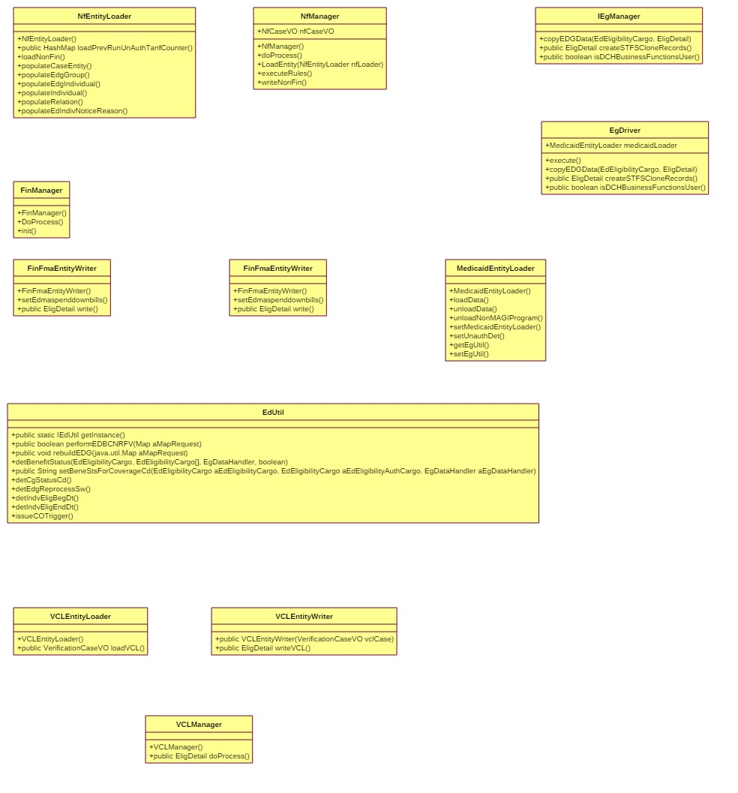

* **EdUtil:**

This Class contains the Driver i.e., Entry Class for determining eligibility. This module invokes following submodule:

* EDG
* Non-Financial
* Financial
* Resource
* Verification
* **EgDriver/IEgManager:**

This class is the EDG Driver, which is invoked from EdUtil. This components, determines following:

* Determines the program group composition eligibility by running OPA Group composition rules engine.
* Loads Entities
* Unloads Entities
* Passes data from Data Access Object(DAO) layer
* Runs eligibility for each month.
* **NFManager:**

This class is used for Non-Financial characteristics determination. This class invokes NFEntityLoader to pass data to OPA. NFEntityWriter to read data from OPA and store them in database.

* **FinManager:**

This class is used for Financial eligibility determination. This class invokes FinFmaEntityLoader to pass data to Financial module of the rules engine. FinFmaEntityWriter to read data from OPA and store them in database. These classes specified are used during Medicaid eligibility determination

* **VCLManager:**

This class is used for Verification eligibility determination. This class invokes VCLEntityLoader to pass data to Verification module of the rules engine. VCLEntityWriter to read data from OPA and store them in database.

#### Exception Handling

Eligibility Application layer will throw the EDBCException when exception happens and it will be caught in Service layer. FrameworkException is used to wrap around it. Logging of exception is done at the service level. Service methods will be throwing the GenericValidationException   to controller layer. Transaction manager will take care of rollback. For more details regarding the lay out the coding structure of the app and the way it traps for errors can be found in the Architecture Technical Bulletin at - [RI Technical Design](https://consulting.global.deloitteonline.com/sites/stateofrhodeislanduhipproject/Deliverables/Work%20Products%20(For%20Review)/Release%207/CCI/Reference%20Documents/RI%20Technical%20Design.docx).

| Exception Name | Exception Class Name | Remarks |
| --- | --- | --- |
| EDBCException | us.ri.eohhs.uhip.ies.framework.exception. EDBCException | EDBCException is represent the exceptions thrown by EDBC components and the actions that could be performed when exceptions occur. |
| GenericValidationException | us.ri.eohhs.uhip.ies.framework.exception. GenericValidationException | GenericValidationException is used to report any exception related to the validation of Tiers data. This is used to report any server side validation and framework history validations. |
| FrameworkException | us.ri.eohhs.uhip.ies.framework.exception. FrameworkException | FrameworkException is used by the framework to report any  exception that occurs during the framework process. |
| ApplicationException | us.ri.eohhs.uhip.ies.framework.exception. ApplicationException | This class provides a wrapper for all the application exceptions. This is the super class for all the application level exceptions. |

#### Caching

The Common Frameworks have provided APIs which get all the lookup data and cache it along with the APIs to get the data. Those have been used in our Reference Dao Layers to get the data used in our application and methods have been written in ReferenceServices to access the LookupData. Caching is also done at the OPA sever level. Further details regarding the lay out of the APIs and the way lookup data is loaded to memory can be found in the Architecture Technical Bulletin at - [RI Technical Design](https://consulting.global.deloitteonline.com/sites/stateofrhodeislanduhipproject/Deliverables/Work%20Products%20(For%20Review)/Release%207/CCI/Reference%20Documents/RI%20Technical%20Design.docx).

### Persistent Layer Design

Further details regarding the technical design that details the coding structure of the application and its classes can be found in the Architecture Technical Bulletin at - [RI Technical Design](https://consulting.global.deloitteonline.com/sites/stateofrhodeislanduhipproject/Deliverables/Work%20Products%20(For%20Review)/Release%207/CCI/Reference%20Documents/RI%20Technical%20Design.docx).

| Domain Object Name | Table Name | Configuration File Name |
| --- | --- | --- |
| EdEligibilityCargo | ED_ELIGIBILITY | PropertyColumnMapper.xml |
| EdIndvEligibiltyCargo | ED_INDV_ELIGIBILITY | PropertyColumnMapper.xml |
| EdEligFMABudgetCargo | Ed_ELIG_FMA_BUDGET | PropertyColumnMapper.xml |
| EdIndvNoticeReasonsCargo | ED_INDV_NOTICE_REASONS | PropertyColumnMapper.xml |
| EdEligNoticeReasonsCargo | ED_ELIG_NOTICE_REASONS | PropertyColumnMapper.xml |
| EDVerificationChecklistCargo | ED_VERIFICATION_CHECKLIST | PropertyColumnMapper.xml |
| EdIndvIncDtlsCargo | ED_INDV_INC_DTLS | PropertyColumnMapper.xml |
| EdEligQhpBudget | ED_ELIG_QHP_BUDGET | PropertyColumnMapper.xml |
| EdMaSpendDownBills | ED_MA_SPENDDOWN_BILLS | PropertyColumnMapper.xml |

### Security Design

Security framework manages access to application resources based on the permission matrix data.

Further details regarding the technical design that details the coding structure of the application and its classes can be found in the Architecture Technical Bulletin at - [RI Technical Design](https://consulting.global.deloitteonline.com/sites/stateofrhodeislanduhipproject/Deliverables/Work%20Products%20(For%20Review)/Release%207/CCI/Reference%20Documents/RI%20Technical%20Design.docx).

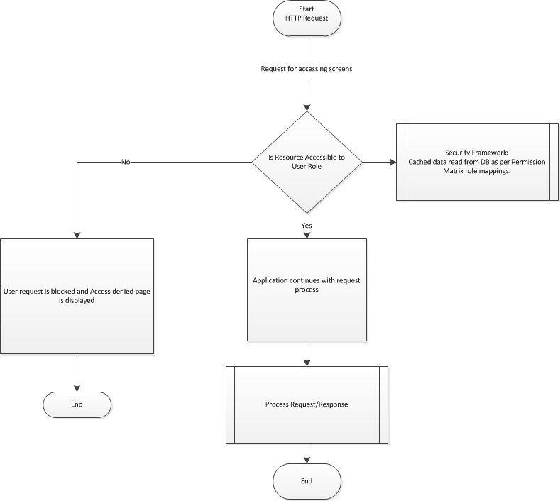

#### Page Level Security (if there are any specific requirements)

| Screen ID | Role / Condition | Access |
| --- | --- | --- |
| Level of Care Assessment | Katie Beckett Unit  LTSS Unit | Read-Write access.  All other users have read-only access. |
| Plan of Care Services | Katie Beckett Unit  LTSS Unit | Read-Write access.  All other users have read-only access. |
| Disability Determination | Katie Beckett Unit  LTSS Unit | Read-write access.  Existing security on the page will remain as-is. |

#### Field Level Security (if there are any specific requirements)

| Screen ID | Element ID | Role / Condition | Access |
| --- | --- | --- | --- |
| NA | NA | NA | NA |

### Reports

|  |  |  |  |  |  |
| --- | --- | --- | --- | --- | --- |
| Name | Trigger | Sender | Recipient | Delivery Mode | Frequency |
| N/A | N/A | N/A | N/A | N/A | N/A |

### Notices

| Name | Trigger / Condition | Delivery Mode |
| --- | --- | --- |
| DHS-1605 | Whenever Initial Determination for Medicaid is approved. | Paper |
| DHS-1605 | Whenever Renewal is Completed | Paper |
| DHS-1605 | Whenever a new member is added | Paper |
| DHS-1605 | Whenever Medicaid is negatively impacted and adequate notice needs to be provided. | Paper |
| DHS-1605 | Whenever LTSS is determination is completed and client is not notified about this change. | Paper |
| DHS-3503 | Whenever Medicaid is Pending for Missing verification. | Paper |
| DHS-3503 | Whenever QHP is Approved Conditionally Approved for missing verification | Paper |

### Master Client Index

|  |  |  |
| --- | --- | --- |
| MCI operation | Technical Condition | Parameter |
| Update/Insert | Whenever any Program is Approved/Closed or Denied. | Individual, Program, Aid Category Code and Eligibility Dates |

### Rules Engine Integration

Further details regarding the technical design describing attributes, source table/column names, derived comments, and output parameters can be found in the Architecture Technical Bulletin at - [RI Technical Design](https://consulting.global.deloitteonline.com/sites/stateofrhodeislanduhipproject/Deliverables/Work%20Products%20(For%20Review)/Release%207/CCI/Reference%20Documents/RI%20Technical%20Design.docx).

#### Input Parameters

| Attribute Name | Attribute ID | Source Table | Source Table Column | Comments (if Derived) |
| --- | --- | --- | --- | --- |
| the eligibility determination date | edbcRunDt | ED_ELIGIBILITY | EDBC_RUN_DT |  |
| the case mode | in_case_text_caseMode | DC_CASES | CASE_MODE_CD |  |
| the benefit period | in_global_date_benefitPeriod | DC_MA_BENEFIT_MONTHS | BENEFIT_MONTH |  |
| the SSI coordination unit has created this information | manualSsiCreate | DC_SSI | MANUAL_CREATE_IND | Will be true if MANUAL_CREATE_IND='M' |
| the SDX process has created this information | sdxSsiCreate | DC_SSI | MANUAL_CREATE_IND | Will be true if MANUAL_CREATE_IND='X' |
| member authorized | MemberAuthorized | DC_CASES | AUTH_REP_IND |  |
| the facility type | facilityTypeCd | DC_FACILITY | FACILITY_TYPE_CD |  |
| the level of care | levelOfCareCd | ED_INDV_LOC_ELIGIBILITY, ED_INDV_ELIGIBILITY, DC_LOC_AUTHORIZATIONS, DC_INDV_LIVING_ARNGMNTS | LEVEL_OF_CARE_CD |  |
| the person is expected to stay at least 30 days | moreThan30DaysSw | DC_FACILITY | MORE_THAN_30_DAYS_SW |  |
| the person is self-employed | SelfEmployed | DC_CASE_PROFILE, DC_INDV_PROFILE | SELF_EMPLOYED_SW |  |
| the person's age (in months) | age | ED_INDV_ELIGIBILITY | AGE_IN_MONTHS |  |
| the person is aged and disabled | agedDisabledSw | NA | NA | Derived in code base |
| the person is the primary applicant | applicant | DC_HEAD_OF_HOUSEHOLD | HOH_BEGIN_DT |  |
| the person is requesting coverage | appliedFor | DC_CASE_PROGRAM_INDV | AID_REQUEST_SW |  |
| the person is requesting assistance | appliedForMA | NA | NA | Derived in code base |
| the person is requesting MPP assistance | appliedForMC | NA | NA | Derived in code base |
| the person is requesting SSP | appliedForSSP | NA | NA | Derived in code base |
| the person's special medicaid approval code | approvalTypeCd | DC_SERVICES_MA | APPROVAL_TYPE_CD |  |
| the person's deceased date | dateOfDeath | DC_INDV | DEATH_DT |  |
| the person is denied SSI | deniedSSI | DC_SSI | APPEAL_FOR_DENIAL_SW, SSI_DENIAL_REASON_CD, SSI_IN_DENIAL_REASON_CD |  |
| the person's disability type | disabilityTypeCd | DC_DISABILITY | TYPE_CD |  |
| the person is disabled | disablesw | DC_DISABILITY | DISABILITY_DETERMINATION_SW |  |
| the person is enrolled in medicare part A | eligibleForMedicarePartA | DC_MEDICARE_CLAIM | MEDICARE_TYPE |  |
| the person's loss of job date | empTerminationDt | DC_EMPLOYMENT | TERMINATION_DT |  |
| the person is employed | employedSw | DC_CASE_PROFILE | EMPLOYED_SW |  |
| the person is entitled to medicare | entitledForMedicare | NA | NA | Derived in code base |
| the person is entitled to medicare part A | entitledForMedicarePartA | NA | NA | Derived in code base |
| The person's SSI federal living arrangement code | fedLivingArrngCd | DC_SSI | FED_LIVING_ARNGMNT_CD |  |
| the person is approved for level of care of highest or high | in_person_boolean_isLOCHighestOrHigh | DC_FACILITY | LEVEL_OF_CARE_CD |  |
| the person is approved for katie beckett medicaid | in_person_boolean_katieBeckettApprovedSw | DC_DISABLE_DETERMINATION | MEETS_DISABILITY_CRITERIA_SW | When the DISABLE_REVIEW_TYPE=”KB” |
| the person | in_person_text_name | DC_INDV | LAST_NAME Appended with FIRST_NAME |  |
| the person is potentially eligible for ABD-blind medicaid | indvADMAReq | NA | NA | Derived in code base |
| the person is potentially eligible for adoption subsidy with non-title IV-E | indvASDWReq | NA | NA | Derived in code base |
| the person is potentially eligible for Women's Cancer Screening | indvBCCPReq | NA | NA | Derived in code base |
| the person is potentially eligible for DD population CNOM | indvDDReq | NA | NA | Derived in code base |
| the person is potentially eligible for AD-low income medicaid | indvECMAReq | NA | NA | Derived in code base |
| the person is potentially eligible for foster care title IV-E | indvFC4EReq | NA | NA | Derived in code base |
| the person is potentially eligible for foster care non-title IV-E | indvFCDWReq | NA | NA | Derived in code base |
| the person is potentially eligible for chafee kids | indvFCTMReq | NA | NA | Derived in code base |
| the person is potentially eligible for AABD-medically needy medicaid | indvG2SMReq | NA | NA | Derived in code base |
| the person is potentially eligible for Katie Beckett Medicaid | indvHCCMReq | NA | NA | Derived in code base |
| the person is potentially eligible for QI-1s | indvQI1Req | NA | NA | Derived in code base |
| the person is potentially eligible for QMB | indvQMBReq | NA | NA | Derived in code base |
| the person is potentially eligible for SLMB | indvSLMBReq | NA | NA | Derived in code base |
| the person is potentially eligible for SSI Appeal | indvSSIAReq | NA | NA | Derived in code base |
| the person is potentially eligible for SSI | indvSSIReq | NA | NA | Derived in code base |
| the person is potentially eligible for adoption subsidy with title IV-E | indvTitile4EReq | NA | NA | Derived in code base |
| the person is potentially eligible for widower or DAC medicaid | indvWidowDACReq | NA | NA | Derived in code base |
| the person has received SSI on or before August 22nd 1996 | isCertForSsiAsOf082296 | DC_SSI | BENEIFT_TYPE_CD=”SSI” | If the BEGIN_DT is on or Before August 22 1996 with Approved SSI record then this is set to TRUE. |
| the person has received DCYF Medicaid prior at the age18 in Rhode Island State | isReceivedDCYFMedicaidAt18Years | CV_ED_MCI_EDG_INDIVIDUAL | TYPE_OF_ASSISTANCE_CD | If any DCYF Medicaid is found in the past as of the individual’s 18th Birthday then this flag is set to TRUE |
| the person's shelter type | laTypeCd | DC_INDV_LIVING_ARNGMNTS | LA_TYPE_CD |  |
| the person's special medicaid approval end date | maApprovalEndDt | DC_SERVICES_MA | MA_EFF_END_DT |  |
| the person's special medicaid approval begin date | maDCHApprovalDt | DC_CASE_PROGRAM_INDV | MA_DCH_APPROVAL_DT |  |
| The person's SSI medicaid status | maEligStatusCd | DC_SSI | MA_ELIG_STATUS_CD |  |
| the person is married | married |  |  |  |
| the person's medicaid type code | medicaidTypeCd | DC_CASE_PROGRAM | MEDICAID_TYPE_CD |  |
| The person's SSI payment status code | paymentStatusCd | DC_SSI | PAYMENT_STATUS_CD |  |
| the person is receiving SSI | receivingSSI | ED_INDV_ELIGIBILITY | SSI_RECIPIENT_SW |  |
| the person is receiving SSI medicaid | receivingSSIMedicaid | NA | NA | If the Individual is currently receiving SSI Medicaid or SSI Case is Pending Approval then this is set to TRUE |
| the person's residency state code | residencyStateCd | DC_DEMOGRAPHICS | RESIDENCY_STATE_CD |  |
| the person is approved for RSDI benefits | rsdiApproval | NA | NA | Derived in code base |
| the person's SSI denial date | ssiDenialDt | DC_SSI | SSI_DENIAL_DT |  |
| the person's SSI denied reason code | ssiDenialReason | DC_SSI | SSI_DENIAL_REASON_CD |  |
| the person is receiving SSI medicaid for this benefit period | ssiTpCdExistsInAuth | NA | NA | If the Individual is currently receiving SSI Medicaid then this is set to TRUE |
| the shelter type | livingArrangement | DC_INDV_LIVING_ARNGMNTS | LA_TYPE_CD |  |

#### Output Parameter

| Attribute Name | Attribute ID | Target Table | Target Table Column | Comments  (if Derived) |
| --- | --- | --- | --- | --- |
| the notice reason | out_noticeReason_text_noticeReason | ED_INDV_NOTICE_REASONS | FAILURE_REASON_CD |  |
| the person's approved medicaid code | out_person_text_MAProgramCd | ED_ELIGIBILITY | TYPE_OF_ASSISTANCE_CD |  |
| the person's approved MPP code | out_person_text_MCProgramCd | ED_ELIGIBILITY | TYPE_OF_ASSISTANCE_CD |  |
| the person's approved SSP code | out_person_text_SSProgramCd | ED_ELIGIBILITY | TYPE_OF_ASSISTANCE_CD |  |

# Glossary

|  |  |
| --- | --- |
| AABD | Aid to Aged, Blind or Disabled |
| APTC | Advanced Premium Tax Credit |
| BHDDH | Department of Behavioral Healthcare, Developmental Disabilities and Hospitals, an agency within the EOHHS Secretariat |
| BENDEX | Beneficiary Data Exchange |
| CHIP | Children Insurance Program |
| CNOM | Cost Not Otherwise Matchable |
| Combined Application | An application for health insurance and human services program |
| CSRA | Community Spouse Resource Assessment |
| CSR | Cost Sharing Reduction |
| DCYF | Department of Children, Youth and Families |
| DEA | Division of Elderly Affairs, a division within DHS |
| DD | Developmentally Delayed |
| DHS | Department of Homeland Security |
| DHS | Department of Human Services |
| DOC | Department of Correction |
| DOH | Department of Health |
| EDBC | Eligibility Determination and Benefit Calculation |
| EDG | Eligibility determination group |
| EDM  EOHHS | Eligibility determination month or benefit month for which benefit is evaluated  Executive Office of Health and Human Services, the Medicaid organizational entity for RI |
| FDSH | Federal Data Services Hub |
| GPA | General Public Assistance |
| ID | Intellectually Delayed |
| IPV | Intentional program violation |
| LTC | Long Term Care Client |
| LTSS | Long Term Services and Support |
| MART | Medical Assistance Review Team |
| ME | Aged/Disability Medicaid or Complex Medicaid |
| Mixed Household | A household where the eligibility results in both MAGI Medicaid and QHP/APTC/CSR. |
| PTC | Premium Tax Credit |
| RCA | Refugee Cash Assistance |
| RDOC | Request for Documentation |
| RIW | Rhode Island Works |
| SDX | State Data Exchange |
| SNAP | Supplemental Nutritional Assistance Program |
| SSA | Social Security Administration |
| SSP  TOA | Social Security Supplemental Payment  Type of Assistance |
| VCL | Verification Checklist |

# Appendix

### Aid Category Codes

| **Visible to User** | **Type of Assistance** | **Aid Category Code** | **Retro Medicaid applicable** |
| --- | --- | --- | --- |
| ~~Optional State Suppl – No SSI / Aged~~ | ~~Optional State Supplement Medicaid~~ | ~~1A~~ | ~~Yes~~ |
| ~~Optional State Suppl – No SSI / Blind~~ | ~~Optional State Supplement Medicaid~~ | ~~1B~~ | ~~Yes~~ |
| ~~Optional State Suppl – No SSI / Disabled~~ | ~~Optional State Supplement Medicaid~~ | ~~1D~~ | ~~Yes~~ |
| SSI Medicaid / Aged | Any TOA where individual receives SSI | AA | Yes |
| SSI Medicaid / Blind / Age 21 years and above | Any TOA where individual receives SSI | AB | Yes |
| SSI Medicaid – Disabled / Age 21 years and above | Any TOA where individual receives SSI | AD | Yes |
| SSI Medicaid/ Blind / Children under 21 years | Any TOA where individual receives SSI | AL | Yes |
| SSI Medicaid – Disabled / Children under 21 years | Any TOA where individual receives SSI | AM | Yes |
| Cat Needy No Cash Assistance / Aged | Pickle Amendment Protected Widowers Aged (60-65) SSI Disabled Widower Actuarial Changes Disabled Adult Children Disabled Widowers/Divorced Spouse Low Income for Aged and Disabled | BA | Yes |
| Cat Needy No Cash Assistance/ Blind / Age 21 years and above | Pickle Amendment Protected Widowers Aged (60-65) SSI Disabled Widower Actuarial Changes Disabled Adult Children Disabled Widowers/Divorced Spouse Aged, Blind Medicaid | BB | Yes |
| Cat Needy No Cash Assistance – Disabled / Age 21 years and above | Pickle Amendment Protected Widowers Aged (60-65) SSI Disabled Widower Actuarial Changes Disabled Adult Children Disabled Widowers/Divorced Spouse Aged, Blind Medicaid Low Income for Aged and Disabled | BD | Yes |
| Cat Needy No Cash Assistance/ Age under 21 years | Pickle Amendment Protected Widowers Aged (60-65) SSI Disabled Widower Actuarial Changes Disabled Adult Children Disabled Widowers/Divorced Spouse Aged, Blind Medicaid Low Income for Aged and Disabled | BL | Yes |
| Cat Needy No Cash Assistance – Disabled / Age under 21 years | Pickle Amendment Protected Widowers Aged (60-65) SSI Disabled Widower Actuarial Changes Disabled Adult Children Disabled Widowers/Divorced Spouse Aged, Blind Medicaid Low Income for Aged and Disabled | BM | Yes |
| LTSS Medicaid / Insititutional / Aged | LTSS Special Income LTSS Med Needy (If the Individual is Institutionalized) | LA | Yes |
| LTSS Medicaid / Blind / Age 21 years and above | LTSS Special Income LTSS Med Needy (If the Individual is Institutionalized) | LB | Yes |
| LTSS Medicaid / Blind / Age under 21 years | LTSS Special Income LTSS Med Needy (If the Individual is Institutionalized) | LL | Yes |
| LTSS Medicaid / Disabled / Age 21 years and above | LTSS Special Income LTSS Med Needy (If the Individual is Institutionalized) | LD | Yes |
| LTSS Medicaid / Disabled / Age under 21 years | LTSS Special Income LTSS Med Needy (If the Individual is Institutionalized) | LM | Yes |
| HCBS Medicaid / Aged | LTSS HCBS Waiver (217-like) LTSS Med Needy (If the Individual is in Community) | WA | Yes |
| HCBS Medicaid / Blind / Age 21 years and above | LTSS HCBS Waiver (217-like) LTSS Med Needy (If the Individual is in Community) | WB | Yes |
| HCBS Medicaid / Disabled / Age 21 years and above | LTSS HCBS Waiver (217-like) LTSS Med Needy (If the Individual is in Community) | WD | Yes |
| HCBS Medicaid / Blind / Age under 21 years | LTSS HCBS Waiver (217-like) LTSS Med Needy (If the Individual is in Community) | WL | Yes |
| HCBS Medicaid / Disabled / Age under 21 years | LTSS HCBS Waiver (217-like) LTSS Med Needy (If the Individual is in Community) | WM | Yes |
| Medically Needy / Aged | ABD – Med Needy | MA | Yes |
| Medically Needy / Blind | ABD – Med Needy | MB | Yes |
| Medically Needy / Child | ABD – Med Needy | MC | Yes |
| Medically Needy / Disabled | ABD – Med Needy | MD | Yes |
| Transitional Medical Assistance / Child | Extended Medical Assistance | UZ | No |
| Transitional Medical Assistance / Caretaker | Extended Medical Assistance | VM | No |
| Cat Needy Non-Citizen Emg. Only / Aged | ABD - EMER (If they are Categorically Eligible) | EA | Yes |
| Cat Needy Non-Citizen Emg. Only / Blind | ABD - EMER (If they are Categorically Eligible) | EB | Yes |
| Cat Needy Non-Citizen Emg. Only / Child | MAGI-EMER | EC | Yes |
| Cat Needy Non-Citizen Emg. Only / Disabled | ABD-EMER (If they are Categorically Eligible) | ED | Yes |
| Cat Needy Non-Citizen Emg. Only / Caretaker | MAGI-EMER | ER | Yes |
| Med Needy Non-Citizen Emg Only / Aged | ABD - EMER (If they are Medically Needy) | NA | Yes |
| Med Needy Non-Citizen Emg Only / Blind | ABD - EMER (If they are Medically Needy) | NB | Yes |
| Med Needy Non-Citizen Emg Only / Disabled | ABD - EMER (If they are Medically Needy) | ND | Yes |
| Chafee Kids Medicaid | Chafee Kids Medicaid | FF | No |
| IV-E Children and Non-IV-E < 19, Mgd Care | Non IV-E Foster Care Medicaid IV-E Adoption Subsidy | FM | Yes |
| IV-E Foster Children | IV-E Foster Care Medicaid | FC | Yes |
| Non IV-E Foster Children Ages 19-21, Mgd Care | Non IV-E Foster Care Medicaid Ages 19-21 | FN | Yes |
| ~~Non IV-E Adoption Subsidy Medicaid~~ | ~~Non IV-E Adoption Subsidy Medicaid~~ | ~~HC~~ | ~~Yes~~ |
| ~~State subsidized non IV-E/Child-3C~~ | ~~Non IV-E State Adoption Subsidy~~ | ~~RC~~ | ~~Yes~~ |
| Katie Beckett Medicaid | Katie Beckett Medicaid | KD | Yes |
| Sherlock Medicaid | Sherlock Medicaid LTSS Sherlock | K1 | Yes |
| Deemed Newborn Medicaid | MAGI Medicaid LTSS MAGI | UH | No |
| Low Income Families Medicaid (LIF) - Child | MAGI Medicaid LTSS MAGI | UF | No |
| Low Income Families Medicaid (LIF) - Adult | MAGI Medicaid LTSS MAGI | UG | No |
| Rite Care Children under 1 | MAGI Medicaid LTSS MAGI | UI | No |
| Rite Care Children under 6 | MAGI Medicaid LTSS MAGI | UJ | No |
| ~~Rite Care Children 6 to 18 type 1~~ | ~~MAGI Medicaid LTSS MAGI~~ | ~~UK~~ | ~~No~~ |
| Rite Care for Pregnant Women | MAGI Medicaid LTSS MAGI | UL | No |
| Parent/Caretaker Category | MAGI Medicaid LTSS MAGI | UE | No |
| CHIP-like MA for Pregnant Women w/ Ins | MAGI Medicaid LTSS MAGI | RE | No |
| CHIP for Pregnant Women w/o Ins | MAGI Medicaid LTSS MAGI | SE | No |
| CHIP-like MA 1 Category 157% FPL w/ Ins | MAGI Medicaid LTSS MAGI | RG | No |
| CHIP-like MA 1 Category 157–190% FPL w/ Ins | MAGI Medicaid LTSS MAGI | RH | No |
| CHIP-like MA 1 Category 190–200% FPL w/ Ins | MAGI Medicaid LTSS MAGI | RI | No |
| CHIP-like MA 1 Category 200–261% FPL w/ Ins | MAGI Medicaid LTSS MAGI | RJ | No |
| CHIP 1 Category 157 FPL% w/o Ins | MAGI Medicaid LTSS MAGI | SG | No |
| CHIP 1 Category 157–190% FPL w/o Ins | MAGI Medicaid LTSS MAGI | SH | No |
| CHIP 1 Category 190–200% FPL w/o Ins | MAGI Medicaid LTSS MAGI | SI | No |
| CHIP 1 Category 200–261% FPL w/o Ins | MAGI Medicaid LTSS MAGI | SJ | No |
| CHIP-like MA 2 Category 157% FPL w/ Ins | MAGI Medicaid LTSS MAGI | RK | No |
| CHIP-like MA 2 Category 157–190% FPL w/ Ins | MAGI Medicaid LTSS MAGI | RL | No |
| CHIP-like MA 2 Category 190–200% FPL w/ Ins | MAGI Medicaid LTSS MAGI | RM | No |
| CHIP-like MA 2 Category 200–261% FPL w/ Ins | MAGI Medicaid LTSS MAGI | RN | No |
| CHIP 2 Category 157 FPL% w/o Ins | MAGI Medicaid LTSS MAGI | SK | No |
| CHIP 2 Category 157–190% FPL w/o Ins | MAGI Medicaid LTSS MAGI | SL | No |
| CHIP 2 Category 190–200% FPL w/o Ins | MAGI Medicaid LTSS MAGI | SM | No |
| CHIP 2 Category 200–261% FPL w/o Ins | MAGI Medicaid LTSS MAGI | SN | No |
| Unborn CHIP-like MA w/ Ins | MAGI Medicaid LTSS MAGI | RF | No |
| Unborn CHIP w/o Ins | MAGI Medicaid LTSS MAGI | SF | No |
| Childless Adult Medicaid | MAGI Medicaid LTSS MAGI | CX | No |
| RIte Care Extended Family Planning LT 190 CIT or LWP | Extended Family Planning Services | 71 | No |
| RIte Care Extended Family Planning GT 190 and LT 253 CIT or LWP | Extended Family Planning Services | 73 | No |
| RIte Care Extended Family Planning LT 190 not LWP | Extended Family Planning Services | 01 | No |
| RIte Care Extended Family Planning GT 190 and LT 253 not LWP | Extended Family Planning Services | 03 | No |
| QMB Only / Aged | Qualified Medicare Beneficiary | PA | No |
| QMB Only / Disabled | Qualified Medicare Beneficiary | PD | No |
| SLMB Only /Aged | Specified Low Income Medicare Beneficiary | XS | Yes |
| SLMB Only/ Disabled | Specified Low Income Medicare Beneficiary | XT | Yes |
| Qualified Individual QI-1 | Qualified Individual QI-1 | Q1 | Yes (same calendar year) |
| Breast and Cervical Cancer Treatment Program. | Cancer Treatment Precancer | CA | No |
| BHDDH DD Support Services CNOM | Intellectually Delayed CNOM | BH | No |
| Early Intervention Services | Early Intervention Services | EI | No |
| D1 Copay Services | D1 Copay Services | D1 | No |
| D2 Copay Services | D2 Copay Services | D2 | No |
| Drug Court for Children under 18 | Drug Court for Children under 18 | DG | No |
| PE - Foster Care Medicaid | N/A (From UHIP Presumptive Eligibility Application) | PF | No |
| PE - Low Income Families (LIF) Medicaid - Child | N/A (From UHIP Presumptive Eligibility Application) | PK | No |
| PE - Low Income Families Medicaid (LIF) - Parent | N/A (From UHIP Presumptive Eligibility Application) | PN | No |
| PE - Rite Care Children under 1 | N/A (From UHIP Presumptive Eligibility Application) | PI | No |
| PE - Rite Care Children under 6 | N/A (From UHIP Presumptive Eligibility Application) | PJ | No |
| PE - Rite Care Children 6 to 18 type 1 | N/A (From UHIP Presumptive Eligibility Application) | PL | No |
| PE - Rite Care for Pregnant Women | N/A (From UHIP Presumptive Eligibility Application) | PM | No |
| PE - Parent/Caretaker Category | N/A (From UHIP Presumptive Eligibility Application) | PN | No |
| PE - Childless Adult Medicaid | N/A (From UHIP Presumptive Eligibility Application) | PX | No |